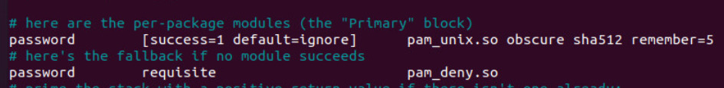



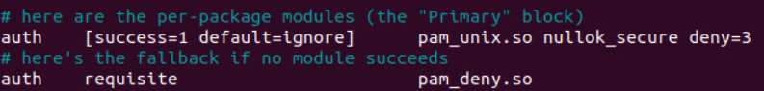







https://www.boxentriq.com/code-breaking/cipher-identifier

