EU Rent

Diagrammes de séquences et Modèle du domaine
Date de remise : 24 novembre 2005

Version : 1.0

Auteure :
Une excellente étudiante du INF5151, Automne 2005

TP 2
INF5151 - groupe 30
Automne 2005
Table des matières

1. Introduction 3
1.1. But du document 3
1.2. Public visé 3
2. Description sommaire de la fonctionnalité du système 3
3. Réservations 4
3.1. On-line reservation 4
3.2. Diagramme de séquences : On-line reservation 5
3.3. Diagramme de classes: On-line reservation 6
4. Cueillette des voitures 7
4.1. Handover 7
4.2. Diagramme de séquences: Handover 9
4.3. Diagramme de classes: Handover 10
5. Locations sans réservation (walk-in) 10
5.1. Walk-in Rental 10
5.2. Diagramme de séquences: Walk-in Rental 13
5.3. Diagramme de classes: Walk-in Rental 13
6. L’allocation de voitures aux réservations dues le jour suivant 14
6.1. Car allocation 14
6.2. Diagramme de séquences : car allocation 16
6.3. Diagramme de classes : car allocation 17
7. Les retours 17
7.1. Car return 17
7.2. Diagramme de séquences : Car return 19
7.3. Diagramme de classe : Car return 20
8. Gestion des réparations 20
8.1. Car maintenance 20
8.2. Diagramme de séquences : Car maintenance 22
8.3. Diagramme de classes : Car maintenance 22
9. Modèle global 23
10. Dictionnaire des données 24
10.1. Les classes 24
10.2. Les associations 27

Introduction

But du document
Identifier et décrire les différentes fonctionnalités du système soit les réservations, la cueillette des voitures, les locations sans réservation (walk-in), l'allocation de voitures aux réservations dues le jour suivant, les retours et la gestion des réparations, dans le but de répondre aux besoins du client. Identifier les différents acteurs du système ainsi que leurs interactions avec ce dernier.

Public visé
Le client
Les différents intervenants participants aux différentes phases de développement.

Description sommaire de la fonctionnalité du système

Le système se divise en six groupes distincts soit :

- Les réservations : Les clients désirant réserver une voiture pour une location.
- La cueillette des voitures : Les clients qui se présente dans une agence pour prendre possession d’une voiture.
- Les locations sans réservation : Les clients qui veulent louer une voiture sans avoir fait de réservation auparavant.
- L’allocation de voitures aux réservations dues le jour suivant : Processus automatisé qui alloue des voitures aux réservations dues le lendemain.
- Les retours : Les client désirant retourner une voiture louée.
- La gestion des réparations : La réparation ou la maintenance d’une voiture de l’agence.

Réservations

On-line reservation

Use case name |  | On-line reservation |  | Version | 1.1
Problem domain |  | EU Rental – advance reservations |  | Author | Hafedh Mili
Purpose |  | Customers need to make a reservation to ensure the availability of the car category and car model that they want, at the pick-up branch that they want.
Actors |  | Customer. In the context of a phone reservation system, the customer would be dealing with a Teller who simply acts as an intermediary between the client and the system
Trigger events |  | The customer’s desire to make a reservation
Use case description
Preconditions
Post-conditions |  | Customer has a reservation for a particular car group, a particular duration, with a particular pickup branch, and a particular drop-off branch  The inventory of available cars of a particular car group at a particular branch for a particular branch is diminished by one for the duration of the rental  The inventory of available cars of that car group at the drop-off branch is increased by one on the projected date of drop-off
Step # | Actor actions (external events) |  | System response |  |  | Decision
 | Customer submits reservation period, pick-up branch, drop-off branch, and car preferences
 |  |  | System checks availability of cars at pick-up branch for the day of rental |  |  | Are there cars available, all car groups combined
 |  |  | Car availability Ok, system prompts customer for personal info
 | Customer submits personal info
 |  |  | System checks customer info |  |  | Is the customer known  Has s/he been blacklisted  Is s/he a frequent customer
 |  |  | Customer OK, system confirms reservation
 |  |  | System updates car inventory at pick-up branch and at return branch
Alternate scenarios
Step # | Alternate actor action |  | Alternate system response |  |  | Alternate decision
3.  3.a.1 |  |  | No cars available at branch on pick-up date, system prompts for a different branch or a different date
3.a.2 | Customer submits new data; go back to step 4
6.  6.a.1 |  |  | Customer is black-listed, System explains situation and terminates session

Diagramme de séquences : On-line reservation
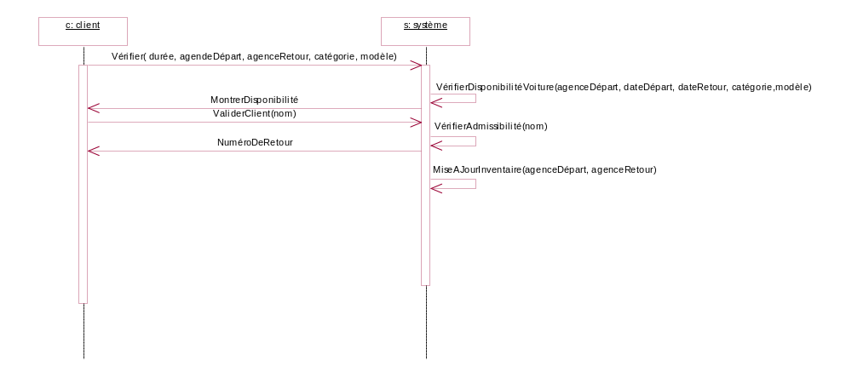

Cueillette des voitures

Handover

Use case name |  |  | Handover |  |  | Version | 1.0
Problem domain |  |  | EU Rental – advance reservations |  |  | Author | Hafedh Mili
Purpose |  |  | Customers finalize the rental contract when they pick up a car that they had reserved. This use case describes the sequence of interactions
Actors |  |  | Customer, and RentalClerk. For all practical purposes, the RentalClerk is considered as an interface to the system
Trigger events |  |  | The customer showing up at branch on day of rental
Use case description
Preconditions |  |  | The customer has a reservation on the given date at the given branch
Post-conditions |  |  | Contract is created and signed  A car is released to customer  Customer credit card charged to estimate of rental cost
Step # | Actor actions |  |  | System response |  |  | Decision
 | Walks in to rental branch, and provides reservation number
 |  |  |  | System validates reservation number |  |  | Is it valid
 | Customer submits driver information
 |  |  |  | System validates driver information |  |  | Do they have a valid license
 |  |  |  | System validates driver eligibility |  |  | Is the driver eligible to rent and drive a car
 |  |  |  | System validates driver record |  |  | Is driver’s driving record acceptable
 |  |  |  | System presents car assignment with customer |  |  | Was this reservation assigned a car as requested by the customer
 | Customer confirms car assignment
 |  |  |  | System validates insurance coverage |  |  | Are they properly insured
 | Customer selects fuel options
 | Customer submits prepayment credit information
 |  |  |  | System validates credit information |  |  | Is credit card valid  Is the credit rating of the customer good enough
 |  |  |  | System checks fund availability |  |  | is the balance enough to cover contract basic cost
 | Customer signs contract
 |  |  |  | System finalizes rental contract
Alternate scenarios
Step # |  | Alternate actor action |  |  | Alternate system response |  | Alternate decision
8. |  | Customer does not like car assigned, s/he selects a different car group or model
 |  |  |  |  | System checks availability of car group/model  GO TO 8 |  | Are there cars from the car group available today  Are there cars from the requested model (if one was requested) available today
9. |  |  |  |  | System validates insurance coverage. Coverage is insufficient, proposes additional coverage
 |  | Customer selects additional coverage. GOTO 9
8. |  | There are additional drivers.  Customer confirms car assignment
 |  | Customer provides additional driver info
 |  |  |  |  | System validates driver information |  | Do they have a valid license
 |  |  |  |  | System validates driver eligibility |  | Is the driver eligible to drive a rental car
 |  |  |  |  | System validates driver record  GOTO 9 |  | Is driver’s driving record acceptable

Diagramme de séquences: Handover

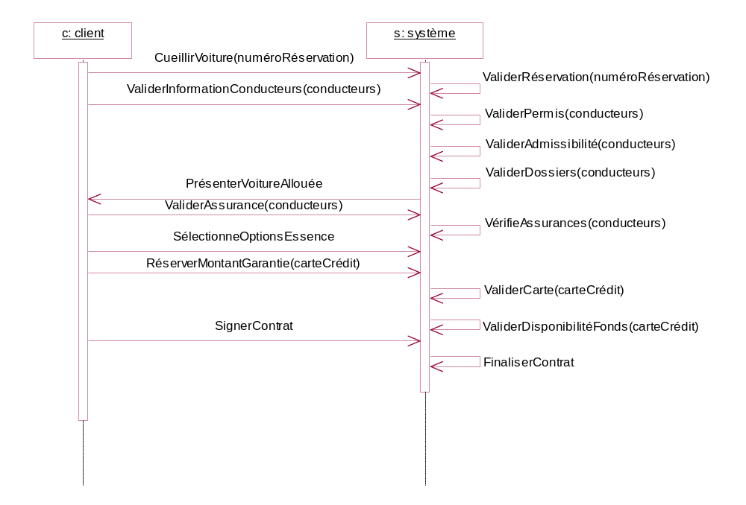

Locations sans réservation (walk-in)

Walk-in Rental

Use case name |  | Walk-in Rental |  | Version | 1.0
Problem domain |  | Rental |  | Author | Hafedh Mili
Purpose |  | A customer walks into branch and requests a rental without advance reservation.
Actors |  | Customer, and RentalClerk. For all practical purposes, the RentalClerk is considered as an interface to the system
Trigger events |  | The customer showing up at branch on day of rental
Use case description
Preconditions |  | There are cars available
Post-conditions |  | A rental contract is created and signed  A car is released to customer  Customer credit card charged to estimate of rental cost
Step # | Actor actions (external events) |  | System response |  |  | Decision
 | Customer submits car preferences and return branch and date
 |  |  | System checks availability of cars |  |  | Are there cars of the requested group available  Are there cars of different groups available
 | Customer submits driver information
 |  |  | System checks customer info |  |  | Is the customer known  Has s/he been blacklisted  Is s/he a frequent customer
 |  |  | System checks driver license |  |  | Do they have a valid driver license?
 |  |  | System validates driver eligibility |  |  | Is the driver eligible to rent and drive a car?
 |  |  | System validates driver record |  |  | Is driver’s driving record acceptable
 |  |  | System presents customer with choice of car groups or models
 | Customer selects car group and model
 |  |  | System validates insurance coverage |  |  | Are they properly insured
 | Customer selects fuel options
 | Customer submits prepayment credit information
 |  |  | System validates credit information |  |  | Is credit card valid  Is the credit rating of the customer good enough
 |  |  | System checks fund availability |  |  | is the balance enough to cover contract basic cost
 | Customer signs contract
 |  |  | System finalizes rental contract
Alternate scenarios
Step # | Alternate actor action |  | Alternate system response |  |  | Alternate decision
10. |  |  | System validates insurance coverage. Coverage is insufficient, proposes additional coverage
 | Customer selects additional coverage. GOTO 9
9. | There are additional drivers.  Customer confirms car assignment
 | Customer provides additional driver info
 |  |  | System validates driver information |  |  | Do they have a valid license  Expiry date  Country of origin
 |  |  | System validates driver eligibility |  |  | Is the driver old enough  Are they physically capable to drive the car
 |  |  | System validates driver record  GOTO 10 |  |  | Is driver’s driving record acceptable

Diagramme de séquences: Walk-in Rental

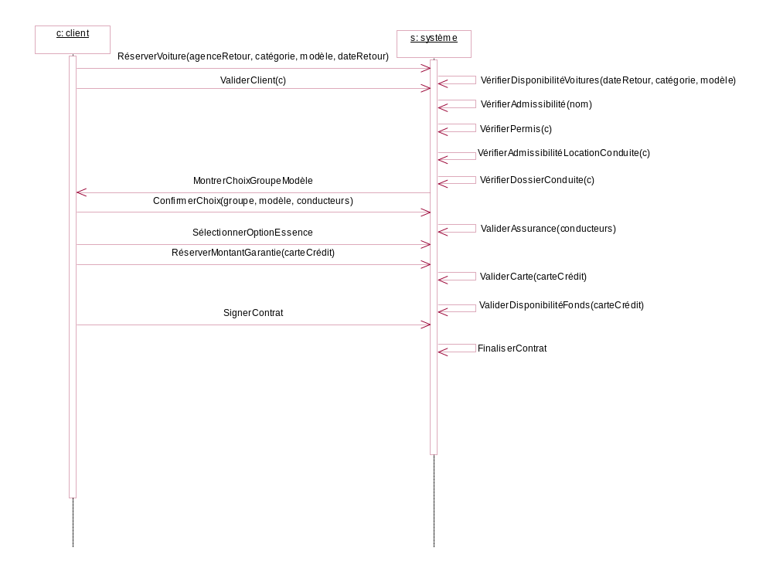

L’allocation de voitures aux réservations dues le jour suivant

Car allocation

Use case name |  | Car allocation |  |  | Version |  | 2.0
Problem domain |  | EU Rental – advance reservations |  |  | Author |  | Hafedh Mili
Purpose |  | At the end of each working day, we need to allocate cars to reservations for the next day to figure out, 1) which cars got assigned and need service, 2) which cars can be made available for walk-in rentals, 3) etc
Actors |  | System trigger
Trigger events |  | A given time of day is reached (end of business day). Rental reservations are treated one by one
Use case description
Preconditions |  | No more walk-in rentals for the day
Post-conditions |  | All the next day reservations have cars reserved for them, or requested from other branches
Step # | Actor actions |  | System response |  |  | Decision
 | End of day event; customer reservation due next day
 |  |  | Identify pool of rentable cars |  |  | which cars are available for rent
 |  |  | Identify reservations due the next day
 |  |  | Assign cars using basic rules |  |  | Which car to assign to a given reservation
 |  |  | Reserve cars for walk-in rentals |  |  | How many cars to set aside of each group
 |  |  | Reserve cars for upgrades |  |  | Which/how many cars to reserve for upgrades
 |  |  | If there are still reservations with no assigned cars
 |  |  | Assign cars using upgrades |  |  | Which cars to assign  Which reservations to upgrade
 |  |  | if there are still reservations with no assigned cars
 |  |  | Use exceptional rules |  |  | Which cars are available for rent  Which cars to assign to reservations
 |  |  | if there are still reservations with no assigned cars
 |  |  | Use in-extremis procedure
 |  |  | endif
 |  |  | endif
 |  |  | endif
Alternate scenarios
Step # | Alternate actor action |  |  | Alternate system response |  |  |  | Alternate decision

Diagramme de séquences : car allocation
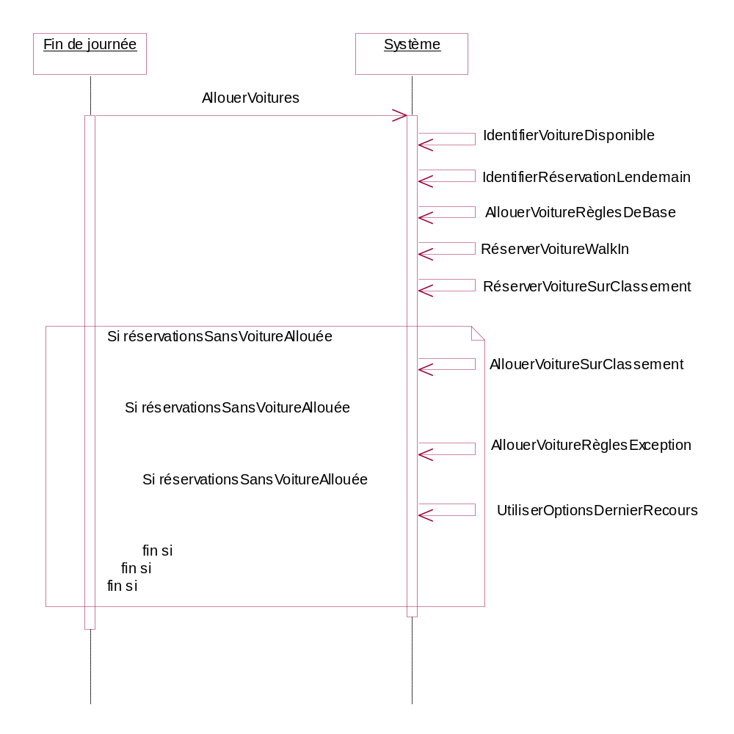

Les retours

Car return

Use case name |  |  | Car return |  | Version |  | 1.0
Problem domain |  |  | Car rental |  | Author |  | Hafedh Mili
Purpose |  |  | At the end of the rental period, customer returns car to a branch
Actors |  |  | Customer via a clerk
Trigger events |  |  | Customer walks in to branch to drop-off car
Use case description
Preconditions |  |  | Customer holds a car rented from EU Rent
Post-conditions |  |  | Rental contract closed and priced  Rental paid for  Car returned  Customer records updated  Branch inventory updated
Step # | Actor actions (external events) |  |  | System response |  | Decision
 | Customer checks-in with car into branch
 |  |  |  | System checks drop-off location |  | Is the location different from the scheduled one  What is the penalty, if they are different
 |  |  |  | System checks return date of rental contract |  | What is the rate basis for the contract  What is the rental basic cost for the contract
 |  |  |  | System checks fuel level |  | What is the cost of the fuel used, if any
 |  |  |  | System checks state of the car |  | Is the car OK  Does it need maintenance  What is the cost of repairs
 | Customer presents guarantee credit card for payment
 |  |  |  | System charges rental amount |  | What is the rental amount  Does the credit card have enough credit left
 | Customer signs card draft
 |  |  |  | System closes contract, inserts new history rental record
 |  |  |  | System updates inventory
Alternate scenarios
Step # |  | Alternate actor action |  | Alternate system response |  | Alternate decision
6. |  | Customer presents a different credit card for payment
 |  |  |  | System validates credit card information |  | Is credit card valid
 |  |  |  | System checks fund availability  GOTO 7. |  | Does the credit card have enough credit left
6. |  | Customer pays cash  GOTO 9
10. |  |  |  | Car rented from competitor, thus schedule car return to competitor
 |  |  |  | System closes contract, inserts new history rental record, and updates inventory

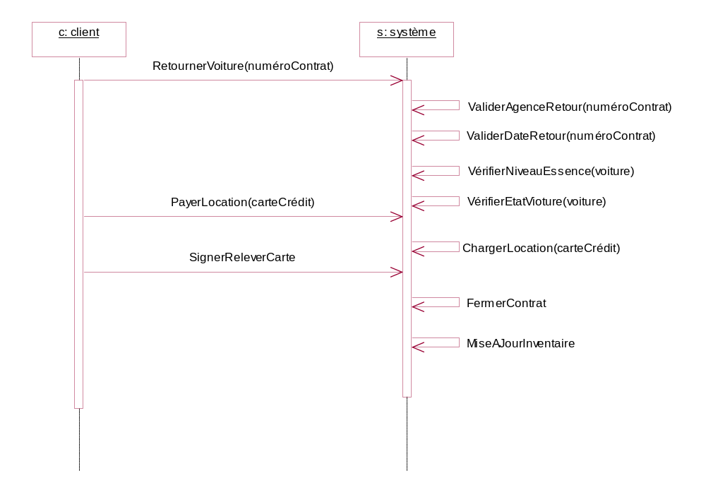
Diagramme de séquences : Car return

Gestion des réparations

Car maintenance

Use case name |  |  | Car return |  | Version |  | 1.0
Problem domain |  |  | Car rental |  | Author |  | Hafedh Mili
Purpose |  |  | At the end of the rental period, customer returns car to a branch
Actors |  |  | Customer via a clerk
Trigger events |  |  | Customer walks in to branch to drop-off car
Use case description
Preconditions |  |  | Customer holds a car rented from EU Rent
Post-conditions |  |  | Rental contract closed and priced  Rental paid for  Car returned  Customer records updated  Branch inventory updated
Step # | Actor actions (external events) |  |  | System response |  | Decision
 | Customer checks-in with car into branch
 |  |  |  | System checks drop-off location |  | Is the location different from the scheduled one  What is the penalty, if they are different
 |  |  |  | System checks return date of rental contract |  | What is the rate basis for the contract  What is the rental basic cost for the contract
 |  |  |  | System checks fuel level |  | What is the cost of the fuel used, if any
 |  |  |  | System checks state of the car |  | Is the car OK  Does it need maintenance  What is the cost of repairs
 | Customer presents guarantee credit card for payment
 |  |  |  | System charges rental amount |  | What is the rental amount  Does the credit card have enough credit left
 | Customer signs card draft
 |  |  |  | System closes contract, inserts new history rental record
 |  |  |  | System updates inventory
Alternate scenarios
Step # |  | Alternate actor action |  | Alternate system response |  | Alternate decision
6. |  | Customer presents a different credit card for payment
 |  |  |  | System validates credit card information |  | Is credit card valid
 |  |  |  | System checks fund availability  GOTO 7. |  | Does the credit card have enough credit left
6. |  | Customer pays cash  GOTO 9
10. |  |  |  | Car rented from competitor, thus schedule car return to competitor
 |  |  |  | System closes contract, inserts new history rental record, and updates inventory

Diagramme de séquences : Car maintenance

