MAD
In-Class Activity 14 (Part 1)
Managing Products using Firebase in Flutter
Due: TBA

Objective: This class activity aims to provide hands-on experience in building a Flutter app that interacts with Firebase Firestore to manage a list of products.
To create a new Firebase project from the terminal when configuring it for your Flutter app, follow these steps:
Install the Firebase CLI and FlutterFire CLI:
- First, install the FlutterFire CLI using the command: “dart pub global activate flutterfire_cli”
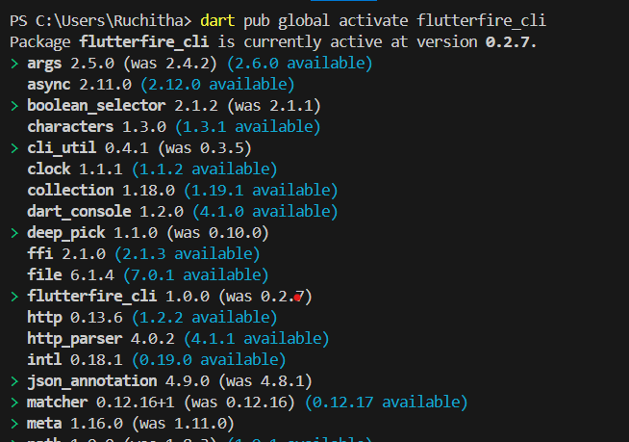

- Run “ npm install -g firebase-tools”
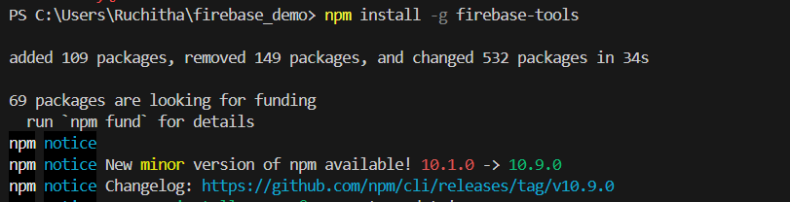

- Login into your firebase account use “firebase login”
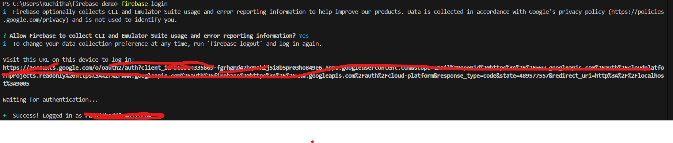
If you get error
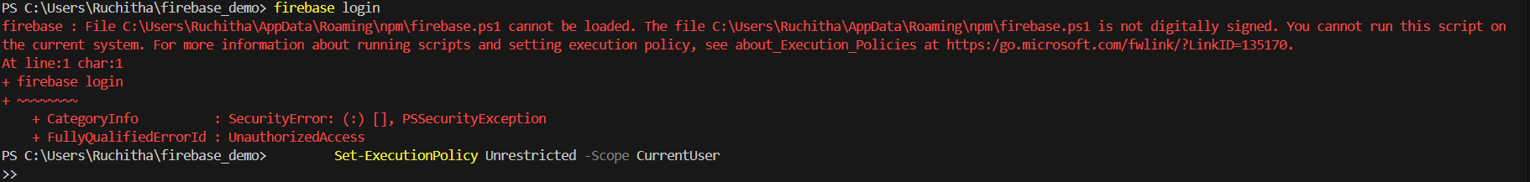
Run “Set-ExecutionPolicy RemoteSigned -Scope CurrentUser”

Create a new Flutter app :
- If you haven’t already, create a new Flutter app using: flutter create my_app.
Create a new Firebase project:
- You can either create the project directly from the Firebase console or let FlutterFire CLI do it for you.
- To create it from the console:
  - Go to the Firebase console. https://console.firebase.google.com/u/0/
  - Click on “Add project” and follow the setup steps.
  - You should see successfully created firebase project
- To create it using FlutterFire CLI:
  - Run: flutterfire configure.
  - Select your Firebase project from the list or use create project
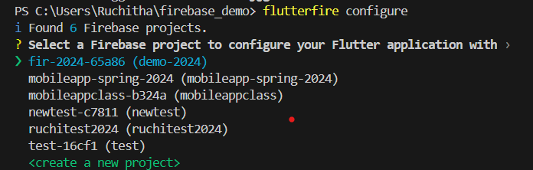

Configure additional Firebase services:
- Enable authentication, Firestore, and storage features in the Firebase console.
Now let’s start using
_____________________________________________________________________________
- Initialize Firebase:

  - Create a new firebase project from the terminal when configuring firebase for the flutter app. Use the create a new project and create a new project. Choose yes for all options
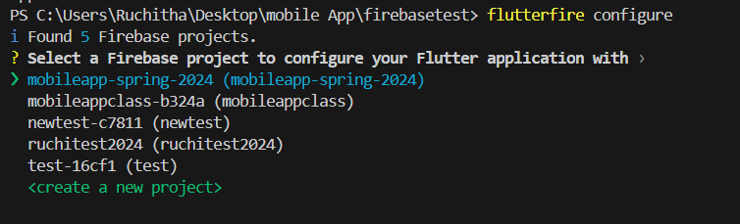
  - Create a Firestore database for a existing or new project in firebase and add an entry using the Firebase Console.

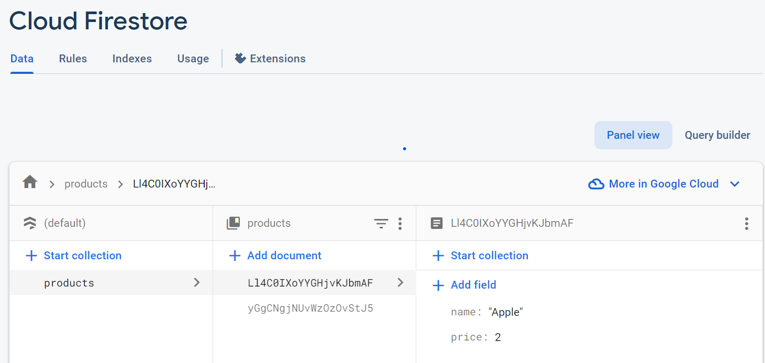
- Create a Project:
  - Click "Add Project" to create a new Firebase project if not create with the configure method
  - Follow the setup instructions.
- Enable Firestore:
  - After creating the project, go to the project's dashboard.
  - In the left sidebar, click "Firestore."
- Set Up Firestore:
  - Click "Create Database" to start setting up Firestore.
  - Choose "test mode" for simplicity (no authentication required).
- Choose a Location:
  - Select the default location and continue.
- Create a Collection:
  - Click "Start Collection" to create a collection.
  - Name it "products."
- Add an Entry:
  - In the "products" collection, click "Add Document."
  - Create a document with fields:
    - Field: name, Type: String, Value: Sample Product
    - Field: price, Type: Number, Value: 19.99
  - Save the document.

Initialize flutter app to access the firestore
  - Add the necessary dependencies for Firebase in your pubspec.yaml file.
firebase_core: ^2.19.0
cloud_firestore: ^4.12.0

  - Initialize Firebase in your Flutter app using Firebase.initializeApp.
import 'package:flutter/material.dart';
import 'package:firebase_core/firebase_core.dart';
import 'package:cloud_firestore/cloud_firestore.dart';
import 'firebase_options.dart';
void main() async {
WidgetsFlutterBinding.ensureInitialized();
await Firebase.initializeApp(
options: DefaultFirebaseOptions.currentPlatform,
);
runApp(const MyApp());
}

- Model Class:
  - Create a model class, e.g., Product, to represent a product with attributes like id, name, and price.
- Firebase Service:
  - Create a service class, e.g., ProductService, to manage Firebase Firestore interactions.
  - Implement methods for creating, reading, updating, and deleting products.
- Create the Product List Widget:
  - Build a widget, e.g., ProductList, to display a list of products.
  - Use StreamBuilder to stream product data from Firebase Firestore and update the UI in real-time.
  - Implement methods for editing and deleting products.
- Display the Product List in the Class Activity:
  - Create a class activity, e.g., YourClassActivity, that uses the ProductList widget.
  - Add a navigation method to move between different screens or class activities.
- Testing:
  - Run your Flutter app and test CRUD operations on the product list.
  - Verify that the list updates in real-time when changes are made in Firebase Firestore.

TO DO : Complete the function to delete the record Future<void> _deleteProduct(String productId) async
import 'package:flutter/material.dart';
import 'package:firebase_core/firebase_core.dart';
import 'package:cloud_firestore/cloud_firestore.dart';
import 'firebase_options.dart';
void main() async {
WidgetsFlutterBinding.ensureInitialized();
await Firebase.initializeApp(
options: DefaultFirebaseOptions.currentPlatform,
);
runApp(const MyApp());
}
class MyApp extends StatelessWidget {
const MyApp({Key? key}) : super(key: key);
@override
Widget build(BuildContext context) {
return const MaterialApp(
// Remove the debug banner
debugShowCheckedModeBanner: false,
title: 'Test',
home: HomePage(),
);
}
}
class HomePage extends StatefulWidget {
const HomePage({Key? key}) : super(key: key);
@override
State<HomePage> createState() => _HomePageState();
}
class _HomePageState extends State<HomePage> {
// text fields' controllers
final TextEditingController _nameController = TextEditingController();
final TextEditingController _priceController = TextEditingController();
final CollectionReference _products =
FirebaseFirestore.instance.collection('products');
Future<void> _createOrUpdate([DocumentSnapshot? documentSnapshot]) async {
String action = 'create';
if (documentSnapshot != null) {
action = 'update';
_nameController.text = documentSnapshot['name'];
_priceController.text = documentSnapshot['price'].toString();
}
await showModalBottomSheet(
isScrollControlled: true,
context: context,
builder: (BuildContext ctx) {
return Padding(
padding: EdgeInsets.only(
top: 20,
left: 20,
right: 20,
bottom: MediaQuery.of(ctx).viewInsets.bottom + 20,
),
child: Column(
mainAxisSize: MainAxisSize.min,
crossAxisAlignment: CrossAxisAlignment.start,
children: [
TextField(
controller: _nameController,
decoration: const InputDecoration(labelText: 'Name'),
),
TextField(
keyboardType: TextInputType.numberWithOptions(decimal: true),
controller: _priceController,
decoration: const InputDecoration(
labelText: 'Price',
),
),
const SizedBox(
height: 20,
),
ElevatedButton(
child: Text(action == 'create' ? 'Create' : 'Update'),
onPressed: () async {
String name = _nameController.text;
double price = double.parse(_priceController.text);
if (name.isNotEmpty && price != null) {
if (action == 'create') {
// Persist a new product to Firestore
await _products.add({"name": name, "price": price});
}
if (action == 'update') {
// Update the product
await _products.doc(documentSnapshot!.id).update({
"name": name,
"price": price,
});
}
_nameController.text = '';
_priceController.text = '';
Navigator.of(context).pop();
}
},
)
],
),
);
},
);
}
// Deleting a product by id
Future<void> _deleteProduct(String productId) async {
ScaffoldMessenger.of(context).showSnackBar(
const SnackBar(
content: Text('You have successfully deleted a product'),
),
);
}
@override
Widget build(BuildContext context) {
return Scaffold(
appBar: AppBar(
title: const Text('CRUD operations'),
),
// Using StreamBuilder to display all products from Firestore in real-time
body: StreamBuilder(
stream: _products.snapshots(),
builder: (context, AsyncSnapshot<QuerySnapshot> streamSnapshot) {
if (streamSnapshot.hasData) {
return ListView.builder(
itemCount: streamSnapshot.data!.docs.length,
itemBuilder: (context, index) {
final DocumentSnapshot documentSnapshot =
streamSnapshot.data!.docs[index];
return Card(
margin: const EdgeInsets.all(10),
child: ListTile(
title: Text(documentSnapshot['name']),
subtitle: Text(documentSnapshot['price'].toString()),
trailing: SizedBox(
width: 100,
child: Row(
children: [
IconButton(
icon: const Icon(Icons.edit),
onPressed: () =>
_createOrUpdate(documentSnapshot),
),
IconButton(
icon: const Icon(Icons.delete),
onPressed: () =>
_deleteProduct(documentSnapshot.id),
),
],
),
),
),
);
},
);
}
return const Center(
child: CircularProgressIndicator(),
);
},
),
// Add new product
floatingActionButton: FloatingActionButton(
onPressed: () => _createOrUpdate(),
child: const Icon(Icons.add),
),
);
}
}

Task # 3 Description: Add Search and Filter Functionality
Objective: Extend the existing product management app by allowing users to search for specific products or filter products by price range.
Task Requirements:
- Implement Search Feature:
  - Add a Search Bar at the top of the product list screen.
  - As the user types in the search bar, filter the displayed products based on the name.
Example: If the user types "Shoe", only products with "Shoe" in their name should be displayed.
  - Make the search case-insensitive for a better user experience.
- Implement Price Filter:
  - Add two TextFields (or a range slider) to filter products by minimum and maximum price.
  - When the user enters a price range and presses a button (e.g., "Filter"), update the product list to show only products within the specified range.
  - Optional: Clear the filter with a "Reset" button.
- Firestore Query Updates:
  - Use Firestore queries to fetch filtered data based on the search input and price range.
  - Ensure the app updates in real-time as users modify the search input or filter values.
- Enhance the UI:
  - Display "No products found" if the search/filter results in an empty list.
  - Add clear feedback to users when filters or searches are applied.

Code Snippet Example: Firestore Query for Search
Stream<QuerySnapshot> _searchProducts(String query) {
return FirebaseFirestore.instance
.collection('products')
.where('name', isGreaterThanOrEqualTo: query)
.where('name', isLessThanOrEqualTo: query + '\uf8ff')
.snapshots();
}
Code Snippet Example: Firestore Query for Price Filter
Stream<QuerySnapshot> _filterProductsByPrice(double minPrice, double maxPrice) {
return FirebaseFirestore.instance
.collection('products')
.where('price', isGreaterThanOrEqualTo: minPrice)
.where('price', isLessThanOrEqualTo: maxPrice)
.snapshots();
}

