Guide for Firebase/Flutterfire Setup for MacOS
by Trinity Gordon

I HIGHLY recommend you install Homebrew on your mac for ease, but this is doable without it.
- Be sure to have a firebase account already created: https://firebase.google.com/
- Create a new Flutter project in VSCode by typing “>new” into the VSCode search bar and selected Flutter: New Project > Application. Keep this open through the entire installation process.
- Open a terminal in VSCode.
- Install Firebase_cli. If you have installed Homebrew, type into terminal: brew install firebase-cli
  - If you don’t have Homebrew installed, you can install it from here: https://firebase.google.com/docs/cli#setup_update_cli
  - To check that firebase has installed correctly, type into terminal: firebase –version. If installed correctly, a version number will print:
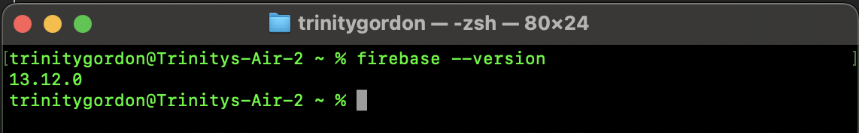
- In the VSCode terminal, type: firebase login . This will either log you in to your Firebase account, or confirm you’re already logged in: 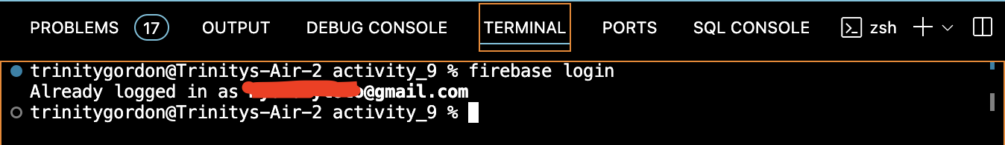
- Install Flutterfire:
  - In terminal, type: dart pub global activate flutterfire_cli .
  - In terminal, type: export PATH=”$PATH”:”$HOME/.pub-cache/bin”
  - Restart the terminal
  - In terminal, type: flutterfire -v. If installed correctly, a version number will print:
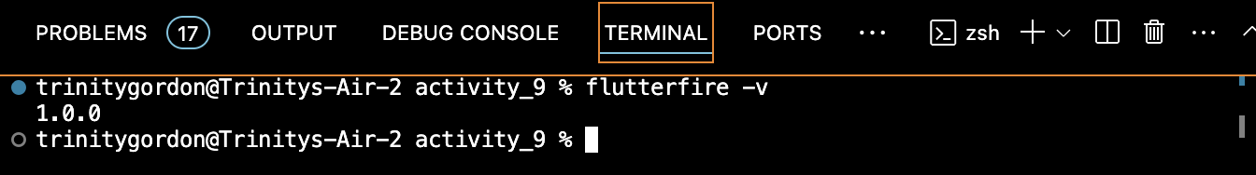
    - If this doesn’t work, in the terminal type: dart pub global deactivate flutterfire_cli
    - In terminal, type: dart pub global activate –overwrite flutterfire_cli
      - If you receive an error, type: dart pub global activate flutterfire_cli
      - 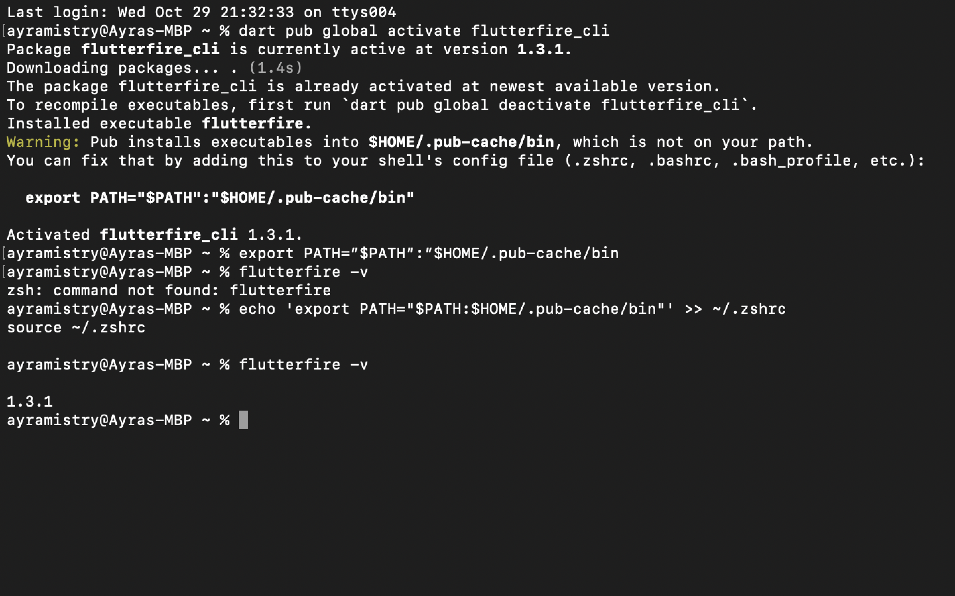
    - Check to see if installed: flutterfire -v
- In the firebase website, create a new project.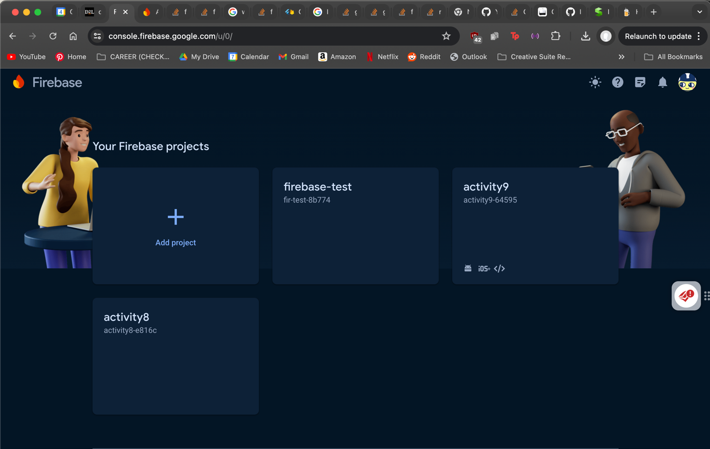
Remember the name as we will use it in the next steps
- In terminal: flutterfire configure
  - Select your firebase project you just created: 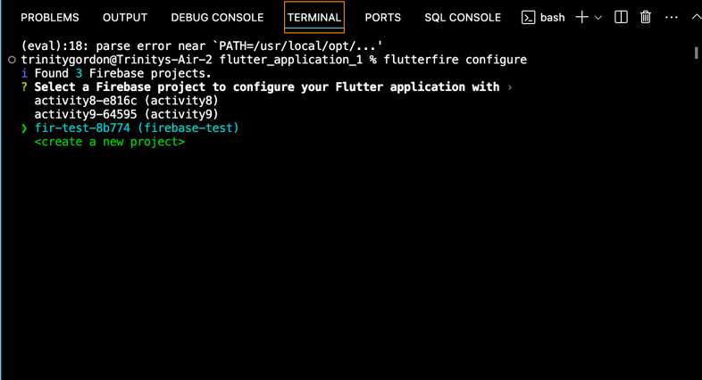
Don’t select ‘<create a new project>’ through terminal. It won’t work due to a bug.

  - Select ‘android’.
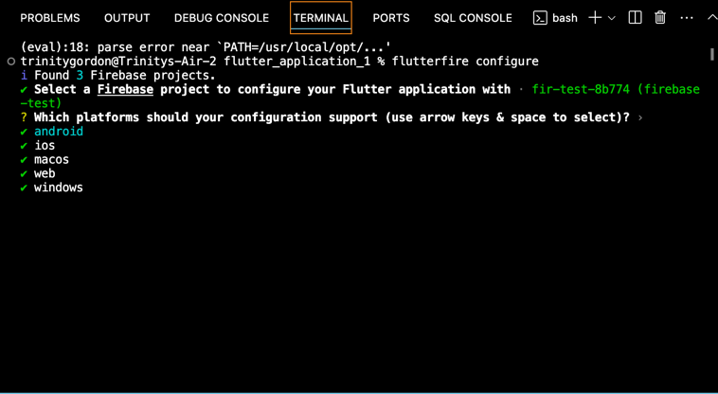
  - In the file explorer in VSCode (right hand menu), go to android -> app ->build.gradle
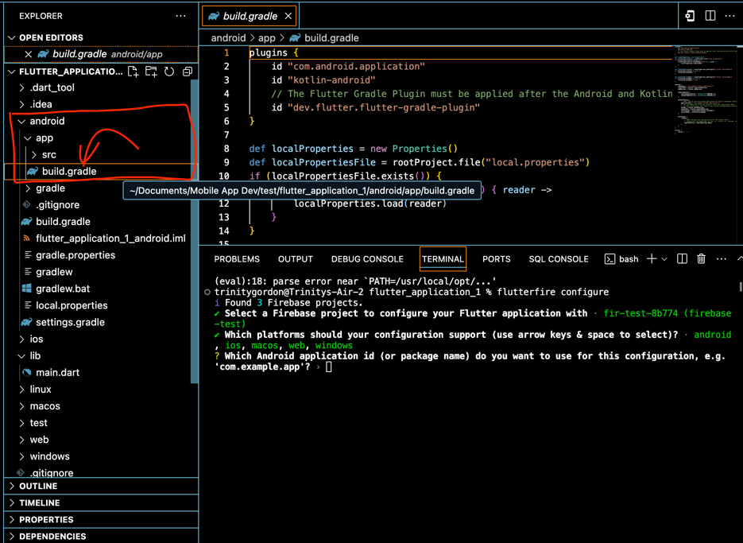
  - In the code, under defaultConfig, copy the id. It should be something like “com.example.<your project name>”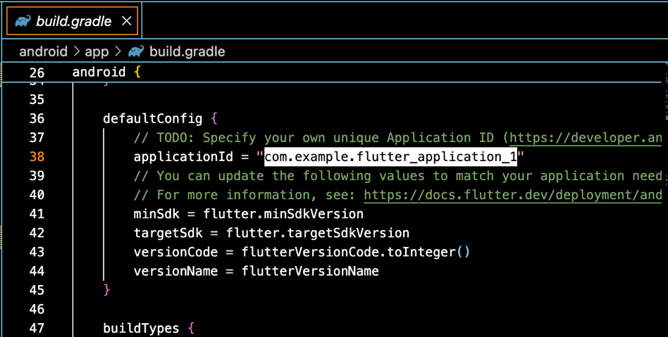

  - When you hit enter, flutterfire will configure and automatically create a new file ‘firebase_options.dart’ in your /lib
If line 3 is red, skip to step f to fix.
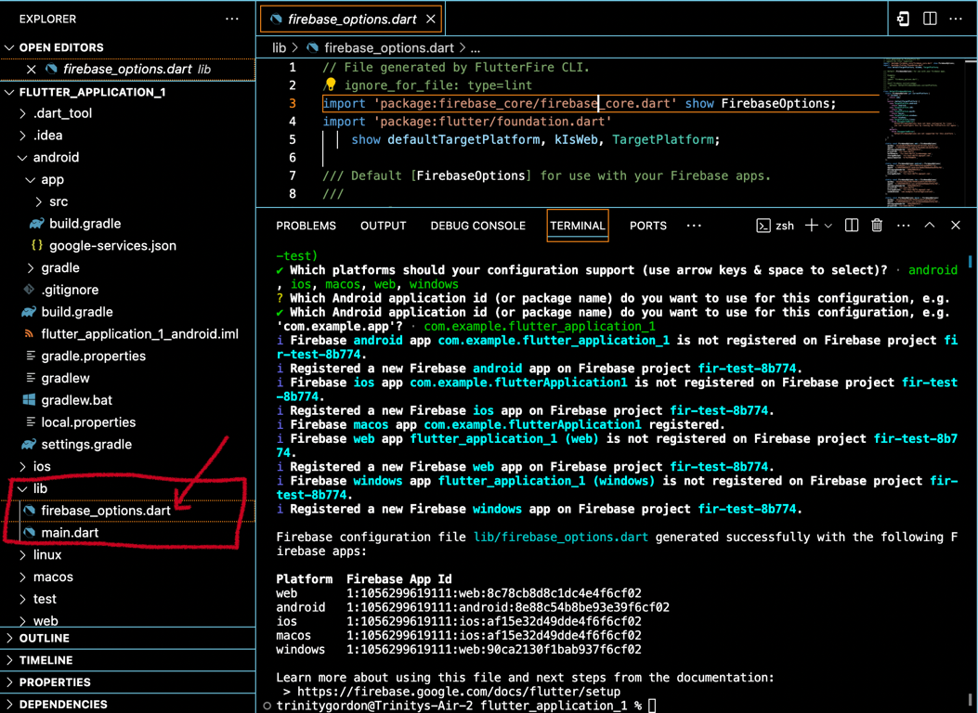

    - !!! If you get the error: xception: /System/Library/Frameworks/Ruby.framework/Versions/2.6/usr/lib/ruby/2.6.0/rubygems/core_ext/kernel_require.rb:54:in `require': cannot load such file -- xcodeproj (LoadError)/System/Library/Frameworks/Ruby.framework/Versions/2.6/usr/lib/ruby/2.6.0/rubygems/core_ext/kernel_require.rb:54:in `require' from -e:1:in `<main>'
      - In your system terminal, type: which ruby
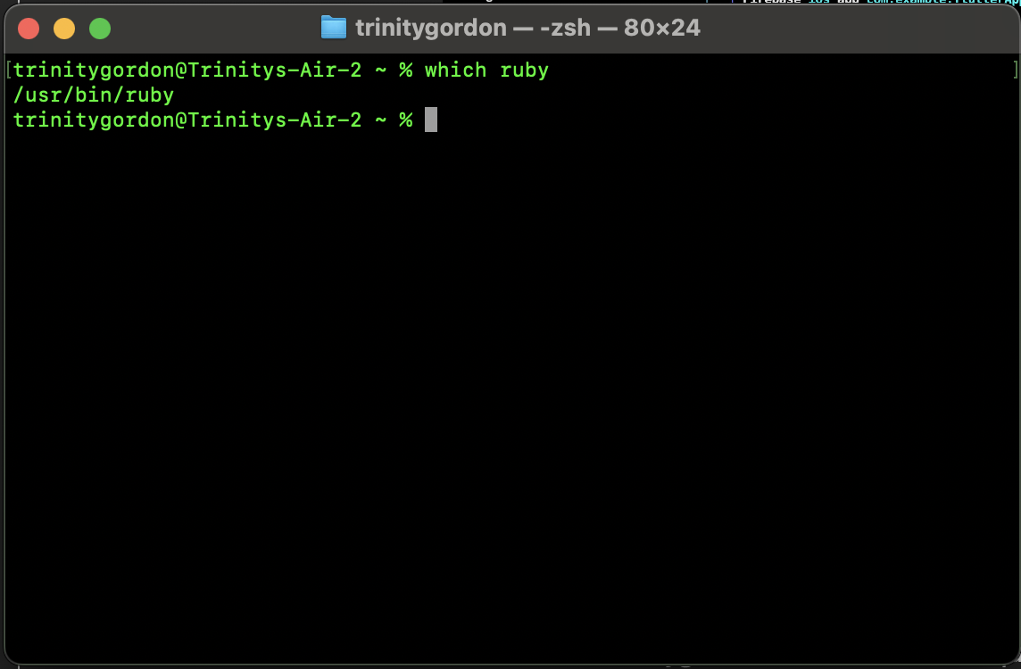
You should be shown the above output.
        - If you receive an error, you need to install Ruby
      - In terminal type: sudo gem install xcodeproj
        - Enter your password and wait. It takes a minute to download everything.
        - In terminal, type: export GEM_HOME="$HOME/.gem"
        - To ensure you have it download, type xcodeproj –version
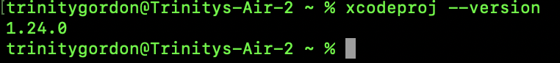
        - Start the flutterfire configure process over (step e)
  - Check ‘firebase_options.dart’ and resolve any import dependencies by right clicking on imports, and if prompted to “Quick Fix”, selecting that option
  - In ‘main.dart’, import ‘firebase_options.dart’ and the firebase package.
  - Also in your lib/main.dart file, initialize Firebase using the DefaultFirebaseOptions object exported by the configuration file:
await Firebase.initializeApp(
options: DefaultFirebaseOptions.currentPlatform,
);
  - 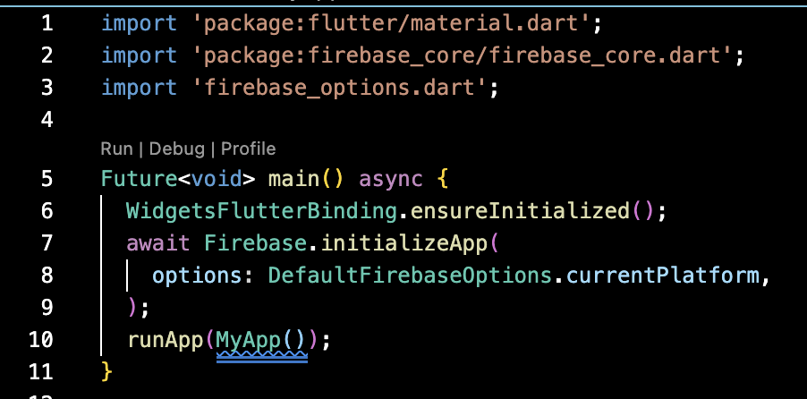
  - When you’re ready, you can flutter run

