Class Activity 17:
Cloud Messaging in Flutter and Firebase
Due to 11/13/2025 @ 7:31 pm (Submission requirement is listed at the end of this task)
Objective: The objective of this class activity is to gain hands-on experience in implementing Firebase Cloud Messaging (FCM) in a Flutter app. We will create an app that can receive and display push notifications sent through Firebase Cloud Messaging.
Activity Steps:
- Firebase Setup:
  - Create a new Flutter project or use an existing one.
  - Set up Firebase in your project if you haven't already. Follow Firebase documentation for this.
- Firebase Cloud Messaging Configuration:
  - Configure your Flutter app to use Firebase Cloud Messaging (FCM).
  - Make sure to Add the necessary dependencies for Firebase in your pubspec.yaml file.
flutter pub add firebase_messaging
flutter pub add firebase_core
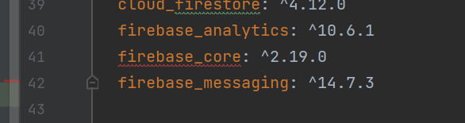
  - The code below as all the remaining steps required
- Generate and Retrieve the FCM Token:
To send a notification to a specific device, you need its unique FCM token. Your app must retrieve this token after initializing Firebase.
- Implementation: The provided code already includes the logic to retrieve the token. Inside the initState method, the line messaging.getToken().then((value) { print(value); }); fetches the token and prints it to the console.
- Verification: Run your app and check the terminal or debug console in your IDE. You will see a long string of characters—this is the FCM token for your device/emulator. Copy this token, as you will need it in the next step to send a test notification from the Firebase Console.
(Note: You can also choose to display this token on the app's screen by updating the state with the token value, but printing it to the console is sufficient for this activity.)
Step-by-Step Actions: Summary of Events:
- Navigate: Firebase Console → Your Project → Engage → Messaging
- Create: Click "Create your first campaign"
- Choose: "Firebase Notification messages" (Don’t Use In-App) – Use Firebase Notification Messages – The In app ask for installation ID
- Compose: Add notification title and body
- Test: Paste your token in "Test on device" section
- Send: Click "Test" button

- Firebase Console

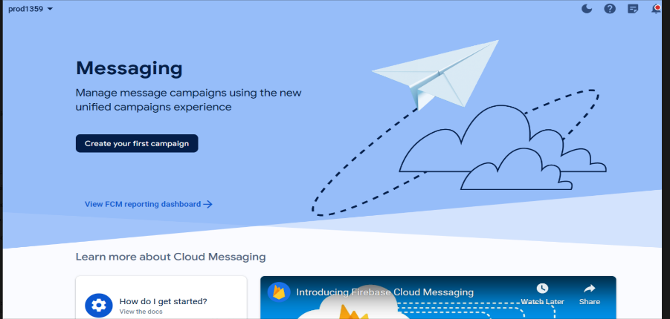
Create Your First Campaign:
In the Firebase console, navigate to the Messaging page.
If you’re a first-time user, click “Create your first campaign.” Otherwise, click “New campaign.”
Customize your message using Firebase the Messaging message templates. You can choose from various template types like Card, Modal, or Top banner.
Style your message by adjusting text/background colors, adding a message title/body, and defining primary and secondary buttons.
Preview your message in the console to get an idea of how it will appear on mobile devices.
  - Create a simple notification message in the Firebase Console. Go to cloud messaging in the firebase. Then click on create your first campaigns. And select notification message. Fill in the title and text and click > send test message and add the token from last step here and click and press test. You can see the message in the app.
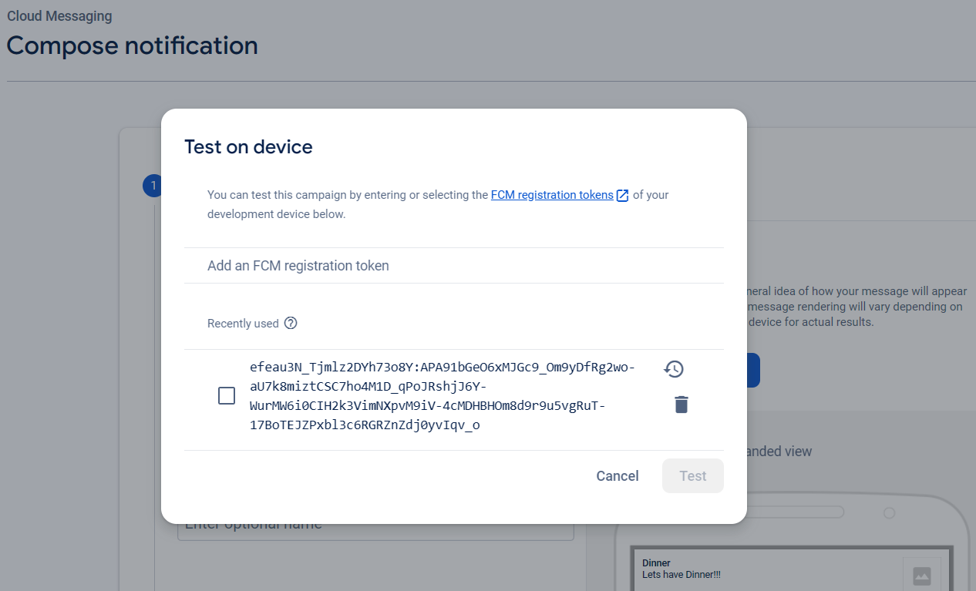
  - Send this message to the app on your device using the FCM token.
- Handle Notifications:
  - Implement code in your Flutter app to handle incoming FCM notifications.
  - When a notification is received, display it on the app's screen.
- Testing:
  - Test your app by sending notifications from the Firebase Console.
  - Verify that the app receives and displays these notifications.
- TO DO Task:
Summary You'll create an app that can:
- Receive regular notifications with cool quotes
- Receive important notifications (displayed differently important vs not important)
- Customize how each notification type looks in the app (displayed differently i.e. color)
  - Implement a more advanced feature, such as handling different types of notification which can be any cool quotes.
  - Customize the appearance of the notifications in the app from the code.
  - One advanced feature you can implement with Firebase Cloud Messaging (FCM) is handling different types of notifications. consider an example where your Flutter app can distinguish between two types of notifications: regular notifications and important notifications. The app will display them differently based on their importance.
Example: Handling Different Types of Notifications
- Configure Notification Types:
  - Define two types of notifications: regular and important.
Send Different Types of Notifications from Firebase Console
For Regular Quote:
- Go to Firebase Console → Messaging → Create Campaign
- Notification title: Daily Inspiration
- Notification text: "The only way to do great work is to love what you do." - Steve Jobs
- Custom data: Add these key-value pairs:
  - Key: type | Value: regular
  - Key: category | Value: inspiration
For Wisdom Quote:
- Notification title: Ancient Wisdom
- Notification text: "The journey of a thousand miles begins with one step." - Lao Tzu
- Custom data: Add these key-value pairs:
  - Key: type | Value: wisdom
  - Key: category | Value: philosophy
For Important Quote:
- Notification title: Urgent Motivation!
- Notification text: "Don't watch the clock; do what it does. Keep going." - Sam Levenson
- Custom data: Add these key-value pairs:
  - Key: type | Value: important
  - Key: category | Value: motivation
- In Firebase Console:
  - When composing a notification message in the Firebase Console, add a custom data field to specify the notification type.
Flutter App:
- Implement code to handle incoming FCM notifications in your Flutter app.
- Parse the FCM message to determine the notification type.
- Based on the notification type, you can customize the appearance of notifications.
Testing Process
- Get your FCM token from the console when you run the app
- Send test notifications from Firebase Console:
  - Click "Send test message"
  - Paste your FCM token
  - Add the custom data fields as shown above
  - Click "Test"
- Observe the differences:
  - Regular quotes: Grey theme with message icon
  - Important quotes: Red theme with warning icon
  - Motivational quotes: Blue theme with trophy icon
  - Wisdom quotes: Purple theme with lightbulb icon
Step 5: Additional Customization Ideas
You can extend this by:
- Adding more quote categories:
  - Funny quotes
  - Love quotes
  - Success quotes
- Different behaviors:
  - Play different sounds for each type
  - Store quotes in a local database
  - Share quotes directly from the dialog
- Visual enhancements:
  - Different animations for each type
  - Background images
  - Custom fonts
Code
import 'package:firebase_core/firebase_core.dart';
import 'package:firebase_messaging/firebase_messaging.dart';
import 'package:flutter/material.dart';
import 'firebase_options.dart';
Future<void> _messageHandler(RemoteMessage message) async {
print('background message ${message.notification!.body}');
}
void main() async {
WidgetsFlutterBinding.ensureInitialized();
await Firebase.initializeApp(
options: DefaultFirebaseOptions.currentPlatform,
);
FirebaseMessaging.onBackgroundMessage(_messageHandler);
runApp(MessagingTutorial());
}
class MessagingTutorial extends StatelessWidget {
@override
Widget build(BuildContext context) {
return MaterialApp(
debugShowCheckedModeBanner: false,
title: 'Firebase Messaging',
theme: ThemeData(
primarySwatch: Colors.blue,
),
home: MyHomePage(title: 'Firebase Messaging'),
);
}
}
class MyHomePage extends StatefulWidget {
MyHomePage({Key? key, this.title}) : super(key: key);
final String? title;
@override
_MyHomePageState createState() => _MyHomePageState();
}
class _MyHomePageState extends State<MyHomePage> {
late FirebaseMessaging messaging;
String? notificationText;
@override
void initState() {
super.initState();
messaging = FirebaseMessaging.instance;
messaging.subscribeToTopic("messaging");
messaging.getToken().then((value) {
print(value);
});
FirebaseMessaging.onMessage.listen((RemoteMessage event) {
print("message recieved");
print(event.notification!.body);
print(event.data.values);
showDialog(
context: context,
builder: (BuildContext context) {
return AlertDialog(
title: Text("Notification"),
content: Text(event.notification!.body!),
actions: [
TextButton(
child: Text("Ok"),
onPressed: () {
Navigator.of(context).pop();
},
)
],
);
});
});
FirebaseMessaging.onMessageOpenedApp.listen((message) {
print('Message clicked!');
});
}
@override
Widget build(BuildContext context) {
return Scaffold(
appBar: AppBar(
title: Text(widget.title!),
),
body: Center(child: Text("Messaging Tutorial")),
);
}
}

Submission Requirements:
- Take screenshots of two types of notifications: regular and important.
- Submit the screenshots along with the GitHub URL (Github Repo Link) and the APK.

