To install the desktop version of Github software, please use this link:

<https://desktop.github.com/>

I find this easier to use. Otherwise you can set up to use the Command Line version of Git.

As we work together on the same code it is necessary to use Github because it saves copies of the existing code and can allow the merging of multiple versions of the code. This way each one of us can go off and work on one thing and save it back to the code base without worrying about affecting someone else’s code.

You will need to register a Github account to use it.

Once you have an account, go to this page:

<https://github.com/Nathan2134/DefaultRisk>

and you should click on “Clone or download” and then “Open in Desktop” as shown.

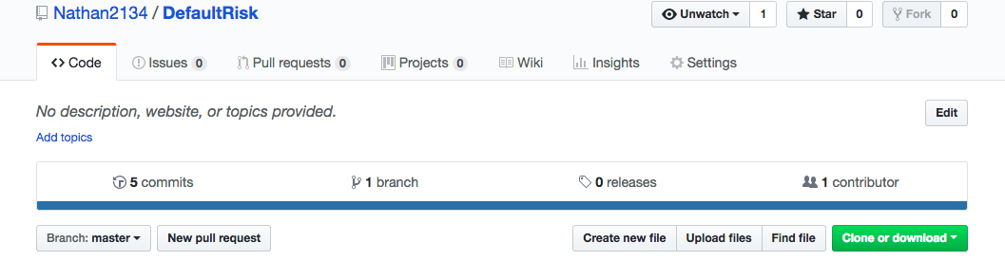

This creates a clone of the existing code (master copy) in your local drive.

You should now go to your Github desktop and Create a New Branch from the master. Name it whatever makes sense to you. You should now be in the branch. The little text box next to “Create New Branch” should now say the name you gave it instead of “master”.

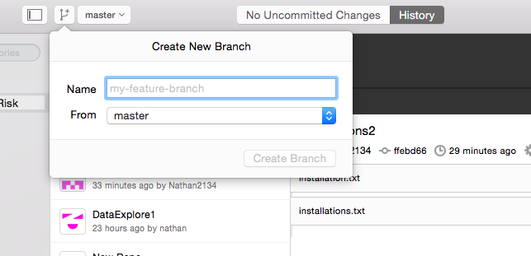

Make changes to your local copy of the files. After you are done, save your files and you can “commit” these changes. This means this will save a snapshot copy of this branch.

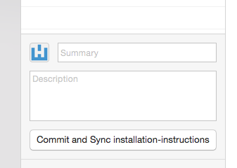

Click “Sync” to upload your change to Github.com:

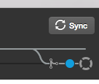

Go to Github.com and click on the “Pull requests” tab, or just click the one on your Github Desktop. The button is right on top of “Sync”.

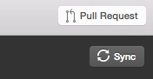

This sends the changes to the master copy on Github.com.