AQA A-Level Computer Science 2027
user
Centre Number: 50739
NEA Grimoire

Contents
Analysis 4
Background Description 4
Introduction 4
Problem Outline 4
Research 5
clocktower.online 5
grimmy.app 6
Pocket Grimoire 7
the-grim.netlify.app 8
botc.app 9
Summary 10
Interview 11
Questions 11
Summary 11
Objectives 12
Success Criteria 12
Modelling of the Problem 13
Design 14
Copyright and Usage Restrictions 14
Systems Diagram 15
User Interface 16
PowerPoint Mock-Up 16
Home Page Designs 17
Main Home Page 17
Settings 17
Grimoire Page Design 18
Character Token Layout 18
Modes 18
Night Information Menu 19
Player Menu 19
Technical Solution 20
Home Page 20
Dialogues 20
Grimoire 20
Dialogues 20
Final Testing 21
Evaluation 22
Appendix 23
1. Additional Images 23
A. Trouble Brewing 23
B. Physical Grimoire Full 24
C. Physical Grimoire 24
D. Circle Equation 25
E. Ellipse Equation 25
2. Code 26
3. Full Interview Transcript 27
4. Testing 28
A. Login Test Result 28
B. Other Test Result 28
5. References 28

PLEASE GO TO https://github.com/nathan3-14/grimoire-nea TO SEE THE PROTOTYPE

Analysis
Anything written in red are notes for me while writing and will not be present in the final version
Please ignore them while marking.

Background Description
Background of the problem in sufficient detail for a third party to understand the problem

Blood on the Clocktower is a popular, Mafia-style party game created by The Pandemonium Institute (TPI), where an informed minority of players need to survive and eliminate the uninformed majority in order to win. However, unlike games such as Werewolf, each player has a unique power.

During gameplay, there is one person, the Storyteller, who is the person running the game, similar to a Game Master in TTRPGs. They have everyone’s characters in a “grimoire” which allows them to see which players have what role, mark who’s dead etc.

The characters that the players could be come from a “script”, essentially a long list of characters. An example of one is Trouble Brewing, the beginner script, pictured in Appendix 1.A. These scripts can consist of both official (released by TPI) as well as homebrew (custom) characters.

For more information, TPI’s Official YouTube channel has a How to Play video.

Introduction
An introduction to the problem or investigation

For my NEA, I am creating a virtual grimoire for Blood on the Clocktower. The application will allow the user to assign roles to players, represented by circles and nametags, add “reminder tokens” as well as help them run the game by providing prompts of what to do or what to tell the player.
It will be a potential replacement for the physical grimoire that comes with the game, pictured in Appendix 1.B.

The application will be web-based and created using the React and Konva libraries in Typescript as React is quite commonly used and regularly recommended to beginners. In addition, I have previous experience in both basic website design and styling. Konva also allows for better canvas interaction or smth.

Problem Outline
When playing in person, it can be difficult to transport all tokens to where the game is being played in a secure way and keep them in the grimoire while moving around during the night. Additionally, if the storyteller wishes to use lots of characters, changing them over can be difficult.
A virtual grimoire would eliminate these problems as it drastically reduces the physical items needed, in some cases down to just a laptop or tablet. However, lots of existing virtual grimoires don’t allow for the same freedoms as physical grimoires do.
Additionally, virtual grimoire would have the ability to provide help to beginners, allowing them to become more confident in storytelling by assisting them in what they need to do.

Research
Provide research into the current problem that identifies other applications and comparisons to the current problem you are solving
+ screenshots
+ what makes them good
+ what could be improved

clocktower.online
clocktower.online has one of the more complex workflows due to its main purpose of online usage. Moreover, in order to run a game, one must first host a game, then select a script and hand out characters, same as others.

Advantages
- Works well
- Has capacity for random character assignment
- Has support for both custom and homebrew scripts

Disadvantages
- Designed for playing entirely online, not in-person
- It is no longer updated (being replaced by botc.app) so doesn’t have newer characters
- Doesn’t allow for the free movement of tokens

clocktower.online viewed in Firefox 140.8.0esr (64-bit)
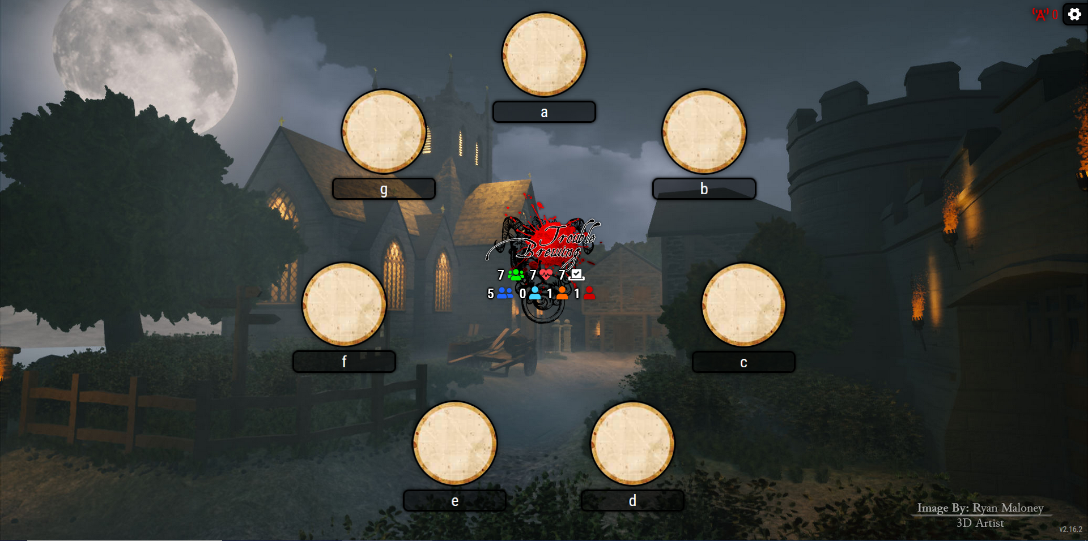

grimmy.app
grimmy.app is likely the app that I will be drawing the most inspiration from. It has a very simple and uncluttered UI while still providing a good user experience. Additionally, it has the option for players to find out their characters without the need for the storyteller to inform them of it.

Advantages
- Tokens can be moved around freely
- Has support for custom scripts
- Simulates an actual grimoire very well
- Has night-time information cards

Disadvantages
- Does not have support for homebrew scripts / characters

A game of Blood on the Clocktower in grimmy.app, on Firefox 140.8.0esr (64-bit), demonstrating its flexible token placement
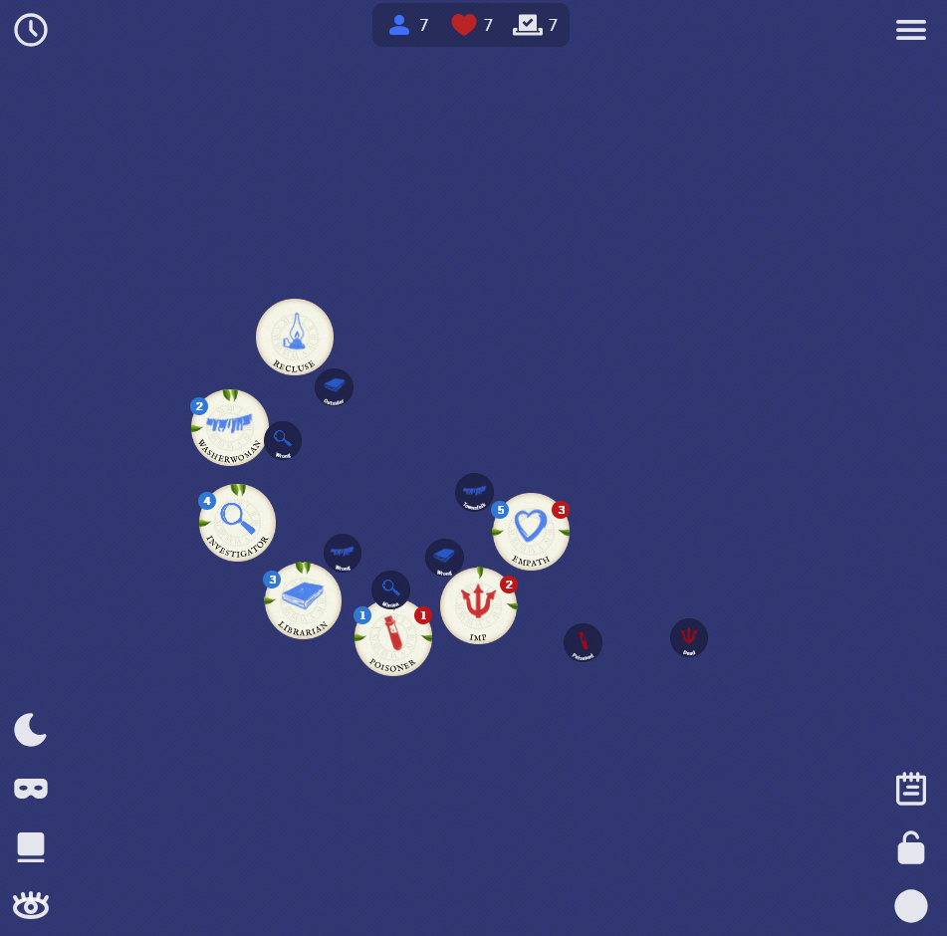

Pocket Grimoire
Pocket Grimoire is also a good example of something similar to what I am trying to make due to its freedom of token movement as well as nametags. However, its UI is not the best and all the separate tabs can be confusing.

Advantages
- Has capacity for both custom and homebrew scripts
- Simulates the in-person experience very accurately
- Has night-time information cards

Disadvantages
- Not very user-friendly

A game of Blood on the Clocktower in the “Grimoire” tab of Pocket Grimoire on Firefox 140.8.0esr (64-bit)
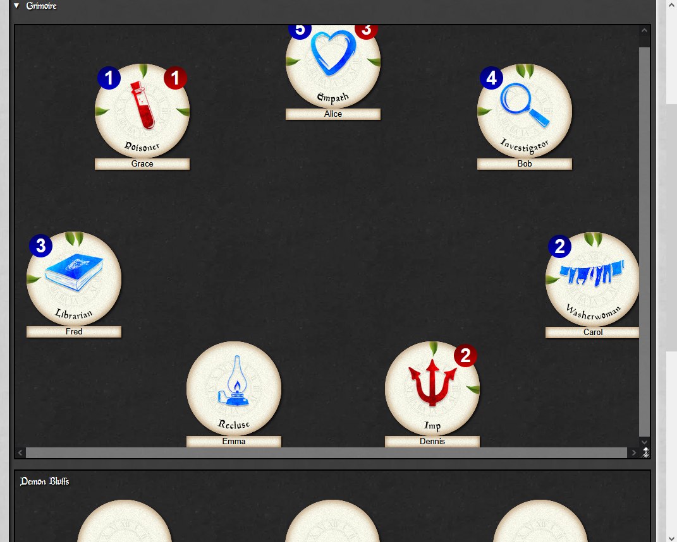

the-grim.netlify.app
the-grim.netlify.app is a good app for players taking notes however it is not nearly as useful for storytelling. The restrictive token layout is also not useful and while the name tags under characters are good features, the way reminder tokens are displayed is not helpful.

Advantages
- Very easy to use
- Has helpful steps in guiding the setup of a game
- Has some help for beginner storytellers

Disadvantages
- Doesn’t allow for the free movement of tokens

A game of Blood on the Clocktower in The-grim.netlify.app on Firefox 140.8.0esr (64-bit)
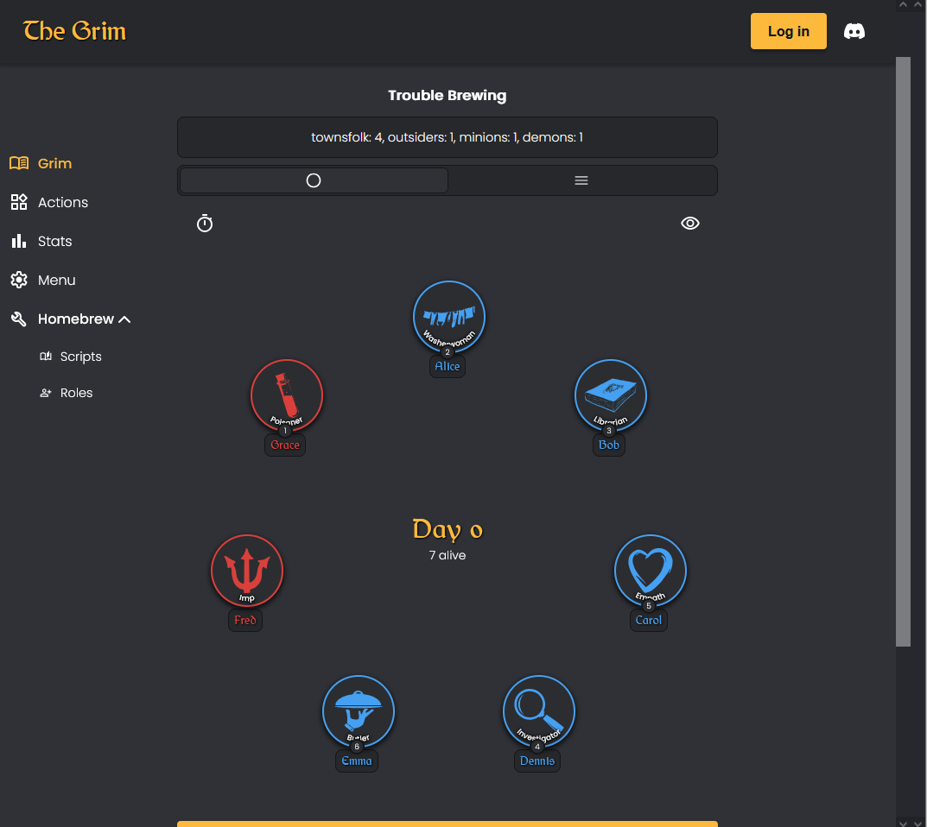

botc.app
botc.app is the go-to app for online play and a direct improvement on clocktower.online. However, its local game functionality is not as good as some of the others’ due to it not being a focus during its creation.

Advantages
- Officially released by The Pandemonium Institute (TPI)
- Is as up-to-date as it is possible to be
- Has support for both custom and homebrew scripts

Disadvantages
- Primarily designed for online play
- Doesn’t allow for the free movement of tokens
- Is a paid software (using a subscription)

An in-progress game of Blood on the Clocktower in botc.app (taken from Trouble Brewing - New App Available Now!) On YouTube
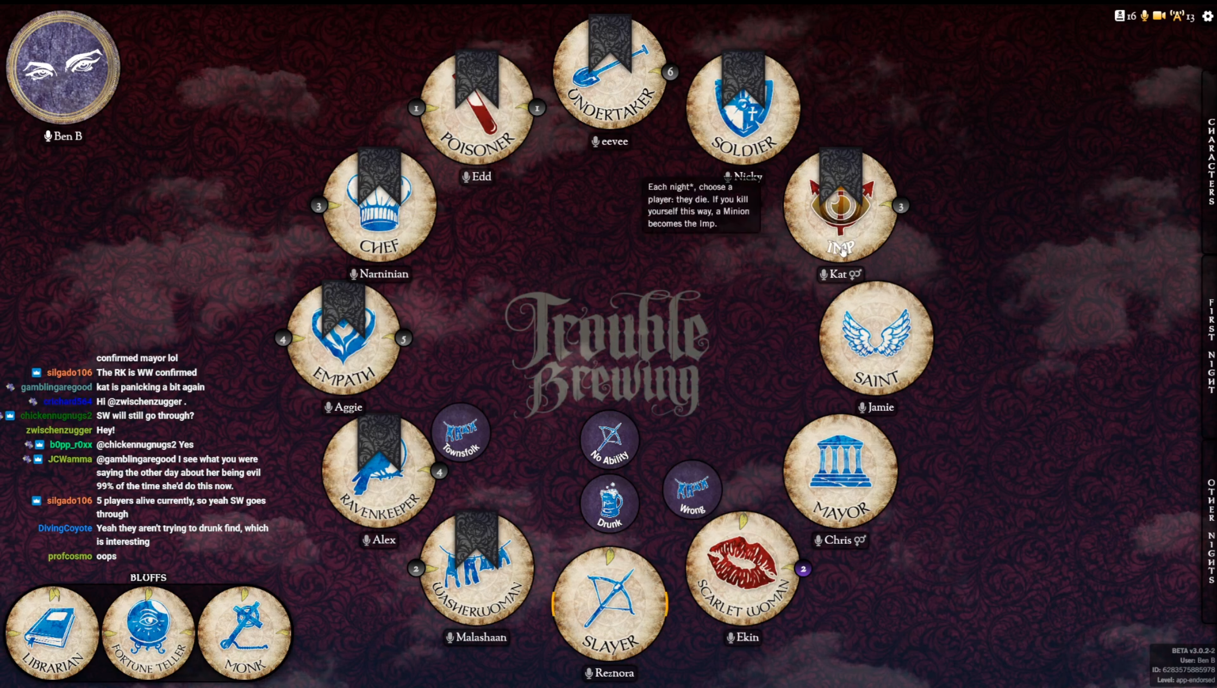

Summary
From the examples I’ve looked at of similar projects that already exist, my main dislike with them is their lack of flexibility when compared to the physical version of the game.
More specifically, the majority of the sites examined do not have the feature of moveable tokens, they are fixed in a particular shape (commonly a circle) and while this is a common layout, physical space constraints may lead to players being sat in others, such as a square or horseshoe. This is disadvantageous as it is better to be able to move the players’ tokens to fit the environment that the game is being played in.

Interview
In order to create the objectives and success criteria for this project, I will be interviewing my friend, PJ, who plays and storytells Blood on the Clocktower, to see what features he would want in an application such as this one.

The transcript of the full interview can be found in Appendix 3.

Questions
The following entries are the summarised responses when PJ was asked the corresponding questions.

- What assistance would be useful in storytelling (i.e. night order, what to do when waking people)?
  - Night order and character. Also being able to use multiple of the same reminder tokens.
- Would alternate colour schemes (such as light/dark mode) be good features?
  - Yes
- Should the app have different modes, i.e. strict vs flexible?
  - Yes
- Would automatic character assignation be a good feature?
  - Yes, as you don’t need the physical tokens
- How closely should the app replicate in-person usage?
  - As closely as possible
- Would physical or digital night information cards be preferable?
  - Digital
- Would having capacity for homebrew characters be useful?
  - Yes
- Would you rather an in-app tutorial or a document-based guide?
  - In-app
- Should there be a feature that tells you what to tell the player?
  - Yes, but it should be optional
- Any other suggestions or ideas for this app?
  - Placeable name tags

Summary
Based off of the interview, the vast majority of the suggested features were seen to be wanted. Furthermore, the addition of name tags for characters will drastically improve the storytelling experience, especially considering they are not a part of the base game.

Objectives
Numbered list of measurable specific objectives covering all required functionality of the solution or areas of investigation

- Basic Functionality
  - Character tokens can be added to or removed from a grimoire
  - Character tokens can be changed without needing to add a new one
  - Reminder tokens can be added to or removed from a grimoire
  - Character tokens can be initially arranged neatly into a set shape
  - Have a section for night information (similar to botc.app’s waking system)
- Additional Functionality
  - Allow players to learn their character through the app (according to their seat)
  - Option to switch between Strict and Flexible modes
  - Placeable name tags
- Basic Storyteller Assistance
  - Include a toggleable night order sheet
  - Include night order indicators on the character tokens
  - Have character abilities show on click / hover of a token
- Additional Storyteller Assistance
  - Have a walk-through for what the storyteller needs to do / tell the player
- Tutorial
  - Include a basic tutorial for how to setup and run a game
  - Create a docs page for more detailed instructions and homebrew tutorials

Success Criteria
In order for this project to be useable, it needs to have completed objectives 1.1-1.3 at a bare minimum and having objective 5.1 completed would be extremely useful for any potential new users, especially ones who are new to Blood on the Clocktower.

Modelling of the Problem
Any modelling that will inform the design stage, graph / network model or an entity relation model, scientific / mathematical models / formulae, data flow diagrams

The below flow charts shows roughly how many existing virtual grimoire programs work.

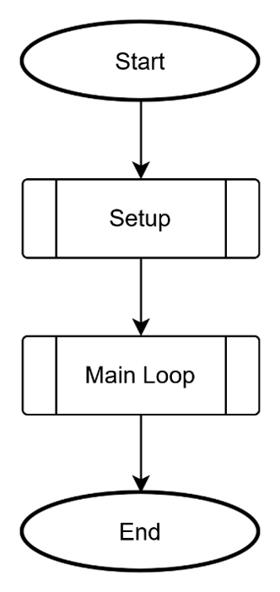

Startup
…

Setup
…
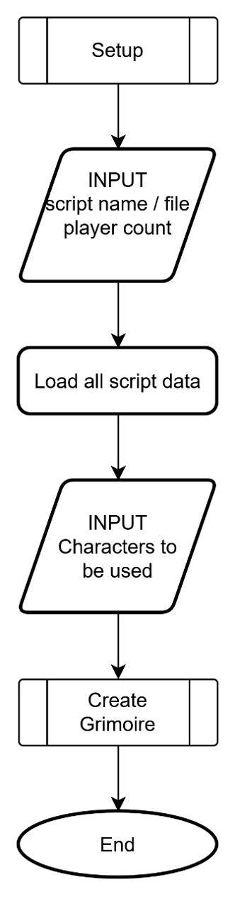

Add other images here
It’s still in 4
Column mode
Say maybe not use direct grim -> settings although does go against page flow diagram so idk

Design
Introduce what a design is.
ANNOTATED flowcharts
Graph schemas
Entity relation diagram
UI Design
Mock-ups (probably PowerPoint) + annotations i.e. colour codes
Pre-Test plans
Test Type | Object being Tested | Actual Test | Expected Outcome
Login | Login Button | Username | Username should be recognised
ADD CLASS DIAGRAM(s)
Reference to custom character actions yaml stuff
https://release.botc.app/resources/

Copyright and Usage Restrictions
Due to the usage restrictions of TPI’s content (Paragraph 2 of Section 2 “Original Visual Assets” of Blood on the Clocktower's Terms of Use), I will be making use of Tomozbot's botc-icons on GitHub throughout.

I will also be making use of the Papyrus and Old English Text MT fonts as provided by online-fonts.com.

Systems Diagram
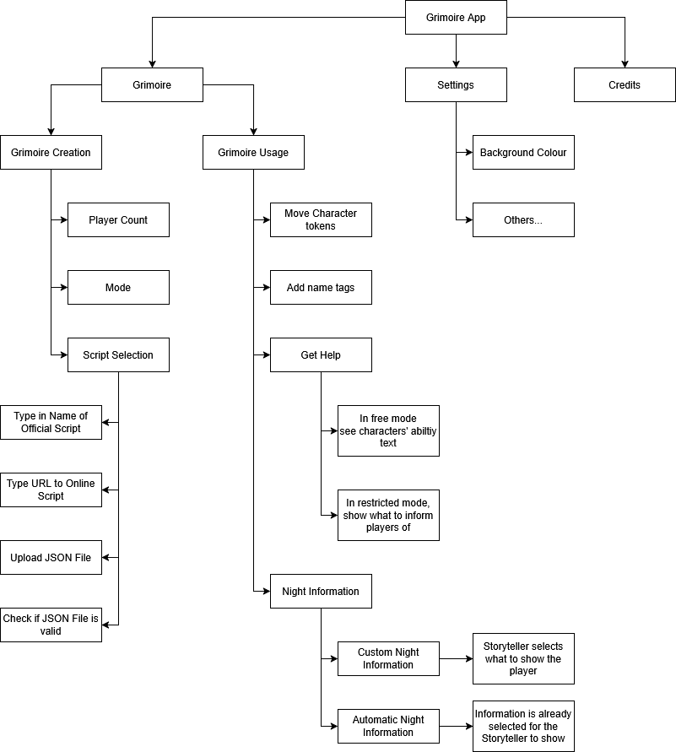

Class Diagrams
Throughout the project, I will be making extensive use of objects to store information about the current session and general settings that’ll be preserved between uses of the app.

Settings
The settings object will be passed to each page so that they can easily have adaptive colours.
This will likely have more properties and will come with pre-set themes such as light or dark.
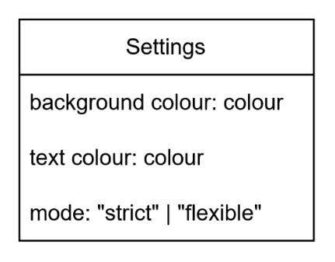

Player Token
Each player on the grim page will have its own designated object within a players list. This enables positions, names, reminders and states to be saved even if the user goes to a different page and back again.
isDead will be toggleable by the user and will toggle whether a “death shroud” is placed over the token.
reminders will have all reminders that are assigned to that player and is what is used to render them.
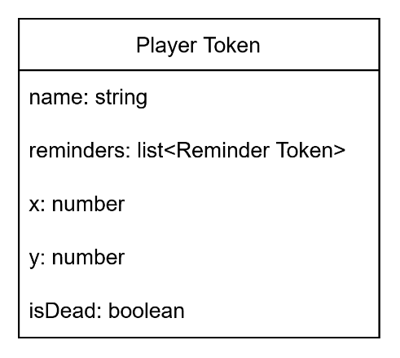

Reminder Token
Additionally, each reminder will have its own object so none are lost during a user’s session.
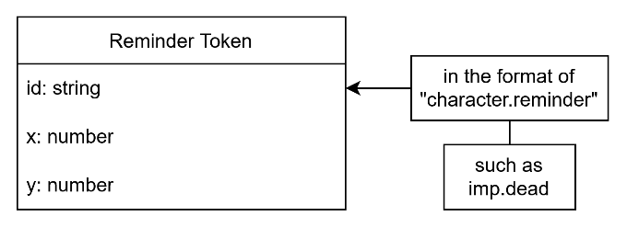

Scripts
When loading in a script, they are always a list of script objects which makes for easier parsing as I know exactly how they’ll be formatted. Due to the item with id “_meta”, I can get the author and name of the script.
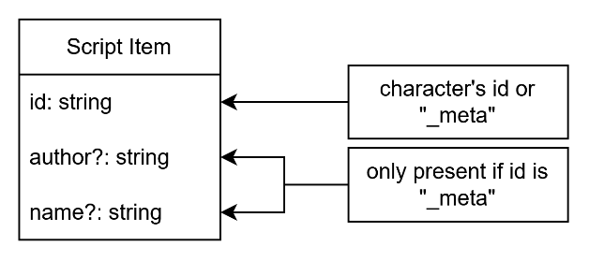

User Interface
My main inspiration for the user interface with be the physical grimoire (pictured in Appendix 1.C) that comes with Blood on the Clocktower itself. This means that the design will be quite minimal with unintrusive menu buttons and pop-up menus for most actions that could be performed.

PowerPoint Mock-Up
In order to assist later stages, I made a rough mock-up in PowerPoint, which includes some possible user actions and their result

Home
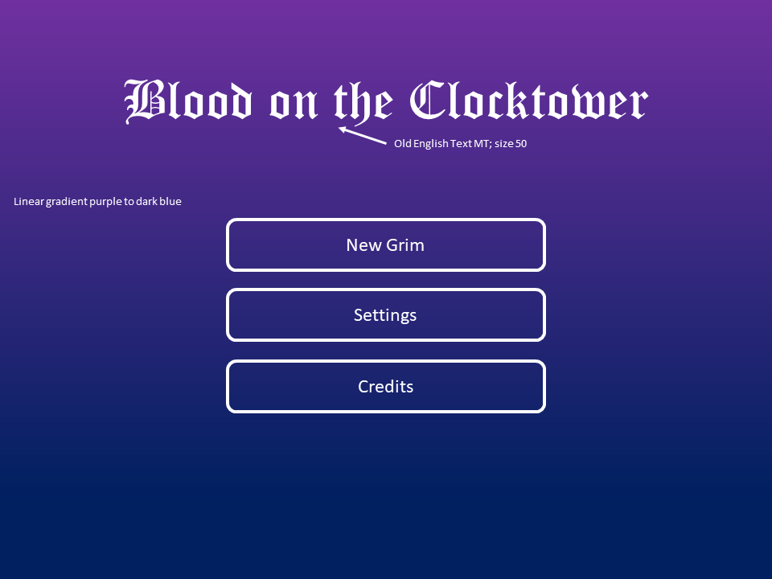

Credits
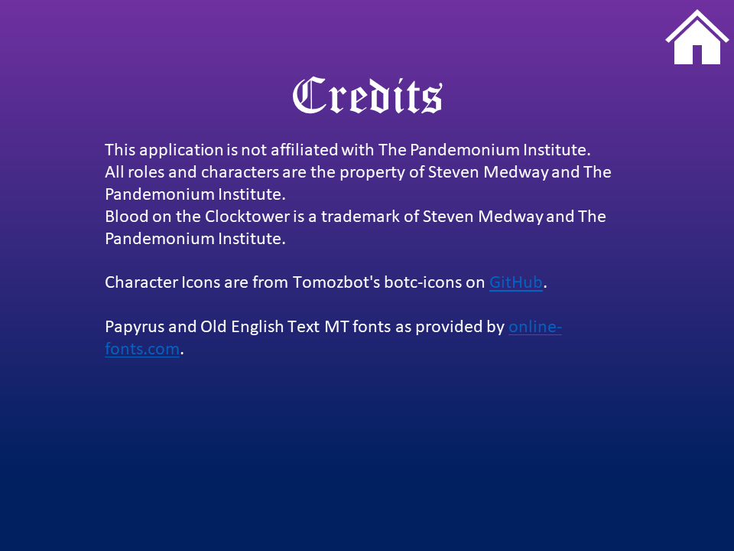

Grimoire Setup

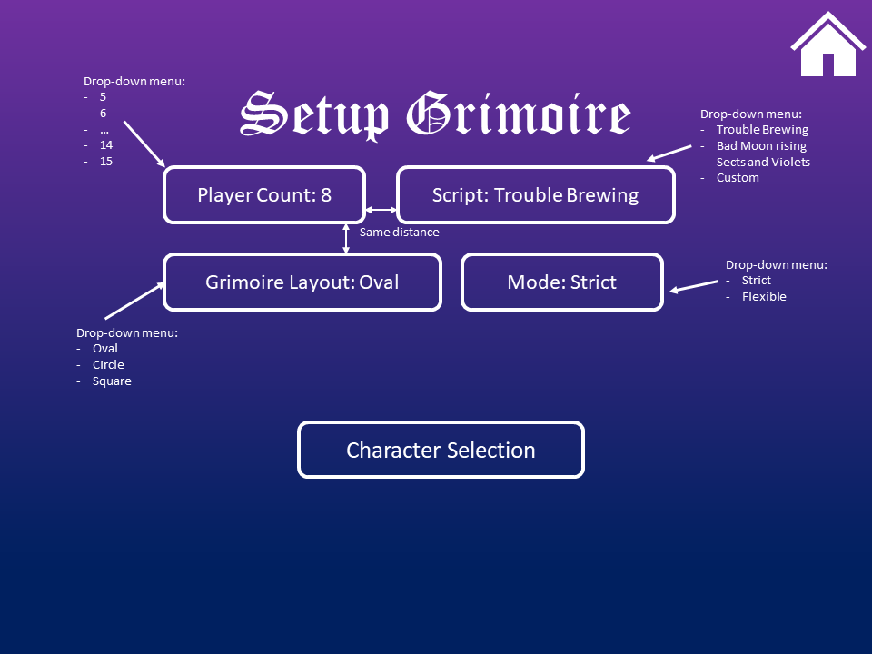

Character Selection
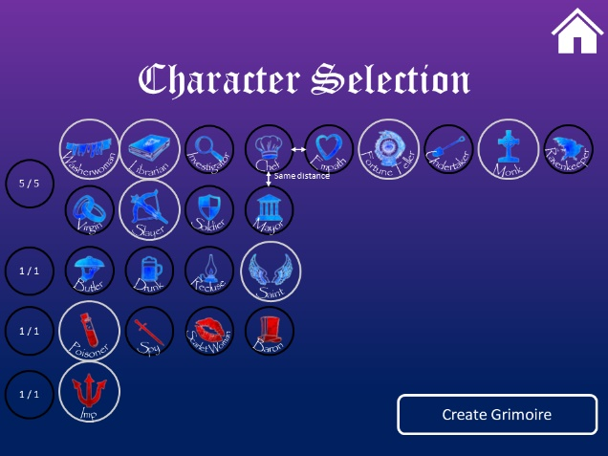

Grimoire
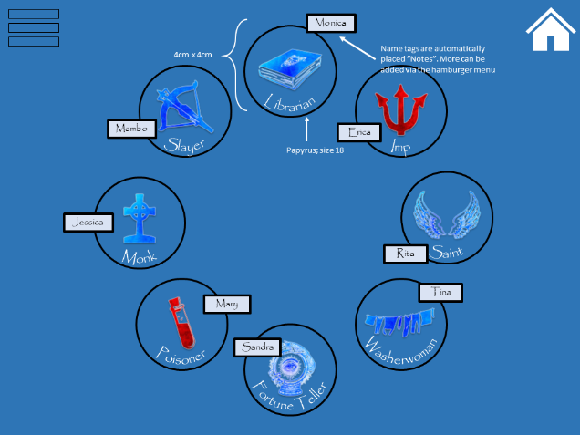

Grimoire (with “change character” dialogue)
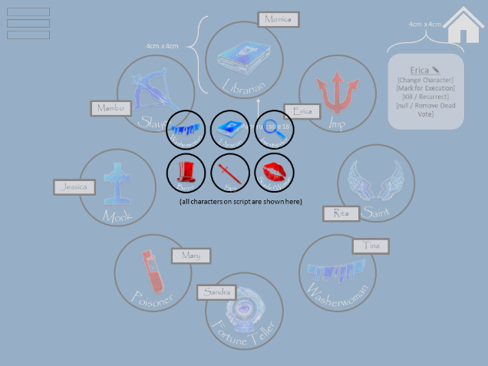

Home Page Designs

Main Home Page
The main home page has two designs, between which the main difference is the “open grim” button, present only when the user returns home after having already created a grimoire, otherwise the main layout (as seen above) is shown.

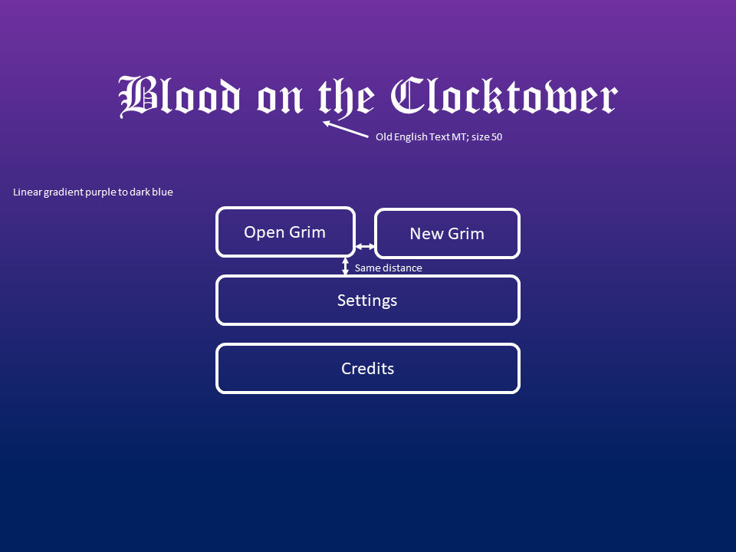

Settings
The settings page, as the name implies, allows the user to change general settings about the entire app, such as background design and colour.

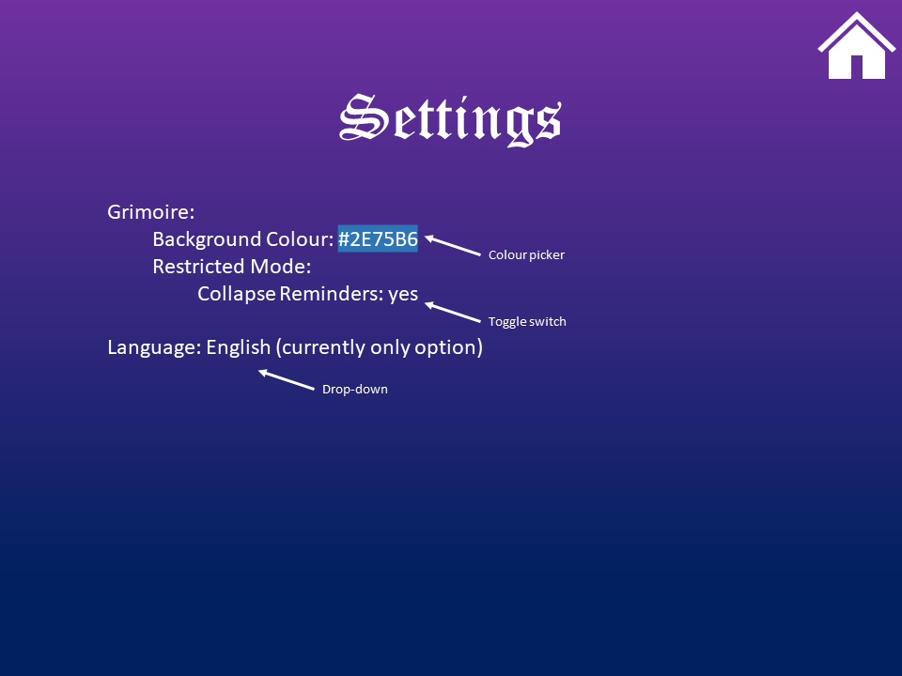

Grimoire Page Design
The grimoire page is where all the players’ character tokens will be held and where the user will spend most of their time within the app.

Character Token Layout
In order for the character tokens to be placed in the shapes required for Objective 1.4, I will be using the parametric equations for both a circle and an ellipse as shown (where $r_{c}, r_{x}$ and $r_{y}$ are the radii of the circle and the ellipse).

Circle:
$$x\left(t\right)=r_{c}sin\left(t\right) \\ y\left(t\right)=r_{c}cos\left(t\right), \text{for }0≤t≤2π$$

Ellipse:
$$x\left(t\right)=r_{x}sin\left(t\right) \\ y\left(t\right)=r_{y}cos\left(t\right), \text{for }0≤t≤2π$$

To make use of these, the tokens will be placed with a unique index value ($i$). These indices can then be used to obtain a value for $t$ using $t=\frac{i}{i_{max}}*2π$, placing them in their correct spot.
The values for $r_{c}$, ${\text{r}}_{\text{x}}$ and $r_{y}$ will change based on the screen size of the device.

Reminder Token Placement
When placing reminder tokens, they need to at the same angle as their corresponding player. However, the only way in which this can work is by placing them assuming the players are initially placed in a circle. In order to obtain this, I use the following set of parametric equations (where $r_{c}$ is the radius of the circle and $\left(p_{x},p_{y}\right)$ is the player token’s position.
$$θ=\tan^{-1}\left(\frac{p_{x}}{p_{y}}\right) \{p_{y}≤0\}$$
$$θ=\tan^{-1}\left(\frac{p_{x}}{p_{y}}\right) +π \{p_{y}>0\}$$
$$x\left(θ\right)=r_{c}\sin\left(θ\right)$$
$$y\left(θ\right)=r_{c}\cos\left(θ\right)$$

Modes
During the creation of a Grimoire, the user will be given the option to be in either the Strict or Flexible mode. The Strict mode ensures that tokens cannot be moved around and must stay in the specified shape. Whereas the Flexible mode only initially places the tokens in the chosen shape but allows the user to freely move them around afterwards.

In addition to the character tokens, the user has the option to add reminder tokens to help them. In Strict mode they will be directly tied to the character token they belong to pointing towards the centre of the grimoire, but in Flexible mode, they too can be moved freely.

Night Information Menu
A button on the Grimoire Page will open an additional dialogue (shown below) that gives the user access to a selection of “cards” that help them show the players they wake up information, such as a player, a character or saying that they were picked in the night.

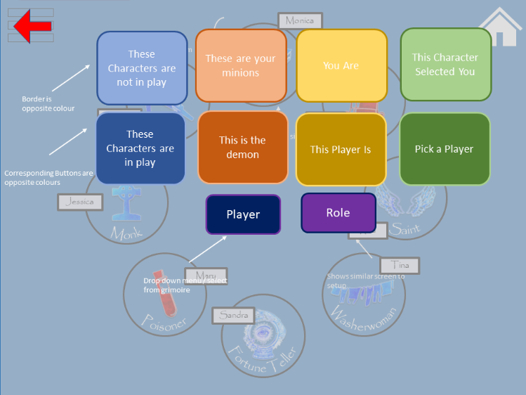

Player Menu
When interacting with a player’s character token, a small menu will pop up. This menu will include actions relating to that player and their character specifically, such as changing the character, its alignment (whether it’s good or evil) or adding a name tag.

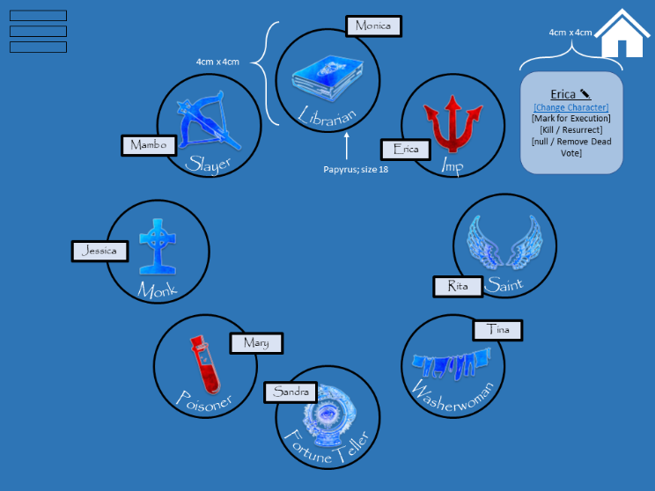

Page Relation Diagram
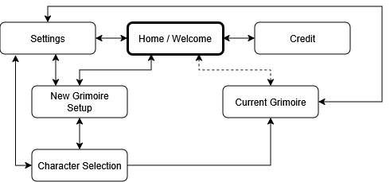

Technical Solution
This section will demonstrate the programming tasks that have been completed based on the design and analysis stages to ensure all objectives have been completed to their fullest extents.

Code Evidence WITH ANNOTATIONS and links to appendix
Iterative Testing

Mentions the custom icons from the asset store

Prototyping
Before beginning on the main program, I decided to create a prototype that is in the same structure as the final project will be, as to create a base that can be built upon and improved so I can play about with the UI and UX, find potential issues with them, and get feedback from potential users.

Home Page
…

Final Testing
Test Title | Object being Tested | Aspect being Tested | Expected Outcome | Actual Outcome | Pass / Fail | Image
 |  |  |  |  |  | Appendix 4.A
 |  |  |  |  |  | Appendix 4.B

Evaluation
Evaluation against success criteria
Effectiveness of Solution
Maintainability
Future Improvements

Appendix

Additional Images

Trouble Brewing
Back to Background Description

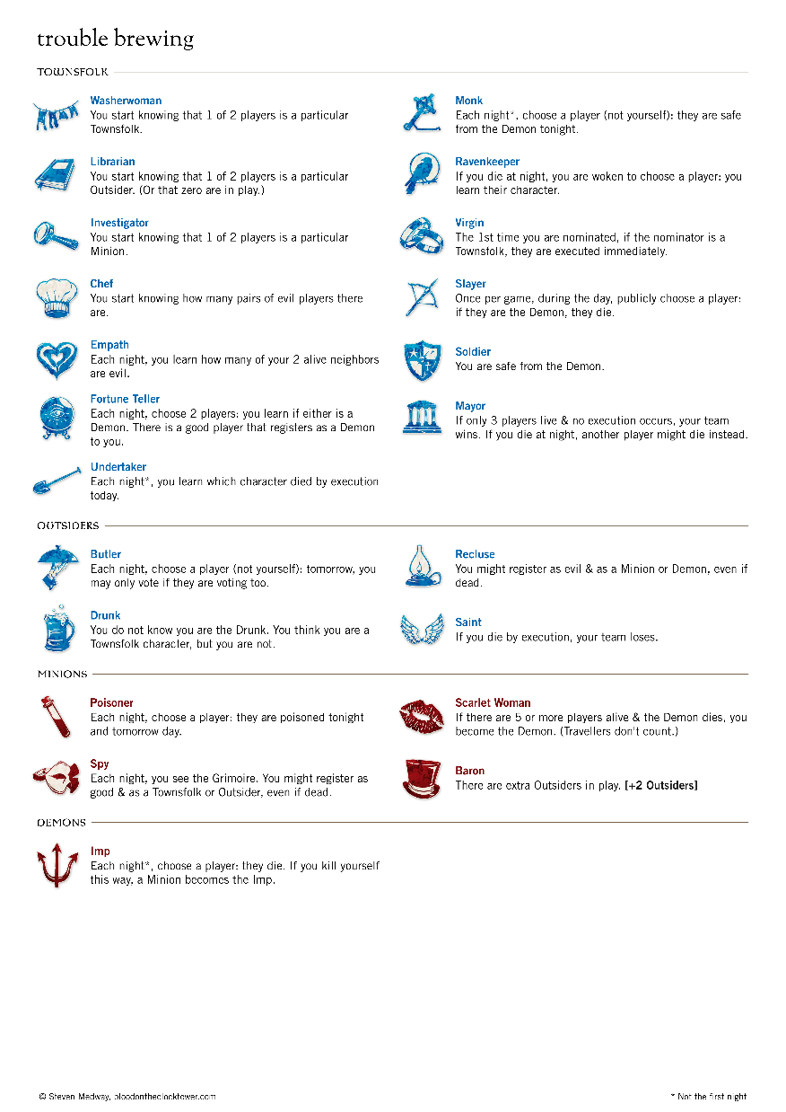

Physical Grimoire Full
Back to Introduction
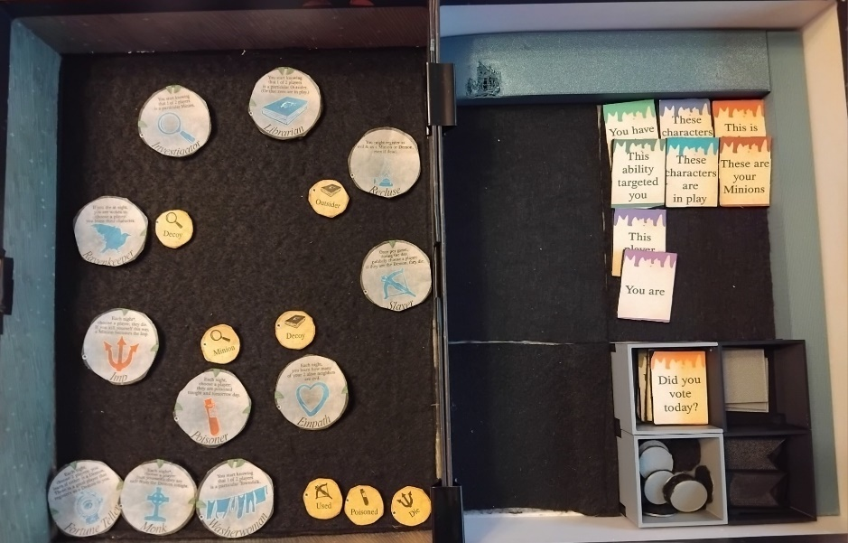

Physical Grimoire
Back to User Interface
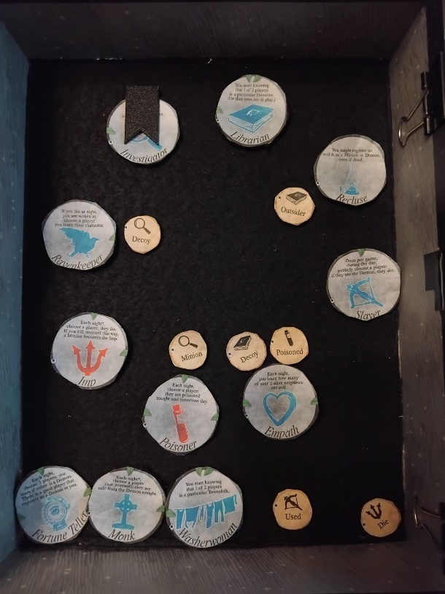

Circle Equation
Back to Character Token Layout
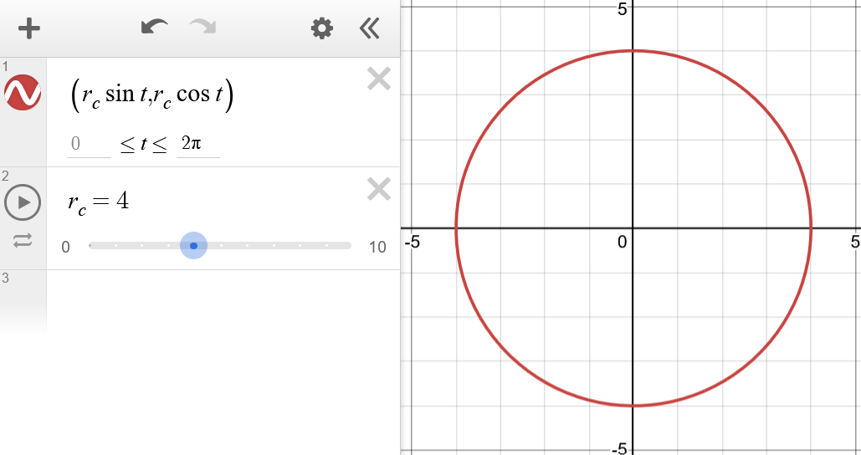

Ellipse Equation
Back to Character Token Layout
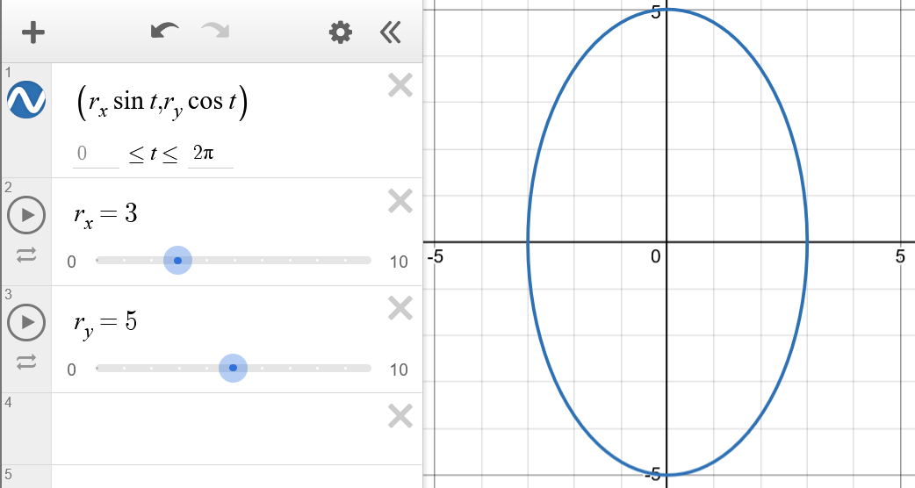

Code

Full Interview Transcript

Q: What assistance (if any) would be useful in storytelling (i.e. night order, what to do when waking people)?
A: Night order and character description so you know what you need to do. Also being able to use multiple of the same reminder tokens for characters such as the Cannibal

Q: Would alternate colour schemes (such as light/dark mode) be useful?
A: Yes

Q: Should the app have different modes, i.e. strict vs flexible (in reference to freedom of token movement)?
A: Yes

Q: Would automatic character assignation be a good feature?
A: Yes, as you don’t need the physical tokens or need to tell [the players] their roles

Q: How closely should the app replicate in-person usage?
A: As closely as possible

Q: (Following on from that), which one of physical or digital night information cards be preferable?
A: Digital

Q: Would having capacity for homebrew characters be useful?
A: Yes

Q: Would you rather an in-app tutorial or a document-based guide?
A: In-app

Q: Should there be automatic waking determiners (i.e. tells you what to tell the player based on their ability)
A: Yes, but it should be optional

Q: Any other suggestions or ideas for this app?
A: Naming of tokens to relate them to the players

Testing
Back to Final Testing

Login Test Result


Other Test Result


References
There are no sources in the current document.

Certain character’s abilities (such as the Cannibal) use other characters abilities so may need additional copies of those characters’ tokens
This question is in reference to freedom of token movement, see grimmy.app (flexible) and the-grim.netlify.app (strict)
For example, telling the storyteller how many of the Empath’s neighbours are evil
Certain character’s abilities (such as the Cannibal) use other characters abilities so may need additional copies of those characters’ tokens

