AQA A-Level Computer Science 2027
Nathan Watson – 3697
Centre Number: 50739
NEA

Contents
Analysis 1
Background Description 1
Introduction 1
Problem Outline 1
Research 2
clocktower.online 2
grimmy.app 3
Pocket Grimoire 4
the-grim.netlify.app 5
botc.app 6
Summary 7
Interview 8
Questions 8
Summary 8
Objectives 9
Success Criteria 9
Modelling of the Problem 10
Design 11
Technical Solution 12
Home Page 12
Dialogues 12
Grimoire 12
Dialogues 12
Final Testing 13
Evaluation 14
Appendix 15
1. Additional Images 15
A. Trouble Brewing 15
B. Physical Grimoire 16
2. Code 16
3. Full Interview Transcript 17
4. Testing 18
A. Login Test Result 18
B. Other Test Result 18
What should be here 18

Analysis
Anything written in red are notes for me while writing and will not be present in the final version
Please ignore them while marking.

Background Description
Background of the problem in sufficient detail for a third party to understand the problem

Blood on the Clocktower is a popular, Mafia-style party game created by The Pandemonium Institute (TPI), where an informed minority of players need to survive and eliminate the uninformed majority in order to win. However, unlike games such as Werewolf, each player has a unique power.

During gameplay, there is one person, the Storyteller, who is the person running the game, similar to a Game Master in TTRPGs. They have everyone’s characters in a “grimoire” which allows them to see which players have what role, mark who’s dead etc.

The characters that the players could be come from a “script”, essentially a long list of characters. An example of one is Trouble Brewing, the beginner script, pictured in Appendix 1.A. These scripts can consist of both official (released by TPI) as well as homebrew / custom characters.

For more information, TPI’s Official YouTube channel has a How to Play video.

Introduction
An introduction to the problem or investigation

For my NEA, I wish to create a virtual grimoire for Blood on the Clocktower. The application will allow the user to assign roles to players, represented by circles and nametags, add “reminder tokens” as well as help them run the game by providing prompts of what to do or what to tell the player.
It will be a potential replacement for the physical grimoire that comes with the game, pictured in Appendix 1.B.

This application will be web-based and created using the Godot Game Engine in GDScript (a high-level language syntactically similar to python) as it is a very versatile game engine and can export to my desired platform.

Problem Outline
When playing, it can be difficult to transport all tokens to where the game is being played in a secure way and keep them in the grimoire while moving around during the night. Additionally, if the storyteller wishes to use lots of characters, changing them over can be difficult.
A virtual grimoire would eliminate these problems as it drastically reduces the physical items needed, in some cases down to just a laptop or tablet.
Additionally, it would be able to help beginners become more confident in storytelling by assisting them in what they need to do.

Research
Provide research into the current problem that identifies other applications and comparisons to the current problem you are solving
+ screenshots
+ what makes them good
+ what could be improved

clocktower.online
clocktower.online has one of the more complex workflows due to its main purpose of online usage. Moreover, in order to run a game, one must first host a game, then select a script and hand out characters, same as others.

Advantages
- Works well
- Has capacity for random character assignment
- Has support for both custom and homebrew scripts

Disadvantages
- Designed for playing entirely online, not in-person
- It is no longer updated (being replaced by botc.app) so doesn’t have newer characters
- Doesn’t allow for the free movement of tokens

clocktower.online viewed in Firefox 140.8.0esr (64-bit)
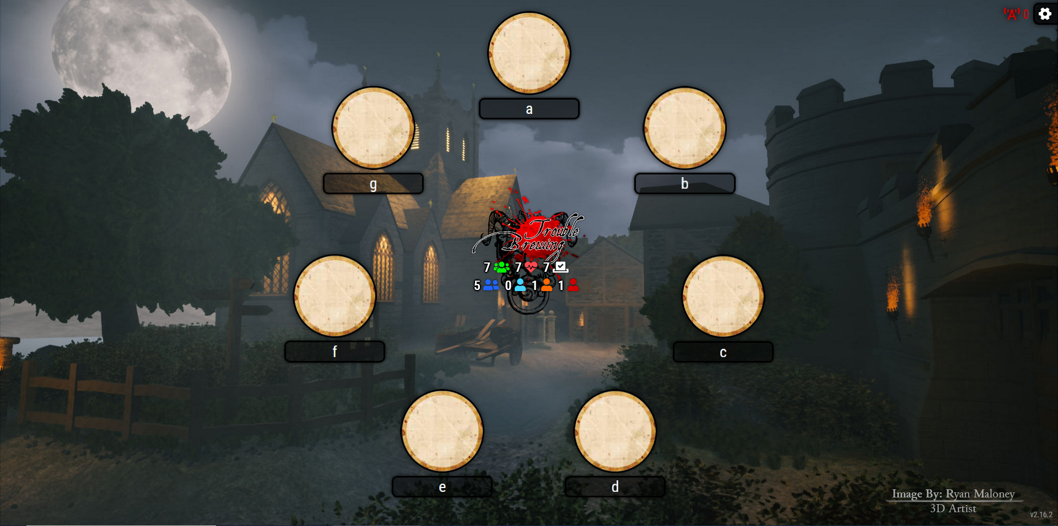

grimmy.app
grimmy.app is likely the app that I will be drawing the most inspiration from. It has a very simple and uncluttered UI while still providing a good user experience. Additionally, it has the option for players to find out their characters without the need for the storyteller to inform them of it.

Advantages
- Tokens can be moved around freely
- Has support for custom scripts
- Simulates an actual grimoire very well
- Has night-time information cards

Disadvantages
- Does not have support for homebrew scripts / characters

A game of Blood on the Clocktower in grimmy.app, on Firefox 140.8.0esr (64-bit), demonstrating its flexible token placement
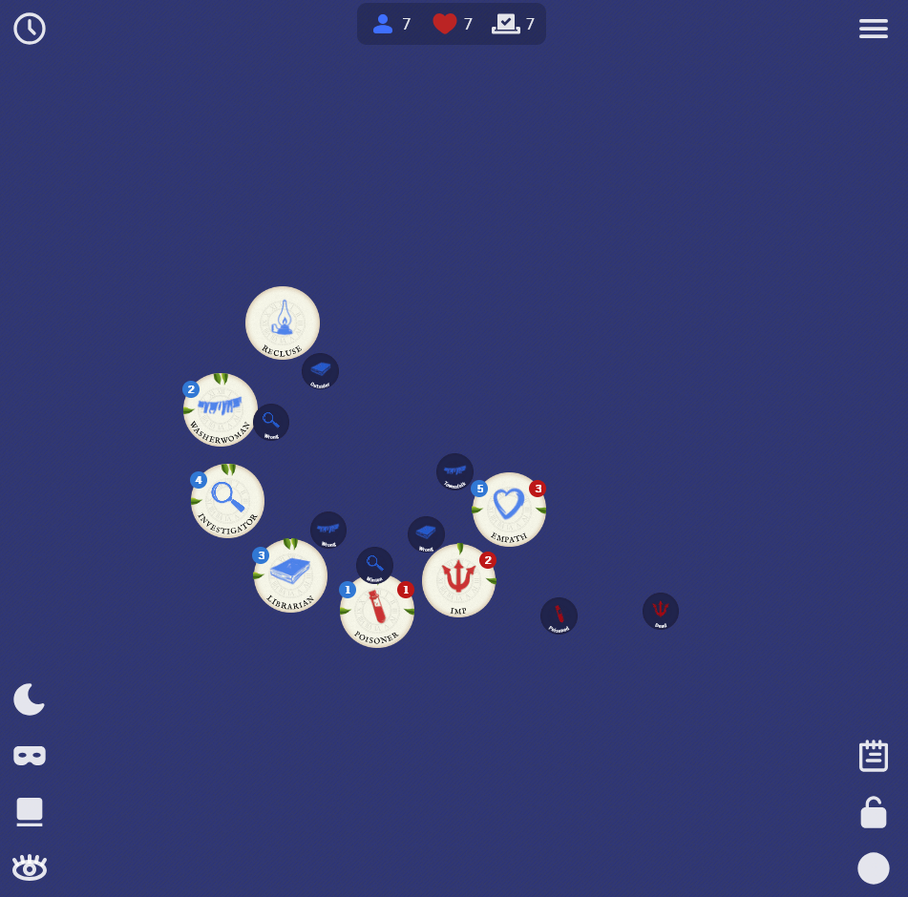

Pocket Grimoire
Pocket Grimoire is also a good example of something similar to what I am trying to make due to its freedom of token movement as well as nametags. However, its UI is not the best and all the separate tabs can be confusing.

Advantages
- Has capacity for both custom and homebrew scripts
- Simulates the in-person experience very accurately
- Has night-time information cards

Disadvantages
- Not very user-friendly

A game of Blood on the Clocktower in the “Grimoire” tab of Pocket Grimoire on Firefox 140.8.0esr (64-bit)
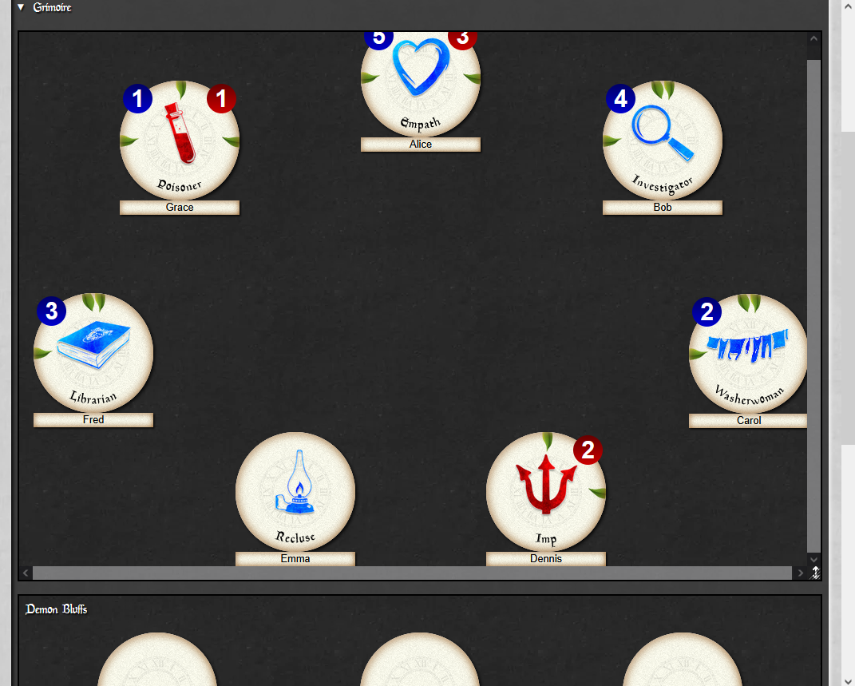

the-grim.netlify.app
the-grim.netlify.app is a good app for players taking notes however it is not nearly as useful for storytelling. The restrictive token layout is also not useful and while the name tags under characters are good features, the way reminder tokens are displayed is not helpful.

Advantages
- Very easy to use
- Has helpful steps in guiding the setup of a game
- Has some help for beginner storytellers

Disadvantages
- Doesn’t allow for the free movement of tokens

A game of Blood on the Clocktower in The-grim.netlify.app on Firefox 140.8.0esr (64-bit)
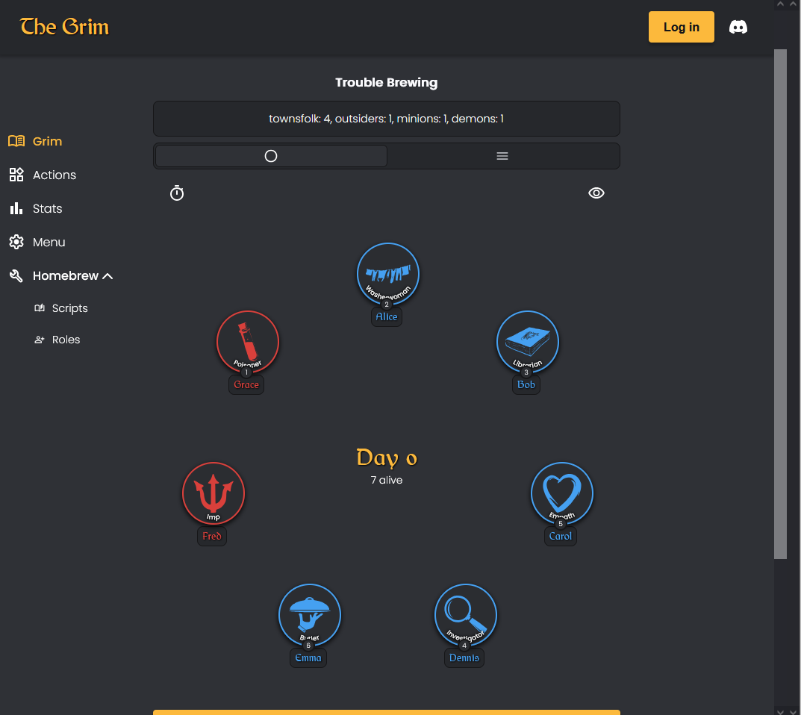

botc.app
botc.app is the go-to app for online play and a direct improvement on clocktower.online. However, its local game functionality is not as good as some of the others’ due to it not being a focus during its creation.

Advantages
- Officially released by The Pandemonium Institute (TPI)
- Is as up-to-date as it is possible to be
- Has support for both custom and homebrew scripts

Disadvantages
- Primarily designed for online play
- Doesn’t allow for the free movement of tokens
- Is a paid software (using a subscription)

An in-progress game of Blood on the Clocktower in botc.app (taken from Trouble Brewing - New App Available Now!) On YouTube
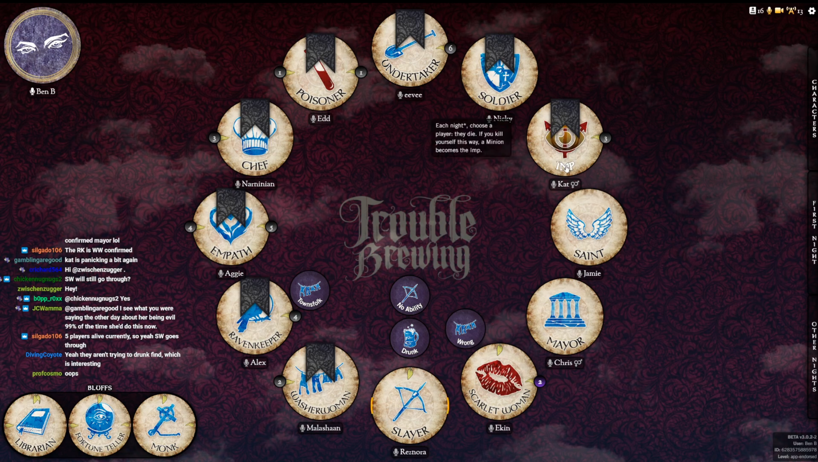

Summary
From the examples I’ve looked at of similar projects that already exist, my main dislike with them is their lack of flexibility when compared to the physical version of the game.
More specifically, the majority of the sites examined do not have the feature of moveable tokens, they are fixed in a particular shape (commonly a circle) and while this is a common layout, physical space constraints may lead to players being sat in others, such as a square or horseshoe. This is disadvantageous as it is better to be able to move the players’ tokens to fit the environment that the game is being played in.

Interview
In order to create the objectives and success criteria for this project, I will be interviewing my friend, PJ, who plays and storytells Blood on the Clocktower, to see what features he would want in an application such as this one.

The transcript of the full interview can be found in Appendix 3.

Questions
The following entries are the summarised responses when PJ was asked the corresponding questions.

- What assistance would be useful in storytelling (i.e. night order, what to do when waking people)?
  - Night order and character. Also being able to use multiple of the same reminder tokens.
- Would alternate colour schemes (such as light/dark mode) be good features?
  - Yes
- Should the app have different modes, i.e. strict vs flexible?
  - Yes
- Would automatic character assignation be a good feature?
  - Yes, as you don’t need the physical tokens
- How closely should the app replicate in-person usage?
  - As closely as possible
- Would physical or digital night information cards be preferable?
  - Digital
- Would having capacity for homebrew characters be useful?
  - Yes
- Would you rather an in-app tutorial or a document-based guide?
  - In-app
- Should there be a feature that tells you what to tell the player?
  - Yes, but it should be optional
- Any other suggestions or ideas for this app?
  - Placeable name tags

Summary
Based off of the interview, the vast majority of the suggested features were seen to be wanted. Furthermore, the addition of name tags for characters will drastically improve the storytelling experience, especially considering they are not a part of the base game.

Objectives
Numbered list of measurable specific objectives covering all required functionality of the solution or areas of investigation

- Basic Functionality
  - Character tokens can be added to or removed from a grimoire
  - Character tokens can be changed without needing to add a new one
  - Reminder tokens can be added to or removed from a grimoire
  - Character tokens can be initially arranged neatly into a set shape
  - Have a section for night information (similar to botc.app’s waking system)
- Additional Functionality
  - Allow players to learn their character through the app (according to their seat)
  - Option to switch between Strict and Flexible modes
  - Placeable name tags
- Basic Storyteller Assistance
  - Include a toggleable night order sheet
  - Include night order indicators on the character tokens
  - Have character abilities show on click / hover of a token
- Additional Storyteller Assistance
  - Have a walk-through for what the storyteller needs to do / tell the player
- Tutorial
  - Include a basic tutorial for how to setup and run a game
  - Create a docs page for more detailed instructions and homebrew tutorials

Success Criteria
In order for this project to be useable, it needs to have completed objectives 1.1-1.3 at a bare minimum and having objective 5.1 completed would be extremely useful for any potential new users, especially ones who are new to Blood on the Clocktower.

Modelling of the Problem
Any modelling that will inform the design stage, graph / network model or an entity relation model, scientific / mathematical models / formulae, data flow diagrams

The below flow chart (I have no idea what’s going on with the subroutine labels) shows roughly how many virtual grimoire programs work.

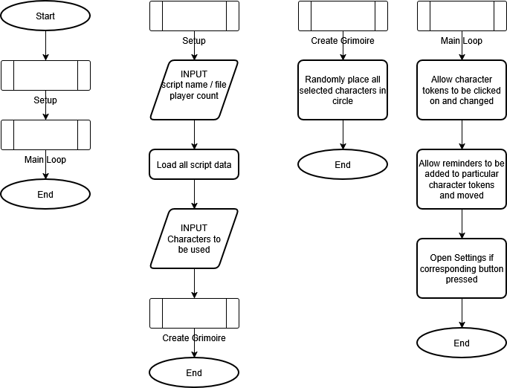

Design
Introduce what a design is.
ANNOTATED flowcharts
Graph schemas
Entity relation diagram
UI Design
Mock-ups (probably PowerPoint) + annotations i.e. colour codes
Pre-Test plans
Test Type | Object being Tested | Actual Test | Expected Outcome
Login | Login Button | Username | Username should be recognised

Reference to unit circle to get in a circle
Reference to custom character actions yaml stuff
https://release.botc.app/resources/

Copyright and Usage Restrictions
Due to the usage restrictions of TPI’s content (Paragraph 2 of Section 2 “Original Visual Assets” of Blood on the Clocktower's Terms of Use), I will be making use of Tomozbot's botc-icons on GitHub throughout.

I will also be making use of the Papyrus and Old English Text MT fonts as provided by online-fonts.com.

Systems Diagram
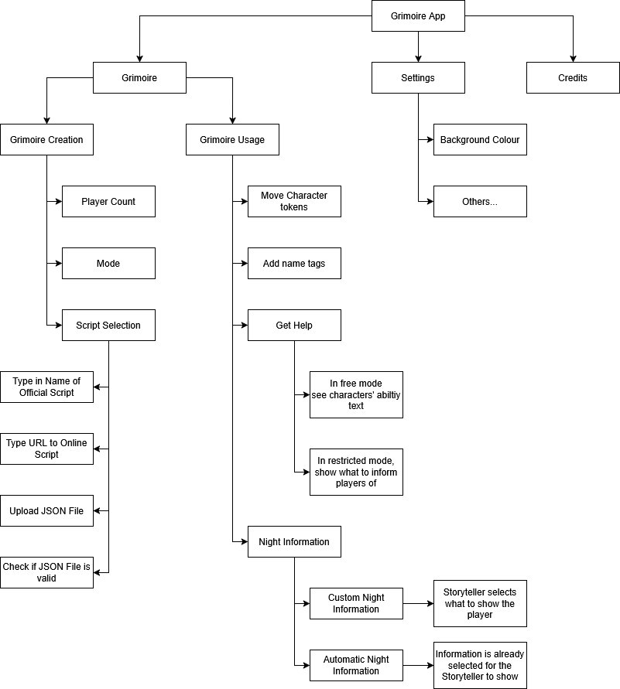

User Interface
My main inspiration for the user interface with be the physical grimoire (pictured in Appendix 1.C) that comes with Blood on the Clocktower itself. This means that the design will be quite minimal with unintrusive menu buttons and pop-up menus for most actions that could be performed.

PowerPoint Mock-Up
In order to assist later stages, I made a rough mock-up in PowerPoint, which includes some possible user actions and their results.

Add screen recording of going through it

Grimoire Design
The grimoire page is where all the players’ character tokens will be held and where the user will spend most of their time within the app. In order to align the
Ellipse
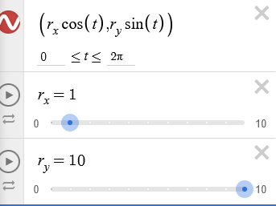

Technical Solution
This section will demonstrate the programming tasks that have been completed based on the design and analysis stages to ensure all objectives have been completed to their fullest extents.

Code Evidence WITH ANNOTATIONS and links to appendix
Iterative Testing

Home Page
…

Dialogues

Settings

New Grimoire Setup

Grimoire
…

Dialogues

Modify Player

Add Token

Wake Player

Final Testing
Test Title | Object being Tested | Aspect being Tested | Expected Outcome | Actual Outcome | Pass / Fail | Image
 |  |  |  |  |  | Appendix 4.A
 |  |  |  |  |  | Appendix 4.B

Evaluation
Evaluation against success criteria
Effectiveness of Solution
Maintainability
Future Improvements

Appendix

Additional Images

Trouble Brewing
Back to Background Description

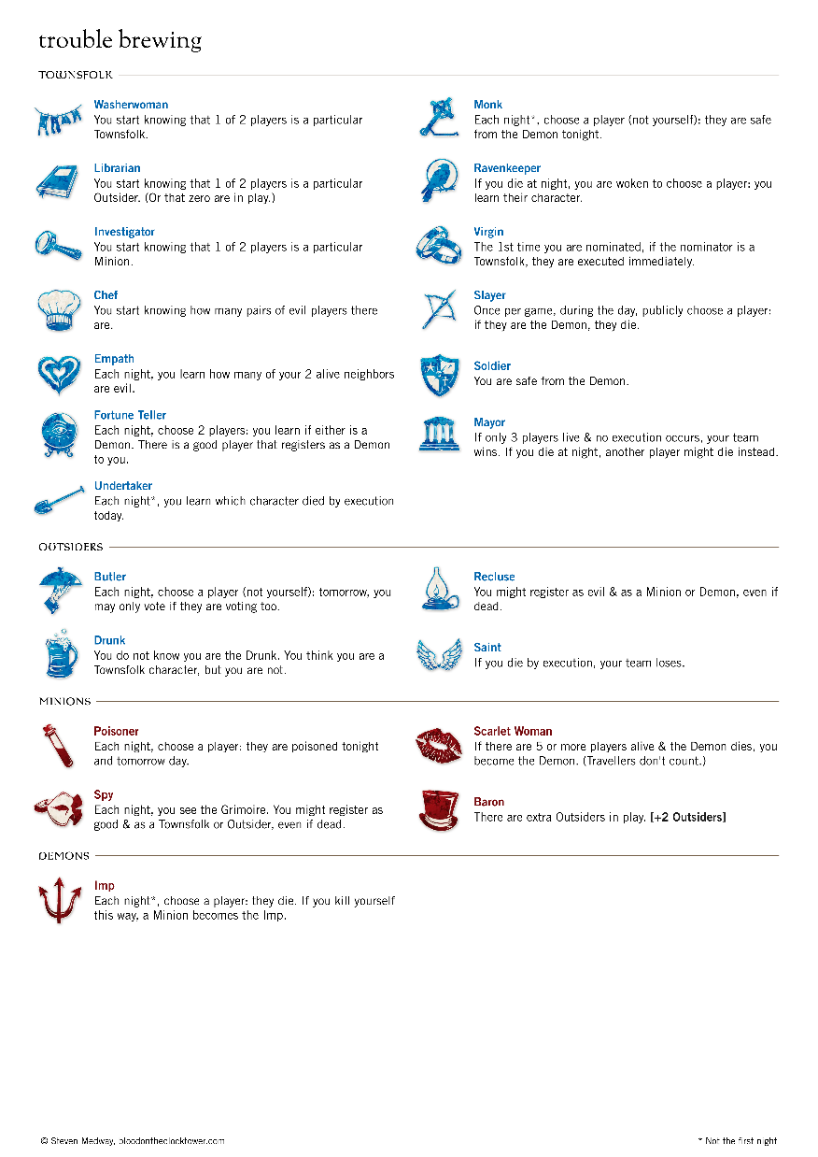

Physical Grimoire Full
Back to Introduction
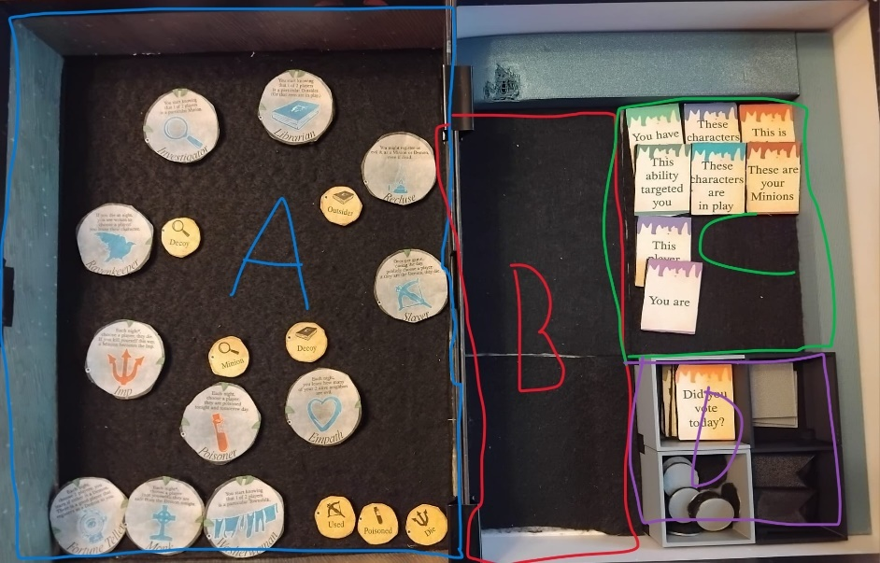
REPLACE WITH UNMARKED VERSION

Physical Grimoire
Back to User Interface
ADD IMAGE OF JUST SECTION A

Code

Full Interview Transcript

Q: What assistance (if any) would be useful in storytelling (i.e. night order, what to do when waking people)?
A: Night order and character description so you know what you need to do. Also being able to use multiple of the same reminder tokens for characters such as the Cannibal

Q: Would alternate colour schemes (such as light/dark mode) be useful?
A: Yes

Q: Should the app have different modes, i.e. strict vs flexible (in reference to freedom of token movement)?
A: Yes

Q: Would automatic character assignation be a good feature?
A: Yes, as you don’t need the physical tokens or need to tell [the players] their roles

Q: How closely should the app replicate in-person usage?
A: As closely as possible

Q: (Following on from that), which one of physical or digital night information cards be preferable?
A: Digital

Q: Would having capacity for homebrew characters be useful?
A: Yes

Q: Would you rather an in-app tutorial or a document-based guide?
A: In-app

Q: Should there be automatic waking determiners (i.e. tells you what to tell the player based on their ability)
A: Yes, but it should be optional

Q: Any other suggestions or ideas for this app?
A: Naming of tokens to relate them to the players

Testing
Back to Final Testing

Login Test Result


Other Test Result


What should be here
Additional research

Certain character’s abilities (such as the Cannibal) use other characters abilities so may need additional copies of those characters’ tokens
This question is in reference to freedom of token movement, see grimmy.app (flexible) and the-grim.netlify.app (strict)
For example, telling the storyteller how many of the Empath’s neighbours are evil
Certain character’s abilities (such as the Cannibal) use other characters abilities so may need additional copies of those characters’ tokens

