Testing

To test the program, I am going to put in various possible inputs to the program and see if the outputs match what is expected. I will also list any possible fixes, and whether or not I have implemented them.

|  |  |  |  |  |
| --- | --- | --- | --- | --- |
| **Input** | **Expected Output/Response** | **Actual Output/Response** | **Possible fix** | **Fix implemented?** |
| Any topic, all wrong answers | Score of 0, scores file reads 0. | Expected |  |  |
| Any topic, Calculation questions have equations in wrong format | Marked as incorrect | Expected | Explain correct answer syntax in text field so user avoids this. | Yes |
| Any topic, leave all answers blank | All Calculation questions marked incorrect. Some Multiple Choice questions are correct. | Expected |  |  |
| Any topic, all correct answers | Given 10 points. Score saved in text file as 10. | Expected |  |  |
| Do not change name field | Name stored as “Enter your name” | Expected |  |  |
| Blank name field | Name stored as blank | Expected | If loop to save name as “Student” | Yes |
| Run test, back to menu, click test again | Runs test again. | “ArrayIndexOutOfBoundsException”  (See screenshot below) | Reset variable questionNo to 0 upon test starting | Yes |

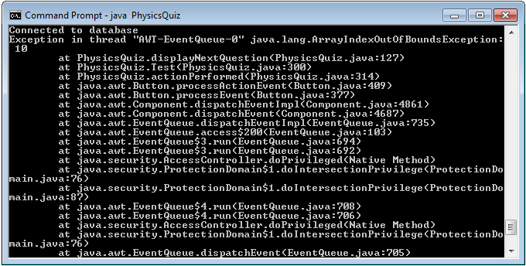

Now this testing stage is complete, I have distributed copies of the program to be beta tested by some of my peers. They will give feedback on the attached document on any problems they encountered and any improvements that they feel need to be made.

Having done these tests, I am confident that the program is ready, as all inputs work as they should do. I am now ready to implement the program.