Development Process

Layout:
The layout of the website is very important as it can greatly impact the readability of the things present on each of the pages in the website. In addition, it can also affect users impressions on the website. Therefore meaning the choice of colours for the background and even the text and text fonts will have a major impact on the website.
With poor choice of colours, such as using colours that don’t contrast.
E.g.
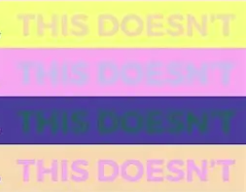

(Sourced from Rebel Toolkit)
This would cause issues for many, especially for those with colour blindness.

As for a poor choice of fonts, fonts such as:


(Sourced from font-generator.com)
These types of fonts and in combination to a poor colour selection would not only make it practically impossible to read by the average person, no better for those with colour blindness, dyslexia or any other reading complications one might have, even if the fonts and colour choices are very readable, it’ll make the website come of as childish/ unprofessional which would cause most users to not trust the website to carry out it’s purpose, mistake the website for the wrong website and waste time trying to find what they believe is the website they’re looking for, or outright be disgusted by it’s layout. This is only more reason to not only choose an appropriate colour scheme and text font for the website. (2.32 WCAG)

So for my choice of colours are:
With my choice of font being:
This choice of colour scheme is contrasting, simple and professional while also theme based around green energy which is fitting for a company aiming to sell renewable energy sources to save the environment and replace fossil fuels.
As for the choice of font, the font is simple and blocky which will allow for the text on the website to be readable and appear professional which would hopefully come off as a trustworthy website for the average customer.

User Interface:

This will be what I aim to create as the user interface of the Login/Sign up screen of the website.
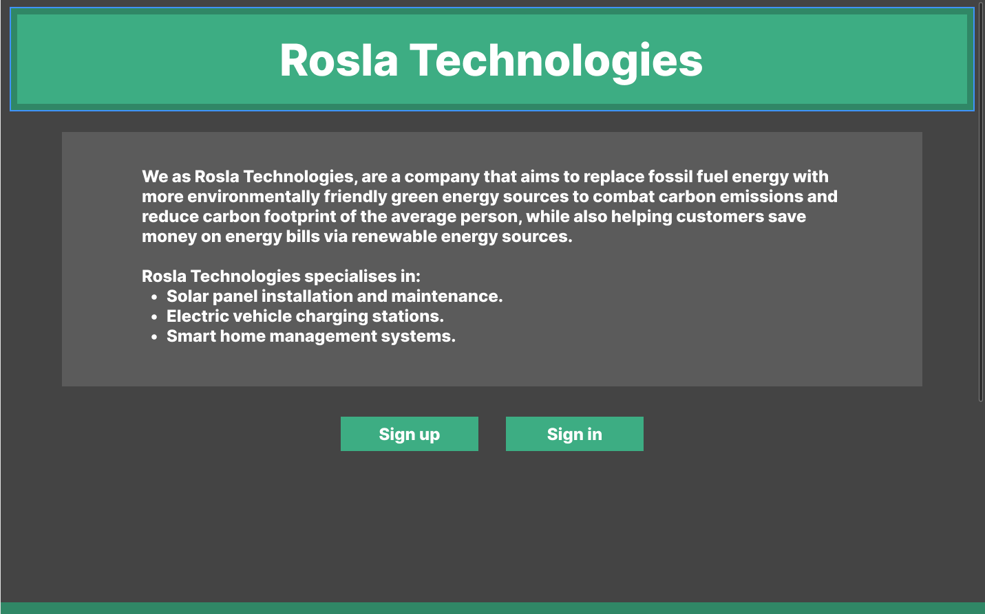
With this layout, the Company name is at the very top of the page in the biggest text so customers will not be able to miss what the name of this website is.

Under it is the information about the company and why it was made. This is to entice customers to read the information about the company and determine whether or not this company is meant for them before signing up/ logging into this company.

And finally under the Information box are 2 options. Sign up and Sign in.
This is to limit navigation clutter by narrowing customers paths down to only 2 options (2.33 WCAG) to make navigation easy and simple for customers.

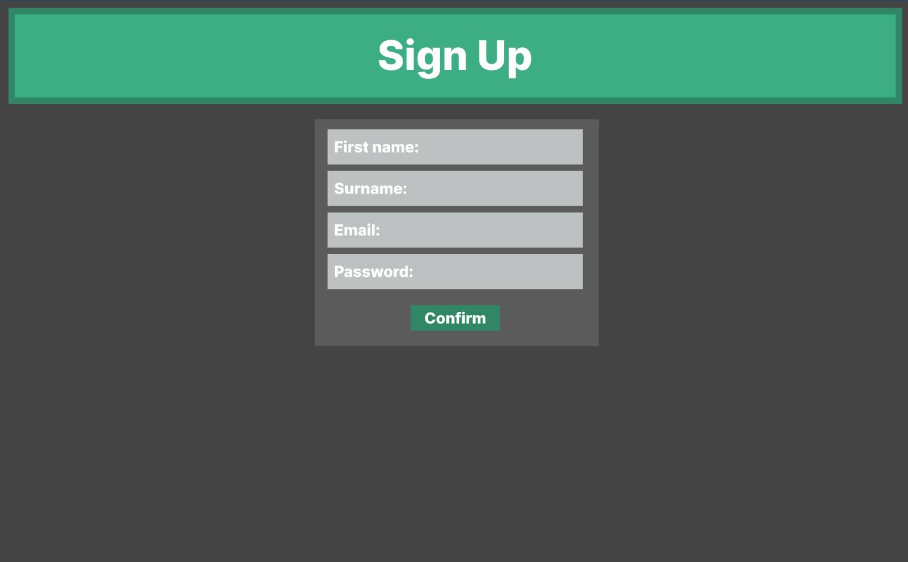
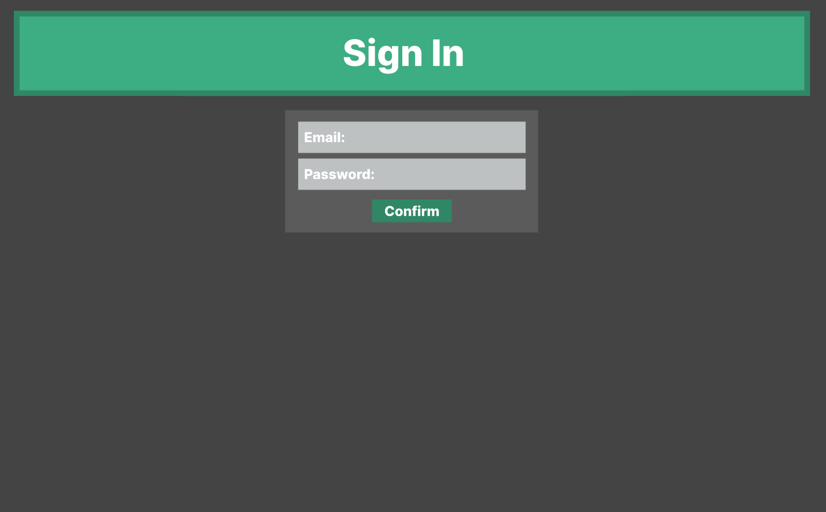

The sign up/ in page is similar to the front page, following the same colour scheme with the only difference being the light grey boxes where the user will have to fill out the details box. The Light grey boxes are there to highlight the only boxes that need to be filled out with a big confirm button at the bottom to finalise their sign in process.

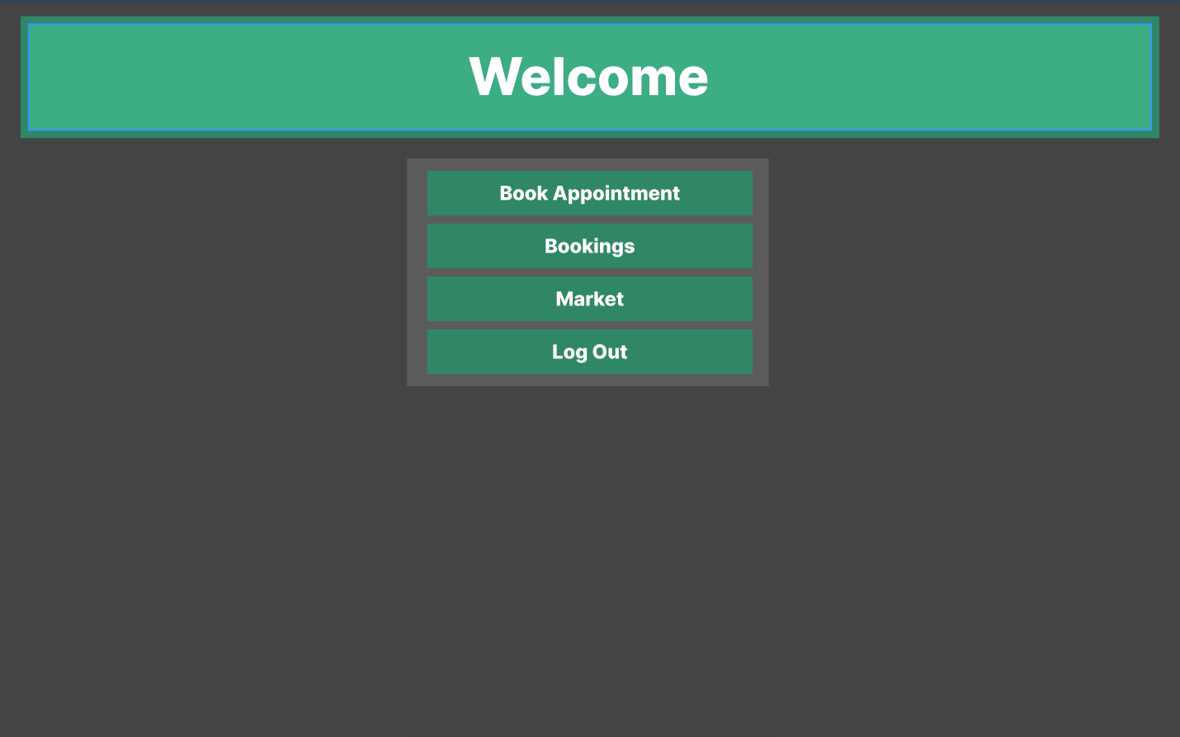
Instead of grey boxes, to prevent confusion, the navigation buttons are now dark green just like the confirm button in the Sign up/ in pages.

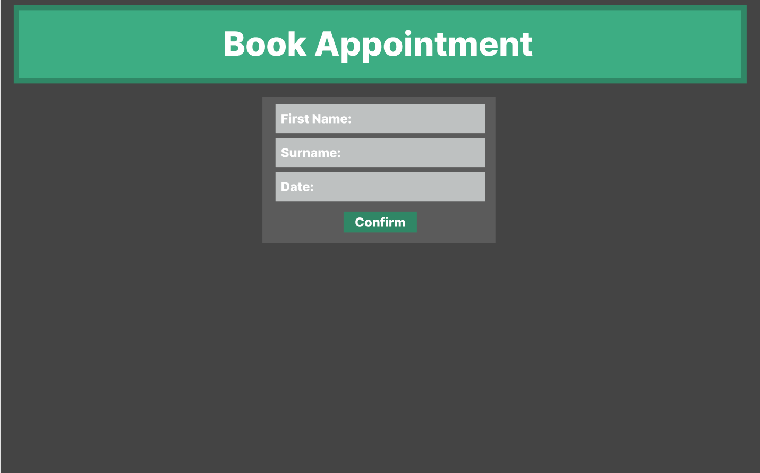
The First name and Surname is required when booking an appointment so that the consultant who is to be assigned to the appointment, will know who they will be having their meeting with to prevent awkward starts during meetings and or accidentally giving the wrong meeting to the wrong client.

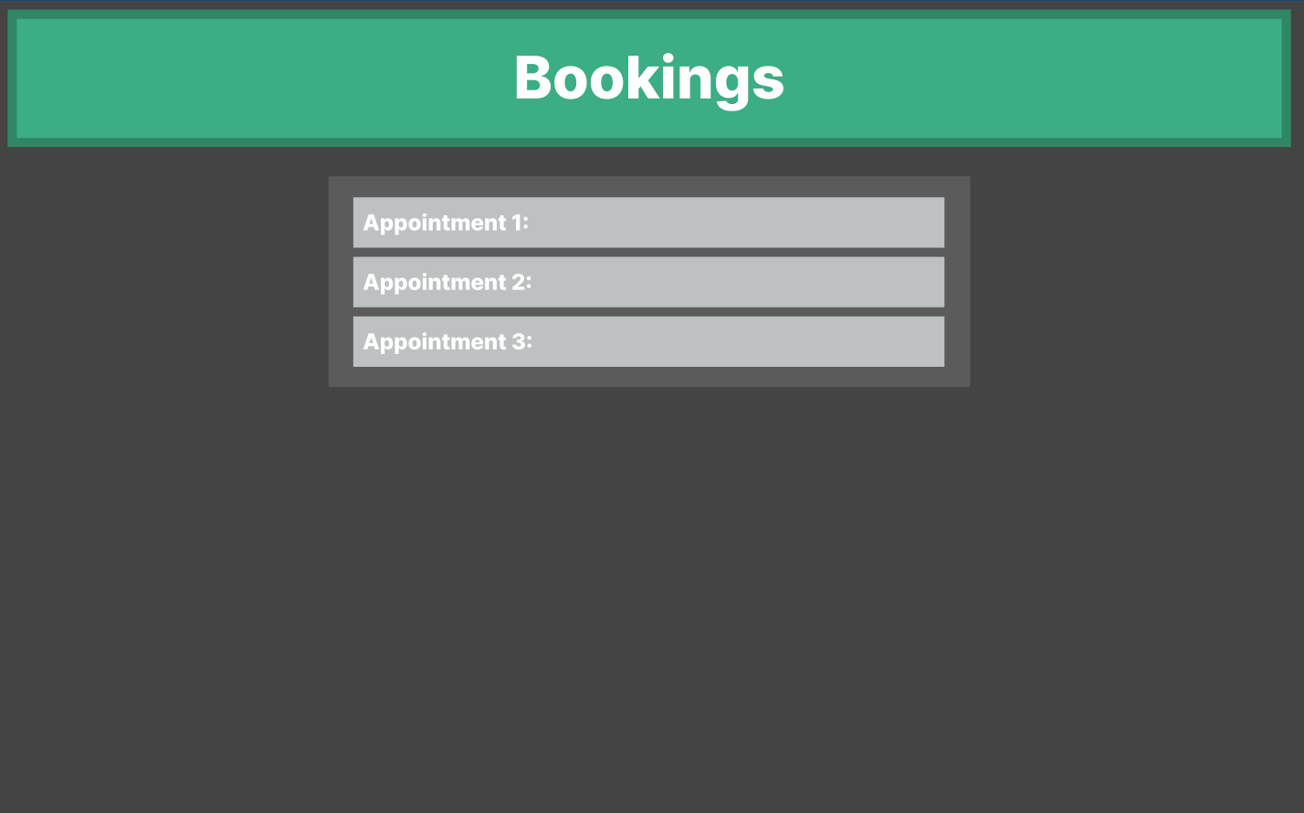
A user will not have to have a minimum of 3 appointments in order to be allowed to use the systems. It is just to highlight that a customer may book multiple appointments for various reasons. So it’d be best that they have the ability to see their bookings and have the ability to edit them this way.

The format of the appointments on display should be in the format of (Appointment 1: 10:45).

The Code:
The code for this system would be simple.
This code will first need an index and how this will be done is:

Display Company Title

Display “We as Rosla Technologies, are a company that aims to replace fossil fuel energy with more environmentally friendly green energy sources to combat carbon emissions and
reduce carbon footprint of the average person, while also helping customers save
money on energy bills via renewable energy sources.
Rosla Technologies specialises in:
Solar panel installation and maintenance.
Electric vehicle charging stations.
Smart home management systems.”

