Design:

PDO connection object.
Text font:
000000

Interface:
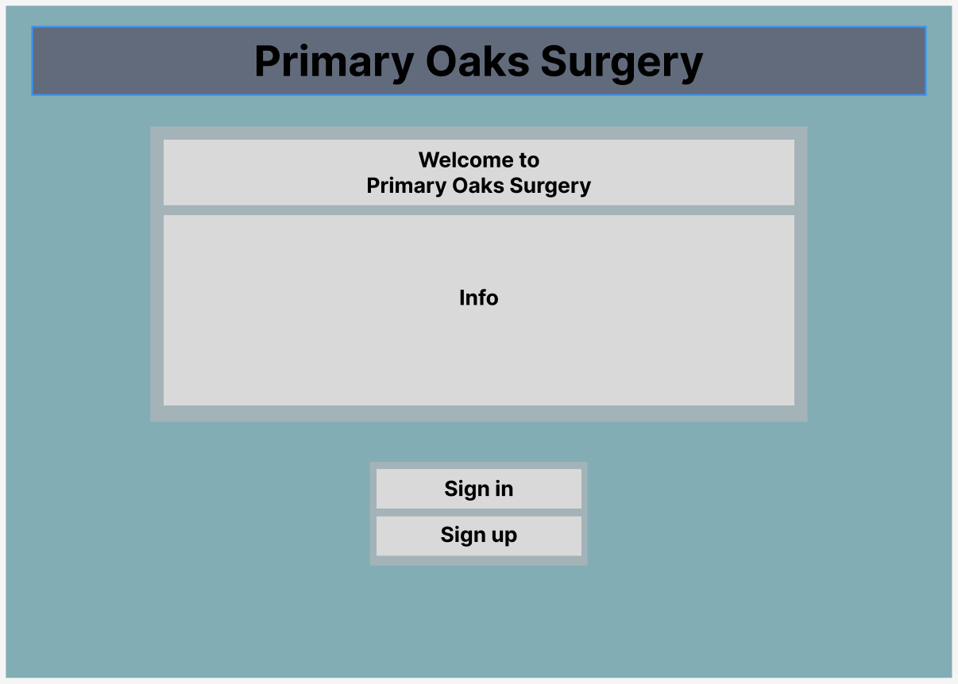
Background colour:
83ADB5
Title box colour:
606C7C
Secondary BG colour:
B1B6BA
Front face colours:
D9D9D9

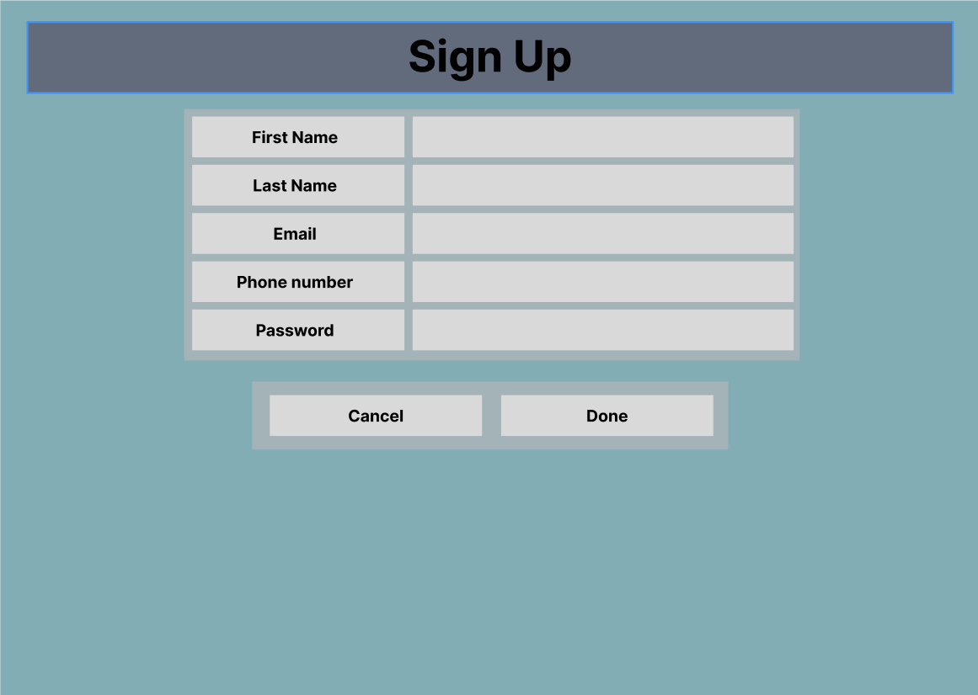

Colours and Layout:
My choice for each of the colours is very specific to increase readability among a wider variety of people with readability issues like: Dyslexia and Colour blindness.
This is done with soft colours that are appeasing to look at but also contrasting enough for the black text to be visible and readable.

The text size is also large, bold and uses a clear font with appropriate to hopefully accommodate for the readability issues mentioned earlier.

As for the layout, I had set the information page in the middle so for what ever information Primary Oaks wishes to put in the info page, it’s placement would encourage users to read the page and learn of any important information they’d need to know before signing up and for the sign up option, I had set the text boxes in the centre of the page so that the boxes are immediately visible for the user to see.

I had also set large, visible buttons and interactive text boxes to mitigate miss clicks as much as possible to help accommodate for users who have shaky hands for reasons such as Arthritis or motor neuron issues.

The reason why the UI was made to be as readable and accessible as possible is because Primary Oaks Surgery is part of the Healthcare system. Healthcare is supposed to be as accessible to anyone and everyone, so being able to book an appointment and can access healthcare with ease is an important priority for Primary Oaks.

Code:
Database:
The software I’ll use for making the database is Xampp. This is because the database is stored locally. This reduces security risks, such as: data interception, from impacting the database which is beneficial for healthcare company who handles sensitive user data.

Upon creating a new database, I’d then need to create a tables.
Tables such as:
Patient – For users to actually be able to sign up into the website to book for an appointment.
Doctor – For doctors to have the ability to access the staff page and see which patient they were assigned.
Booking – For admins to assign doctors with patients
Audit – Logs every user interaction like Sign ups

Patient table has: patientid, fname, sname, dob, gender, password
Doctor table has: doctorid, doctorname, role, password
Booking table has: bookingid, patientid, doctorid, bookingdate, completed
Audit table has: auditid, patientid, code, longdesc, date

After the tables were successfully connected to one another, I’d then need to develop the code function that connects the website to the database.

This will be nicknamed dbconn file:
FUNCTION dbconn():
SET server_name TO "localhost"
SET user_name TO "root"
SET password TO ""
SET database_name TO "posdatabase"

TRY:
CREATE a new database connection using server_name, database_name, user_name, and password
SET connection error mode to "exception"
RETURN the database connection
CATCH any connection error AS error:
LOG "Database error" and the error message
THROW the same error again
END FUNCTION

Once the connection has been established, I’d then need to develop the functions that will be repeatedly used throughout the code.

This will be called the common file:
FUNCTION user_message:

IF a session variable called "usermessage" exists THEN
SET message to the value of "usermessage" plus "</p>"
REMOVE "usermessage" from the session (to free memory)
RETURN message
ELSE
SET message to an empty string
RETURN message
END IF

END FUNCTION
This is the user message function, it simply displays any messages that the system would display to, for example, display if there was an error or if you successfully logged in.

