**Asset Log**

In this document, I will iteratively document the assets I used during the development of the solution for Health Advice Group. This will include sources of information to do with errors during the development of the solution, images used in the solution, libraries that are used and anything else.

**08/02/2024**

* I installed the python flask library
* I used the educative website to find the correct way to use regular expressions in order to validate the password: <https://www.educative.io/answers/how-to-do-password-validation-in-python-using-regex>
* I used the bootstrap framework to get the CDN links for the HTML & CSS and JavaScript: <https://getbootstrap.com/>
* I used the bootstrap framework to add a navigation bar to all HTML pages: <https://getbootstrap.com/docs/5.3/components/navbar/>
* I used the logo website to get a new logo: <https://app.logo.com/editor/colors>

* I used the freecodecamp website to find out how to make a footer stick to the bottom of the page: <https://www.freecodecamp.org/news/how-to-keep-your-footer-where-it-belongs-59c6aa05c59c/>
* I used the bootstrap framework to get a message template: <https://getbootstrap.com/docs/5.3/components/alerts/>

**09/02/2024**

* I used this stack overflow post to see how to add an icon into the tab of the website: <https://stackoverflow.com/questions/4888377/how-to-add-a-browser-tab-icon-favicon-for-a-website>

**11/02/2024**

* I used the nibusinessinfo website to get a sample terms and conditions template so I can use it in the terms and conditions page of my site: <https://www.nibusinessinfo.co.uk/content/sample-website-terms-and-conditions-use>
* I used the bootstrap framework to get a modal template for the terms and conditions when the user initially creates their account: <https://getbootstrap.com/docs/5.3/components/modal/>
* I used the nodens website to get this image of a medical background to use for the homepage: <https://nodens.eu/abstract-medical-background-with-flat-icons-and-symbols-template-design-with-concept-and-idea-for-healthcare-technology-innovation-medicine-health-science-and-research/>
* I used w3 schools to find out how to correctly position a background image: <https://www.w3schools.com/html/html_images_background.asp>
* I used tomorrow.io to screen shot what the weather forecast and air quality will look like: <https://www.tomorrow.io/weather/widget/>
* I used iconduck to get an image icon of a note pad: <https://iconduck.com/icons/67872/notepad>
* I used iconduck to get an image icon of a house: <https://iconduck.com/icons/96056/house>

**12/02/2024**

* I used tomorrow.io to get the weather forecast widget for the weather forecast page: <https://www.tomorrow.io/weather/widget/>
* I used the bootstrap documentation to get a card template for the different health conditions: <https://getbootstrap.com/docs/5.3/components/card/>
* I used Wikipedia to get a bullet point symbol: <https://en.wikipedia.org/wiki/Bullet_(typography)>
* I used stack overflow to find out how to add a bullet point automatically to the text area for the symptoms so the input would be formatted automatically: <https://stackoverflow.com/questions/57042145/add-bullets-to-each-new-line-within-a-textarea/57042927#57042927>

**13/02/2024**

* I used the NHS website to get information on all conditions: <https://www.nhs.uk/conditions/>
* I used the air quality widget from tomorrow.io: <https://www.tomorrow.io/weather/widget/>

**14/02/2024**

* I used digital ocean to find out how to replace strings in python: <https://www.digitalocean.com/community/tutorials/python-remove-character-from-string>

**15/04/2024**

* I used stackoverflow to find out how to require the user to login before accessing a certain page: <https://stackoverflow.com/questions/65434221/prevent-users-from-directly-accessing-url-and-redirect-to-login-if-not-logged-in>
* I used stackoverflow to find out why I was getting a wraps not defined error: <https://stackoverflow.com/questions/49666707/global-name-wraps-is-not-defined-error-in-flask>
* I used programiz to find out how to get the current date and time: <https://www.programiz.com/python-programming/datetime/current-datetime>
* I used w3 schools to find out how to correctly use the update statement: [SQL UPDATE Statement (w3schools.com)](https://www.w3schools.com/sql/sql_update.asp)
* I used stackoverflow to find out how to make a div container scrollable: <https://stackoverflow.com/questions/9707397/making-a-div-vertically-scrollable-using-css>

**16/02/2024**

* I used the google translate API widget to add language translation into the site: <https://docs.google.com/forms/u/0/d/e/1FAIpQLSfAyBtxLmBe3s1m-6nkSBcs7W_8EAUmwmPTEXlSqctg1QCRBw/formResponse>
* I used adobe stock to get this template image of weather for the about us page: <https://stock.adobe.com/uk/search?k=weather>

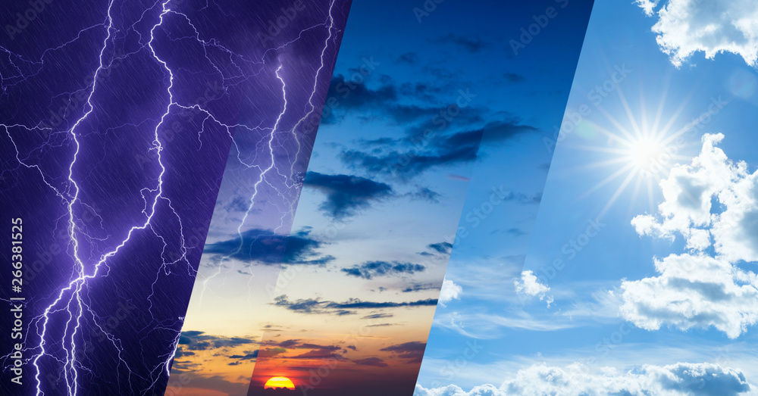

* I used everyday health to get this image of a health smartphone for the about us page: <https://www.everydayhealth.com/healthy-living/health-fitness-and-telemedicine-are-part-of-record-tech-revenue-forecast/>



* I used digitalocean to find out how to convert a string to a date object in order for form validation: <https://www.digitalocean.com/community/tutorials/python-string-to-datetime-strptime>
* I used w3 to find out how to delete a record: <https://www.w3schools.com/sql/sql_delete.asp>
* I used stackoverflow to find out how to delete a particular value in a certain column: <https://stackoverflow.com/questions/5126167/delete-the-column-for-the-particular-value>