Task 2: Test log
Normal data
Extreme data
Erroneous data
Description of test | Test data to be used (if required) | Expected outcome | Actual outcome | Comments and intended actions
Testing if user is able to create a new account  (Test 1) | Password = Password1  Confirm_password = Password1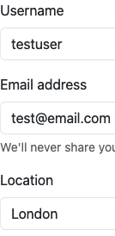  (normal data) | User will be able to create an account, data will be hashed, data will be inserted into the database and then the user will be redirected to the login page | User is not able to create account and page refreshes without any error messages | I did not add in the get_flashed_messages() function to display the flashed messages.  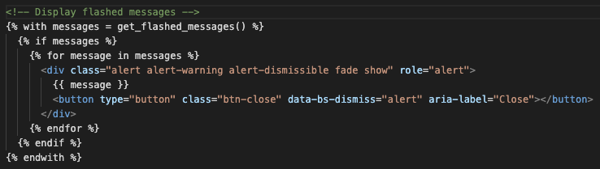  I added in the message flashing code to see what the error is.
Testing if user is able to create a new account  (Retest for creating account) | Password = Password1  Confirm_password = Password1 | The data will be incorrect but I will be able to see what error is being flashed to find out what the issue is | The same outcome as the previous test | The reason for this error was because I did not make the form of type POST meaning it could not submit the form.  I added in the POST method to the form.
Testing if user is able to create a new account  (Retest for creating account) | Password = Password1  Confirm_password = Password1 | User will be able to create an account, data will be hashed, data will be inserted into the database and then the user will be redirected to the login page | 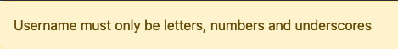 | The cause for this output is username does not match the regular expression pattern for the username, which is incorrect since this should be allowed input  I added in the print statement to print the result of re.match to see what it was outputting
Testing if user is able to create a new account  (Retest for creating account) | Password = Password1  Confirm_password = Password1 | Will see the result of re.match for the username which will return None |  | The match function is returning none meaning that the username did not match the regular expression which is incorrect  I changed match to search to see what the output would be  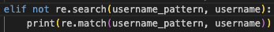
Testing if user is able to create a new account  (Retest for creating account) | Password = Password1  Confirm_password = Password1 | Will see the result of re.search for the username |  | I forgot to add the + on the end of the patterns for all of the patterns which should be what is causing the problem.  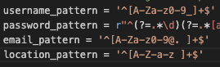  I added the plus on all strings that needed it
Testing if user is able to create a new account  (Retest for creating account) | Password = Password1  Confirm_password = Password1 | Will see the result of re.search for the username | 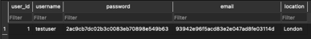 | The data is now inserted into the database and data is hashed which meant that the missing plus is what was causing the issue so the test is now successful
Test to see if I am able to create an account with existing username | Password = Password1  Confirm_password = Password1  (Errenuous data) | I will not be able to create an account with already existing username and instead will be flashed the corresponding message | 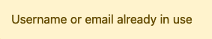 | Test successful, expected outcome achieved
Testing to see if I am able to create an account with an invalid username | Password = Password1  Confirm_password = Password1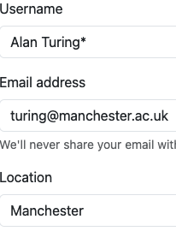  (Erroneous data) | I will not be able to create an account and will be flashed a message telling me the username is invalid |  | Test successful, expected outcome achieved
Test to see if I can create an account with a username less than 4 characters | Password = Password1  Confirm_password = Password1  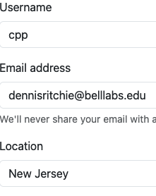  (Erroneous data) | I will not be able to create an account and message will flash me saying username must be certain character length | 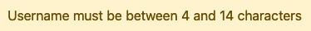 | Test successful, expected outcome achieved
Test to see if I can create account with invalid password | Password = pswrd  Confirm_password = pswrd  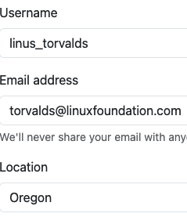  (Erroneous data) | I will not be able to create an account and message will flash me saying password must be x |  | Test successful, expected outcome achieved
Test to see if I can create account with non matching passwords | Password = Password1  Confirm_password = Password2  (Erroneous data) | I will not be able to create an account and message will flash me saying password must match | 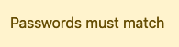 | Test successful, expected outcome achieved
Test to see if I can create account with invalid email | Password = Password1  Confirm_password = Password1  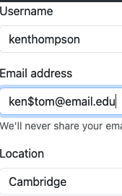  (Erroneous data) | I will not be able to create an account and message will flash me saying invalid email |  | Additionally the front end also checks for valid email so there is double validation. Test successful, expected outcome achieved.
Test to see if I can create account with email that is less than 6 characters | Password = Password1  Confirm_password = Password1  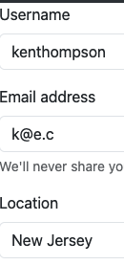  (Erroneous data) | Front end will display message saying please enter valid email |  | Initially I thought that the front end would catch it but the back end catches it instead. Test successful, expected outcome achieved.
Test to see if I can create account with invalid location | Password = Password1  Confirm_password = Password1  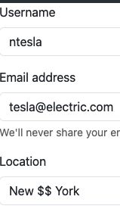  (Erroneous data) | I will not be able to create account and will be flashed message asking to enter valid location | 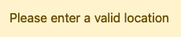 | Test successful, expected outcome achieved.
Test to see if I can create account with location that’s less than 4 characters | Password = Password1  Confirm_password = Password1  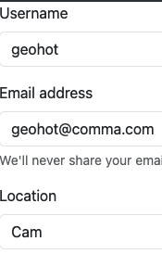  (Erroneous data) | I will not be able to create account and will be flashed message saying location must be x characters |  | All register tests are now complete and successful.
Test to see if user can log in | 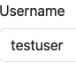  Password = Password1  (normal data) | I will be able to log in and then will be redirected to the index page | 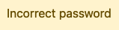 | This was caused because I forgot to hash the password so I was comparing the non-hashed against the hashed password  I added in the code to hash the password and then check it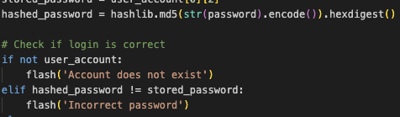
Test to see if user can log in  (retest for test to see if user can login) | Password = Password1 | I will be able to log in and then will be redirected to the index page | I am successfully logged into page | Test is successful.
Test to see if user can log into non existing account | 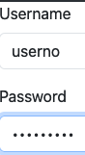  Password = Password1  (Erroneous data) | I will not be able to log in and will be flashed message saying account does not exist | 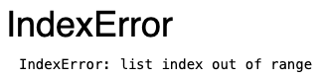 | This error was caused by the organisation of the if statements, the code first needs to check if the user query returned a result and if so then access using bracket notation the query.  I changed the organisation to fix this  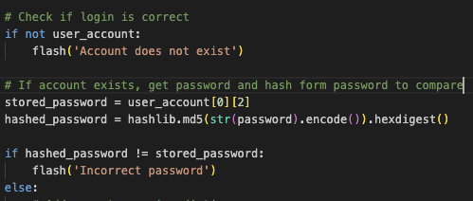
Test to see if user can log into non existing account  (retest for seeing if the user can log into non existing account) | Password = Password1 | I will not be able to log in and will be flashed message saying account does not exist |  | The code will still check the query if the query returns nothing so an else statement is needed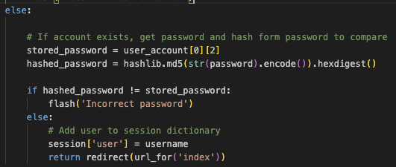
Test to see if user can log into non existing account  (retest for seeing if the user can log into non existing account) | Password = Password1 | I will not be able to log in and will be flashed message saying account does not exist | 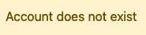 | Test is successful
Test to see if user can log into account with incorrect password | 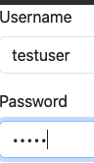  Password = pword  (Erroneous data) | I will not be able to log in and will be flashed a message saying incorrect password | 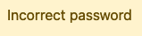 | Test is successful

09/02/2024
Test to see if user can log out | N/A | I will be able to logout |  | I forgot to return the index page in the route  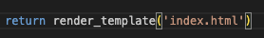  I added in the return statement
Test to see if user can log out  (retest to see if user can log out of account) | N/A | I will be able to logout | I have logged out | Test is successful.

11/02/2024

Test to see if user can create account with extreme data | 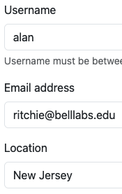  Password = Password1  Confirm password = Password 1  (Extreme data) | User will be able to register account with extreme data |  | I was not able to create an account with extreme data. This is because I am using < instead of <= which would allow for extreme data.  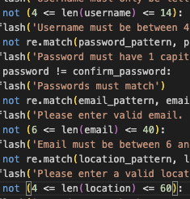  I have made the changes.
Retest of test to see if user can create account with extreme data | Confirm password = Password 1  (Extreme data) | User will be able to register account with extreme data |  | User is now able to successfully register an account with extreme data.

12/02/2024

Test to see if I can create admin account | 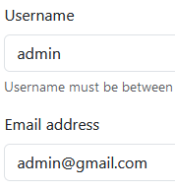  Password = Password1  Confirm password = Password 1  (normal data) | I will be able to register an admin account | 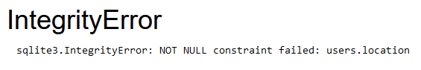 | I got a not null constrain failure because I was trying to insert into the users table instead of the admin table  I changed the query to insert into admin
(Retest to see if I can create admin account) | Same data | I will be able to register an admin account | 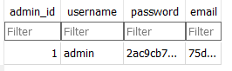 | I am able to successfully create an admin account
Test to see if I can log in as admin | 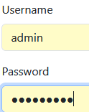  Password = Password1  (normal data) | I will be able to login as admin | I am logged in | Test successful

13/02/2024
Test to see if I can create a health condition as admin | 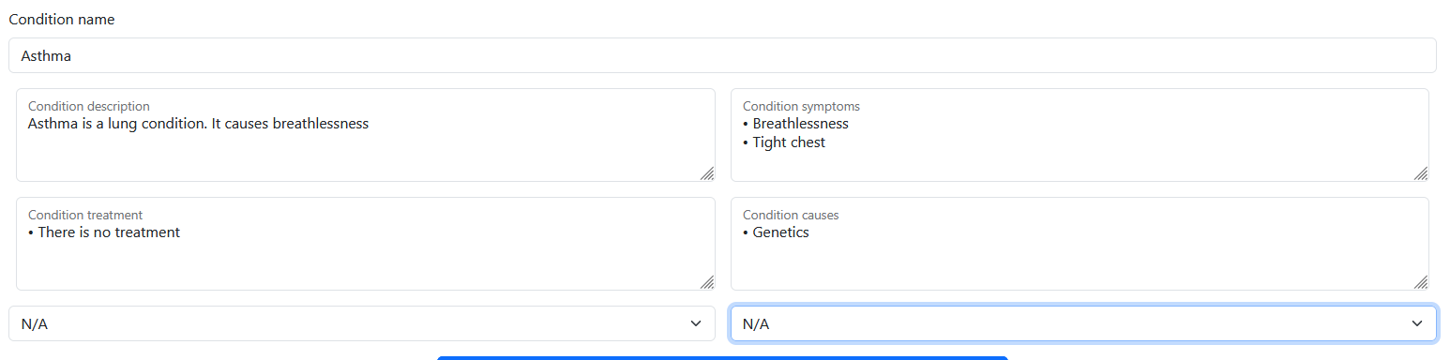  (normal data) | I will not be able to add a condition due to the input being not valid by accident |  | The description had full stops and new lines in it which the regular expression pattern did not. I have added in the correct regular expression.
Restest to see if I can create a health condition as admin | Same data | I will be able to add in the condition |  | The data was successfully added, but the condition type is not being inserted correctly.  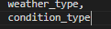  I was accidentally inserting a function into the database instead of the value from the form
Restest to see if I can create a health condition as admin | Same data | I will be able to add in the condition |  | Test successful.

15/02/2024
Test to see if I can add a entry into the health tracking tool | 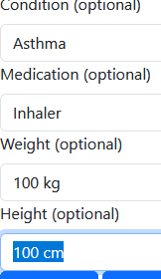  (normal data) | I will not be able to because of a validation error | 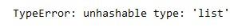 | I added in the code snipper to display the flashed messages as well to see what the validation errors were. I also removed the brackets around the regular expression patterns for the height and weight patterns  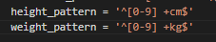
Retest of adding entry to health tracking tool (1) | Same data | I will not be able to because of a validation error | 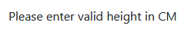 | The regular expression for the height is not working, meaning it will not work for weight either  I fixed the regular expressions  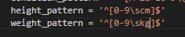  I also added in a + on the end
Retest of adding entry to health tracking tool (2) | Same data | I will not be able to because of a validation error | 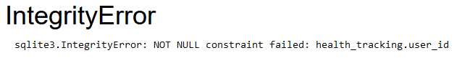 | I forgot to insert the user id  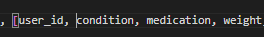  I added in the user_id
Retest of adding entry to health tracking tool (3) | Same data | I will be able to add in the data | 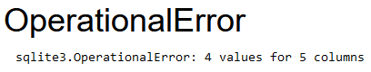 | I forgot to add in a extra placeholder  I added in the placeholder  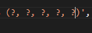
Retest of adding entry to health tracking tool (4) | Same data | I will be able to add in the data | 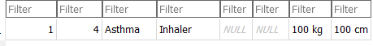 | Test successful
Test to see if I can add a note | 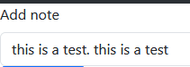  (normal data) | I will be able to add in the note |  | I forgot to add in the user id in the insertion query  I added in the user id into the query
Retest of seeing if I can add a note (1) | Same data | I will be able to add in the note | 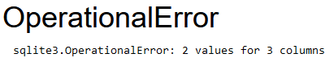 | I forgot to add in an extra placeholder  I added in the extra placeholder  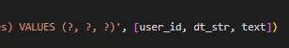
Retest of seeing if I can add a note (2) | Same data | I will be able to add in the note |  | Test successfull

16/02/2024
Test to see if I can book risk assessment | 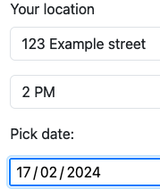  (normal data) | I will be able to book risk assessment | 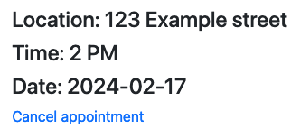 | Test successful
Test to see if I can book risk assessment with invalid location | 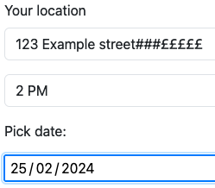  (Errenuous data) | I will not be able to book risk assessment and a message will be flashed instead | 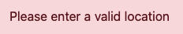 | Test successful
Test to see if I can book risk assessment with no time | 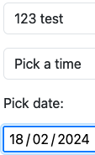  (Errenuous data) | I will not be able to book risk assessment and a message will be flashed instead | 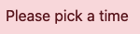 | Test successful
Test to see if I can book risk assessment with date in past | 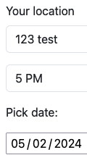  (Errenuous data) | I will not be able to book risk assessment and a message will be flashed instead | 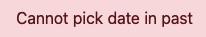 | Test successful

