Extended Project Qualification

EPQ 2020
Nathan Brown-Bennett

EPQ Title: An investigation into Cyber Security and whether it is secure for modern day use?

Abstract
This project aims to explore and define security, apply, and differentiate it between information security (IT Sec), Information Communication Security (ICT Sec) and Cyber Security. In order to assess how secure Cyber Security is for modern day operations of data security and its effectiveness in comparison to other security methods, I look at how Cyber Security works and used to work in a field of expertise whilst modernisation, automation and security changes throughout the years have changed its function in comparison to other methods, focusing on why and whether cybersecurity is important in the world of business as well as daily use.

Literature Review

Perfect Security - https://play.google.com/books/reader?id=EGcFAAAAQAAJ&hl=en_GB&pg=GBS.PA8
This dissertation is useful because it helps to show the contrast between what we thought security was and what it has become, the problem with it is that it is over 200years old and so may not be seen as temporally valid, but still overall holds a good insight into security.

https://searchsecurity.techtarget.com/definition/physical-security#:~:text=Physical%20security%20is%20the%20protection,%2C%20theft%2C%20vandalism%20and%20terrorism.
TechTarget is a good website as it presents a list of things physical security specifically protects as well as comparing the way in which threats can bypass or breach physical security. However, a problem to note would be the amount of information the site cramps into its first page making it rather hard to follow, though overall, the information is very specific, relevant, and helpful making it a good website.

https://www.thoughtco.com/history-of-locks-4076693
Thought. Co’s History of locks page is good at giving an insight into the development of locks throughout years of development, as well as giving names of different people which aided in creation or invention of locks. On the other hand, it does not state what failures or how successful these locks ended up being, overall it is a good source/page to gain an insight into the development of locks but not an overall good website in judging how successful these locks were.

https://youtu.be/PGv5BqNL164
This video is very useful and does not really have any bad or unnecessary information in it, it explains how hackers get into systems, how people defend against it, trace and track, different computer systems and overall, the video is useful in judging how a hacker’s mind works in order to figure out the best way to defend against one.

https://www.ripublication.com/ijcir17/ijcirv13n5_19.pdf
This dissertation published in 2017 titled “Applying Artificial Intelligence Techniques to Prevent Cyber Assaults “was key to helping me understand the connection between Cyber Security and Artificial Intelligence and helped me widen where I was looking to learn more about cybersecurity. Although it was published three years ago, it is very much still accurate today.

These are just a handful of an example of the sources I have referenced in my EPQ, all carefully chosen and decided. I use a wide range of sources such as videos, blogs, articles, and dissertations because my field of study is based on cyberspace and computing. Using a wide range of sources allows me to gain more information from various credited publishers, which wasn’t available from just research papers alone, ensuring I could produce an EPQ that was accurate and up to date.

Contents

Page 1. Title - An investigation into Cyber Security and whether it is secure for modern-day use?
Page 1. Abstract
Page 2. Literature Review
Page 3. Contents
Page 4. What is Security
I. Perfect Security vs Modern Day Security
Page 7. Information Technology vs Information Communication Security vs Cyber Security
I. Google Form Survey
II. Misconceptions of Cyber Security and Information Security
III. Defining and Distinguishing the terms
IV. A short history on the Origins of Cyber Security
Page 11. How Effective Has Cyber Security Been In Modern Practice?
I. The Statistics and Faults
II. Problem 1: People aren’t Cyber Aware
III. Problem 2: Cyber Security isn’t being taught
IV. Problem 3: Human Error means Robotic Staffing
V. What’s being done to combat
Page 19. Conclusion: The Effectiveness of Security Practices in Cyber Security

What is Security?
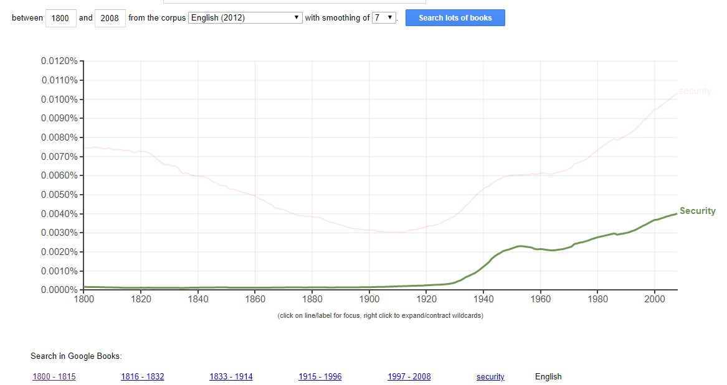
The Oxford English Dictionary defines security as being “the state of being free from danger or threat.”, a fixed, objective term stating that, for example an object thought or person cannot be unwillingly moved, changed, or damaged. The Google Books Ngram Viewer archive shows early records of this word first appearing in the early 1800s in a document published by Archibald Redfoord titled “Union, Necessary to Security. Addressed to the loyal inhabitants of Ireland”, From the documents around this area, ‘Security’ pertained towards physical, political and monetary circumstances such as securing your home from intruders, securing your country from invaders and securing your finances from thieves. Despite this, the usage of this word during the 1800s was very little.

This definition of security is the most common definition across the Oxford English Dictionary, The Cambridge English Dictionary and Merriam Webster and holds true as these threats have changed and increased over time.

Security has always been a necessity for humans. Archaeological research has shown us the first form of Physical Security, the protection of personnel, hardware, software, networks and data from physical actions and events that could cause serious loss , was the use of locks. Dating back to 4000 years ago,The best thing early locksmiths could do to protect themselves was to add more features such as false keyholes that might confuse a trespasser or slow them down in the process of protecting their goods. As time moved on humanity had been striving for security and protection, but never actually achieved a state of Security by the definition above until the 1770s when Joseph Bramah invented what he believed to be the 100% theft-proof lock, creating for the next 70 years a period of time called “Perfect Security” where anything put under that lock and key was officially in “the state of being free from danger or threat”, aka. Secure.

It wasn’t until 1851 when this definition of security was broken for the first time when locksmith Alfred Charles Hobbs successfully picked the state-of-the-art Bramah lock in two weeks. This abolished our sense of perfect security and we haven’t felt anything close to it since. However Hobbs is quoted after breaking the lock saying “Rogues are very keen in their profession, and know already much more than we can teach them.” and that we should learn from smarter thieves and focus less on defending against them.

Perfect Security vs Modern Day Security
Hobbs’ quote is where the second definition of security from the OED and how modern security practices operate, fit in, “Procedures followed, or measures taken to ensure the security of a state or organization.” This thought has been adopted strongly in the technological front where we are learning more and more each day through hacking conferences, vulnerability reports and forensic analyses on a scene or a case. A hacker in its general sense is “any skilled computer expert who uses their technical knowledge to overcome a problem.” Unfortunately, through its portrayal in media and cases of its abuse, the term has gained a huge negative connotation, to which the word colloquially refers to, “a person who uses computers to gain unauthorized access to data.”

Nowadays there are teams of hackers who use their ability to solve problems and help, these people are commonly referred to as “White Hats” and have huge events and conferences dedicated to spreading their findings and teaming up. On the other hand for their counterparts, “Black Hats”, as Norton puts it, “Their primary motivation is usually for personal or financial gain...Not only do black hat hackers seek to steal data, but they also seek to modify or destroy data as well.”

Norton finds it important for us to understand that “Although the word hacker tends to evoke negative connotations when referred to, it is important to remember that all hackers are not created equal. If we didn’t have white hat hackers diligently seeking out threats and vulnerabilities before the black hats can find them, then there would probably be a lot more activity involving cybercriminals exploiting vulnerabilities and collecting sensitive data than there is now.”⁷

The threats that we face now are to Digital Security, those we are securing against are hackers. Research reveals that hacking originated from 1878 when a group of teenage boys would disconnect or redirect phone calls from a newly started company called Bell Telephone. This method of hacking is called Phone Phreaking, the “fraudulent manipulation of telephone signalling in order to make free phone calls...The term phreak comes to the words phone, free, and freak” and some would argue this largely ended when the phone companies updated their systems, but following on with the examples of John Draper, Kevin Mitnick and many other countless pioneers of the 20th century joined in, it looked like we had just entered the beginning of phreaking and the rise of the hacking movement.

Lockpicking and Phreaking are two examples of threats to physical security that have changed over the years due to developments into how these services are run. Events such as LockCon and DefCon help us learn about security problems, find vulnerabilities, and further secure ourselves. As we move develop, experiment, and innovate throughout the years, we move closer and closer into a digital age where almost everything precious to us, is online. Our finances, our campaigns, our ideas, our protection, our homes and our lives.

It seems we may never again reach a place of “Perfect Security”, and instead we should look to our new definition of security to feel safe. Using the examples of LockCon, DefCon and the battle between White and Black Hat Hackers, Security in place nowadays means that there is an active push for our protection, for exposing and resolving vulnerabilities and a sense of our safety being in the trust of those working to protect us. Henceforth why Digital Security is paramount in our modern day lives and why it is very important to understand how to best equip ourselves in the Cyber field.

The questions left being, what is Cyber Security, and does it fit this definition?

Information Technology vs Information Communication Security vs Cyber Security
Google Form Survey
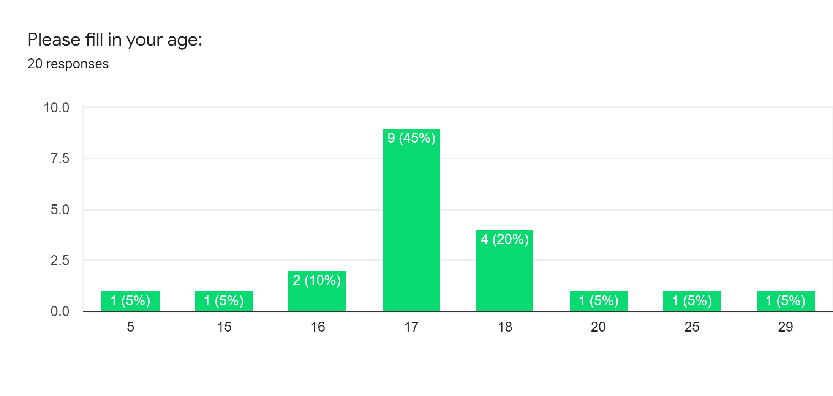
Upon research of the topic, I found multiple articles about Cyber Security, and even asked local students and employees in the field of digital security to define the topic in their own way, and received conflicting feedback on what Cyber Security and common terms in the field actually meant. To see how well understood these terms are in my social group, I created a Google Form Quiz with the title “Cyber Quiz” . I managed to get 20 responses to my Google form (with 10 pilot surveys prior). The questions were set in a way to change order on every form to ensure it was more difficult for a participant to have repeated the form with the correct answers. I chose to collect age, to try to see if I could keep track of the average amount of knowledge for an age group, however the most common age of respondents was 17 Years old.

The survey was out of 6 points and included a mixture of closed and open-ended questions. The questions in my survey aimed to discover how much average people know about general technological concepts. The questions in my survey were:
“What's the minimum required password length?”
“Is public Wi-Fi secure for use?”
“Which of the following is closest to the definition of a computer hacker?”
“What is a Black Hat Hacker?”
“What does Cyber mean?”
“What does Security mean?”
“In your opinion, what's the difference between Cyber Security, ICT security and Information Security?”
“On a scale of 1 - 10, how much would you say you know about cybersecurity?”
“In your opinion, what's one way to protect yourself / your devices that everyone should know?”
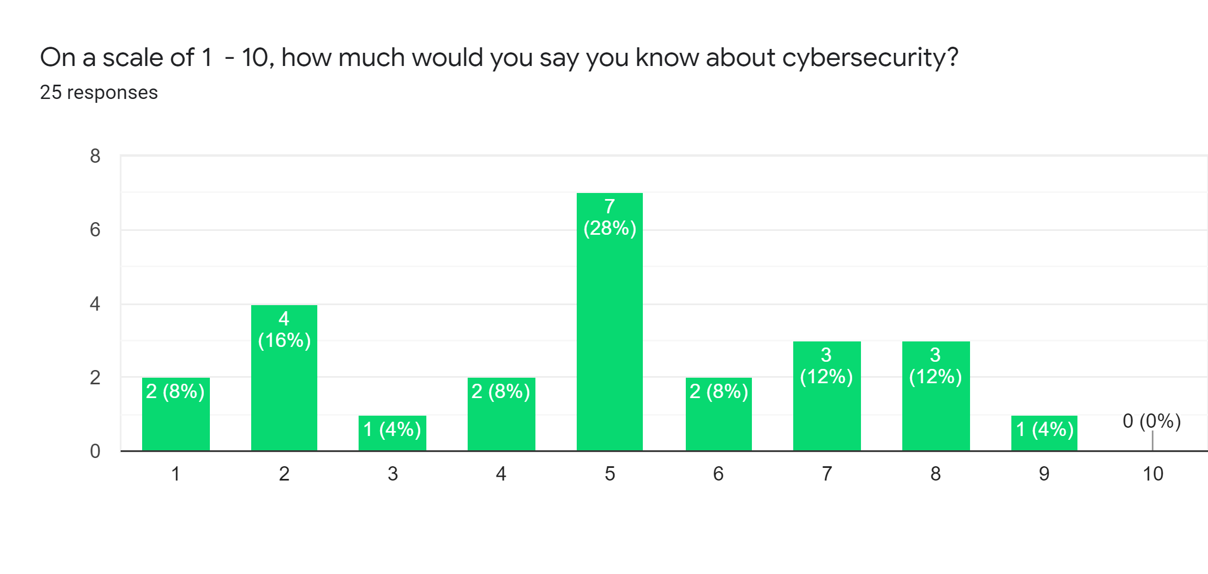

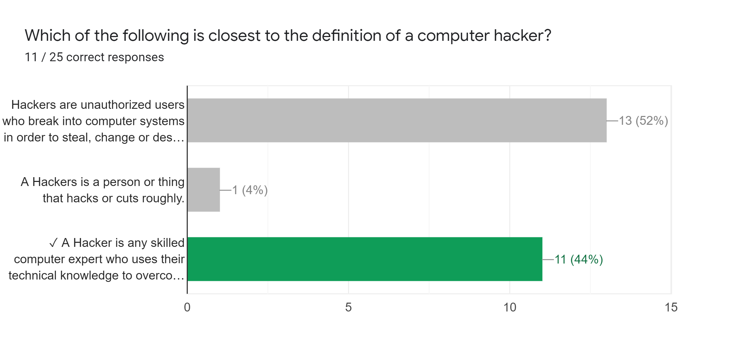
It became immediately evident in my research that despite most participants claiming they were a 7 on a 1 - 10 scale regarding the amount of knowledge they thought they had about cyber security, the average person of all age groups scored about 3.64 out of 6 points, scoring an average of 60.7% across the respondents, putting them still high up on the scale at a solid 6 out of 10.

However, with 60% thought to be subject knowledge, points began to be lost when differentiating between definitions of key terms, for example, when it came to defining the term “Computer Hacker” only 44% of the entire cohort managed to get the correct answer.

Misconceptions of Cyber Security and Information Security
The biggest loss of points came from the qualitative response question, “In your opinion, what’s the difference between Cyber Security and Information Security?” where the answers ranged from extremely vague or unclear to close, logically thought through or creative with answers such as:

“In my opinion cyber security is to do with a whole network and your device whereas information security is to do with your personal information”
“In my opinion Cyber Security is a form of defense system which restricts or keeps you safe from the internet like firewalls.
I think that, ICT Security sounds like it has more to do with the computer itself, like anti-virus systems.
I believe that Information Security is the type of security which prevents your information from being stollen, like when a website encrypts your data.”
“In my opinion i think cyber security is like passwords and ict security is to do with computer viruses”

The fields of Data, Cyber, Communication and Information Security are paramount in the event that your data is at danger of manipulation or being stolen for protecting our daily lives. Since, having such an important role in our lives, surely such a topic should be understood a little bit more by members of the public and students in the field.

Cyber Security lies amongst the other forms of Computer / Digital Security and often gets misconstrued as a subsection under Information Security. This is evident in statements like “While cybersecurity can be viewed as a subset of information security, ultimately both focus on data protection.”. And leads to a lessened focus on Cyber Security practices and articles on the topic, for a much broader, Information Security view.

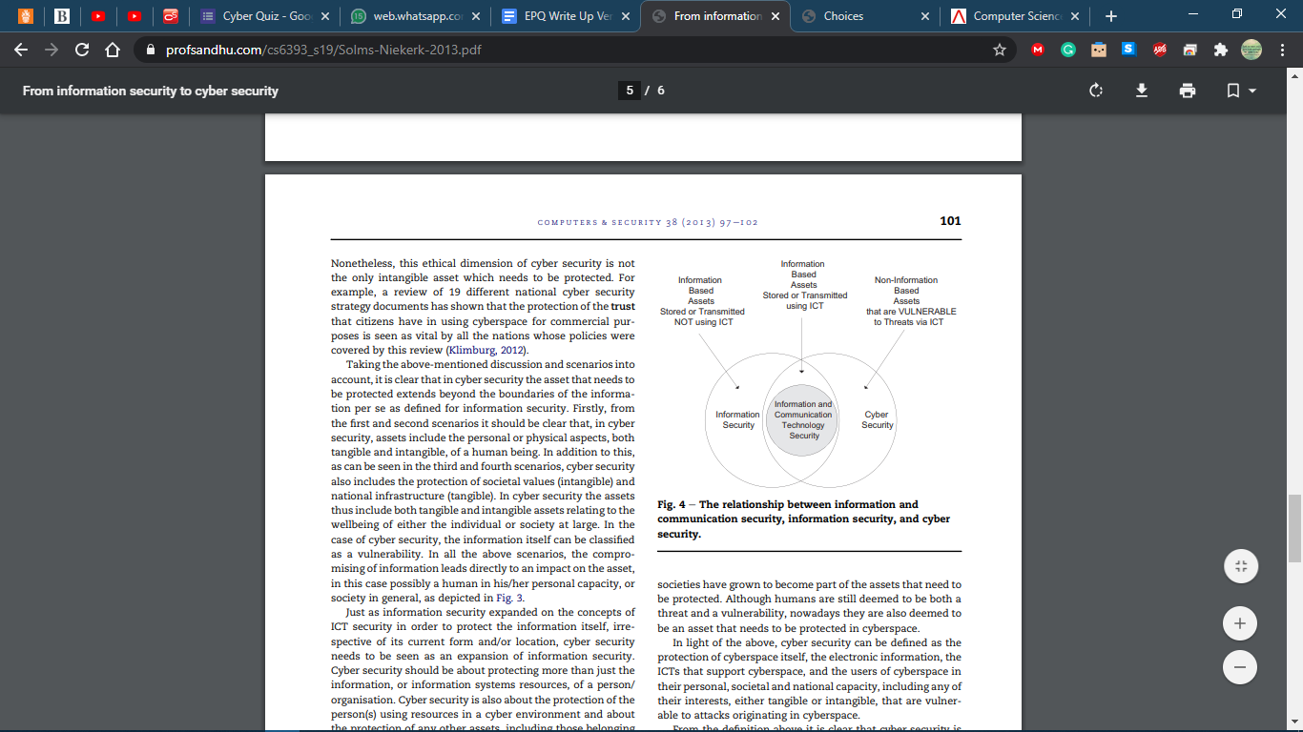
This view has been supported by other journalists such as Jake Olcott who claims, “Cybersecurity is all about protecting data that is found in electronic form...from being compromised or attacked.” whereas Information security “is another way of saying “data security.” So, if you are an information security specialist, your concern is for the confidentiality, integrity, and availability of your data.” Olcott makes the argument that Cyber Security is the branch of Information Security that deals with the absolute protection of data within the electronic sense more than anything else.

There is a lot of ambiguity between the bounds that make Cyber Security, Information Technology, and Internet Communication Security different. A research paper conducted by Rosssouw von Solms et al (published by the Nelson Mandela Metropolitan University in 2013) makes the counter-argument that although "there is a substantial overlap between cybersecurity and information security, these two concepts are not totally analogous. Moreover, the paper posits that cybersecurity goes beyond the boundaries of traditional information security to include not only the protection of information resources but also that of other assets, including the person him/herself”. The work of Rosssouw von Solms et al uses the examples of Cyber-Bulling, Home Automation such as IOTs, Digital Media threats such as piracy and Cyber terrorism to show us just how different and separate the Cyber Security field is compared to Information and ICT technology, in what it manages and aims to protect on its own.
Defining and Distinguishing the terms
Solms neatly disambiguates the terms, defining Information security as “the protection of information, which is an asset, from possible harm resulting from various threats and vulnerabilities.” and Cyber Security as “not necessarily only the protection of cyberspace itself, but also the protection of those that function in cyberspace and any of their assets that can be reached via cyberspace.”, showing us that the two operate in tandem, but on their own target very important and different areas.

Applying Solms' definition of Cyber Security, Urs E. Gattiker's 'The Information Security Dictionary' outlines six reasons why IT security and Cyber Security are very important fields of research and study.
- Everybody has enemies
- Every enemy has one strength
- Technology makes us vulnerable
- Attacks will strike technology at its seams
- Technology Interdependence Exacerbates the Problem
- Collaboration between Public and Private Organizations is a Must

For Gattiker and Solms an expert in the field of Information Technology will do their best to prevent personal or sensitive and confidential information from unauthorised access in any means. Whereas a Cyber Security expert will do their absolute best to ensure nothing linked to cyberspace becomes vulnerable to be leaked for an unauthorised purpose. Thus, by definition, Cyber Security aims to, keep systems secure in "the state of being free from danger or threat "
A short history on the Origins of Cyber Security
The field of Cyber Security begins with the creator of the email, Ray Tomlinson, who wrote the first anti-virus software to chase Creeper, a virus which spread through computer systems printing “I’M THE CREEPER: CATCH ME IF YOU CAN” in 1972. Around this time the practice of computer security existed separately from software and hacking. From the 80s onwards Computer Security was advice, government advice and plans against unauthorised access to documents and the United States Department of Defence Rainbow Series, which were a collection of security standards and guidelines for computer use.

Three years after the Trusted Computer System Evaluation Criteria, commonly dubbed “The Orange Books” were issued in 1983, German hacker Markus Hess changed up the game for Cyber Security Protocols and Professionals in place by hacking 400 military computers, including mainframes at the Pentagon through a bypassed internet gateway in Berkeley that allowed him access onto the Arpanet with intent to sell to the KGB. He was found out by Clifford Stole who was a Nasa Computer Scientist who led the hacker into a honeypot trap⁴.

This defining moment in cybersecurity history marked the beginning of creative and interesting cyber threats, such as Robert Morris’ Morris Worm slowing down the whole internet, as well as a huge spike in demand for Data Protection Officers.

This lead to the 90s explosion of Antivirus Scanners which scanned all binaries (executables or compiled computer program files that will perform a particular function) on a computer system, but still relied on the user dealing with risks and problems presented by the program to the user, when a malicious binary was discovered. These programs constantly develop nowadays to look for a list of strings (a sequence of characters, either as a literal constant or as a variable. The latter may allow its elements to be mutated and the length changed, or it may be fixed (after creation).) that are typically found in malware, working to make an active push for our protection, for exposing and resolving vulnerabilities and a sense of our safety being in the trust of those working to protect us, and hence keep us, secure.

How effective are modern practices in the field of Cyber Security at securing our systems in our societies, our institutions, and our governments?

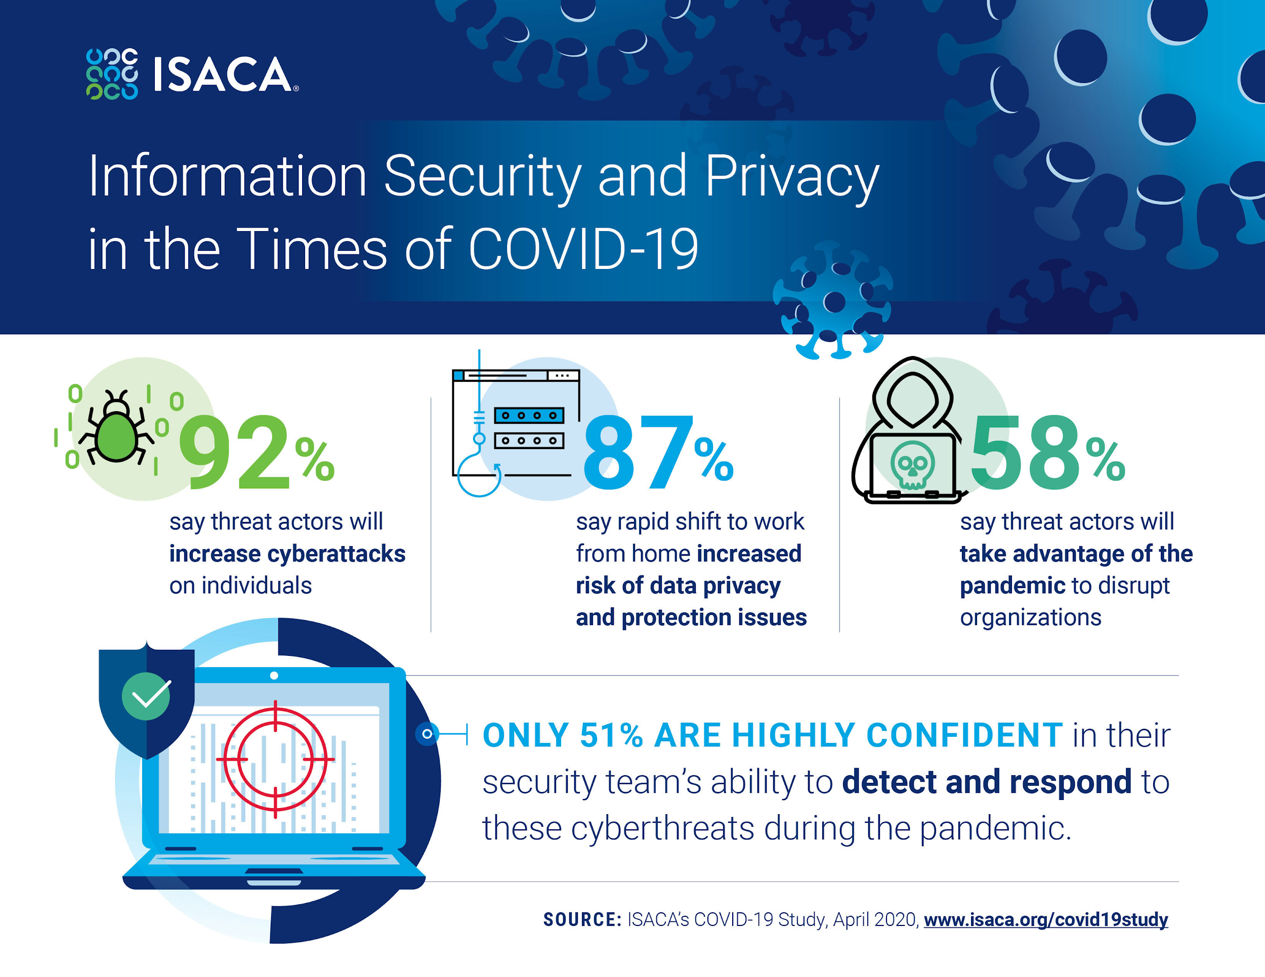
How effective has Cyber Security been in modern practice?
The Statistics and Faults
The University of Maryland will tell you that “[Malicious] Hackers attack every 39 seconds, on average 2244 times a day”, IBM claims that “The average time to identify a breach in 2019 was 206 days.” it's not hard therefore to see how, according to Cybint Solutions, “62% of businesses experienced phishing and social engineering attacks in 2018.”

From just the statistics on the frequency of malicious cyber-attacks, the practice of Cyber Security is massively ineffective in our communities. And this is largely due to the lack of Cyber Security professionals, protocols and awareness in business, employee, domestic and government protection.

ISACA, the global association providing IT professionals with knowledge and training, tells us that during the pandemic, only 51% of businesses are highly confident in their security team’s ability to detect and respond to cyberthreats.

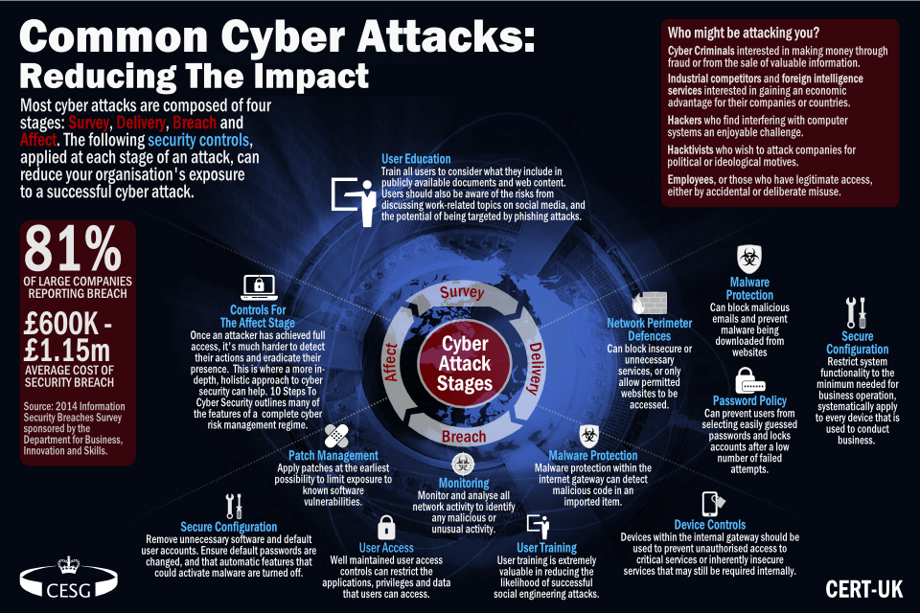
Small companies and start-ups aren’t the only ones affected, with LinkedIn (2016) and Adobe(2013) being corporate giants failing to effectively protect themselves and users in a total of one billion, four hundred forty-seven million nine hundred thousand known accounts compromised in the last 20 years from 7 technological corporations, A cybersecurity slip up can be a huge problem. Equifax, a business affected by malpractice says,

“Cyber-attacks are much more likely to occur through mundane errors like a user choosing an easy-to-guess password or not changing the default password on something like a router.”

Employee education in data protection, is crucial to the security of data in a system, the push for data protection training came about by Cyber Security professionals when 81% of large companies in the UK reported a breach in 2014, costing between £600,000 - £1.15m in damages.²⁸ This happens to be around the same time Sony Pictures was hacked putting cybersecurity to the top of the agenda.

Big companies today have IT technicians and support teams but lack the cybersecurity teams who are needed to deal with these matters. Verizon’s 2017 Data Breach Investigations Report (DBIR) showed us that even today, the same threat tactics are still effective in infiltrating data because many organisations are missing a core foundation of security tools and processes. Businesses need a team to educate and ensure the systems being used to house data and to make data are protected and being constantly secured.

Since most data breaches are occurring due to basic and common flaws employee side and employer side, it could be said that the modern-day practice of cyber security is largely ineffective, but this doesn't make it obsolete.
There are two faults with the practice of Cyber Security in its modern use that leave the field of Cyber Security exposed, ineffective and largely unsuccessful providing any form of security at all, and if these aren't being addressed, Cyber Security may quickly fail to provide any secure value for modern use.
Problem 1: People aren’t cyber aware
Books such as Cybersecurity and Cyberwar: What Everyone Needs to Know®
By P.W. Singer, Allan Friedman lay out in interesting and engaging language the simple to advanced concepts of cyber security, such as types of viruses to be aware of and how they work.
Popular channels such as BBC also try to use their platforms to educate their audience to be alert when using technology of scams, viruses and how to best protect themselves through specials or dedicated episodes.

Despite the efforts made to increase Cyber Awareness, they have had no significant effect on the population and this is because, despite being shown how to correctly behave to a cyber threat or protect yourself digitally, the average consumer and daily user of technology doesn’t perceive the risk that they could be putting themselves or the company in until its too late.

Although it is possible that attackers are becoming more skilled at hacking and masking attacks that the watchful public have no chance at detecting them, there is also the reality that security interfaces are often too difficult for the average person to use. A system that is too difficult to use will eventually lead to users making
mistakes and avoiding security altogether

Problem 2: Cyber Security isn’t being taught

A huge problem with Cyber Security is that it isn't being included in Computer Science classes despite the huge issue of an increasing number of Cyber Attacks. Without education and awareness on the necessity of the field of Cyber Security, less people will be incentivised to study it, leading to less protection of systems in the long run.

To combat this and prevent security spiralling out of reach, 2018 US President Barack Obama put $62 million towards a new CyberCorps Reserve program that would train and provide scholarships to people who took cybersecurity jobs with the federal government.

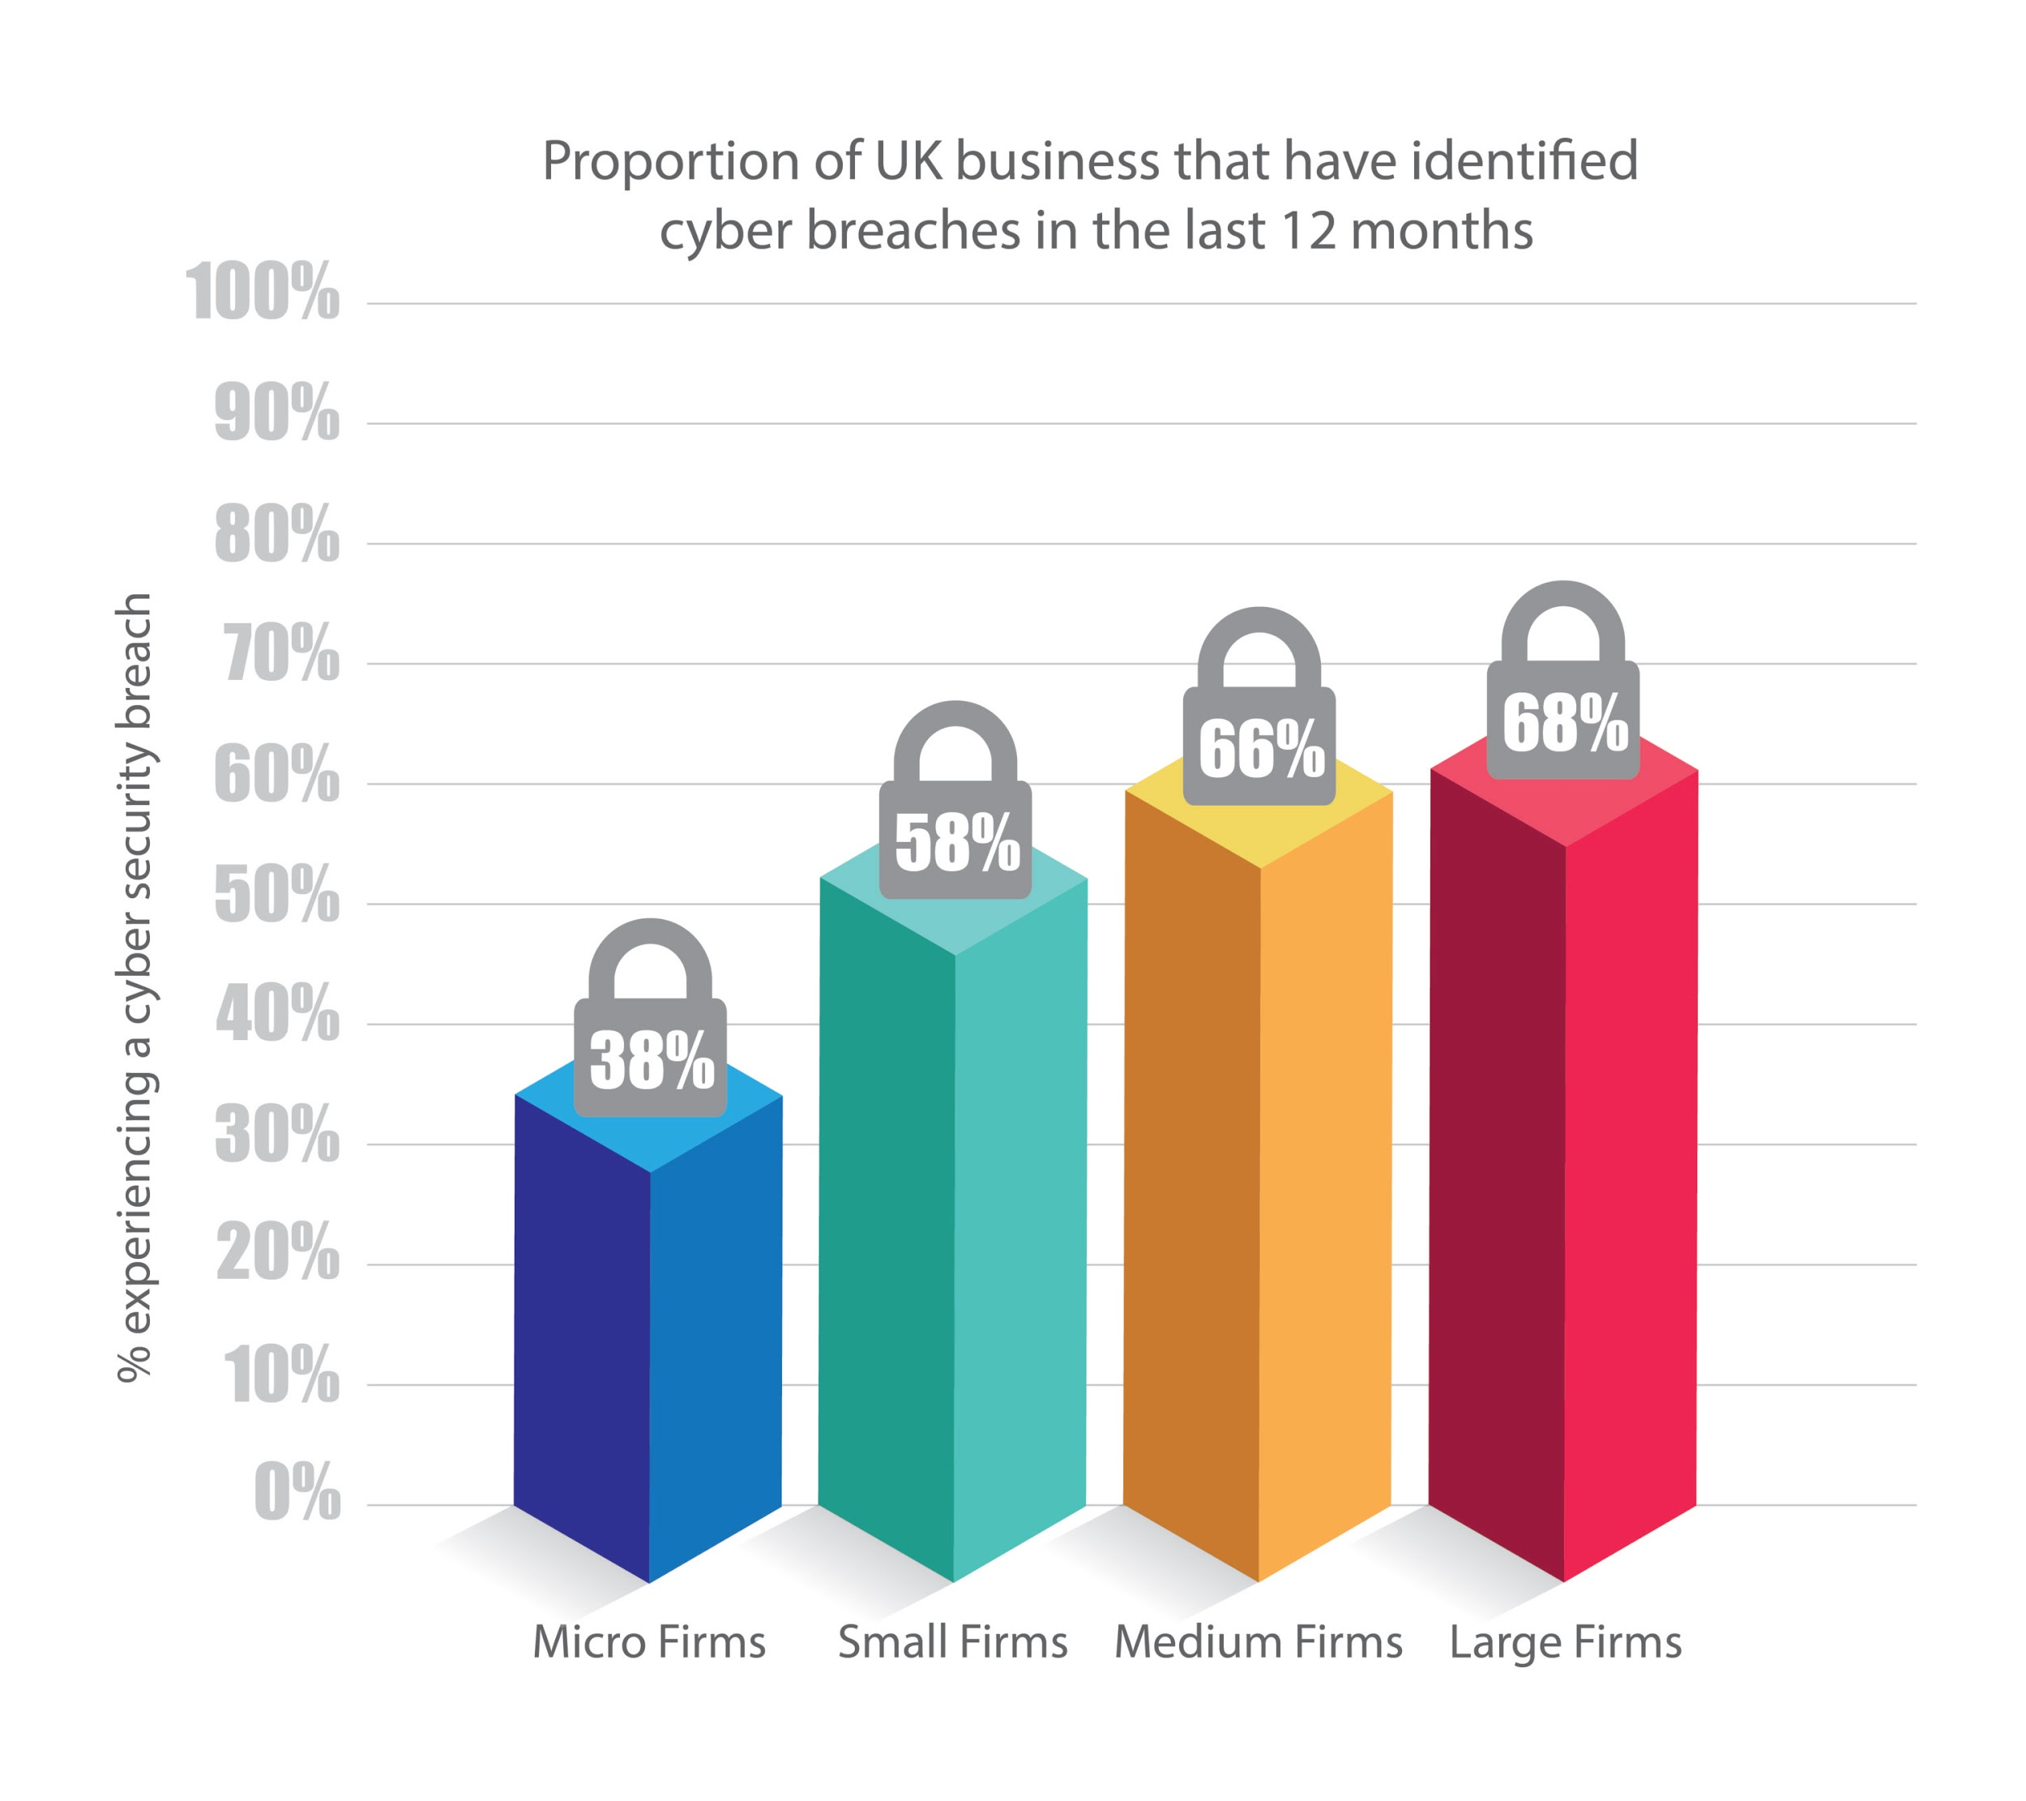
Pushes to include aspects of Cyber Security into general education aren’t uncommon. Despite most Computer Science classes avoiding the topic, Countries have their own programs for educating computer science students with the necessary knowledge and skills for a job in cybersecurity: Israel has a training program called Magshimim which offers after-school training in cybersecurity to primary and secondary school students from groups “in the periphery” that are underrepresented in the IDF’s Intelligence Corps.

China’s answer to the lack of cyber security knowledge in the public comes from the People’s Liberation Army. It runs its own Information Engineering University in Zhengzhou, and earlier this year Chinese philanthropist Henry Cheng announced a donation of about $45 million to the China Internet Development Foundation to support additional cybersecurity training

The United Kingdom uses a collection of entertaining and straightforward computer games and online puzzles called the Cyber Security Challenge to cultivate and identify talent in the field.
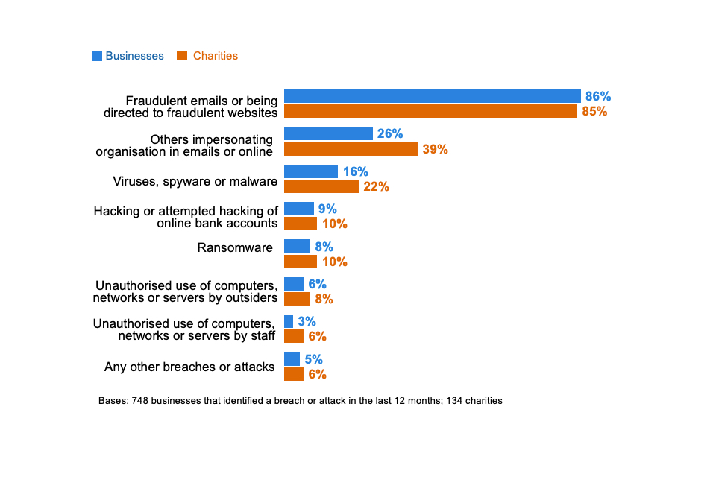
In the UK you can also take a Computer Science with Cyber Security course to have a more in depth knowledge on the matter, this growing course has meant that the number of Computer Science students graduating each year has swelled from 17,000 in 1994-95 to nearly 27,000 in 2013-14.

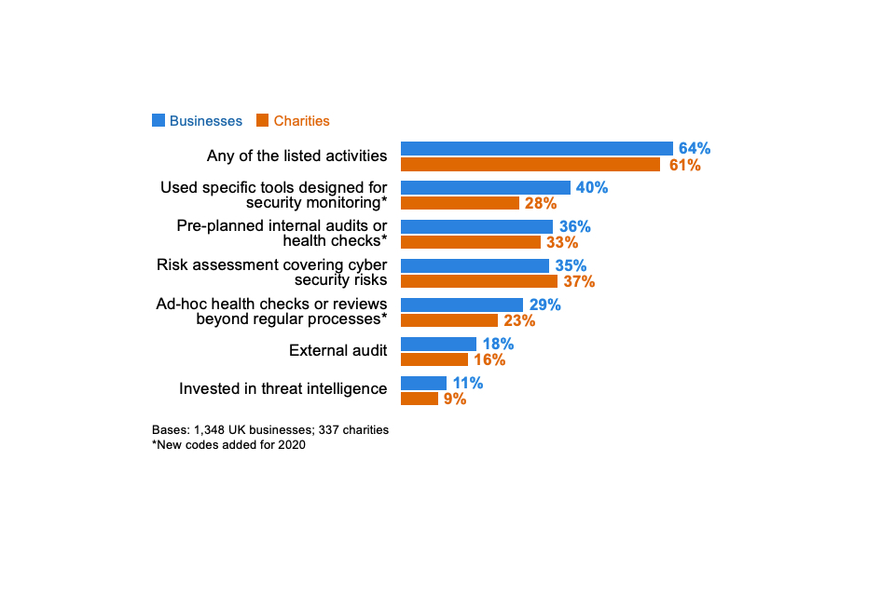
This growing popularity has caused concern among UK education professionals, who believe there may not be enough viable employment options available for computer science graduates. In fact, large and medium firms reported the highest numbers of security breaches in 2017 and yet still neglect the importance of a dedicated Cyber Security team, let alone computer science graduates.
The most disheartening statistics we can draw from this is that for the year of 2020, charities are 2% more prepared against cyber threats than businesses. Despite clear efforts being made in recent years to ensure that Cyber Security is being taught more and that awareness grows surrounding the subject, Many businesses neglect the need for Students, Experts and Cyber Security Teams, and this is due to human error in these fields being a significant liability.

Problem 3: Human Error means Robotic Staffing

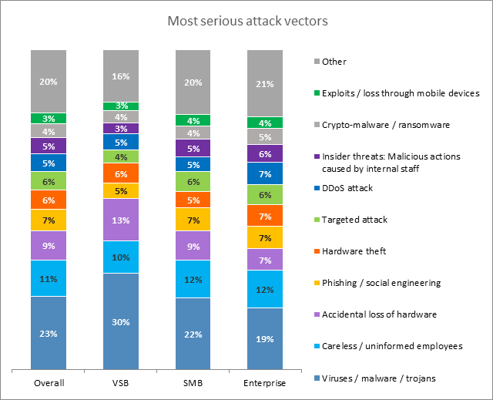
Since careless and uninformed employees take up a significant chunk of serious attack vectors in breaches and have led to a significant 11% increase in the number of viruses and malware infiltrating businesses, Job openings for employees and cyber security students have decreased as business’ feel more concerned and worried about employing a young or inexperienced Cyber Security team or staff who could slip up on a protocol due to being uninformed and cause a huge problem for their data.

When Kaspersky assessed “Where do businesses feel vulnerable?” The highest percentage was attributed to “The inappropriate sharing of data via mobile data” (47%) and the third-highest percentage was a given to “Inappropriate resource use by employees”.

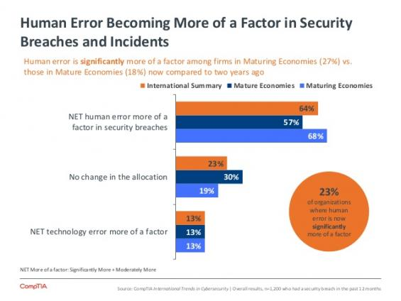
Kaspersky put this simply to say that “When security incidents happen at a business, it’s important that employees are on hand to either spot the breach or mitigate the risks …. However, employees don’t always act when their company is hit by a security incident. In fact, in 40% of businesses around the world, employees hide an incident when it happens.”

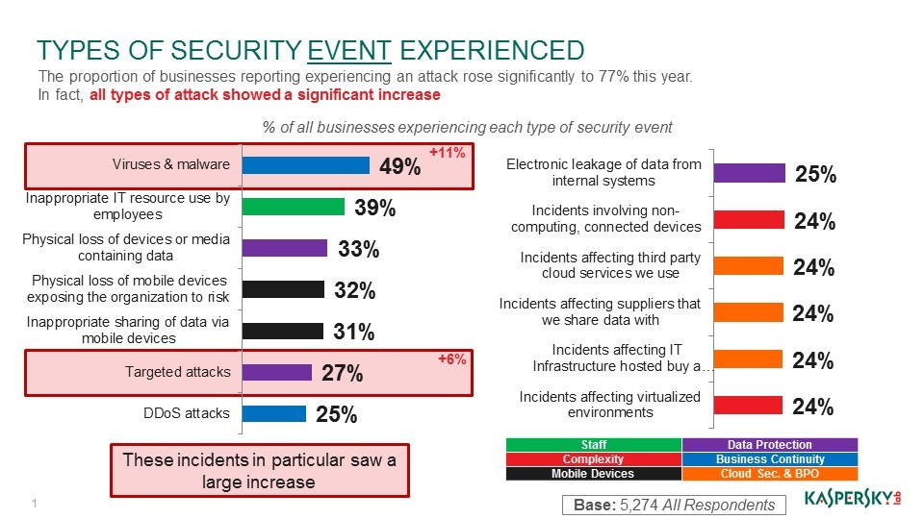

From this, we can infer that employees can’t be trusted to keep documents secure or report a breach or problem when discovered due to “the fear factor” that the employee could face disciplinary action in the event of an accidental breach, which isn’t necessary.

Computer weekly makes it clear that Data Protection Officers in the field need to be “Adopting a positive “data-aware” culture… for protecting the rights and freedoms of data subjects.” Instead of having, as Kaspersky puts it, “Employees are Making Businesses Vulnerable from Within”

Despite it being difficult to find information regarding companies that have successfully recovered after a breach because in “Giving such information out you are letting the world know that you were breached, which in turn can tarnish the image of the company.” (Robert Walters), many companies have made the effort to inform employees and the wider public how to keep up to date on security methods. Adobe is a great example of this.

Adobe is an American software company. Officially known as Adobe Systems, the company is known for its multimedia and creativity software products. Ever since their breach in October 2013, Adobe have been making it obvious they are including in their staff training cyber security as well making it obvious they are providing Cyber-Security methods for the wider communitysuch as its Women in Security (Wins) programme at its India offices in Noida and Bangalore. Wins is a knowledge sharing programme developed internally at Adobe focusing on security awareness for women employees.

However, due to the serious risk, money and time spent in educating employees and creating a ‘positive “data-aware” culture’. Following a simple four step recovery from breach program.

However, many Businesses’, Data Protection Officers and Employers have opted for an even more efficient and reliable method to ensure their business is secure. As modern-day security practices have moved from the Physical to the Digital, the need for physical IT professionals, helpdesks and Cyber Security teams have been exchanged for a more manageable and quicker process. Why rely on a professional report to discover in 206 days there has been a breach and then work on discovering which computers and systems have been and could be compromised, when you can have an automated system tell you which computers and when a breach occurred?

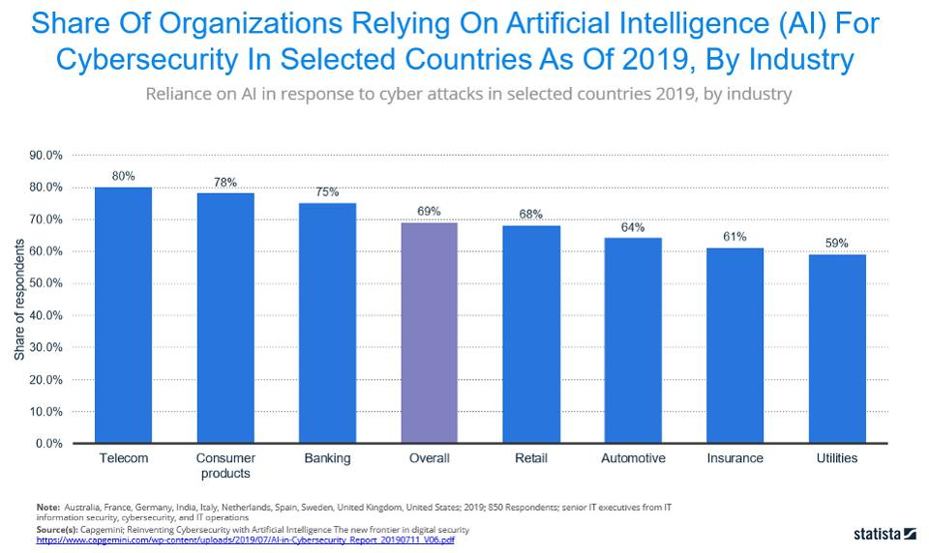
This futuristic method of targeting breaches uses a field of technology called Artificial Intelligence.

Artificial Intelligence is the ability of a computer or computer-controlled robot to perform tasks commonly associated with intelligent beings.

Using Artificially Intelligent software, Cybersecurity threats can be managed more efficiently and effectively for a company than by having a dedicated team.

On face value, this would mean that the need for studying Cyber Security and jobs in the field should very soon become obsolete. AI can use “security tools analysing data from millions of cyber incidents and using it to identify potential threats” before they happen. However, Artificially Intelligent and Machine Learning systems rely on human data to learn and train from, just as Human Error can be due to a simple slip up in typing or being uninformed, an artificially intelligent system must learn from a dataset to find patterns. Hackers can manipulate the dataset from which these machines learn from and make them produce false positives or allow vulnerabilities too pass by unannounced.

Using just one of these methods, an Artificially Intelligent system or a Physical Cyber Security team can still lead to huge problems and leaks, drastically dropping the effectiveness of Cyber Security, and leaving systems with one of these methods far from secure. However, a 2017 research paper from Amaan Anwar & Syed Imtiyaz Hassan at Hamdard University, in India poses a solution to both problems.

“To promote increment the development of cyber security, a holistic perspective of associations cyber environment is required in which AI is consolidated with human knowledge, since neither individuals nor AI alone has proven overall success in this sphere. In this manner, socially mindful utilization of AI techniques will be needed to further mitigate related risks and concerns. “

What’s being done to combat this?

Ever since 2016, Europe has been pushing Cyber Security to the forefront of regulations and criteria for employees and employers to follow, while these strict measures don’t apply to the at risk domestic user, The General Data Protection Regulation, rolled out across Europe in 2018, enforces companies and businesses to train staff to understand data protection and makes a leak of data a financial penalty to deter companies from letting it slip by. The regulations are so strong that a GDPR breach can lead to “a maximum fine of €20 million (about £18 million) or 4% of annual global turnover – whichever is greater – for infringements”.

Due to the harsh penalties of the General Data Protection Regulation (Articles 30 and 40), many companies are adopting both AI technologies to instantly report devices that are vulnerable or in need of remote servicing, as well as training courses in GDPR and Cyber Security for all staff and a dedicated (on-site or online) Cyber Security team to deal with issues as and when they appear. This has meant, more staffing and increased jobs in the Cyber Security field and ultimately led to a push in Cyber Security Education in all settings, from workplaces, to early years and schools, to colleges and even YouTube advertisements during your favourite video, prompting you to ensure you’re Cyber Safe

Conclusion: The Effectiveness of Security Practices in Cyber Security

This paper presents a review of the current effectiveness of security methods in the practice of modern Cyber Security and assesses how it has changed in comparison to the effectiveness of previous methods in the past and considers them to gain insight into the reasons whether Cyber Security has been effective or not in practice.

If more countries took Cyber Security as important and valuable as Europe is currently doing with the General Data Protection Regulation in place, then we would drastically see a decrease in incoming threats and outgoing data leaks from business’, but cyber security in practice is still failing to reach the domestic user of technology and engage members of the public to take heed of the cautions and follow the guidance given.

Cyber Security in the last decade has become more and more important, adapting to the new definition of Security and constantly trying to make an active push for our protection, for exposing and resolving vulnerabilities and a sense of our safety being in the trust of those working to protect us. And because of this adopted ethos, Cyber Security may never reach Perfect Security, but if we follow the guidelines and keep pushing for embedding it in our curriculum, it will continue to be as secure as it can be for our modern day use.

Bibliography

"A Dissertation on the Construction of Locks: Containing ...." http://books.google.fr/books/about/A_dissertation_on_the_construction_of_lo.html?id=EGcFAAAAQAAJ.

2 "What is physical security? - Definition from WhatIs.com." 21 Sept. 2016, https://searchsecurity.techtarget.com/definition/physical-security.

3 "The 4,000 Year Old History of Locks." 05 Feb. 2020, https://www.thoughtco.com/history-of-locks-4076693.

4 "Black Hat, White Hat & Grey Hat Hackers - Differences ...." 24 Jul. 2017, https://us.norton.com/internetsecurity-emerging-threats-what-is-the-difference-between-black-white-and-grey-hat-hackers.html.

5 "Phreaking | communications | Britannica." https://www.britannica.com/topic/phreaking.

6 "DEF CON® Hacking Conference." https://defcon.org/main.html.

7 In the form of online banking, PayPal. Etc...

8 "Change.org · The world’s platform for change." https://www.change.org/.

9 Sites such as https://www.albright-ip.co.uk/ offer to sell your ideas with or without a patent

⁰ https://www.kaspersky.co.uk/ Internet Security for example

¹ Sites such as https://www.wirelesshomes.co.uk/ allow you to buy products to make your house an Internet of Things (IOT) which means that all your devices are connected on the network for you to remotely control.

² https://digi.me/ looks at all your data, your social media accounts and services and puts them all together for protection and easy access.

³ https://forms.gle/9uhwXJC64WoCzyPw7 My Google Form “Cyber Quiz”

⁴ "Cybersecurity vs Information Security: What's the difference?." 04 May. 2020, https://securityscorecard.com/blog/information-security-versus-cybersecurity.

⁵ "Cybersecurity Vs. Information Security: Is There A Difference?." https://www.bitsight.com/blog/cybersecurity-vs-information-security.

⁶ "From information security to cyber security - ScienceDirect." 01 Oct. 2013, https://www.sciencedirect.com/science/article/pii/S0167404813000801.

⁷ https://link.springer.com/content/pdf/bfm%3A978-1-4020-7927-6%2F1.pdf - The Information Security Dictionary: Defining the Terms that Define Security ...By Urs E. Gattiker

⁸ https://www.lexico.com/definition/cyberspace

¹⁹"‘I’m the creeper; catch me if you can!’ | TheHill." https://thehill.com/blogs/pundits-blog/technology/161833-im-the-creeper-catch-me-if-you-can.

2⁰ "Trusted Computer System Evaluation Criteria ['Orange Book']." 08 Oct. 1998, https://csrc.nist.gov/csrc/media/publications/conference-paper/1998/10/08/proceedings-of-the-21st-nissc-1998/documents/early-cs-papers/dod85.pdf.

2¹ "Study: Hackers Attack Every 39 Seconds | A. James Clark ...." 09 Feb. 2007, https://eng.umd.edu/news/story/study-hackers-attack-every-39-seconds.

2² "Incident Response Services and Threat Intelligence | IBM." https://www.ibm.com/security/services/ibm-x-force-incident-response-and-intelligence.

23 "15 Alarming Cyber Security Facts and Stats | Cybint." 20 Jun. 2020, https://www.cybintsolutions.com/cyber-security-facts-stats/.

2⁴ "How Cyber Attacks Happen | Equifax UK." https://www.equifax.co.uk/resources/identity-protection/how-cyber-attacks-happen.html.

²⁵https://books.google.co.uk/books?id=B88ZAgAAQBAJ&lpg=PA1&pg=PA1#v=onepage&q&f=false

²⁶"Internet safety: Caught in the Web - a Newsround Special ...." 06 Feb. 2012, https://www.bbc.co.uk/newsround/13908828.

²⁷"Garfield's Cyber Safety Adventures: Cyberbullying - YouTube." https://www.youtube.com/watch?v=00AUE1ZBNKI.

²⁸"[1901.02672] Cyber Security Awareness Campaigns: Why do ...." 09 Jan. 2019, https://arxiv.org/abs/1901.02672.

²⁹"Using behavioural insights to improve the public’s use of ...." https://assets.publishing.service.gov.uk/government/uploads/system/uploads/attachment_data/file/309652/14-835-cyber-security-behavioural-insights.pdf.

³⁰"Why computer science programs don’t require cybersecurity ...." 14 Apr. 2016, https://slate.com/technology/2016/04/why-computer-science-programs-dont-require-cybersecurity-classes.html.

³¹"CyberCorps®: Scholarship for Service." https://www.sfs.opm.gov/.

³²"Magshimim cyber education program | Rashi Foundation." https://www.rashi.org.il/magshimim-cyber-program.

³³"Billionaire donates 300 mln yuan to cyber security training." 02 Feb. 2016, http://usa.chinadaily.com.cn/china/2016-02/02/content_23362030.htm.

³⁴"Home Page - Cyber Security Challenge UK - Cyber Security ...." https://www.cybersecuritychallenge.org.uk/.

³⁵"The Human Factor in IT Security: How Employees are Making ...." https://www.kaspersky.com/blog/the-human-factor-in-it-security/.

³⁶"Why ‘no breach’ is bad news for your compliance." https://www.computerweekly.com/opinion/Why-no-breach-is-bad-news-for-your-compliance.

³⁷"Recovering from a cyber security breach." https://www.robertwalters.co.uk/career-advice/cyber-security/steps-to-recover-from-a-data-security-breach.html.

³⁸https://www.adobe.com/industries/government/data-security.html

³⁹https://www.adobe.com/uk/security.html

⁴⁰"artificial intelligence | Definition, Examples, and ...." https://www.britannica.com/technology/artificial-intelligence..

⁴¹"The Impact Of Artificial Intelligence On Cyber Security." https://www.cybersecurityintelligence.com/blog/the-impact-of-artificial-intelligence-on-cyber-security-4946.html.

⁴²"Applying Artificial Intelligence Techniques to Prevent ...." http://www.ripublication.com/ijcir17/ijcirv13n5_19.pdf.

⁴³https://assets.publishing.service.gov.uk/government/uploads/system/uploads/attachment_data/file/811796/Teaching_online_safety_in_school.pdf

⁴⁴https://www.cybersecuritychallenge.org.uk/resources/teachers

⁴⁵"About Get Cyber Safe." https://www.getcybersafe.gc.ca/cnt/bt/index-eng.aspx.

"A Dissertation on the Construction of Locks: Containing ...." http://books.google.fr/books/about/A_dissertation_on_the_construction_of_lo.html?id=EGcFAAAAQAAJ.
"What is physical security? - Definition from WhatIs.com." 21 Sept. 2016, https://searchsecurity.techtarget.com/definition/physical-security.
"The 4,000 Year Old History of Locks." 05 Feb. 2020, https://www.thoughtco.com/history-of-locks-4076693.
"Black Hat, White Hat & Grey Hat Hackers - Differences ...." 24 Jul. 2017, https://us.norton.com/internetsecurity-emerging-threats-what-is-the-difference-between-black-white-and-grey-hat-hackers.html.
"Phreaking | communications | Britannica." https://www.britannica.com/topic/phreaking.
"DEF CON® Hacking Conference." https://defcon.org/main.html.
In the form of online banking, PayPal. Etc...
"Change.org · The world’s platform for change." https://www.change.org/. Sites such as https://www.albright-ip.co.uk/ offer to sell your ideas with or without a patent
https://www.kaspersky.co.uk/ Internet Security for example
Sites such as https://www.wirelesshomes.co.uk/ allow you to buy products to make your house an Internet of Things (IOT) which means that all your devices are connected on the network for you to remotely control.
https://digi.me/ looks at all your data, your social media accounts and services and puts them all together for protection and easy access.
https://forms.gle/9uhwXJC64WoCzyPw7 My Google Form “Cyber Quiz”
"Cybersecurity vs Information Security: What's the difference?." 04 May. 2020, https://securityscorecard.com/blog/information-security-versus-cybersecurity.
"Cybersecurity Vs. Information Security: Is There A Difference?." https://www.bitsight.com/blog/cybersecurity-vs-information-security.
"From information security to cyber security - ScienceDirect." 01 Oct. 2013, https://www.sciencedirect.com/science/article/pii/S0167404813000801. https://link.springer.com/content/pdf/bfm%3A978-1-4020-7927-6%2F1.pdf - The Information Security Dictionary: Defining the Terms that Define Security ...By Urs E. Gattiker
https://www.lexico.com/definition/cyberspace
"‘I’m the creeper; catch me if you can!’ | TheHill." https://thehill.com/blogs/pundits-blog/technology/161833-im-the-creeper-catch-me-if-you-can. "Trusted Computer System Evaluation Criteria ['Orange Book']." 08 Oct. 1998, https://csrc.nist.gov/csrc/media/publications/conference-paper/1998/10/08/proceedings-of-the-21st-nissc-1998/documents/early-cs-papers/dod85.pdf.
"Study: Hackers Attack Every 39 Seconds | A. James Clark ...." 09 Feb. 2007, https://eng.umd.edu/news/story/study-hackers-attack-every-39-seconds.
"Incident Response Services and Threat Intelligence | IBM." https://www.ibm.com/security/services/ibm-x-force-incident-response-and-intelligence.
"15 Alarming Cyber Security Facts and Stats | Cybint." 20 Jun. 2020, https://www.cybintsolutions.com/cyber-security-facts-stats/. "How Cyber Attacks Happen | Equifax UK." https://www.equifax.co.uk/resources/identity-protection/how-cyber-attacks-happen.html.
https://books.google.co.uk/books?id=B88ZAgAAQBAJ&lpg=PA1&pg=PA1#v=onepage&q&f=false
"Internet safety: Caught in the Web - a Newsround Special ...." 06 Feb. 2012, https://www.bbc.co.uk/newsround/13908828.
"Garfield's Cyber Safety Adventures: Cyberbullying - YouTube." https://www.youtube.com/watch?v=00AUE1ZBNKI.
"[1901.02672] Cyber Security Awareness Campaigns: Why do ...." 09 Jan. 2019, https://arxiv.org/abs/1901.02672.
"Using behavioural insights to improve the public’s use of ...." https://assets.publishing.service.gov.uk/government/uploads/system/uploads/attachment_data/file/309652/14-835-cyber-security-behavioural-insights.pdf.
"Why computer science programs don’t require cybersecurity ...." 14 Apr. 2016, https://slate.com/technology/2016/04/why-computer-science-programs-dont-require-cybersecurity-classes.html. "CyberCorps®: Scholarship for Service." https://www.sfs.opm.gov/.
"Magshimim cyber education program | Rashi Foundation." https://www.rashi.org.il/magshimim-cyber-program.
"Billionaire donates 300 mln yuan to cyber security training." 02 Feb. 2016, http://usa.chinadaily.com.cn/china/2016-02/02/content_23362030.htm. "Home Page - Cyber Security Challenge UK - Cyber Security ...." https://www.cybersecuritychallenge.org.uk/.
"The Human Factor in IT Security: How Employees are Making ...." https://www.kaspersky.com/blog/the-human-factor-in-it-security/.
"Why ‘no breach’ is bad news for your compliance." https://www.computerweekly.com/opinion/Why-no-breach-is-bad-news-for-your-compliance. "Recovering from a cyber security breach." https://www.robertwalters.co.uk/career-advice/cyber-security/steps-to-recover-from-a-data-security-breach.html.
https://www.adobe.com/industries/government/data-security.html
https://www.adobe.com/uk/security.html
"artificial intelligence | Definition, Examples, and ...." https://www.britannica.com/technology/artificial-intelligence..
"The Impact Of Artificial Intelligence On Cyber Security." https://www.cybersecurityintelligence.com/blog/the-impact-of-artificial-intelligence-on-cyber-security-4946.html.
"Applying Artificial Intelligence Techniques to Prevent ...." http://www.ripublication.com/ijcir17/ijcirv13n5_19.pdf.
https://assets.publishing.service.gov.uk/government/uploads/system/uploads/attachment_data/file/811796/Teaching_online_safety_in_school.pdf
https://www.cybersecuritychallenge.org.uk/resources/teachers
"About Get Cyber Safe." https://www.getcybersafe.gc.ca/cnt/bt/index-eng.aspx.

