**1. Initial Setup and Project Planning**

* **Task 1.1:** Set up project repository and version control (GitHub/GitLab) Completed
* **Task 1.2:** Define project structure (folders for classes, tests, UI, etc.) Completed
* **Task 1.3:** Set up development environment (IDE, build tools, etc.) Completed

**2. Design & Architecture**

* **Task 2.1:** Design Converter class structure (methods for each unit type: length, volume, weight, time) Completed
* **Task 2.2:** Define unit types and conversion methods (e.g., convertLength method, etc.) Completed
* **Task 2.3:** Design UI wireframe for user interface (Sketch/Draw interface layout)

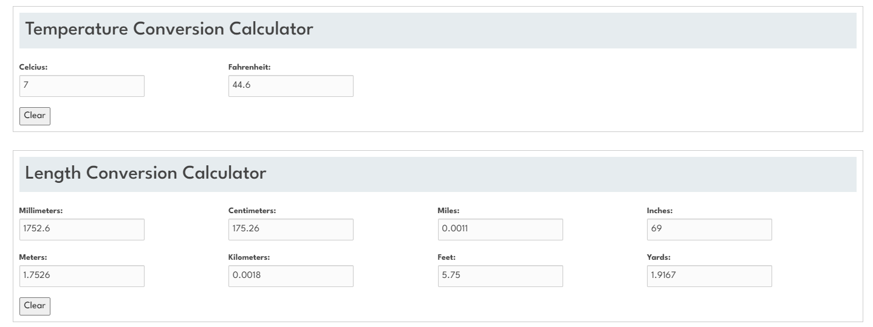 Completed

* **Task 2.4:** Design control flow diagrams for the converter logic Completed

**3. Converter Class Implementation**

* **Task 3.1:** Implement method to convert length (e.g., meters to kilometers, inches to feet, etc.) Completed
* **Task 3.2:** Implement method to convert volume (e.g., liters to gallons, cubic meters to liters, etc.) Completed
* **Task 3.3:** Implement method to convert weight (e.g., kilograms to pounds, ounces to grams, etc.) Completed
* **Task 3.4:** Implement method to convert time (e.g., seconds to minutes, hours to days, etc.) Completed

**4. Unit Testing**

* **Task 4.1:** Write unit tests for length conversion methods Completed
* **Task 4.2:** Write unit tests for volume conversion methods Completed
* **Task 4.3:** Write unit tests for weight conversion methods Completed
* **Task 4.4:** Write unit tests for time conversion methods Completed
* **Task 4.5:** Write tests for error handling (e.g., invalid input) Completed

**5. Control Flow Testing**

* **Task 5.1:** Identify all decision points in the conversion methods Completed
* **Task 5.2:** Write test cases to ensure all decision points are covered (e.g., correct conversion for boundary values, invalid inputs, etc.) Completed
* **Task 5.3:** Perform testing to ensure that all branches and loops are executed correctly (e.g., valid vs invalid inputs) Completed

**6. Integration Testing**

* **Task 6.1:** Test the UI with the backend converter logic to ensure smooth integration Completed

**7. Additional Testing**

* **Task 7.1:** Perform boundary value analysis and statement coverage testing. Completed

**8. UI Development**

* **Task 8.1:** Implement the user interface based on the wireframe (using a framework like Java Swing) Completed
* **Task 8.2:** Add input fields for users to enter the value to convert Completed
* **Task 8.3:** Add dropdown for unit selection and conversion Completed
* **Task 8.4:** Display results to the user in a clean format Completed
* **Task 8.5:** Add interface to change from converting length, volume, weight, time and implement correct methods. Completed
* **Task 8.6:** Add user-friendly error messages for invalid inputs (e.g., invalid units, non-numeric values) TODO
* **Task 8.7:** Style the UI for a pleasant user experience (consider mobile/desktop compatibility) Completed

**9. Testing UI**

* **Task 9.1:** Test the user input fields (ensure proper data entry and validation) Completed
* **Task 9.2:** Perform usability testing to ensure the UI is intuitive and responsive Completed
* **Task 9.3:** Perform UI integration testing with the converter class to ensure correct results are displayed for valid inputs Completed
* **Task 9.4:** Test error handling on the UI (e.g., invalid input or unsupported unit types) TODO