**Document Management System – Nathan Crowley**

1. Logical DOC
   1. What is Logical DOC?
      * Community Edition is an **open source** DMS available under the GNU Lesser General Public License (LGPL).
      * *Source code* for LogicalDOC Community Edition is available for entire community **free** to use and **modifiable**.
      * ** LogicalDOC keeps detailed record of all changes made to documents and stores them in database. This means you can review historical data on any document and see WHAT changes were made and by WHO **
      * ** Documents can also be **EMAILED** to and from server. You can use **Outlook** to send AND receive files straight from your desktop **
      * Written in **Java**.
      * Variety of UI’s making it accessible t workers **in office AND at home**.
      * LogicalDOC will interface **Microsoft Office** and document **scanners** making EASY upload of documents to CLOUD server.
      * Easy to distribute your work across networks. Integrates with many other document cloud-storage (Google Drive, Dropbox, etc) allowing uploads from these platforms.
   2. Overview:
      * Community edition offers:
        1. Basic access control
        2. Advanced search
        3. Web based UI
        4. SOAP and REST API
        5. Integration extensions for Joomla and WordPress
      * Support for **HTTPS.**
      * Includes **workflow engine** for workflow management.
      * Document password and data theft protection.
      * Users and group logs.
      * Database Engines
        1. MySQL / MariaDB
        2. Oracle
        3. SQL Server
        4. PostgreSQL
        5. Embedded (for trial only)
   3. API:
      * LogicalDOC provides SOAP and REST API.
      * Easiest way to interface with API is using **bindings and samples**.
        1. These are **completely open source**.
        2. Cover core functionality in a language specific way for quick as possible integration.
      * Definition of each Web Service is accessible directly from your instance at **http://<your_server>:8080/services** from here you have access to the WSDL document, to allow your dev environment to auto create appropriate proxy objects to speed up development.
   4. Open Source:
      * Open source – free Community Edition wit access to source code.
   5. Reviews:
      * Overall: 4.7/5
      * Ease of use: 4.6/5
      * Customer Service: 4.7/5
      * **Pros:**
        1. On premise and / or in the cloud.
        2. Ease of implementation
        3. Generic and customized reports to understand business dynamics and support decisions as well as simplify automation choices.
      * **Cons:**
        1. iOS app to improve
        2. Drag and drop always active on the browser.
   6. References:
      * <https://www.logicaldoc.com/support/api>
      * <https://sourceforge.net/projects/logicaldoc/>
      * <https://techooid.com/open-source-document-management>
      * https://www.capterra.com.de/software/100251/logicaldoc

EXTRA:

* + - LogicalDOC cloud:
      1. Does not require software downloads nor client installations. The browser is all you need.
      2. Can securely access the documents wherever they are, without the need for a VPN or complex infrastructures.
      3. **SaaS subscription** – pay only for the resources needed.
    - Free Apps for IOS / Android.

1. OpenKM Community Version:
   1. What is OpenKM Community Version?
      * **Java-based** platform that allows users to **store**, **manage, track** documents.
      * Software to manage electronic documents, images, user admin tools to control data and access to data **security** and **logs**.
      * Established in 2003 suitable for **any size organisation**.
      * **Source code** is hosted on GitHub.
      * Community Version supported by developers via the ‘forum of the user community’.
      * NOT supported by OpenKM Team devs
   2. Overview:
      * Advanced search is key highlight.
      * Upload bulk documents.
      * Easy and fast download of folders as ZIP.
      * Messaging & Chat facilities.
      * Recycle bin for each user.
      * **\*\* Cloud version is pay as you use \*\***
   3. API:
      * ** Complete API via **REST API \*\***
      * Meaning you can call ANY method from ANY language. (python/PHP/Java).
      * **JavaDOC** for all methods.
      * Possible to integrate with third-party applications like CRM and CMS.
   4. Open Source:
      * Open source – free Community Edition WITHOUT cloud as that Is pay to use.
      * Community Edition is restricted with some features such as:
        1. Only support through public forms
        2. No access to advanced configuration
        3. **Basic** add-ins for Microsoft Word/Excel/Outlook
      * Database support for MySQL / PostgreSQL / H2 / HSQL.
   5. Reviews:
      * Overall: 4.7/5
      * Ease of use: 4.2/5
      * Customer Service: 4.2/5
      * **Pros:**
        1. “The most valuable advantage of OpenKM is its API”
        2. “easy to connect OpenKM to other systems”
        3. “Open source. Feature rich”
      * **Cons:**
        1. “UI is a little dated”
        2. “few features that I had trouble getting more info on.”
   6. References:
      * <https://www.capterra.com.de/software/125417/openkm>
      * <https://www.openkm.com/en/comparison-of-versions.html>
      * <https://www.goodfirms.co/software/openkm>
2. Alfresco Community Edition:
   1. What is Alfresco?
      * **Open sourced** version of Alfresco Content Services for those with capability to self-support.
      * Written in **Java** and used PostgreSQL for database.
      * **Open API** so can be easily integrated and adapted to specific business requirements.
   2. Overview
      * Compatible with Windows / Linux / etc
      * Offline and Mobile app features make easy remote access.
      * Tools for task lists, **version** **control**, tracking, etc.
      * Easily modified - Flexible and highly scalable.
      * **Cloud** deployable.
   3. API:
      * **REST API** gives access to all features of Alfresco.
   4. Open Source:
      * Open source community edition includes:
        1. Bug fixes for current version
        2. Regular stable version updates issued by Alfresco dev team
        3. Source code publicly available under LGPLv-3 License.
   5. Reviews:
      * Overall: 3.9/5
      * Ease of Use: 3.5/5
      * Customer Service: 3.5/5
      * **Pros:**
        1. *"It's a great system for organizing files in a secure way - access control is excellent”*
        2. *Good flexibility in adding coworkers alongside external guests to document repositories.”*
      * **Cons:**
        1. *"It is browser compatibility issues. There are some problem when uploading large files."*
        2. *"Free version only permit associate an user for administrator, if this person abandon your user, you lost yours documents. Will present compatibility problems on depend of Java version an browsers."*
   6. References:
      * <https://www.capterra.com/p/52548/Alfresco-One/>
      * <https://www.alfresco.com/de/bpm-software>
      * https://contentsnare.com/open-source-document-management-systems/
3. OpenDocMan:
   1. What is OpenDocMan?
      * Web based , free document management system written in PHP designed to comply with ISO 17025.
   2. Overview:
   3. API:
   4. Open Source:
   5. Reviews:
   6. References:
4. Templafy:
   1. What is Templafy?
      * Platform for enterprises which improves productivity, compliance in document creation and distribution.
      * Smart way to manage, update, and share business documents throughout your organisation.
   2. Overview:
      * ‘All in one’ DMS – over 600+ customers worldwide (IKEA, Pandora, KPMG,..)
      * Easy to use UI.
      * Cloud based.
      * Mobile app - Compatible with range of devices
      * Automated compliance checks – gives feedback to employees easily.
      * Create a range of files within the system and manage them from single feed.
      * ** Used the **CLOUD** to access documents across devices **.
      * Contact for **PRICING** – depends on number of users/features/add-ons.
   3. API:
      * Open API – good documentation.
      * Access to assets stored in DAM via the Templafy task pane.
      * Centralize the management of assets and sync other storage systems (Dropbox, SharePoint, etc).
      * Embed Templafy as an iFrame or pop-up window in other external systems such as CMS / CRM.

*(CMS = used to manage your website.*

*CRM = focuses on managing customer/client relationships.)*

* 1. Open Source:
     + **N/a**
  2. Reviews: (Capterra.com)
     + Overall: 4.8/5
     + Ease of use: 4.9/5
     + Customer Service: 4.5/5
     + **Pros**:
       1. "User-friendliness and it saves time for the users. Compliance in terms of branding, content and legal."
       2. "Invest 2-4 hours getting comfortable with the functionality and administration. I am sure you will love it and see the significant benefits for your organization and all the users."
       3. *“Great service and a very friendly team behind it.”*
     + **Cons**:
       1. *"I was not able to find any disadvantages right now but Pricing is bit high for small organizations."*
       2. *"Double authentication can be a bit annoying. When in a rush, it can be a bit annoying to wait for extra loading time."*
  3. Reference:
     + <https://www.templafy.com/>
     + <https://www.capterra.com/p/154533/Templafy/#about>
     + <https://www.techradar.com/best/best-document-management-software>
  4. Screenshots:

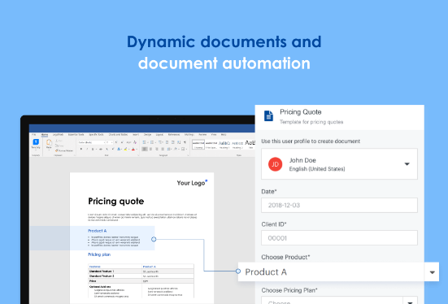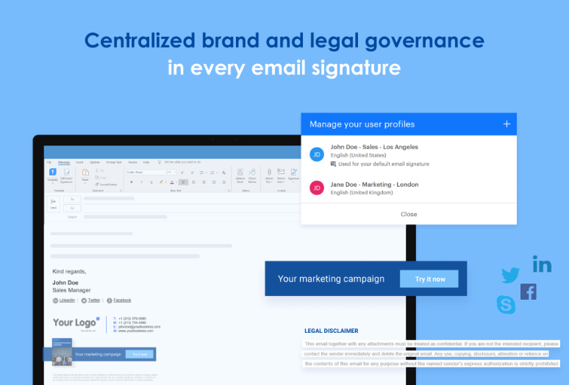

1. M-Files:
   1. What is M-Files?
      * Single vault for plethora of files, you can easily find them by client/project/date/status/etc.
      * The software aims to avoid duplication. M-Files would alert you if document saved twice by analysing names and project data.
      * Free trial available but must get in touch for a quote.
   2. Overview:
      * Mobile apps.
      * Document alerts
      * 5000+ customers
      * M-Files highest leadership position in 2020 *‘Nucleus Research Content Management Technology Value Matrix Report’*
      * Names ‘Best Overall Document Management Software of 2020’ by Business.com.
      * ** **elastic CLOUD service** **
      * Version Control
      * E-signature capabilities
      * Permission management
   3. API:
      * M-Files Web Service is **REST-like** web service available within M-Files Web Access.
      * Connection via **HTTPS.**
      * Supports most ‘user’ operations but NOT ‘admin’ functions.
   4. Open Source:
      * **N/a**
   5. Reviews:
      * Overall: 4.2/5
      * Ease of Use: 4/5
      * Customer Service: 4.1/5
      * **Pros:**
        1. *"This application helps in all these functions and much more by its high-quality features that are superb easy to handle as well."*
        2. *"It is an easy-to-use and powerful document management system that facilitates the management, finding and tracking of documents for companies of all sizes.*
      * **Cons:**
        1. *"Typical for some IT-solutions: "almost anything can be done with M-Files. Takes away focus of what problem exactly is solved with M-files."*
        2. *"It's not a user-friendly program, there is no drag and drop option (currently) and it almost impossible to work with this software in a way that we work with windows."*
   6. References:
      * <https://www.capterra.com/p/122215/M-Files/>
      * <https://developer.m-files.com/APIs/>
      * <https://www.m-files.com/>
      * <https://www.techradar.com/best/best-document-management-software>
   7. Screenshots:

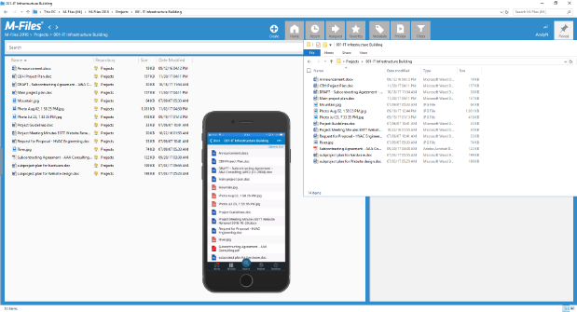

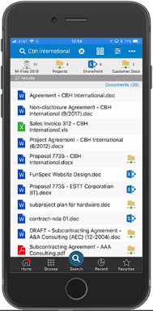 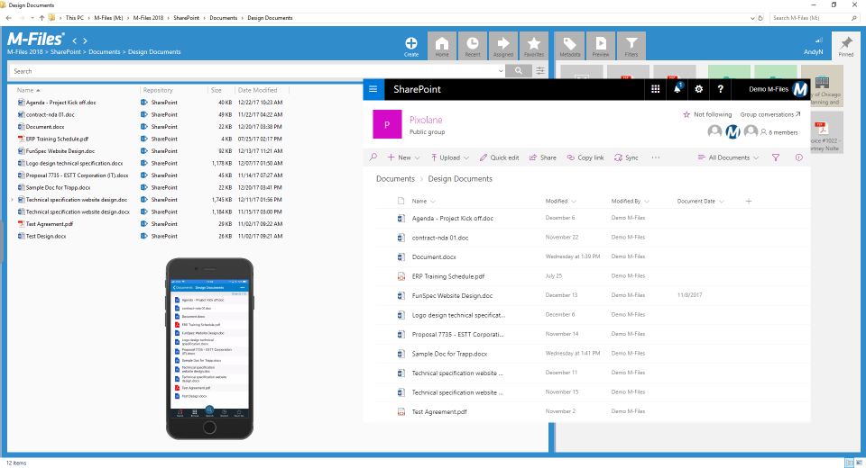

**Ranking**

1. Logical DOC
2. Alfresco Community Edition **- java based**
3. OpenKM  **- java based.**
4. SeedDMS
5. Templafy

Names - rating - API - open source - cloud

|  |  |  |  |  |  |  |
| --- | --- | --- | --- | --- | --- | --- |
| **Name** | **Rating (x/5)** | **API** | **Open Source** | **Cloud** | **Technology** | **Ranking** |
| **LogicalDOC** | 4.7 | SOAP / REST API | YES | YES | Java  HTTPS  Outlook | **1** |
| **Alfresco** | 3.9 | REST API | YES | YES | Java  PostgreSQL | **2** |
| **OpenKM** | 4.7 | *Complete* REST API | YES | NO (pay as go) | Java  JavaDOC | **3** |
| **SeedDMS** | N/A | REST API | YES | NO (web-based) | PHP  MySQL | **4** |
| **Templafy** | 4.8 | *Templafy* Open API | NO | YES | N/A | **5** |