Document Management System

Nathan Crowley

|  |  |  |  |  |  |  |
| --- | --- | --- | --- | --- | --- | --- |
| ***Name*** | ***Rating (x/5)*** | ***API*** | ***Open Source*** | ***Cloud*** | ***Technology*** | ***Ranking*** |
| **LogicalDOC** | 4.7 | SOAP / REST API | YES | YES | Java  HTTPS  Outlook | 1 |
| **Alfresco** | 3.9 | REST API | YES | YES | Java  PostgreSQL | 2 |
| **OpenKM** | 4.7 | *Complete* REST API | YES | NO (pay as go) | Java  JavaDOC | 3 |
| **SeedDMS** | N/A | REST API | YES | NO (web-based) | PHP  MySQL | 4 |
| **Templafy** | 4.8 | *Templafy* Open API | NO | YES | N/A | 5 |

Top Two choices:

1. LogicalDOC Community Edition

* https://www.logicaldoc.de/de/download-logicaldoc-community

1. Alfresco Community Edition

* <https://www.alfresco.com/ecm-software/alfresco-community-editions?gclid=EAIaIQobChMI1-Gnn4id8QIVo-jtCh3eOQ9GEAAYASAAEgJoTfD_BwE>

**LogicalDOC**

LogicalDOC Community Edition is an ***open source*** document management system, written in ***Java***, available under the ‘GNU Lesser General Public License’.

*Source code* is available for entire community free to use and modifiable.

LogicalDOC has **great** ***version control***. A detailed record of all changes made to documents is stored in a database (MySQL, Oracle, SQL Server, PostgreSQL). This allows users to review historical data for any document, as well as seeing WHAT changes were made and by WHO.

LogicalDOC will interface Microsoft Office allowing documents to be emailed, using ***Outlook***, to and from the ***Cloud server***.

There is a variety of UI’s allowing for good accessibility for workers both **in office** AND **at home**.

**Overview**

The ‘Community Edition’ offers basic access control, advanced text search, a Web-based UI and ***SOAP and REST API.*** With support for **HTTPS** for API calls.

Also included is a ***workflow engine*** for workflow management.

**API**

The easiest way to interface with API is using ***bindings and samples***.

These are downloadable ZIP files that anyone can download and open inside an IDE to show sample API calls.

Definition of each Web Service is accessible directly from your instance at **‘*http://<your server>:8080/services’***from here you have access to the *WSDL* document, to allow your dev environment to automatically create appropriate proxy objects to speed up development.

**Download**

Easily download from website. A download UI is given to:

* + Register a username and email
  + Choose a database engine
  + Register a database with username, password, port number, IP.
    - **I was unsure on how to connect to the jccs or ccs database**

**Reviews**

Reviews from ‘Capterra.com’ shows a general trend of great reviews, with overall rating of ***4.7/5***, and wide range of customers.

**Pros**:

* + ‘Ease of implementation’
  + ‘Generic and customized reports to understand business dynamics and support decisions as well as simplify automation choices’

**Cons**:

* + ‘IOS app could improve’
  + ‘Drag and Drop always active on browser’

**Screenshots**

* Document Dashboard.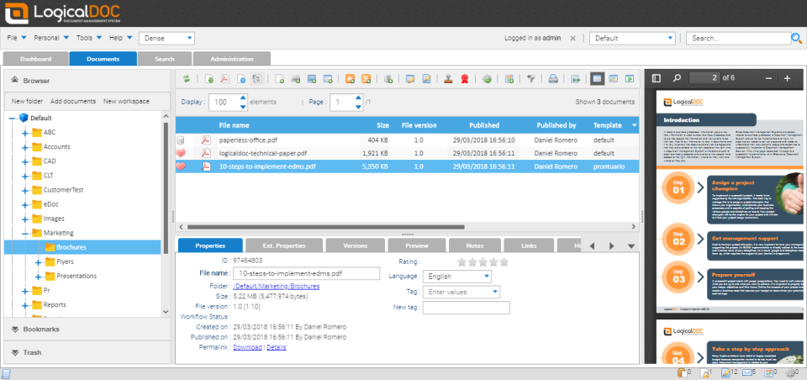
* Search interface and properties tab.

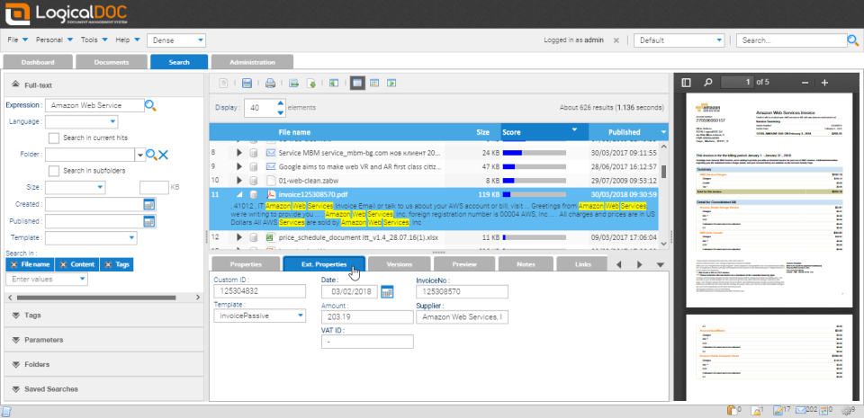

* Mobile interface

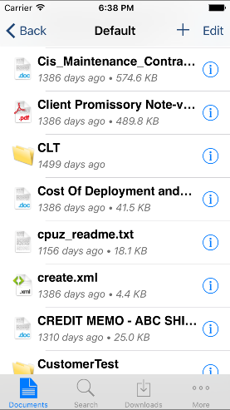

**References**

* + - <https://www.logicaldoc.com/support/api>
    - <https://sourceforge.net/projects/logicaldoc/>
    - <https://techooid.com/open-source-document-management>
    - https://www.capterra.com.de/software/100251/logicaldoc

-----------------------------------------------------------------------------------------------------------------------------------------

**Alfresco**

Alfresco Community Edition is an ***open source*** document management version of Alfresco Content Services for customers with the capabilities to self-support. It is written in ***Java*** and uses ***PostgreSQL*** for the backend database. Alfresco’s ***Open API*** is used to easily integrated and adapt to specific business requirements.

**Overview**

Alfresco Community Edition is compatible with Windows, Linux, etc.

There is great remote access to documents with ***mobile app*** and ***offline*** capabilities. Alfresco provides tools for ***version control*** as well as tracking of documents and task lists. As well as being ***cloud deployable***.

**API**

Alfresco provides a REST API that gives access to all features and methods.

The Open source community edition includes bug fixes for the latest released version, and regular stable version updates issued directly from Alfresco development team.

***Source code*** is publicly available.

**Reviews**

Reviews from ‘Captra.com’ were good with an overall rating of ***3.9/5*** which isn’t as great as LogicalDOC but still respectable. But there was a complaint directed towards the community version and its short comings.

**Pros**:

* + "It's a great system for organizing files in a secure way - access control is excellent”
  + “*Good flexibility in adding coworkers alongside external guests to document repositories”*

**Cons**:

* + "It is browser compatibility issues. There is some problem when uploading large files."
  + "Free version only permit associate an user for administrator, if this person abandon your user, you lost yours documents. Will present compatibility problems on depend of Java version an browsers."

**Download**

* + Install **Docker** and start it
  + Download and unzip the Alfresco Community Download docker-compose
  + Open terminal and navigate to folder with **docker-compose.yml** file
  + Run docker-compose.

**Screenshots**

* Dashboard

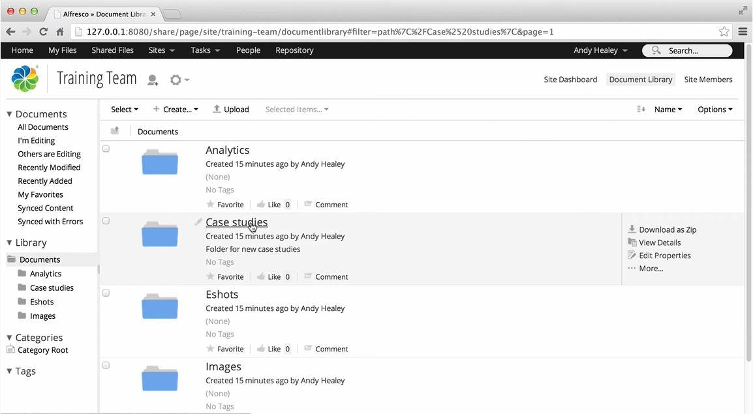

* Personalised dashboard

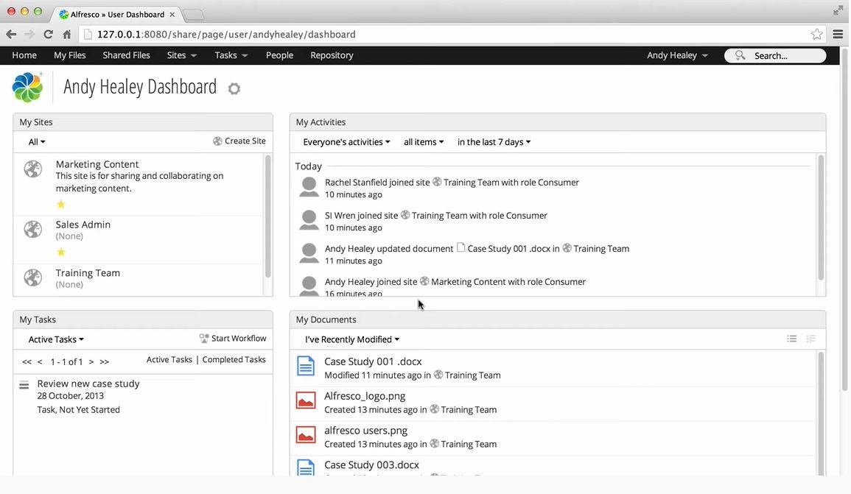

**References**

* + - <https://www.capterra.com/p/52548/Alfresco-One/>
    - <https://www.alfresco.com/de/bpm-software>
    - https://contentsnare.com/open-source-document-management-systems/