**Undergraduate Work Placement Report 2021**

**Title Page**

**School of Computer Science & Information Technology**

**University College Cork**

|  |  |
| --- | --- |
| **Student Name** | Nathan Crowley |
| **Student Number** | 118429092 |
| **Company Name** | Clearstream Global Securities Services Ltd |
| **Workplace Mentor** | Colum O’Riordan |
| **Workplace Mentor Role** | IFS IT Vestima Prime Manager |
| **Workplace Mentor Signature** | XXXXXXXXXXX |
| **Academic Mentor** | Frank Boehme |

**1 Summary**

The Work Placement Programme began on the 22/03/2021 and concluded on the 27/08/2021.The Work Placement took place with Clearstream Global Securities Services Ltd, based in Albert Quay, Co. Cork. Clearstream are a post-trade services provider owned by Deutsche Börse AG.

The work was carried out in the IFS IT Vestima Prime department. The role given was IT intern – developer. The IFS IT Vestima Prime department comprised of 10-12 employees with Colum O’Riordan acting as manager and Martin Allen acting as development manager.

The work week consisted of Vestima Prime daily catch-up meetings at 9.30am, which revolved around the daily tasks of the development team as well as any issues that arose since the most recent catch-up. The work week consisted of 38.75 hours broken down to Monday to Friday usually 9.00am – 5.30pm. The employment period consisted of both large projects as well as small daily tasks. The smaller daily tasks consisted of meetings, training, code fixes, etc. The larger tasks consisted of five projects:

1. SQL JCCS Cutovers with Java & XML implementation.
2. Java Servlet & JSP file uploader to JCCS’s Mr. T.
3. JIRA internal ticketing system tasks.
4. Document Management System research.
5. Proof of Concept regarding Document Management System research.

The Work Placement period allowed for the acquisition of many new skills as well as the enhancement of prior skills. The first two weeks consisted of company structure and business operation presentations. The presentations taught fundamental business terminology such as Mutual funds & Hedge funds, along with their differences and key features. The internal CATS system was demonstrated, and the process of logging hours was shown. The next stage comprised of setup with the Vestima Prime team and internal systems. The daily catch-up process was shown along with being exposed to development cycles, which improved communication skills working with a small development team of 10-12 employees. The months that followed improved technical skills of tools such as Java programming language, SQL, XML, SOAP UI testing, DDL/DML checks for cutovers, JIRA, GitHub commit and pull process, Java Servlet/JSP development, etc.

**2 The Company**

Clearstream Global Securities Services Ltd are a post-trade services provider owned by Deutsche Börse AG. Clearstream provides settlement and custody as well as other related services for securities across all asset classes. Clearstream maintains around 2,500 customers in over 110 countries. The customer base extends over 58 domestic markets, with over 300,000 domestic and internationally traded bonds, equities, and investment funds. Clearstream has offices in Cork, Luxembourg, Prague, and Singapore. The Cork office has some 480 employees in all departments.

Clearstream aims to be a ‘one-stop-shop’ that offers clients both Hedge & Mutual funds operations, offering everything to client as one package. Hedge and Mutual funds are handled separately by Clearstream, Vestima Prime handles the Hedge Funds, with Vestima Plus handling the Mutual Funds. The operational teams are Client team, Trading, Data Management, Corporate Action, Reconciliation & Incident Management, Core Client services, Investment Funds transfer, etc.

Each Clearstream department has a ‘Head of Unit’, followed by a ‘Team Manager’ with sub managers such as ‘Development manager’. The IFS Vestima Prime development comprises of 10-12 employees.

The business flow consists of six steps:

1. Client places an order.
2. Clearstream (CCS) processes the order and creates an ‘Order to Fund’.
3. The Order is Accepted or Rejected by the Fund Administrator.
4. Clearstream informs the client the order has been Accepted or Rejected.
5. Fund Administrator passes a ‘Contract Note’ to Clearstream.
6. Clearstream confirms the details of the ‘Contract Note’ and confirms the order to the client.

Clearstream (“the Custodian”) charges a fee to the clients who have holdings (“a Position”) on the books. Clearstream has a 2020 revenue of €2.936 billion, with net profits of €1.105 billion. With a share price of €149.90 as of 25/08/2021.

**3 My Work Placement**

**Week 1 – 4 - Rough**

The Work Placement Programme began on the 22/03/2021, in the Albert Quay office, with a tour of the office space. Following the tour there was HR presentations on Clearstream’s business operations, fundamental financial terms such as ‘A Fund is an investment vehicle allowing people to invest as a collective.’, ‘Hedge Funds are higher risk, handled by Vestima Prime. Mutual Funds are lower risk, handled by Vestima Plus’, ‘Clearstream has many operational teams such as: Client teams, Trading, Data Management, Corporate Action, etc.’, etc. The presentations improved company knowledge, financial knowledge and gave in sighted into the business.

Meetings took place with IFS IT Vestima Prime manager, Colum O’Riordan, and Head of Unit, Peter Carroll. The development team setup process began.

**My Work Placement**

**Week 5 - 8**

**My Work Placement**

**Week 9 - 12**

**My Work Placement**

**Week 13 - 16**

**My Work Placement**

**Week 17 - 20**

**My Work Placement**

**Week 21 - 23**

**Appraisal of the Placement Module**

**The Administration of the 2021 Program**

**Appendix**

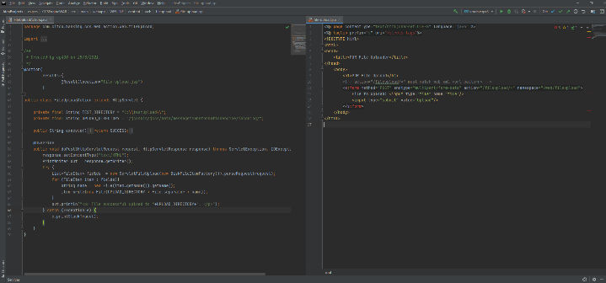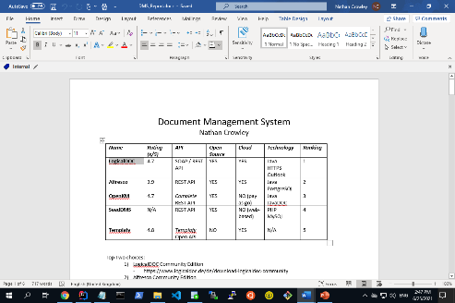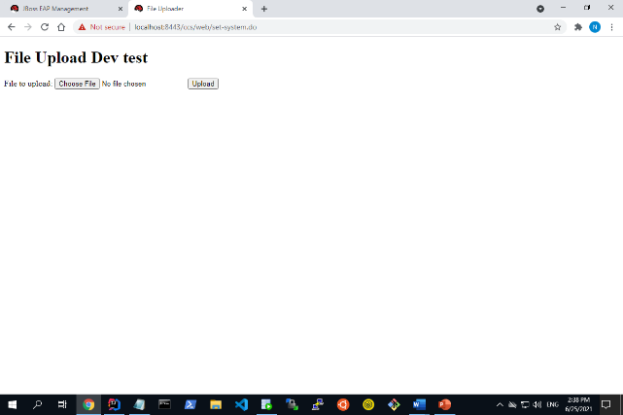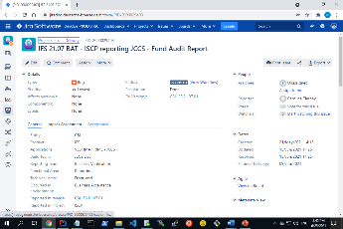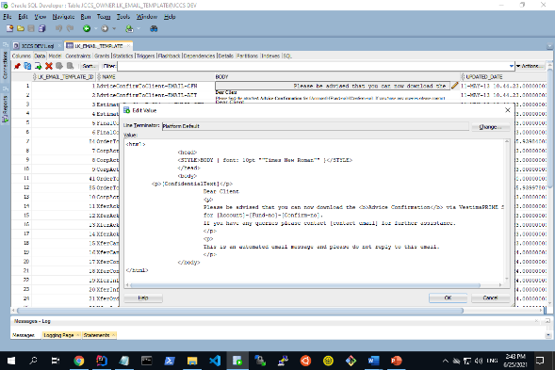

**References**

<https://www.deutsche-boerse.com/dbg-en/investor-relations/financial-reports/annual-reports/annual-report-2019>.

<https://www.clearstream.com/clearstream-en/about-clearstream>.

<https://en.wikipedia.org/wiki/Clearstream>.