The Overlooked Complexity

**(Addressing Space in Modern Data-Intensive Systems)**

| **Sr.no** | **Title** | **Page.no** |
| --- | --- | --- |
| 1 | **Introduction** | 1 |
| 2 | **Literature Review** | 2 |
| 3 | **A Proposed Solution or Approach** | 2 |
| 4 | **Methodology and Implementation Section** | 3 |
| 5 | **Evaluation or Discussion** | 4 |
| 6 | **What is the future of space complexity according to AI?** | 6 |

**_________________________________________________________________________________**

### 

# Introduction

In today’s world, data is being generated at an extremely fast rate from many different sources such as social media, mobile applications, sensors, and online transactions. This rapid growth of digital data is often called the ***Data Explosion***. While having large amounts of data can be very useful for analysis and decision-making, **it also creates serious challenges for computer systems**.

[Simplify: Navigating Data Growth with Pure’s All‑Flash Simplicity](https://www.youtube.com/watch?v=JPwEKQCoJyk)

Traditionally, computer science has focused on time complexity ,that is, how fast an algorithm can run. However, as data continues to increase, space complexity ,how much storage is required has become just as important. If data is not managed properly, it can lead to problems such as storage systems becoming full, slower processing of queries, and higher costs of maintaining infrastructure.

To deal with this problem, several strategies are commonly used. These include applying data retention policies, log rotation and pruning, data deduplication, compression, and summarization of data. Each method has its own advantages and limitations, and choosing the right approach depends on the system’s needs.

In fact, many well-known programmers and researchers have studied these issues.

* **Google** engineers introduced **MapReduce** and **Bigtable** to handle massive logs, **Facebook** and **Twitter** apply aggressive **log pruning** and **real-time aggregation** to save space.
* Tech magazines such as ***ACM Communications*** and ***IEEE Computer*** frequently publish articles highlighting the risks of uncontrolled data growth and the latest solutions in compression and storage efficiency.

This research paper will study the problem of uncontrolled data growth and suggest practical methods to manage it more efficiently. A small Python program will also be demonstrated to show how techniques such as compression, trimming, and summarization can reduce storage usage.

___________________________________________________________________

# Literature Review

1. **Data Retention and Deletion Policies**  
    Organizations define policies to retain data only as long as it is needed, automatically deleting old or irrelevant data. For example, GDPR compliance requires systematic data purging after legal retention periods.
2. **Log Rotation and Pruning**  
    Systems like Linux **logrotate** limit storage usage by rotating logs (e.g., keeping 7 days of logs) and pruning older files. This prevents log files from consuming infinite disk space.
3. **Data Deduplication**  
    Removes redundant data at block or file level. Widely used in backup systems, deduplication can reduce storage requirements by 50–90%, especially for repetitive datasets.
4. **Compression and Archiving**  
    Compression tools like **gzip, zlib,** and **LZMA** shrink data without loss of integrity, while archiving consolidates files for efficient storage. Trade-offs include slower access due to decompression overhead.
5. **Real-time Data Aggregation and Summarization**  
    Instead of storing raw telemetry, aggregation techniques store summarized statistics (e.g., hourly averages of sensor readings instead of per-second data). This balances precision with efficiency.

___________________________________________________________________

# **A** **Proposed Solution or Approach**

A proposed solution to the challenge of uncontrolled data growth lies in adopting a multi-layered space-efficient data management framework that combines retention policies, log rotation, deduplication, compression, and real-time summarization. Instead of depending on a single method, organizations can deploy these strategies collectively to achieve long-term scalability and sustainability. Data retention and deletion policies are the first line of defense, ensuring that outdated or irrelevant data does not consume storage indefinitely; for example, financial institutions are legally required to retain data for a fixed period, after which systematic deletion prevents unnecessary storage costs. Log rotation and pruning further help by cycling out older logs, as practiced by web servers like Apache and Nginx, which archive or remove past logs while keeping the most recent records available for monitoring and debugging. Deduplication techniques play a vital role in storage systems, where identical files or blocks are consolidated—companies like Dropbox and Google Drive rely heavily on deduplication to reduce storage overhead for millions of users uploading the same content. Complementing this, compression and archiving tools such as gzip or zlib shrink large datasets without compromising integrity, making them indispensable for cloud storage providers like Amazon Web Services (AWS), which optimize bandwidth and storage costs. At a higher level, real-time data aggregation and summarization techniques are essential in high-frequency environments such as IoT or video streaming; platforms like Netflix summarize viewing logs to understand trends while avoiding the storage of every raw click or playback event. Similarly, Google Analytics aggregates website traffic into meaningful summaries rather than storing each individual request. By layering these solutions, organizations can maintain not only cost-efficiency but also ensure accessibility of essential data for analysis. The adaptability of this hybrid approach makes it suitable for diverse contexts, from social media platforms handling user-generated content to healthcare systems managing patient records. Ultimately, the strength of this framework lies in balancing space efficiency with data fidelity, enabling modern systems to handle exponential data growth without compromising performance or scalability.

___________________________________________________________________

# Methodology and Implementation Section

This Python script processes a large log file by trimming, cleaning, summarizing, and compressing it for efficient storage and analysis. It begins by reading all entries from large_sample_log.txt and retains only the last 5000 lines. From these, it removes any duplicate entries to ensure uniqueness. It then analyzes the cleaned data by counting the frequency of each log level (assumed to be the second word in each line), providing a quick summary of log types such as **INFO or ERROR**. The processed logs are saved to a new file, processed_logs.txt, and also compressed into a gzip file, processed_logs.txt.gz, to reduce disk space usage. Finally, the script reports the sizes of the original, processed, and compressed files, along with the total time taken for processing.

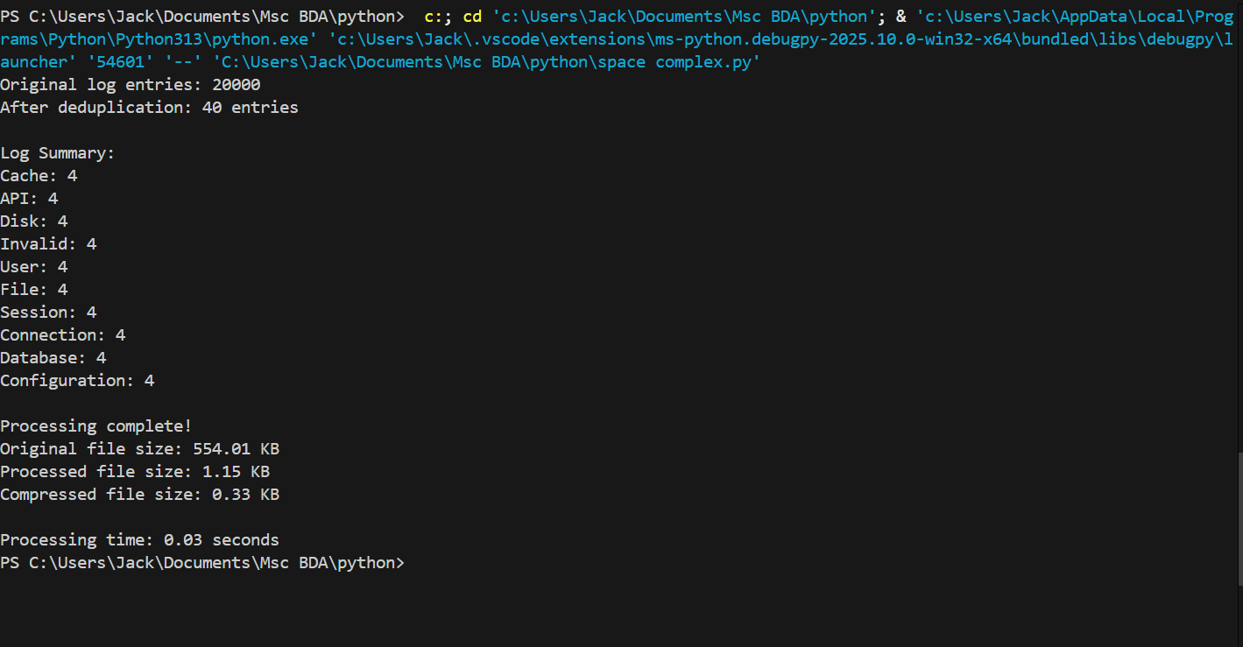

______________________________________________________________

# Evaluation or Discussion

### **Limitations:**

1. **Memory Usage:** The script reads the entire file into memory using readlines(), which may cause memory issues for very large log files. This approach doesn't scale well in environments with limited resources.
2. **Assumption on Log Format:**  
    The script assumes that the log level is always the second word in each line (line.split()[1]). This is brittle and may break if the log format varies (e.g., multiline logs, different timestamp formats, or missing fields).
3. **Loss of Order:**  
    Deduplication via set() removes the original order of logs, which might be critical for certain types of log analysis or debugging.
4. **No Timestamp Filtering:**  
    The trimming is done purely based on line count, not log recency. A more intelligent method would retain logs from the latest time window (e.g., last 24 hours), which might be more relevant than simply the last 5000 lines.
5. **Basic Compression:**  
    While gzip is effective, other compression algorithms (like zstd or bz2) might provide better ratios or performance depending on the use case.

### **Potential Extensions:**

1. **Stream Processing:** Modify the script to process logs line-by-line or in chunks using generators, reducing memory overhead and improving scalability.
2. **Structured Parsing:**  
    Use a log parser (e.g., regex or a library like python-json-logger) to extract structured fields like timestamps, levels, and messages, enabling more accurate and flexible summarization.
3. **Time-Based Filtering:**  
    Integrate timestamp parsing to retain logs from a specific time window rather than a fixed number of lines.
4. **Configurable Pipeline:**  
    Turn the pipeline into a configurable script or tool, where log format, deduplication method, and summarization criteria can be defined externally.
5. **Visualization and Reporting:**  
    Extend the summary to generate visual dashboards or export to JSON/CSV for integration with monitoring tools.

### **Trade-Offs:**

* **Space vs. Accuracy:**  
   Deduplication and compression save space but may discard valuable information (e.g., frequency of repeated errors).
* **Simplicity vs. Flexibility:**  
   A simple script is easy to maintain but lacks adaptability to different formats and use cases.
* **Performance vs. Completeness:**  
   Fast processing may overlook edge cases or anomalies in the logs that are only detectable with deeper parsing.

_________________________________________________________

# What the future would look like according to AI?

In the future, space complexity in log management will likely be addressed through intelligent, autonomous systems that combine AI with scalable infrastructure. Rather than storing every log line, systems will use real-time AI models to analyze logs as they’re generated, filtering and summarizing them on the fly. Only critical, anomalous, or high-impact logs will be retained, significantly reducing storage needs. Additionally, edge computing may be used to preprocess logs closer to the source, minimizing the amount of data sent to central servers. These changes will create more efficient, decentralized, and responsive log handling architectures.

Furthermore, future AI systems will continuously learn from user interactions and system behavior to improve log relevance and retention strategies. Compression will become smarter and more adaptive, applying different levels of compression based on content importance. Logs may also be tokenized or embedded, allowing for compact representations that AI can still interpret without needing the raw text. Combined with cloud-native, serverless infrastructures, these advancements will enable organizations to manage massive volumes of logs with minimal space, faster insights, and less manual intervention—transforming log management from a storage problem into a strategic asset.