Superconductivity and the Meissner Effect

Nathan Everett

Michigan State University

March 4, 2019

**Abstract**

**Introduction:** With the discovery of liquid helium low temperature experiments could be performed. One of these experiments bred the discovery of superconductivity. This paper focuses mainly on the Meissner Effect. **BCS Theory:** In certain solids near absolute zero electrons bind into a composite boson which condenses into a superfluid. This superfluid can flow through the solid with zero electrical resistance. **Meissner Effect:** Magnetic flux lines in a superconducting solid are expelled when it is cooled below its critical temperature. This is what is described as the Meissner Effect. The superconducting material in this state exhibits perfect diamagnetism, meaning it creates a magnetic field that is equal and opposite to all external magnetic fields. This effect is created due to currents present on the surface of the superconducting material. **Critical Magnetic Field:** There is a limit to the strength of surface currents present on a superconducting material. When the material is subject to a large magnetic field, large surface currents break down the state and superconductivity stops. The way in which the superconductive state breaks down classifies conventional superconductors into two types.

**1. Introduction**

On July 10, 1908 liquid helium was produced for the first time, allowing for experiments to be done on the ultra-low temperature scale. On April 8, 1911 Heike Kamerlingh Onnes set out to measure the resistivity of mercury at cryogenic temperatures. He discovered that at about 4.2 K the resistance fell abruptly to 0. This was the first observation of the phenomenon dubbed Superconductivity [1]. Since its inception, superconductivity has been proven to be one of the most important discoveries of the 20th century. Although it is not completely understood, there are numerous theories with experimental backing that offer an explanation for the mechanisms behind the phenomenon. This paper will briefly explain the Bardeen-Cooper-Schrieffer (BCS) theory of superconductivity, then will go into classical explanations of the Meissner Effect.

**2. BCS Theory**

The BCS theory of superconductivity is the most widely accepted explanation for conventional superconductors which awarded the three physicist who wrote it the Nobel Prize in 1972 [2]. The theory goes something like this: Electrons flow freely in a metal when an electric field is applied. When these travelling electrons encounter impurities in the metal they collide and produce heat; this is what is known as electrical resistance. When a superconducting material (which doesn’t have to be a metal) is cooled down below its Critical Temperature TC, it experiences a sudden phase transition where its electrical resistance drops down to exactly zero. The electrons in the solid interact with phonons which cause neighboring electrons to pair up. The two electrons, both with spin ½, create a composite particle with spin 0 called Cooper Pairs. These integer spin particles act like bosons which condense into a superfluid. Just like how a traditional superfluid can flow with no viscosity, Cooper Pairs can flow in a superconductor with no resistance [3].

**3. Meissner Effect**

Superconductivity is defined by two properties; the first is exactly zero electrical resistance, the second is the expulsion of magnetic flux lines. This second property, called the Meissner Effect, is perhaps the most confusing of the two. Throughout the rest of this paper I aim to concisely explain this important phenomenon and its properties.

3.1 Classical Diamagnetism

If we want to explain the Meissner Effect in a classical framework, we must also be able to explain diamagnetism classically. In the classical theory of electricity and magnetism, magnet fields cannot do work on the system. Meaning, magnetscannot add energy to the system. In diamagnetic systems, an opposite magnetic field is induced and energy is added to the system. Because of this, it is often claimed that there is no explanation of classical magnetism. However, the Darwin Hamiltonian given by

$$E_{b}=\frac{1}{8π}∫B^{2}\left(r\right)dV=\frac{1}{8π}∫{\left(B_{e}+B_{i}\right)}^{2}dV$$

Where Be is the external magnetic field and Bi is the internal magnetic field due to moving charged particles. This gives rise to a magnetic energy term and can therefore model diamagnetism. This is in disagreement with the previously accepted Bohr-van Leeuwen theorem, which states that the Hamiltonian of interacting charged particles does not depend on the external vector potential and therefore cannot be explained classically [4].

We can see that this is proven further when we look at Feynman’s Disk Paradox. This paradox states that when a charged ring with two freely moving charged particles is placed around a long solenoid and that solenoid is turned on, the particles start to rotate. At first glance this seems to violate conservation of angular momentum, but if we take into account the momentum stored in the magnetic field we see that no laws were violated. This momentum/energy stored in the magnetic field is responsible for diamagnetic effects of systems [5].

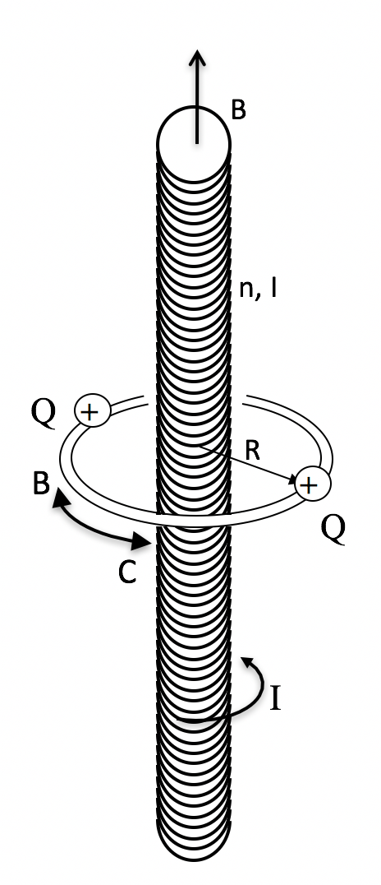Figure 1. Schematic representation of the Feynman Rotator. Richard Feynman used this example to demonstrate how angular momentum could be stored in electric and magnetic fields. This thought experiment was dubbed “Feynman’s Paradox” albeit it not being a paradox at all [6].

3.2 Perfect Diamagnetism

The Meissner Effect is what makes a superconductor different from an ideal conductor. The best way to demonstrate this difference is with the following thought experiment. If we have a perfect conductor, that is such when we cool it below a temperature Tc, we expect an external magnetic field to penetrate the hull. Through abstraction of Lenz’ law,

$$ε= -\frac{dΦ}{dt}$$

where ε is the induced electromotive force and Φ is the magnetic flux, we expect that when the external field is shut off that currents will appear, creating a magnetic field. Another way we can think about this is through the microscopic description of Ohm’s Law. If we define the electric field to be,

$$E=\frac{J}{σ}$$

then we see that with the condition of perfect conductivity (i.e. $σ=∞$) the electric field becomes zero. Using the Maxwell Equation,

$$-\frac{∂B}{∂t}=∇×E$$

we see that $\frac{∂B}{∂t}=0$. This means the magnetic field must be constant in the hull. So when the external magnetic field is turned off, we still expect a constant magnetic field to be present (see figure 2 c). However, this does not happen with superconductors. Instead, the moment the superconductor is cooled below Tc the magnetic field lines are expelled. Additionally, when the external field is turned off, the superconductor does not continue to produce an opposing field [7].

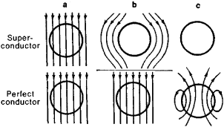Figure 2. Visual representation of the Meissner Effect. A uniform magnetic field is applied to a superconducting and perfectly conducting spheres. From steps a to b, the samples are cooled down to T < Tc. From steps b to c the magnetic field is turned off [8].

This process is what can be described as Perfect Diamagnetism. Diamagnetism is an intrinsic magnetic property that describes a system which creates an opposing magnetic field when subject to a changing external magnetic field. Typical electromagnetic systems such as current loops entering a magnetic field are considered diamagnetic systems. We see that a superconductor is perfectly diamagnetic because it creates a completely opposing magnetic field only when an external magnetic field is present [9].

3.4 Surface Currents

At first glance it is hard to see how this perfect diamagnetism is achieved. By definition, a superconducting material has an internal magnetic field **B** = 0; this is true even when an external magnetic field is present. Using the Maxwell Equation

$$∇×B= μ_{0}J$$

We see that with **B**=0 then **J**=0 as well. If there can be no current in the bulk of a superconductor, then how is the induction created to oppose an external magnetic field? We find that the currents which create this opposing magnetic fields are actually present on the surface of our material. Because there is a magnetic field present outside the hull, surface currents do not violate any of our presuppositions. Additionally, this abstraction still holds when the superconductor is placed in a circuit; if it is used to pass current across a potential difference, then the currents must stay on the surface of the material. We will see that there is a limit to which this process is sustainable [7].

**4. Critical Magnetic Field**

The expulsion of magnetic field lines is only valid under certain conditions. If the field strength becomes too large, then the effect breaks down and superconductivity halts. The mechanism behind this fails to have truly classical reasoning, so I will only offer a cursory explanation. We have seen that the presence of an external magnetic field will cause surface currents to form in a superconducting material. When the magnetic field strength grows, so must these currents to create an equal and opposite magnetic field. However, if the electron momentum within the superconductor exceeds a certain value, it will excite the electrons and cause them to break their bound state causing them to undergo a phase transition out of the superconducting state. This magnetic field strength is called the Critical Magnetic Field. This destruction of the superconducting state can also be achieved with no external magnetic field by simply being overdriven in a circuit, however it is most useful to describe the effect in terms of the critical field [7].

Conventional superconductors can be classified based on their reaction to the exposure of their critical field. If the superconducting state ceases when the critical field is reached, the superconductor is said to be of Type 1. A Type 2 superconductor has two critical fields. When the first field is reached the superconductor enters what is called a Vortex State, meaning that magnetic field lines can penetrate certain areas of the hull and create vortices within the material. When the second field is reached superconductivity ceases completely [10].

**5. Conclusion**

The picture of superconductivity is not explained adequately without a thorough explanation of the Meissner Effect. This effect importantly distinguished the phenomenon from the realization of a perfect conductor. It is also important to understand this effect if one wants to accurately classify different superconducting mediums and investigate their properties further. Although this phenomenon does have a quantum explanation, it is essential to be able to explain the macroscopic phenomenon in a classical framework to both accurately understand what is happening and to offer a more approachable explanation for those whom are unfamiliar with the subject.

**6. References**

[1] Delft, Dirk van, and Peter Kes. “The Discovery of Superconductivity.” EuroPhysicsNews, [www.europhysicsnews.org/articles/epn/pdf/2011/01/epn2011421p21.pdf](http://www.europhysicsnews.org/articles/epn/pdf/2011/01/epn2011421p21.pdf)

[2] Superconductors.org. (2018). Theory of Superconductivity. <http://www.superconductors.org/oxtheory.htm>

[3] Cooper, L. (1956). Bound Electron Pairs in a Degenerate Fermi Gas. Physical Review, 104(4), pp.1189-1190.

[4] Essén, Hanno, and Miguel C. N. Fiolhais. “Meissner Effect, Diamagnetism, and Classical Physics—a Review.” American Journal of Physics, vol. 80, no. 2, 2012, pp. 164–169., doi:10.1119/1.3662027.

[5] Lombardi, Gabriel. (1983). Feynman's disk paradox. American Journal of Physics - AMER J PHYS. 51. 213-214. 10.1119/1.13272.

[6] Caballero, Danny. “PHY482 Conservation Laws Slides.” Physics 482, dannycaballero.info/phy482msu/notes/20-slides.html#/.

[7] Rose-Innes, Alistair Christopher., and E. H. Rhoderick. Introduction to Superconductivity. Pergamon Press, 1994.

[8] TheFreeDictionary.com. (2018). superconductivity. [online] https://encyclopedia2.thefreedictionary.com/superconductivity [Accessed 26 Nov. 2018].

[9] Britannica, The Editors of Encyclopaedia. “Diamagnetism.” Encyclopædia Britannica, Encyclopædia Britannica, Inc., 24 Nov. 2015, www.britannica.com/science/diamagnetism.

[10] Kittel, C. and McEuen, P. (n.d.). Introduction to solid state physics. 8th ed. Wiley.