Internal Energy of Smarties and their Nutritional Counterpart

Nathan Gillispie and the Door Table.

Experiment date: September 21, 2022

# Introduction

Ultimately, we want to determine the heat capacity of a bomb calorimeter so we can determine the energy of the combustion of Smarties candy. The heat capacity of calorimeter is determined by combusting a benzoic acid standard and comparing the rise in temperature to the enthalpy of combustion of benzoic acid using the following equation:

|  |  |
| --- | --- |
|  | (1) |

where is the change in temperature measured in the water and is the heat transferred to the water. This value is calculated using the following equation:

|  |  |
| --- | --- |
|  | (2) |

where change in enthalpy is calculated using enthalpies of formation of each of the relevant compounds in the combustion of benzoic acid. This works due to the definition of enthalpy and since we are using a bomb calorimeter which results in a constant volume process (). The term becomes which is less than 5% of . In general, we find that for most processes due to this term.

# Data

**Table 1:** Measured values of standard and smarties including calculated energy of combustion.

|  |  |  |  |
| --- | --- | --- | --- |
|  | Mass of sample (g) |  |  |
| Benzoic acid standard |  |  | 6.9±0.1 |
| Smarties candy |  |  | 7.3±1.5 |

# Results and Discussion

Using the thermo data table and equation 2, we calculate the enthalpy and energy of combustion for benzoic acid to be -3226.7kJ/mol and -3225.5kJ/mol respectively. [1] Calculations shown in appendix. Using average bond enthalpy, we calculate the enthalpy of combustion for benzoic acid to be -3310kJ/mol. [2]­ This calculation is shown in the appendix. Here we have a typical discrepancy found between experimental and calculated enthalpies.

To calculate ΔUsur for our benzoic acid standard, we begin by taking the negative molar enthalpy of combustion times sample weight divided by the molar mass of benzoic acid:

Error is propagated using worst-case scenario for all calculations. To calculate the calorimeter constant, we use equation 1:

We can calculate the internal energy of combustion for the smarties candy given the exact same volume of liquid in the surroundings and the change in temperature. Solving for ΔU in equation 1 and plugging in values, we get

The back of the smarties bag gives the energy as 25kCal/7g. Since we combusted 0.488g of smarties, we can calculate the “literature value” of energy of combustion of smarties:

We can compare both results using the difference method:

Since 0 falls within the calculated range at the end we can conclude the literature value of energy of smarties agrees with our value.

# Safety and References

A bomb calorimeter involves inherently dangerous pressures. When disassembling anything under pressure, make sure pressures are equilibrated.

1. Engel, T; Reid, P. *Physical Chemistry: Thermodynamics, Statistical Thermodynamics, and Kinetics*, 4th Ed.; Pearson Education: Glenview, IL, 2019; pp. 630-635

2. Engel, T; Reid, P. *Physical Chemistry: Thermodynamics, Statistical Thermodynamics, and Kinetics*, 4th Ed.; Pearson Education: Glenview, IL, 2019; p. 93

# Appendix

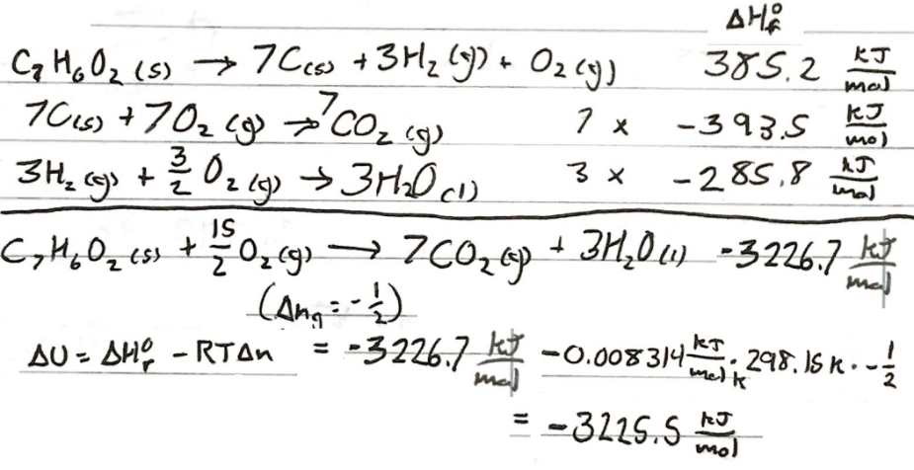

**Figure 1:** Calculation of enthalpy and internal energy of combustion of benzoic acid.

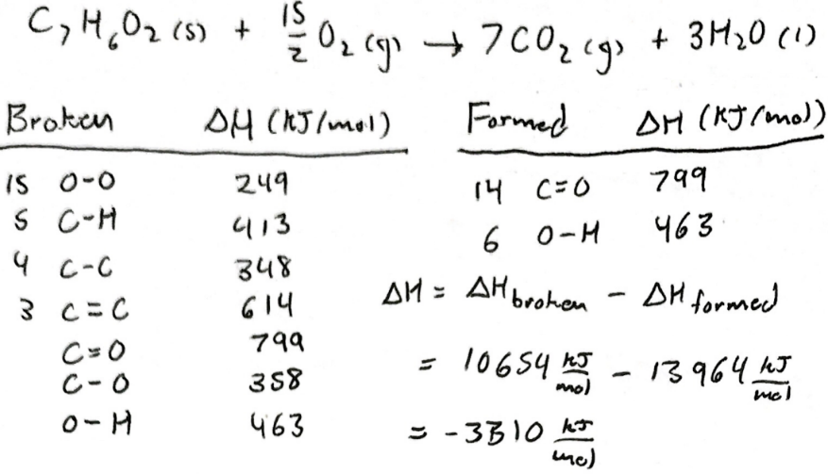

**Figure 2:** Calculation of enthalpy of combustion of benzoic acid using average bond enthalpy.