**Sagan Workshop 2020: Getting Started with Python**

The hand-on activities we will use during the workshop are based around Jupyter Notebooks using software written in Python3. If you are unfamiliar with these tools, the guide below should help you set them up on your personal computer and provide an overview of their capabilities. *You should setup your Python distribution in advance of the workshop; if you need assistance, reach out via the Slack channel!* In this document, we use the Courier New font to indicate a command you type into the command prompt.

**The Python Distribution**

You first need a working copy of Python3. Even if your operating system comes with a system level Python distribution installed (e.g. most flavors of Linux include this), we recommend you follow these instructions to install the standalone Anaconda Python distribution. System level distributions are often far out of date, and are difficult to upgrade without breaking the entire operating system.

You can download the free Anaconda here: <https://www.anaconda.com/products/individual>

Versions exist for Windows, Mac, and Linux. *Choose the Python 3.7 download appropriate for your operating system.* Note that the Individual Edition is free, while the Team and Enterprise distributions require license agreements. For the Sagan workshop, and most data analysis you would do for independent research, the Individual Edition is sufficient.

*These downloads are between 300-600 MB, depending on operating system.* If your internet is limited in bandwidth, you can utilize the Miniconda distribution, which is much smaller (~50 MB) at <https://docs.conda.io/en/latest/miniconda.html> . This gives you the same core packages as Anaconda, but strips out many extra packages that may not be needed. If you do need missing components later on, it is straightforward to add them individually.

**Windows**  **MacOS** 

The Windows and Mac versions of Anaconda and Miniconda are installed in the normal way by double-clicking the downloaded installer. Follow the prompts to install the Python distribution. You will interact with Python from a terminal prompt.

**Linux **

The Linux version is installed by running the ‘sh’ script from the command line in a terminal:  
bash Anaconda3-2020.02-Linux-x86_64.sh

After accepting the license agreement, you will be asked for a location into which to install the distribution. I use the default (/home/username/anaconda3). All of the Python packages we will be using will be installed into your account under the directory you specified. This will take quite some time to complete. When you are asked “Do you wish the installer to initialize Anaconda3 by running conda init?”, answer “yes”. This will add code to your .bashrc file which initializes Anaconda Python whenever you open a new terminal window.

Now close the terminal and open another (so that the new .bashrc takes effect).

**Update to the latest version**   

Next update the installation to the latest version by typing:  
conda update conda

Answer “y” when asked if you wish to update, and wait for the update to finish. You now have a working Python distribution installed in your account.

**Custom Working Environment**    

If you are developing code or running a program that requires you to install custom packages, it is useful to create a virtual environment for that project. This environment allows you to create local installations of your python environment for specific purposes; if you do something undesirable in a virtual environment, you can delete it and start over, without having to reinstall conda.

To create a virtual python3 environment for use with the Sagan workshop, type the following:  
conda create –-name sagan

This creates a directory ~/anaconda3/envs/sagan, which contains a local copy of your python directory. You can modify the python environment in here without risk of damaging the base install.

To ‘activate’ your custom environment, type:  
conda activate sagan

The beginning of your terminal prompt should change from to [sagan], and any packages that you install now will end up in ~/anaconda3/envs/sagan. Note that each new terminal you open needs to have the activate command run on it.

**Python Jupyter Notebooks:**   

Jupyter Notebooks are a handy, interactive way to work through programming problems in a GUI environment in your web browser. They allow you to easily document your work (just like a real lab notebook) and visualize the results of each step in a computer program. The activities for the Sagan workshop are in the form of Jupyter Notebooks, so if you are not familiar with them, read the following instructions. *Note: We are still using the classic Notebook interface, not the new JupyterLab interface.*

Jupyter comes included with the full Anaconda distribution.

If you installed miniconda, run the following to add the Jupyter Notebook package:  
conda install -c conda-forge notebook

You can start running a Jupyter notebook with:  
jupyter notebook

This will launch the Jupyter kernel and load an interface in your local web browser. If you are not familiar with python, you should work through the tutorial: *Sagan2020PythonIntro.ipynb*

This is a Jupyter Notebook, and you can open it from the Jupyter interface in your browser.

Work your way through the notebook. Interactive code is indicated by this:

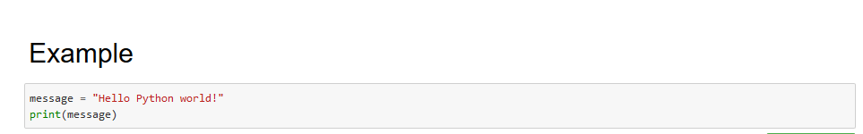

You can modify the commands in the shaded box. To re-run the code, type CTRL-Enter

When you are done, click on the Jupyter icon http://localhost:8888/static/base/images/logo.png?v=641991992878ee24c6f3826e81054a0f in the upper left. This will return you to the file-lister interface, where you can load additional notebooks.