Patient One

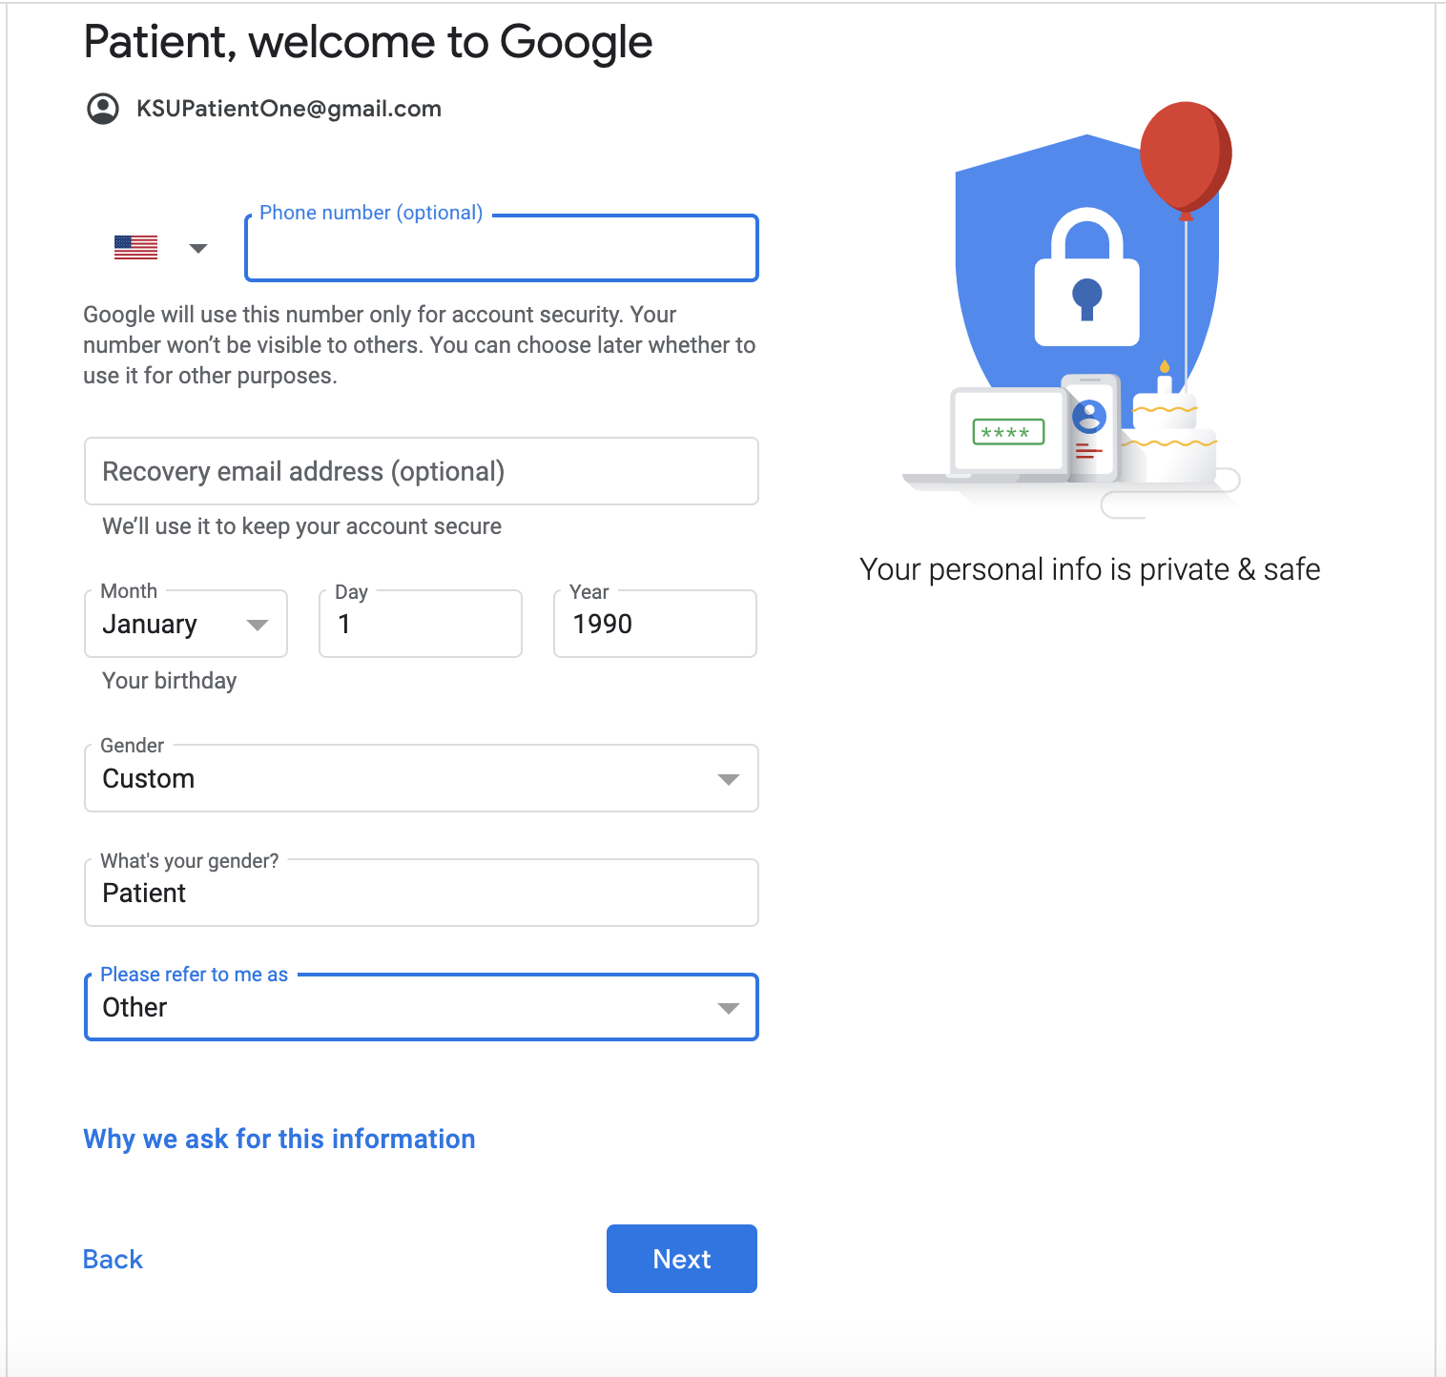

Doctor One

