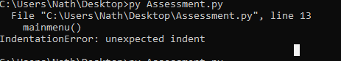

Figure 1

The error of indentation error means that there was a problem with the codes indentation. The specific type of error was an unexpected indent this means that on line 13 there was an indent in the code specifically the code of mainmenu() was indented when it shouldn’t be indented this was simpily fixed by removing the indent in the code on line 13

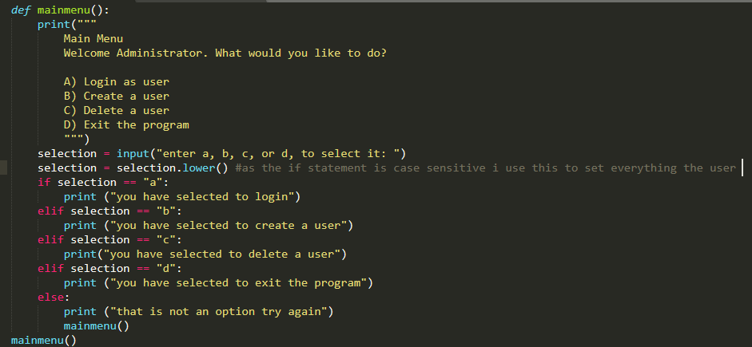

Figure 2

this is an example of where i avoided errors in my code by turning the input into all lowercase for the menu to not be case sensitive and send the user to the right menu this was done by setting the input as a variable then running the function selection.lower() this can be seen in the picture above

when checking for username and password i ran into an error where it wouldnt read the full file this was due to there being a line break in the file in the middle of the usernames and passwords this caused csv to stop reading from there causing usernames to be allowed to be created that shouldnt be able to be created. It was fixed by removing the linebreak in the txt file

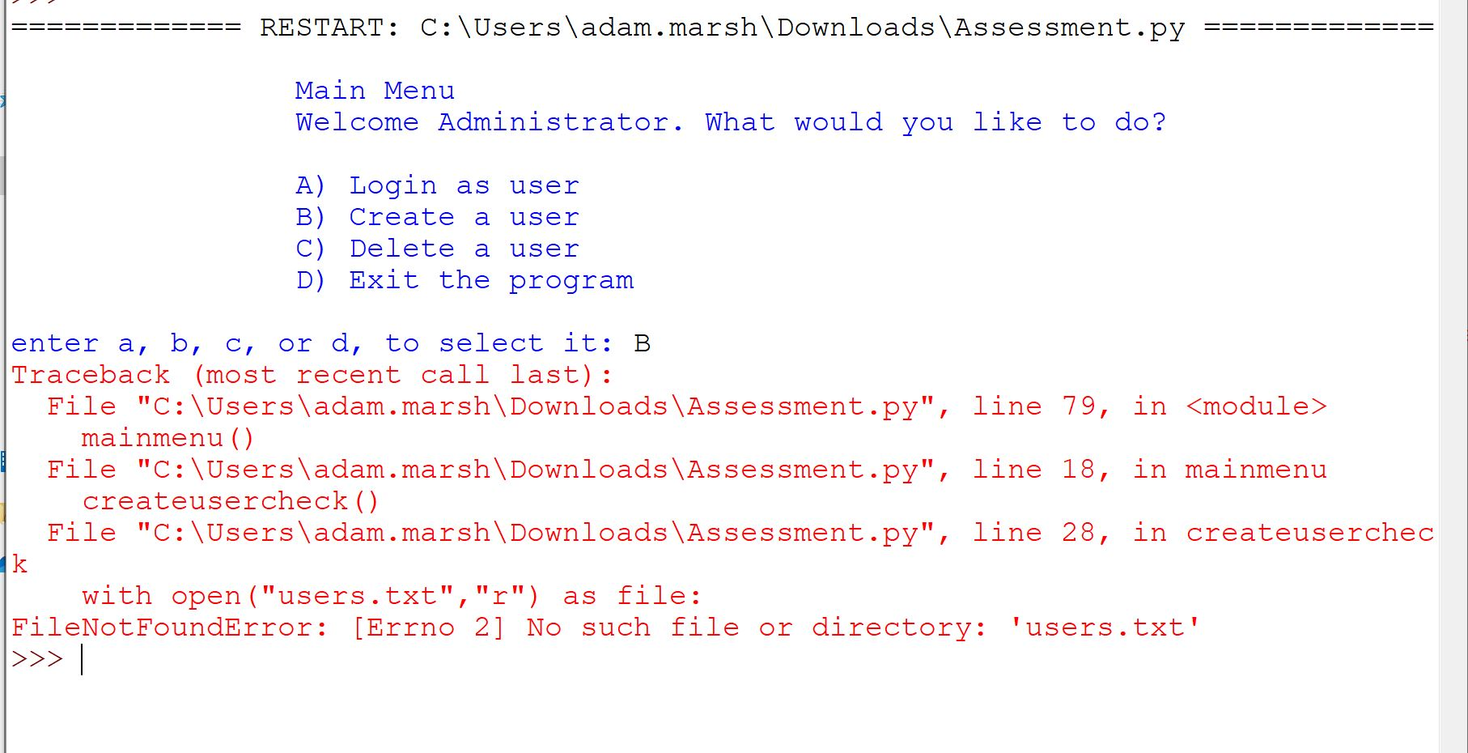

Figure 3

The traceback part of the error explains how it got to the area of the error to allow to work backwards. It shows that the error comes from line 28. The main error is filenotfounderror whitch means that the file that was trying to be read could not be found in the directory of the python file. This was created due to changing the way the program reads and writes to the file. This was fixed by adding a line of code that opens the file in appendix mode which creates the file if it dosnt already exist then closes the file immediately without making changes to the file. This was researched from W3 schools and the edit can be seen in figure 4

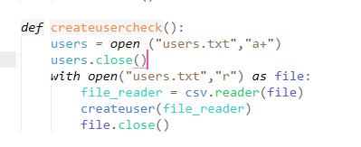

Figure 4

There was an error that caused the users to be printed to the text file differently then expected. This can be seen in figure 5. The error was identafied by using the help section in the official python discord. It was explained that using csv.writer and inputting a list causes it to separate every single letter in each part of the list as a spererate values in csv and does not consider each value of the list as a single value. This was fixed by writing to it as a text file and not under csv.writer as explained to me.



Figure

The administrator program is effective at allowing the creation and modification of users. It allows all the users to be stored in a text file allowing them to be stored inbetween the program being closed and reopened. The use of text files allowed this to happen allong side the inbuilt module CSV. The program does not allow for a user with a changed password to re login in the same instance of the program and it dosnt allow for multiple users to be deleted in the same instance of the program. The program followed the basic flow chart that was created as seen in figure 5. The program could be improved by allowing for a user to login after the password has been changed, allowing for multiple users to be deleted in one instance of the function. It cal also be improved by adding encryption to the usernames and password so they are not stored in their pliantext form.

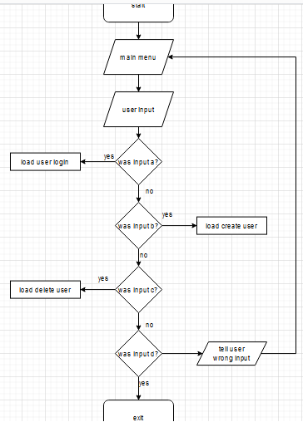

Figure

Bibiliography

<https://www.w3schools.com/python/default.asp> (general python knowlege)

python discord (discord.gg/python) (specific assistance)

<https://docs.python.org/3/library/csv.html> (general CSV knowlege)