CIVE 202 Project 4 Report: Risk Assessment
University of Nebraska-Lincoln

CIVE 202 Group 6

Savanna Flores

Nathan Jones

Gavin Rothmeyer

April 21, 2026

Table of Contents
Introduction 3
Methods 4
Results & Discussion 5
Conclusion 8
Appendix A: Figures 9
Appendix B: Reference List 14

Introduction
Project Goals:
The purpose of this project is to conduct a natural disaster risk analysis for two states using the FEMA National Risk Index (NRI) data and the CDC/ATSDR Social Vulnerability Index (SVI) Risk Averse, LLC has tasked the team with performing analysis to evaluate bias in the NRI method by applying and comparing the consultant developed risk method. Comparison of the results will highlight differences in risk identification and the effects on a community. All client specific requirements will be addressed upon completion of this project. The two states selected include Iowa and Nebraska. Sources that are relevant for data analysis include National Centers for Environmental Information, and U.S. Census Bureau. All analysis will be done within a Jupyter Notebook, an annotated code document, a GitHub repository, an engineering timesheet, and a detailed technical report.

Task 1: Analyze Data
The NRI CSV and Metadata files will be downloaded from the FEMA data site for Iowa and Nebraska. The corresponding SVI data will be downloaded from the ATSDR site. The data will be interpreted to find missing values and understand what is required for merging. The metadata will be used for a clean understanding of the information and overall creates a foundation of understanding for further analysis. The NRI definition of risk is the likelihood of a natural hazard occurring and its consequences on the surrounding environment. The NRI calculates this using three components: Expected Annual Loss, Social Vulnerability, and Community Resilience. This gives every community a risk index score to rank against other communities geographically.

Task 2: Python Code
A structured Jupyter Notebook (.ipynb) will organize imported data, analysis, combining NRI and SVI data, filling missing values, applying risk analysis from both NRI and consultant methods, and graphic visuals. Risk index scores will be calculated using the NRI formula: $Risk Index = \frac{Expected Annual Loss * Social Vulnerability}{Community Resilience}$ and using an alternatively developed risk scoring method for comparison. The notebook will include summary tables and figures that compare the calculated risk scores from each method and use GeoPandas to display the risk information on a map.

Task 3: Documentation and Reporting
A Jupyter Notebook (ipynb) that presents the code structure and sequential prompts will be created. Attached will also be an Annotated Code Document, which will describe all Excel-to-Python logic through detailed individual line-by-line explanations. The technical report will include an Introduction, explain the Methods, analyze and discuss Results, and a References section. Additionally, a GitHub repository will store all code, documentation, and a README file containing User Guide information. Lastly, a Gantt Chart will display task sequences, task durations, and all project milestones.

Table 1: Final Deliverables
Deliverable | Files Included | Date
Raw Data File | CIVE202_Spring2025_ Group_Project4_Raw | 4/21/26
Python Code | CIVE202_Spring2025_ Group_Project4_Code.ipynb | 4/21/26
Organized Files | GitHub Link containing this data | 4/21/26
Scope of Work | CIVE202_Spring2025_ Group_Project4_SOW.DOCX | 4/21/26
Annotated Code | CIVE202_Spring2025_ Group_Project4_ACD.DOCX | 4/21/26
Written Report | CIVE202_Spring2025_Group_Project4_Report.DOCX | 4/21/26

Methods
Study Design and Objectives
This study evaluates how FEMA’s National Risk Index (NRI) defines natural hazard risk and compares it to an independently developed Project Risk Definition. The goal is to determine whether the NRI’s methodology introduces categorical bias—systematic differences in risk classification that may advantage or disadvantage certain communities. The analysis focuses on Census tracts in Iowa and Missouri, two Midwestern states with distinct hazard profiles, demographic patterns, and levels of social vulnerability.

Dataset: 2025 NRI Census Tract level
Study Area: State of Iowa and Missouri
Risk Definition:
Risk is defined using the Expected Annual Loss (EAL) metric provided in the NRI dataset.
EAL represents FEMA’s estimate of the average economic loss expected per year from natural hazards, incorporating both the probability of hazard occurrence and the severity of potential impacts.
This metric was selected because it is quantitative, comparable across counties, and directly reflects hazard-related risk.
Data Cleaning and Preprocessing:
  - Filtered the dataset to include only counties located in Iowa and Missouri.
  - Removed all rows where EAL or hazard-specific loss values were zero, as these represent counties with no recorded or modeled risk.
  - Removed all rows containing non-applicable values to ensure complete records for analysis.
  - Retained only variables relevant to risk assessment, including EAL, population, hazard-specific loss components, and county identifiers

Results & Discussion

Conceptual Differences Between the Two Definitions
Project Risk Definition:
Risk is defined using Expected Annual Loss (EAL) from the NRI dataset.
Implications of Project Risk Definition:
- Risk is treated as purely economic (dollars lost per year).
- Social factors (vulnerability, resilience) are not included.
- Zero-risk counties are excluded, which removes low-risk communities from the analysis.
- The analysis becomes state-specific, not national.

NRI’s Official Risk Definition:
The NRI defines risk as a composite index combining: Expected Annual Loss (EAL), Social Vulnerability, Community Resilience, and Hazard-Specific Scores (e.g., tornado, flood, drought).
NRI’s “Risk Index” is multidimensional, not just economic.
Implications of NRI’s Definition:
- Risk includes social inequities (e.g., poverty, age, disability).
- Risk includes community capacity to respond and recover.
- Risk is comparable across all U.S. counties.
- Low-loss but highly vulnerable communities may still score high.

Ethical Implications of Risk Definitions
Bias Between States:
Using EAL alone introduces systematic bias for a multitude of communities. This can be demonstrated with wealthier states, such New York, with expensive infrastructure because they show higher economic losses, even if hazards are similar. Even rural or low-income states, such as Iowa, may appear at lower risk due to the fact property values are lower. Also, the states that have strong data collection systems may appear “riskier” because they report more accurately than other states that do not, and not because hazards are worse.
The ethical concern with this is risk becomes a reflection of property value, not human vulnerability.
Implications for Funding:
Our simplified project risk definition could lead to problems with funding. Counties with high economic assets could be over-prioritized or under-prioritizing vulnerable communities with low property values. This could be seen by funding inequities where wealthy counties receive more attention because they look “riskier”. It could also influence where Risk Averse LLC allocates resources, staff, and future data collection.
Meanwhile, the NRI’s composite index directs attention to socially vulnerable communities, encourages funding for resilience, and supports more equitable hazard mitigation planning.
The ethical concern with this is a narrow definition of risk can unintentionally reinforce economic inequality in hazard mitigation funding.

Implications for State and Community Decision-Making:
State and community decision-making could be negatively impacted with the project risk definition. They may focus on protecting high-value assets rather than protecting their people and low-income or rural communities may be overlooked. Policies could also be affected to prioritize economic efficiency over equity.
Whereas, communities who use the NRI definition are more likely to make more ethical decision. They are more likely to invest in social programs, resilience, and preparedness. Communities that are highly vulnerable may even be identified even if their economic losses are low.
The ethical concern with this are different definitions of risk lead to different winners and losers in policy, funding, and protection.

Overall Ethical Evaluation:
Our project risk definition (risk is defined using the Expected Annual Loss (EAL) metric provided in the NRI dataset) is valid, but it is narrower and more economically focused than then NRI’s. This simplicity improves clarity and reproducibility, but it also removes social context, resilience factors, low-risk counties, potentially biases results toward wealthier areas, and could influence funding decisions in ways that disadvantage vulnerable populations.
The NRI’s definition is more complex but more ethically aligned with equitable hazard mitigation.
Results for Iowa and Missouri
Under our project risk definition, Iowa and Missouri look most “at risk” where damage is costly, while under the NRI definition, they look most “at risk” where people are least able to cope.
Aspect | EAL-only (my definition) | NRI composite definition
What stands out in Iowa | Counties with higher property values, larger towns, and more infrastructure | Counties with higher social vulnerability (e.g., pockets of rural poverty, aging populations, low resilience)
What stands out in Missouri | Metro areas (e.g., around Kansas City, St. Louis) and high-value corridors | Both urban vulnerable neighborhoods and rural, low-resilience counties in the south and southeast
Who looks “low risk” | Many rural, low-income counties with low dollar losses | Wealthier, resilient counties, even if they have high asset values
Overall pattern | Risk clusters where assets are expensive | Risk clusters where people are vulnerable and systems are weak

Overall, our results for Iowa and Missouri showed minor and vast differences in their risk values when we compared them to the NRI definition to our project risk definition.

In Figure 1, the risk values do show some major differences but overall, it was close. However, in the second figure for risk value of winter weather, we can clearly see our project risk definition impacted the risk value greatly. This shows us that some places can seem at a lower risk than they are and that this can happen for a multitude of reasons. For us, what made the risk value go up for so many places is the frequency these events happen.

Similar results happened with Figure 3: Tornado Risk by County – NRI vs. Custom Definition for Missouri and Figure 4: Winter Weather by County – NRI vs. Custom Definition for Missouri.

For Figures 6-8, it shows us the map of Iowa with the NRI tornado and winter weather definition and then our project risk definition for those two categories. To look deeper into one of these examples, Figure 5 and 7, the NRI definition is failing by deeming almost all of the state a low risk for tornados. However, the actual case when we used our project risk definition is a closer look across the state where tornados have frequently happened. If we had only consulted the NRI definition, there would have been many counties overlooked for funding to send resources or safety. In our project risk definition map, there are only a few counties that show a higher risk for tornadoes but knowing this is still beneficial to be able to help the people that live in these areas.

Similar results for figures 9-12 showing a map of Missouri comparing tornadoes and winter weather with the NRI definition and our project definition. After examining our project risk definition maps, there is much more diverse data throughout the state which will be able to tell us which counties need the most help before or after natural disasters.
Implications for People Impacted by Natural Disasters
Under Project Risk Definition:
Residents in poorer rural counties or vulnerable neighborhoods may not be recognized as “high risk”, even though they may have fewer resources to evacuate or rebuild. They may also face longer recovery times and experience deeper long-term social and economic harm. The communities that receive the most attention would be larger cities and higher-value agriculture, Missouri’s metro regions, Iowa’s more developed counties with significant infrastructure.
Under NRI Risk Definition:
In Iowa, counties with higher social vulnerability and lower resilience, including rural areas with limited capacity to respond will receive attention. Likewise, in Missouri, both vulnerable urban neighborhoods and rural counties in the south/southeast with high vulnerability and low resilience will receive attention. Communities with high poverty, limited transportation, older housing, or weak health systems are not going to be recognized as high risk, under the NRI definition, even though they may have fewer resources.
Connection to FEMA Funding and Future Mitigation
Under Project Risk Definition:
Funding would tend to flow to higher-value counties in Iowa and Missouri, and to urban and economically dense areas. These consequences lead to vulnerable rural communities and low-income neighborhoods receiving less mitigation funding. While also prioritizing data and services where losses are expensive, and not where people are most at risk. In short, dollars drive decisions, and people with fewer resources are left behind.
Under NRI Risk Definition:
Funding would flow to socially vulnerable communities in both Iowa and Missouri, rural counties with limited capacity, as well as vulnerable urban neighborhoods. This will create more equitable distribution of mitigation resources, investments in preparedness, infrastructure, and social support where it is needed the most. Here, human need and vulnerability drive decisions, not just property value.

Conclusion
This assessment compared FEMA’s National Risk Index definition of a natural hazard risk against a definition using Expected Annual Loss applied to census tracts for Iowa and Missouri. The results demonstrate that the groups chosen risk definition have consequences for which communities have been identified as higher risk. The EAL approach highlights areas that are wealthier and denser while the more rural, low-income communities face greater difficulty in disaster recovery. The NRI approach incorporates vulnerability and resilience alongside the economic loss, which provides a more equitable definition of risk for both states. Our definition of risk applied the frequency of each event by the exposure to create a well-defined version of risk.

Appendix A: Figures
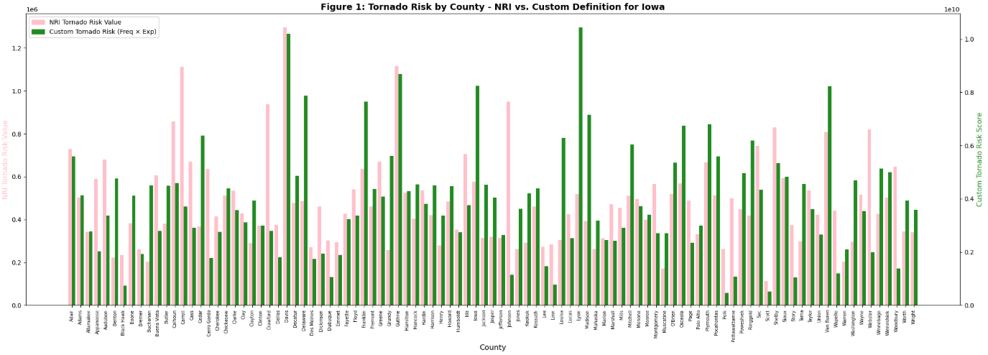
Figure 1. Tornado Risk by County NRI vs. Custom for Iowa
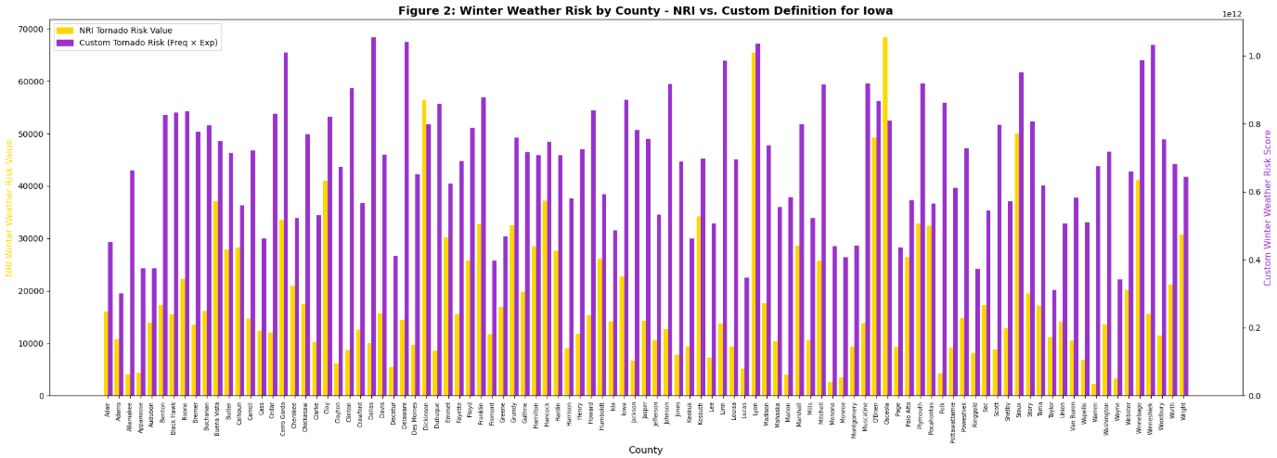
Figure 2. Winter Weather Risk by County NRI vs. Custom for Iowa
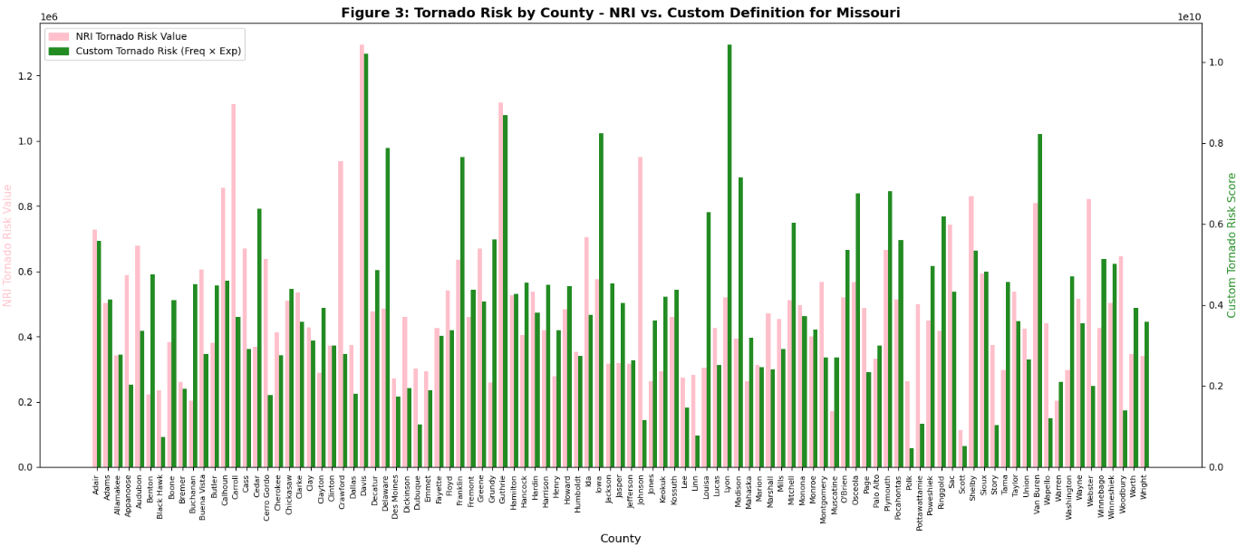
Figure 3. Tornado Risk by County NRI vs. Custom for Missouri
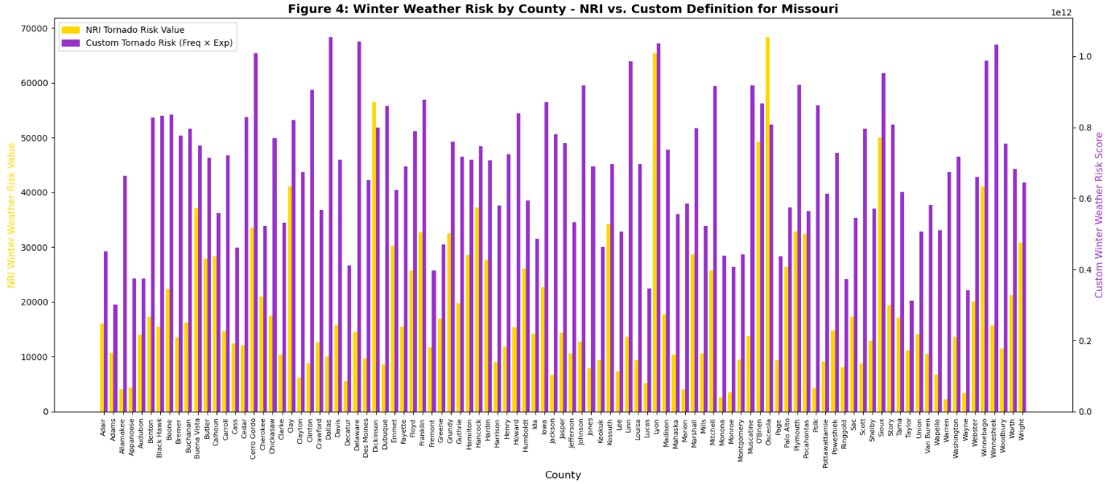
Figure 4. Winter Weather Risk by County NRI vs. Custom for Missouri
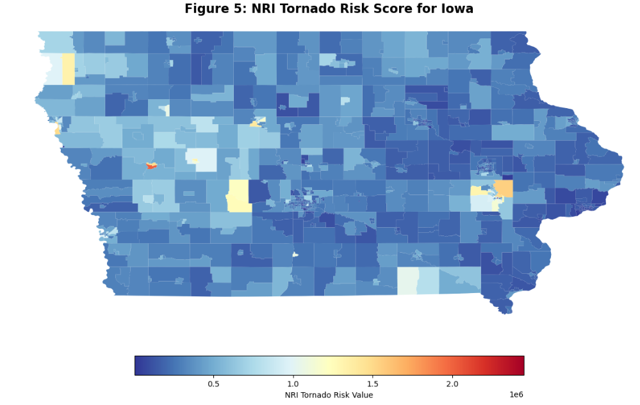
Figure 5. NRI Tornado Risk Score for Iowa
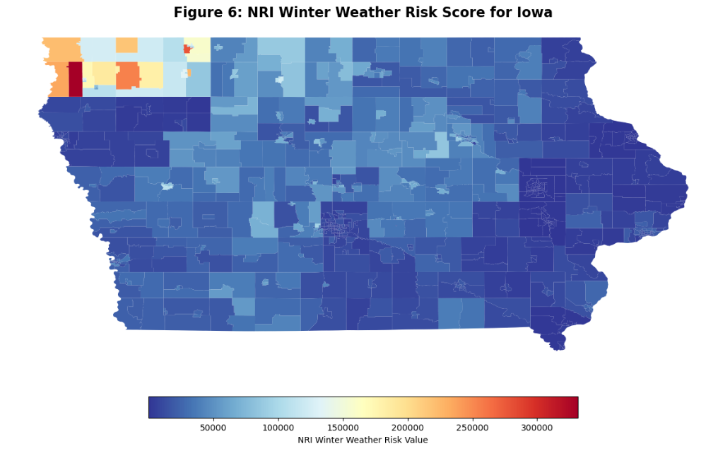
Figure 6. NRI Winter Weather Risk Score for Iowa
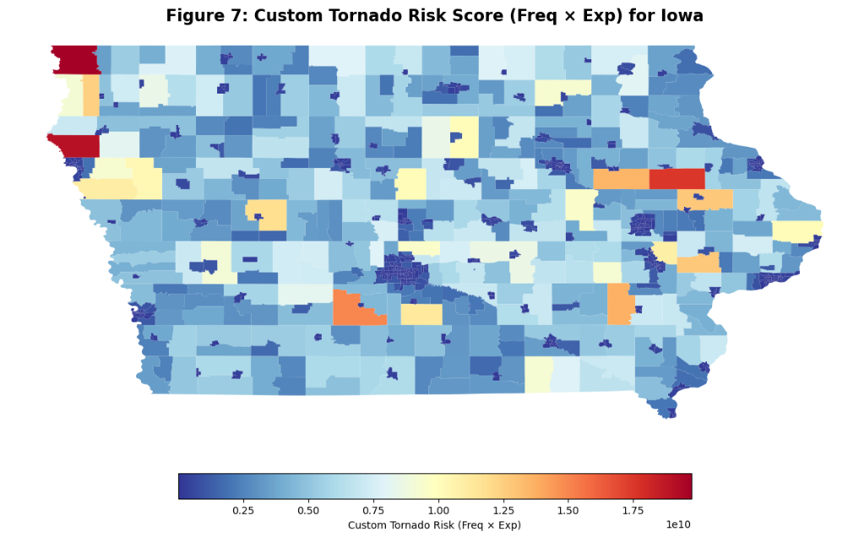
Figure 7. Custom Tornado Risk Score for Iowa
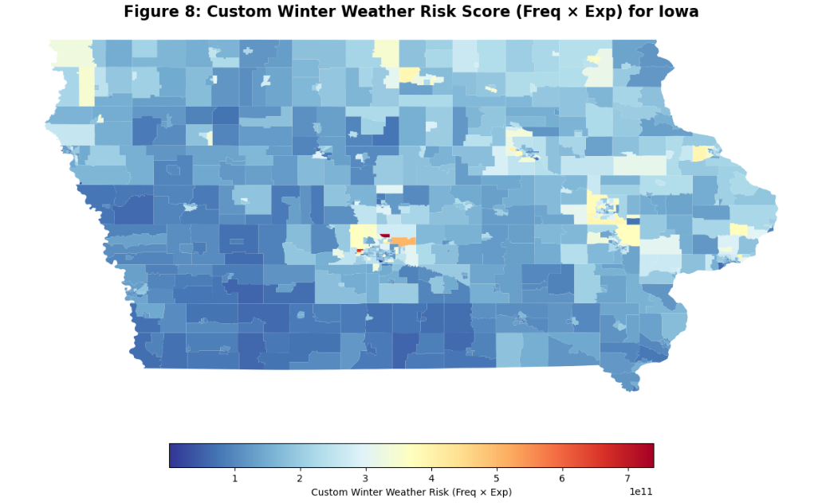
Figure 8. Custom Winter Weather Risk Score for Iowa
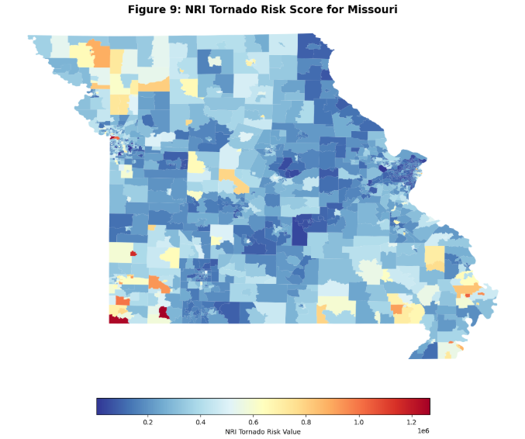
Figure 9. NRI Tornado Risk Score for Missouri
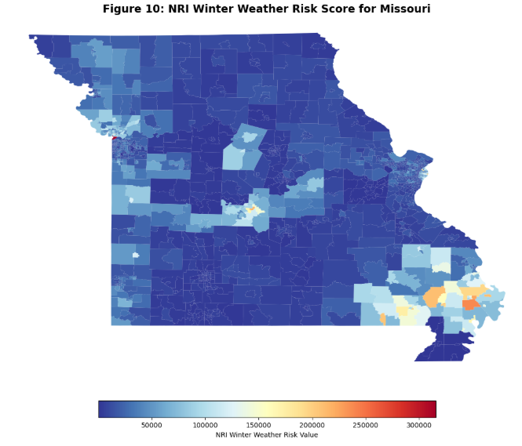
Figure 10. NRI Tornado Risk Score for Missouri
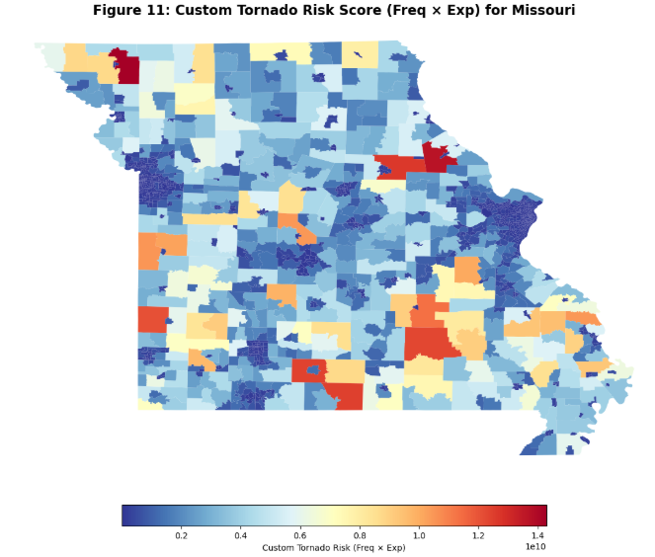
Figure 11. Custom Tornado Risk Score for Missouri
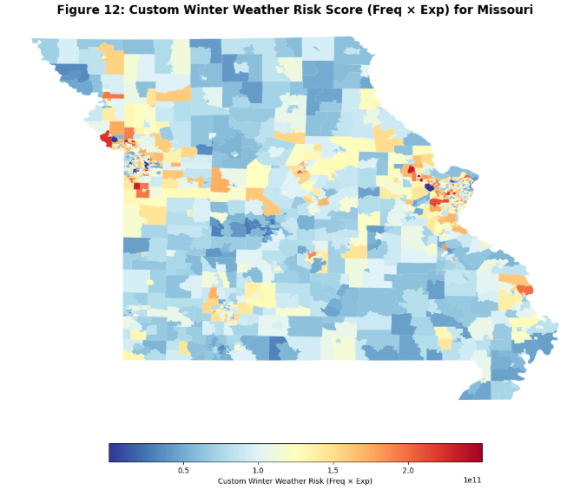
Figure 12. Custom Winter Weather Risk Score for Missouri

Appendix B: Reference List
National Centers for Environmental Information. (2025). Billion-dollar weather and climate disasters. National Oceanic and Atmospheric Administration. https://www.ncei.noaa.gov/access/billions/
U.S. Census Bureau. (2025). American Community Survey (ACS). United States Census Bureau. https://www.census.gov/programs-surveys/acs

