**Proposed model structure**

Hydro, for each sub-basin

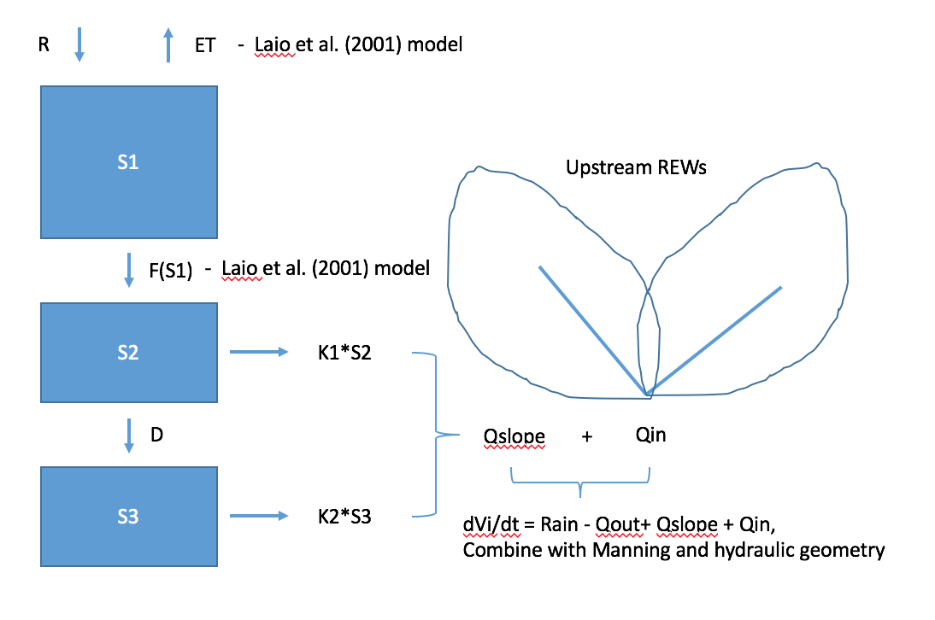

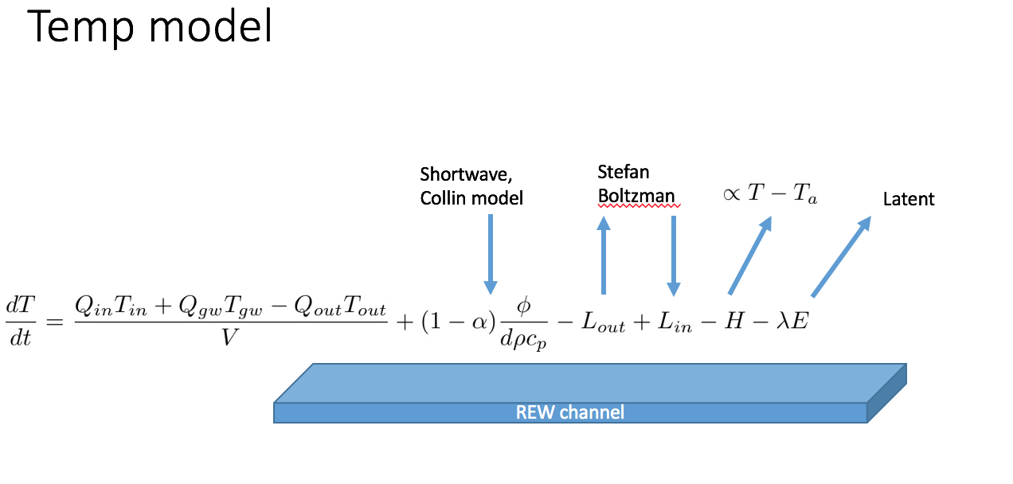

Model application

|  |  |  |
| --- | --- | --- |
| **Model state variables should be able to inform questions relating to…**   * **Trib refugia extent** * **Impact of aspect on hydrology and stream temperature** * **Fish flow thresholds** * **Algae flow/temp** * **Export to ocean?** * **…..??????**   **Are we missing any relevant state variables? Currently, Q, T, along with some internal model variables like REW storage.**  **Scale/resolution of state variables – This will be something we can iterate on, highly dependent on eco-folks requirements, computational tractability, and model structure. REW spatial scale along with the model timestep.** | **We want to examine sensitivity of state variables to…**   * **Shifts in rainfall climatology** * **Temperature** * **Veg type/cover** * **Shifts in H20 abstraction.** | **Scenario development options**   * **Synthetic rainfall generators to examine impact of shifts in rainfall statistics** * **Bias Correction, spatial downscaling (BCSD) -- Resample and rescale historical record to match monthly climate projections (used in several hydrologic studies, e.g. Maurer et al 2010). However, such a method doesn’t alter rainfall event frequency, only magnitudes. Could expand the idea; break the year into fall/winter/spring and use winter resampling with BCSD to examine increased frequency, and fall/spring resampling to examine decreased frequency.** * **Data products , e.g. WRF model using GCM’s for boundary conditions (Salathe, 2012)** |

**Forcing/parameterization data decisions**

* **Rainfall –** 
  + **PRISM, PERSIANN, interpolation of gauges, data fusion.**
  + **There are some newer products out**
    - **MSWEP: 3-hourly 0.25° global gridded precipitation (1979–2015) by merging gauge, satellite, and reanalysis data**
    - **WRF fed by NCAR/NCEP re-analysis (P and T) –**
* **ET –** 
  + **PM, PT, Hargreaves?**
  + **N/S differences?**
  + **FOG**
* **SOIL wise –** 
  + **Classify as mélange, mudstone, eastern…3 lumped parameter sets?**
* **Network and Channel characteristics** 
  + **Manning ‘n’ from bathy lidar?**
  + **W from LiDAR ? (currently hydraulic geometry)**
  + **Jesse’s work on S*A for network extraction – differentiate between geology (if the scale is small enough for this to be relevant)**

**Alternative model frameworks?** 