This assignment was carried out in R. All tables were made using the Stargazer package, all graphs were made in ggplot2, all models were fitted using the lme4 package.

Part A

Q1 Provide some summary statistics about the levels in the data. How many units are there at each level (overall N of each level), and how many units are there within levels (N within each level).

There are 12 different Government office regions (level 3), 4429 different households (level 2), and 4655 individuals (level 1). The table below provides information for every region on the number of households, individuals, and the mean number of individuals per household.

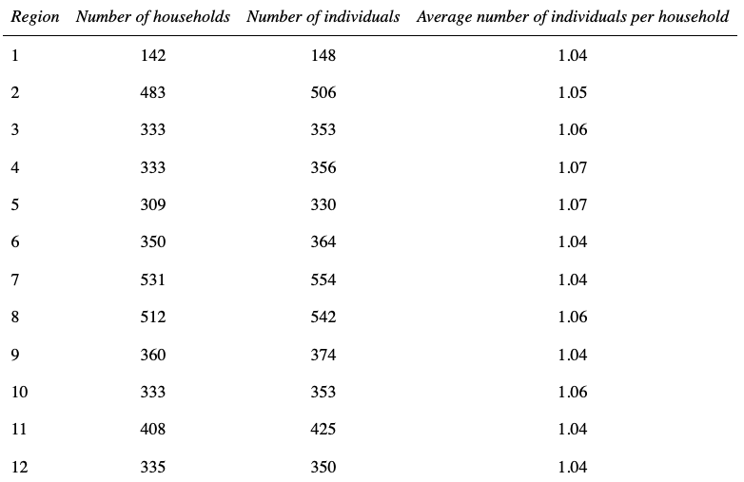
However there were some missing values, after dropping rows with incomplete values the dataset contains 12 different Government office regions (level 3), 3883 different households (level 2), and 4064 individuals (level 1). The table below provides information for every region on the number of households and individuals, and the mean number of individuals per household. The rest of this assignment will be conducted with the missing values removed.
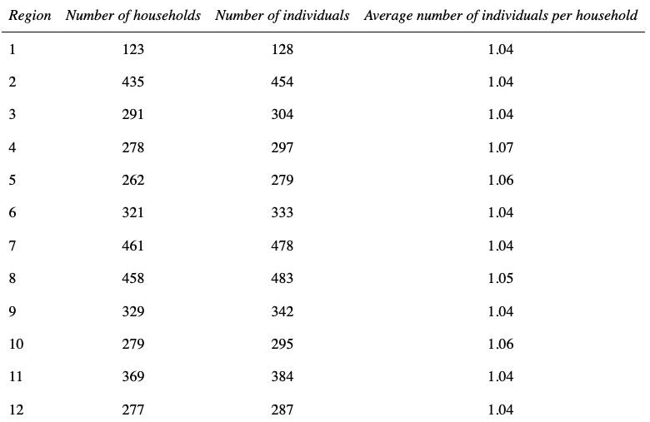

Q2. Specify the generalised equations of a three level multilevel model with random slopes at levels 2 and 3. State the assumptions of the model.

Using the Latex feature for Jupyter notebooks:

Q3. Start from the single level null model and add in the household and then region levels.

A. Display the model coefficients in a table.

Using the tab_model() function for R (Lüdecke, 2020), I created a table with coefficients for the single level null model, a two level model with household at level two, a two level model with region at level two, and the three level model :

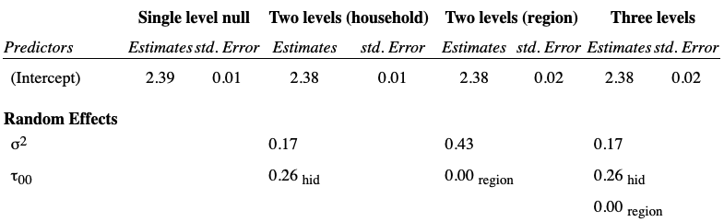

B. Does the addition of the household level improve the fit of the model?

We can use the likelihood-ratio test to asses whether the 2 level household model fits the data better than the single level null model. To do so we calculate the likelihood ratio test statistic, and compare the result to a chi-squared distribution on one degree of freedom.
The likelihood ratio test statistic for these models is approximately 94.45, and the 5% point on a chi-squared distribution with two degrees of freedom is approximately 3.84.
We therefore have strong reasons to believe that the addition of the household level improves the fit of the model.

C.What evidence is there for an improvement in fit?
There are a number of reasons to believe the addition of the household level improves the fit of the model.

First, the likelihood-ratio test conducted in the answer to the previous question provides strong evidence that we have a statistically significant improvement in model fit.

We can also create a 'caterpillar' plot using the ggplot2 package which displays ranked residuals from the household model (in black), with their 95% confidence intervals (in grey), as well as a red line for the average effect.
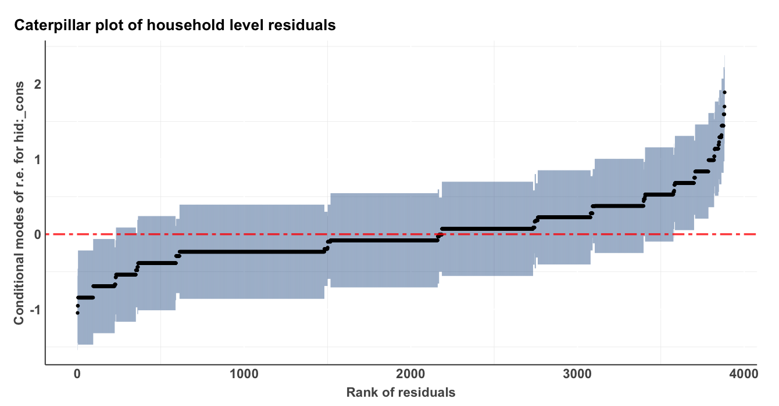
We can see that the confidence individuals of a large number of households do not overlap with this line. In a single level model, all these households would be fit in a similar way, however there is clearly large differences between households, therefore we can expect an improvement in fit in moving to a two level model with households at level 2.

We can also conduct likelihood-ratio tests to asses whether the addition of region at level two provides an improvement in fit over a single level model, and whether a three-level model with household at level two and region at level three provides an improvement in fit over the two-level models.

The likelihood-ratio test statistic for the addition of region at level two is approximately 20.19, which suggest a highly statistically significant improvement in fit.

The likelihood-ratio test statistic for the three-level model is approximately 94.3 when compared to the two-level model with region at level two, and approximately 20 when compared to the two-level model with household at level two. It both cases the test suggests strongly statistically significant improvements in model fit.

Q4: Calculate the VPC at the household and regional levels for the 3 level variance components model.

The residual variances for our model are 0.1672, 0.2588, and 0.0036 for the individual, household, and region levels respectively.

The region VPC is calculated as the ratio of the region variance to the overall variance of the model, therefore:

Region VPC ≈ 0.0036 / ( 0.1672 + 0.2588 + 0.0036)
≈ 0.008

The household VPC is calculated as the ratio of the household variance to the overall variance of the model, therefore:

Household VPC ≈ 0.2588 / ( 0.1672 + 0.2588 + 0.0036)
≈ 0.602

We can therefore say that approximately 0.8% of the variance in our model is between regions, and approximately 60% is within regions, between households (with the remaining variance (≈ 39%) happening within households, between individuals).

Q5. Add in the following explanatory variables in the model (random intercepts model only; no random slopes or coefficients)- age, sclfsato, urban, female, hhtenure, hiqual3. Take out any non-significant associations.
The variable hhtenure was recoded as two binary dummy variables: 'local authority/housing association rent' corresponds to the variable 'rent_local_auth' and 'private rent' corresponds to the variable 'rent_private'. 'Owner/mortgaged' is the reference category.

The variable hiqual3 was also recoded as binary dummy variables: 'school level qualification' corresponds to the variable 'school_qual', and 'No qualification' corresponds the the variable 'no_qual'. 'Degree or equivalent ' is the reference category.

The minimum value for age is 16. For ease of interpretation, 16 was subtracted from the age variable.

Variables were added to the model one by one (dummies of a same variable were added at the same time), each time a likelihood-ratio test was conducted to asses whether the addition of the variable was statistically significant. Female was the only variable which did not pass the test (LR test-statistic of 0.230), and was therefore dropped.

A. Display the model coefficients in a table.

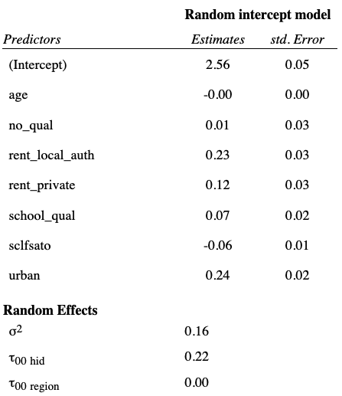

B. Interpret the coefficients.

Q6. Add in random slopes for age, at the household and regional level
A. Does this improve the fit of the model?
We can use the likelihood-ratio test to asses whether the model with age as random slopes at levels two and three fits the data better than the random intercepts model.
The test statistic is approximately 30.05. The 95% critical value on a chi-squared distribution with four degrees of freedom is 9.48. We therefore have strong evidence of an improvement in fit.

B. Take out from the model any non-significant random slope(s) for age

In the above question we established that adding random slopes for age at level two and level three lead to a statistically significant improvement in fit.

However when we add the random slopes individually we find that the likelihood-ratio test statistic is approximately 30.498 for a model with random slopes for age at the household level and 1.096 for a model with random slopes for age at the household level.
The 95% critical value on a chi-squared distribution on two degrees of freedom is 5.99, so the random slope for age at the region level is not statistically significant and is therefore dropped.
Our model output is therefore:
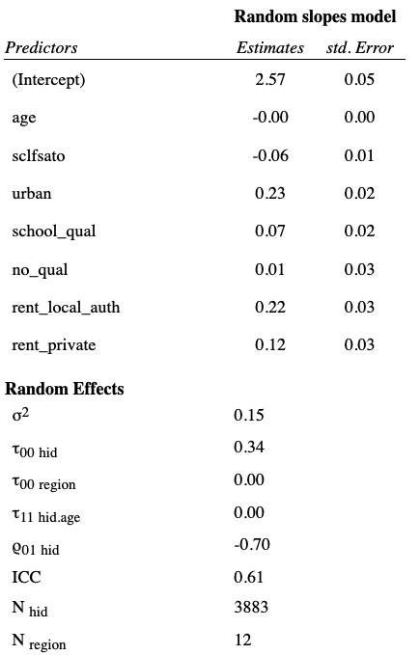
C.Interpret the random slope(s) for age, with the help of graphs.
Due to the reasoning above, our model only contains a single random slope for age (at the household level).

As we can see from the table above, the effect of the random slope for age at the hid level is very small, (the table displays it as 0.00 due to rounding but it's value is approximately 0.00004). However we know from our likelihood ratio test that it is statistically significant.
We can create a plot showing the variation between households in how the predicted score for neighborhood mistrust varies according to age. For greater legibility this plot only includes households with at least two members, and the lines have been colored to represent regions.
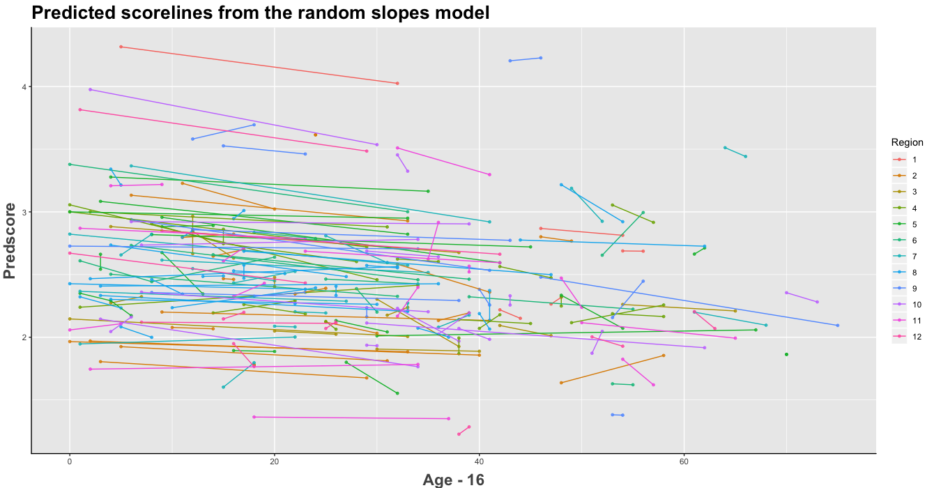
As expected, the general effect of age is quite small. For individuals in some households there is a large effect of age on the predicted value for neighborhood mistrust, however for some households this effect is much smaller.

Using ggpot2, we can create a plot showing how between-household variance changes as a function of age.
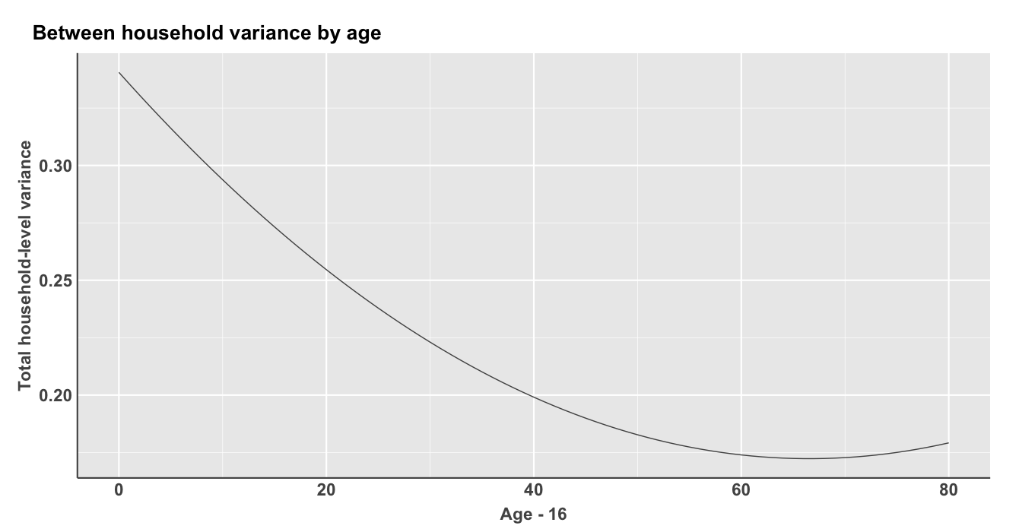
We can also create a plot showing the variation between households in how the predicted score for neighborhood mistrust varies according to age. For greater legibility this plot only includes households with at least two members, and the lines have been colored to represent regions.

As we can see, whilst for individuals in some households there is a large

Q7. Examine potential interaction effects between age and the other explanatory variables- interpret the interactions using graphs. Is the random slope of age explained by these interaction terms?
There are six different possible interaction terms for age. Adding each of these in turn to the random intercept model from question 5, and conducting likelihood ratio tests, we find significant improvements in fit from the interaction terms with worry_crime (the test statistic is approximately 47.89), the household tenure dummy variables (the test statistic is approximately 20.57), and urban ( the test statistic is approximately 5.36).

However there was no significant improvement in fit from adding interaction terms with female (the test statistic is approximately 0.52), sclfsato (the test statistic is approximately 0.66), and education dummy variables (the test statistic is approximately 2.48).

Comparing a three level model random intercept model with all the significant variables (age, sclfsato, urban, school_qual, no_qual, rent_local_auth, rent_private, ageXworry_crime, ageXurban, ageXrent_local_auth, and ageXrent_private) to a random slope model with the same explanatory variables and with a random slope for age at the household level, we find that the addition of a random slope model provides a statistically significant improvement in fit (33.62)

Q8. After fitting all the explanatory variables, is a three level model still appropriate? - 2 marks

Q9. Display and interpret the parameters in your final model in a table. - 5 marks

Q10. Examine residuals at all three levels- are the assumptions of the regression model met? - 5 marks

Part B: Dependent variable: worry_crime (20 marks)
Fit a multilevel logistic model with worry_crime as the dependent variable.
- Q11. Start from the single level null model and add in the household and then GOR levels. Display the model coefficients for the 3 level variance components model in a table. - 5 marks
- Q12. Is a three level model appropriate? Is a 2 level model appropriate? Is a single level model appropriate? If a 2 level model is appropriate, which two level models (individuals within HH or individuals within GOR)? State your reasons for choosing between a 2 vs 3 level model. - 5 marks
- Q13. Having decided whether a multilevel or single level model is appropriate, add in the explanatory variables from your final model in Part A. Compare the models using a Table. Are the associations with worry_crime similar to the associations with nhood_mistrust? - 5 marks
- Q14. Take out any non-significant explanatory variables from the model. Interpret the coefficients in your final model in a table. 5 marks

Q11. Start from the single level null model and add in the household and then GOR levels. Display the model coefficients for the 3 level variance components model in a table
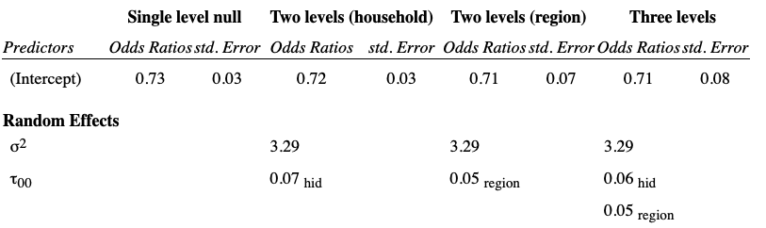
Q12. Is a three level model appropriate? Is a 2 level model appropriate? Is a single level model appropriate? If a 2 level model is appropriate, which two level models (individuals within HH or individuals within GOR)? State your reasons for choosing between a 2 vs 3 level model.

Conducting likelihood ratio tests against the single level null model we find a non-significant improvement in fit for the two-level model with household at level 2 (the test statistic is 0.6337), but a significant improvement in fit for the two-level model with region at level 2 (the test statistic is 41.5984).
Therefore a two-level model would be appropriate with region at level two, but not with household.
A three-level model provides a significant improvement in fit when compared to the single level null model (the test statistic is 42.0264) and to the two-level model with household at level 2 (the test statistic is 41.3927), however the improvement in fit is not significant compared to the two-level model with region at level 2 (the test statistic is 0.428).
Both the three-level model and the two-level model with region at level 2 show improvements in fit over the other models, however since there is no statistically significant difference in fit between this model, the most appropriate model is the more parsimonious two-level model with region at level 2.
Q13. Having decided whether a multilevel or single level model is appropriate, add in the explanatory variables from your final model in Part A. Compare the models using a Table. Are the associations with worry_crime similar to the associations with nhood_mistrust?
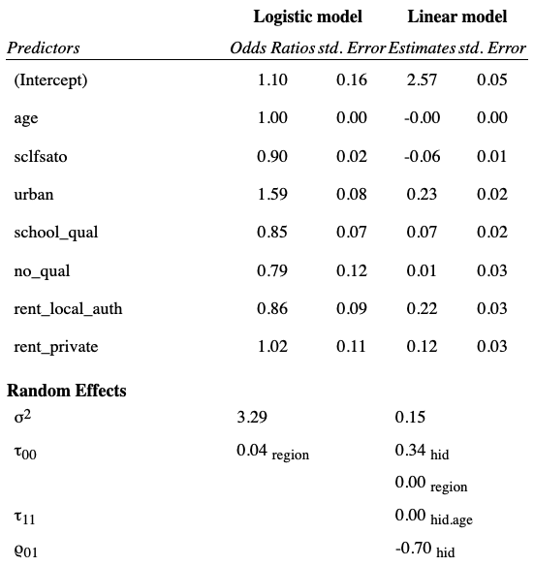

Hi Julian,

Sorry I was just searching for this email to chase you and realise you replied within 10 minutes and I just missed it!

Not sure about the length of postponement, I think it should be until we are sure that Nathan can carry out the proposed internship project safely and in line with government guidance around COVID-19. So things like your office reopening, being able to approach and interview people, these things will be a requirement.

Nathan what do you think?

Many thanks,
Reka

Hi all,

I agree with what Reka says in her e-mail. Another issue is that the university campus looks like it will not be open until January

