GréineQ
Reinforcement Learning for Home Battery Dispatch
on a Solar-Connected Microgrid
B9AI105 Reinforcement Learning
Continuous Assessment 1
[Member 1 Name] ([Student ID])
[Member 2 Name] ([Student ID])
[Member 3 Name] ([Student ID])
Dublin Business School
Submission date: 7 July 2026
Repository: github.com/NathanLCR/rl-battery-dispatch (branch: Qagent)
Live dashboard: https://greineq-agent.sudocod.com/

Abstract
Rising global energy and fuel costs make home battery dispatch a timely problem. This project presents GréineGrid Qagent, a tabular reinforcement learning (RL) system that learns battery dispatch policies from real Ausgrid solar-and-load data merged with AEMO NSW1 spot prices for a single residential customer. We formulate a custom Markov decision process with 324 discretised states and three actions (hold, charge from surplus solar, discharge to offset load), and train Q-Learning and SARSA agents entirely from scratch in NumPy. A monetised reward function aligns training with household grid-import cost in Australian dollars, including retail tariff margin, feed-in credit for curtailed solar, and optional battery degradation. On a held-out test split of 53 days, Q-Learning and SARSA reduce import cost by roughly 33% versus a tertile rule baseline but do not beat greedy self-consumption, which captures most of the gap to a perfect-foresight oracle. Reward redesign aligning training with retail AUD cost is essential. Tariff sensitivity and a Streamlit digital-twin dashboard (https://greineq-agent.sudocod.com/) complete the evaluation.
Keywords—Reinforcement learning; Q-Learning; SARSA; home battery; energy management; microgrid; Ausgrid; tabular methods

1. Introduction

1.1 Problem Context
Rising wholesale fuel and electricity costs have put household energy bills at the centre of public debate worldwide. Volatile international fuel markets, supply-chain disruptions, and the transition away from fossil generation have increased retail tariffs in many countries, including Australia, where households face higher grid import prices even as rooftop solar adoption grows [7]. In this context, home batteries are promoted as a way to store cheap midday solar and reduce exposure to expensive evening peak imports, turning energy storage from a convenience into a practical response to cost-of-living and energy-security pressures.
Residential electricity users with rooftop photovoltaic (PV) systems face a daily scheduling problem. Solar generation peaks around midday while household demand often peaks in the morning and evening. Without storage, surplus solar is exported to the grid at a low feed-in rate while later demand is met by expensive grid imports. A home battery can shift energy in time, but the controller must decide at each timestep whether to charge from available surplus, discharge to meet deficit, or hold—under constraints on state of charge (SOC), power limits, and same-day solar availability. This is a real operational problem for Australian networks such as Ausgrid, where half-hourly smart-meter data capture the variability that any practical controller must handle. Recent building-energy reviews identify storage-aware dispatch as a central use case for renewable integration in residential settings [2].

1.2 Why Reinforcement Learning?
Battery dispatch is not a one-shot prediction task. The value of charging now depends on future load, PV, and prices over the remainder of the day. Reinforcement learning (RL) frames the controller as an agent that selects actions, receives rewards, and transitions to new states—exactly the sequential decision-making structure described in the MDP formalism [1]. Unlike supervised learning, there is no historical label for the “correct” action at each timestep; the agent must discover a policy through interaction with a simulated environment. This project implements tabular Q-Learning and SARSA from scratch, which is appropriate when the discretised state space remains small enough for a Q-table (324 states, 3 actions) while still reflecting real household dynamics. Surveys of RL in smart grids and buildings report that reward design and state representation strongly influence whether learned policies transfer beyond simulation [2], [8].

1.3 Why Not Rule-Only or Supervised Learning?
Rule-based controllers—such as “charge when PV is high, discharge when load is high”—are easy to deploy but myopic: they react to current conditions without learning long-horizon trade-offs across the day. Supervised learning would require labelled optimal actions, which are unavailable for real households unless derived from an oracle with perfect foresight. RL instead optimises cumulative reward over full episodes (one calendar day, 48 thirty-minute steps), allowing policies to improve through trial and error while remaining interpretable via the learned Q-table.

1.4 Contributions
This report documents the following contributions of the GréineGrid Qagent project:
- A custom MicrogridEnv MDP calibrated on merged Ausgrid Customer 1 and AEMO NSW1 data, with deterministic battery physics and exogenous PV, load, and price trajectories.
- A discretised tabular state space (SOC, PV, load, price, time-of-day) yielding 324 states and a Q-table of 972 values, implemented without third-party RL libraries.
- A monetised reward redesign (v1 wholesale proxy → v2 household cost) that aligns training objectives with the primary evaluation metric: total grid import cost in AUD.
- Rigorous baselines including no-battery floor, perfect-foresight oracle, greedy self-consumption, and a tertile rule—enabling honest comparison of RL against strong heuristics rather than a weak straw-man.
- Comparative evaluation of Q-Learning (off-policy) and SARSA (on-policy) on train/val/test day splits, with supplementary experiments on tariff sensitivity and reward ablation.
- A Streamlit digital-twin dashboard for visual replay of dispatch decisions on historical days (live deployment: https://greineq-agent.sudocod.com/).

1.5 Report Outline
Section 2 reviews related work on RL for energy management and tabular methods. Section 3 describes the dataset, MDP formulation, reward design, discretisation, algorithms, and evaluation pipeline. Section 4 presents training dynamics and test-set results. Section 5 discusses findings, limitations, and business relevance. Section 6 concludes and outlines future work. References follow IEEE style; supplementary material appears in the Appendix.

2. Literature Review

2.1 Battery Dispatch and Self-Consumption
Home energy management systems (HEMS) aim to minimise electricity cost and maximise self-consumption of locally generated solar. Simple strategies prioritise using PV generation to meet on-site load before importing from the grid—a principle often called greedy self-consumption. More advanced approaches incorporate time-of-use tariffs, demand response signals, and battery degradation costs [2], [6]. Industry interest in behind-the-meter storage has grown with retail price volatility and export limits, making dispatch optimisation a practical rather than purely academic concern.

2.2 Reinforcement Learning for Energy Scheduling
RL has been applied to microgrid operation, electric-vehicle charging, and residential battery control. Michailidis et al. [2] review RL for renewable-energy utilisation in buildings (2015–2025), covering algorithms, reward functions, and baseline comparisons. Vamvakas et al. [8] evaluate RL frameworks on smart-grid applications more broadly. For smart homes with rooftop PV and storage, Lee and Choi [3] use model-free Q-Learning to schedule ESS charge/discharge and controllable appliances under time-of-use pricing, while Wei et al. [4] employ deep RL (PPO) for real-time scheduling with continuous actions. Liu et al. [5] demonstrate tabular Q-Learning with ε-greedy exploration for BESS market scheduling. Xu et al. [6] compare DRL variants (DQN, DDPG, TD3) on residential hybrid systems with cost and self-consumption objectives. Agents typically observe SOC, load, generation, and price—closely matching our state variables. Most published work uses either dynamic programming with simplified models or deep networks for continuous states; our project deliberately stays tabular to satisfy CA1 requirements and to preserve interpretability of the learned Q-table.

2.3 Tabular Q-Learning and SARSA
Sutton and Barto [1] provide the foundation for model-free tabular RL. Q-Learning updates toward the maximum Q-value over next-state actions (off-policy), learning the greedy policy while exploring with ε-greedy action selection. SARSA updates using the action actually taken under the current behaviour policy (on-policy), which can yield safer learning when exploration has real cost—as in battery cycling or high-price import periods. Both algorithms are suitable when |S| and |A| are small enough to store Q(s,a) explicitly. Lee and Choi [3] and Liu et al. [5] show that tabular Q-Learning remains competitive for BESS dispatch when the discretised state space is small. The curse of dimensionality motivates binning continuous observations before tabular learning [1]; this trade-off between state fidelity and table size is central to our methodology.

2.4 Research Gap and Our Approach
Much of the energy-RL literature either relies on synthetic simulators with simplified tariffs [4], [6] or compares RL only against weak baselines [2]. Gautam [7] notes that DRL for power-system resilience is advancing rapidly, yet applied residential studies with real metering data and strong heuristic bounds remain scarce. Few projects combine (i) real half-hourly household data [9], (ii) wholesale-linked retail costing [10], (iii) tabular Q-Learning and SARSA implemented from scratch, and (iv) oracle and greedy-SC bounds that quantify how much improvement remains. GréineGrid Qagent fills this gap by building a reproducible pipeline from Ausgrid and AEMO sources through a custom environment to multi-baseline evaluation. We explicitly report when a simple greedy heuristic captures most of the oracle gap—a finding that shapes how RL value should be communicated to stakeholders rather than overstating algorithmic superiority.

3. Methodology
This section describes the data pipeline, MDP formulation, reward design, state discretisation, learning algorithms, training protocol, and software implementation used in GréineGrid Qagent.

3.1 Data and Experimental Setup

3.1.1 Data Sources and Merge Pipeline
Two public datasets are combined to build daily microgrid episodes. The Ausgrid Solar Home Electricity Data record half-hourly household load and rooftop PV generation for more than 300 anonymised customers in New South Wales (2012–2013) [9]. Five customers were retained for this project; all primary experiments use Customer 1. In the raw Ausgrid files, general consumption is labelled GC and gross solar generation GG. These were renamed load_kwh and pv_kwh respectively. Data arrive in wide format—grouped by consumption category, date, and customer ID with 48 half-hour columns from 00:30 through to 00:00 the following day—and were unpivoted to one row per timestamp.
Wholesale electricity data come from the Australian Energy Market Operator (AEMO) PRICE_AND_DEMAND files for the NSW1 region [10], providing regional reference price (RRP) and system demand at 30-minute resolution. Ausgrid timestamps are recorded in local civil time (including daylight saving); AEMO uses fixed Australian Eastern Standard Time. Both sources were converted to Australia/Sydney and aligned to the same physical instant before merging. Rows are inner-joined on timestamp so every interval carries a valid price. RRP in AUD/MWh is divided by 1000 to obtain price_per_kwh. A derived column net_load_kwh = load_kwh − pv_kwh summarises the instantaneous site balance (positive values indicate net import requirement before battery action).

3.1.2 Exploratory Data Analysis
Exploratory analysis on Customer 1 motivates both the MDP design and the evaluation split. Figure 1 shows the distribution of NSW spot prices (AUD/kWh). The distribution is strongly right-skewed with a modal band near 0.05 AUD/kWh, a thin upper tail near 0.32 AUD/kWh, and occasional negative prices when supply exceeds demand and producers are effectively paid to consume.
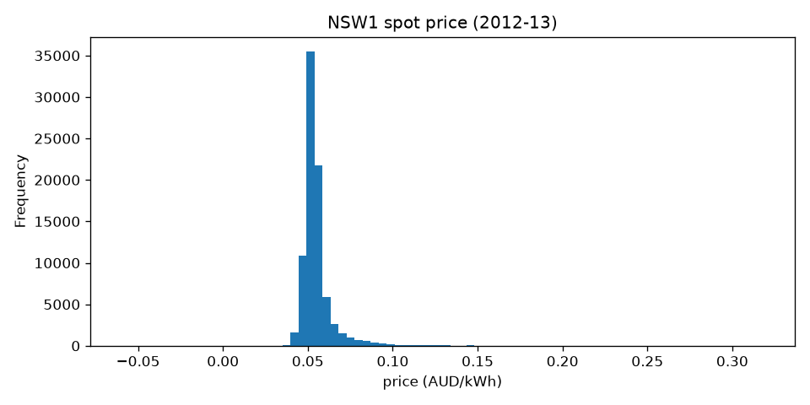
Fig. 1. NSW spot price distribution (AUD/kWh).

Figure 2 plots the average daily profile of Customer 1 load, PV, and price. Solar generation follows a bell curve peaking around midday while household load is elevated in morning and evening. Wholesale price tends to peak near 18:00. This mismatch is the core scheduling challenge: store midday solar surplus and discharge during the evening price and load peak—the behaviour RL agents and baselines are compared on.
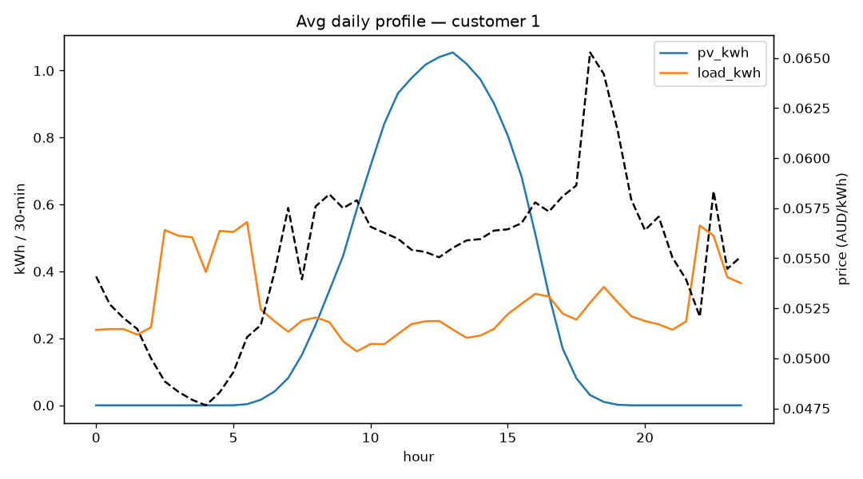
Fig. 2. Average daily profile — Customer 1 load, PV, and price.

Figure 3 shows monthly average solar and load, revealing opposite seasonal patterns (higher PV in summer, higher consumption in winter). Strong seasonality motivates a month-stratified train/validation/test partition rather than a simple chronological cut, so that each split contains representative summer and winter days.
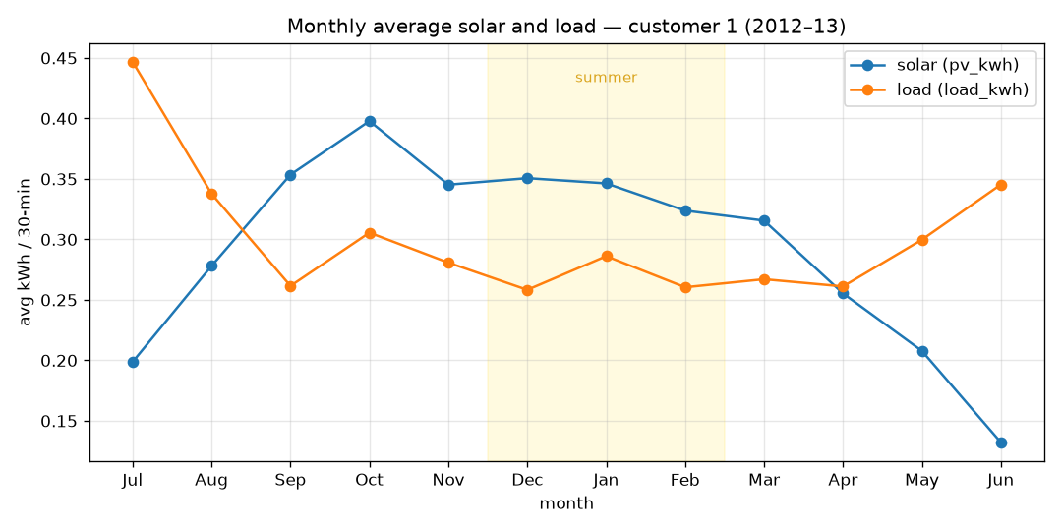
Fig. 3. Monthly average solar generation and load — Customer 1.

3.1.3 Episode Construction and Data Split
Each RL episode is one calendar day of exactly 48 consecutive 30-minute steps. Days with incomplete intervals are excluded. Two daylight-saving transition days (7 October 2012 and 4 July 2013) contained only 46 readings because of skipped or repeated hours and were discarded.
The day-level partition in day_split.json applies month-stratified sampling at approximately 70% train, 15% validation, and 15% test (256 / 54 / 53 days respectively), with fixed random seed 50 for reproducibility. Customer 2 was excluded from split generation because it contains only 284 complete days (versus ~365 for other customers), with whole months partially missing, which would break monthly stratification. Discretiser tertile thresholds are fitted on training rows only; validation supports periodic greedy evaluation during training and test is held out for all final policy comparisons reported in Section 4.
Split | Days | Share | Purpose
Train | 256 | ~70% | Fit discretiser; sample episodes for RL updates
Validation | 54 | ~15% | Greedy policy checkpoint every 500 episodes
Test | 53 | ~15% | Held-out comparison of all policies (primary results)

Table I. Month-stratified day-level partition for Customer 1 (seed = 50).

3.2 MDP Formulation
The battery dispatch problem is modelled as a finite-horizon Markov decision process ⟨S, A, P, R, γ⟩ following standard RL notation [1] and building-energy MDP practice [2]. At each discrete timestep t ∈ {0, …, 47} the agent observes a state s_t ∈ S, selects an action a_t ∈ A, receives reward r_t = R(s_t, a_t, s_{t+1}), and transitions to s_{t+1}. Episodes terminate after 48 steps. The discount factor γ = 0.95 reflects a within-day planning horizon: rewards later in the evening are still valued but weighted less than immediate cost reductions.
Action space (|A| = 3):
Action | Code | Semantics
Hold | 0 | No deliberate charge or discharge
Charge | 1 | Store surplus solar (PV − load > 0), subject to power and SOC limits
Discharge | 2 | Offset load deficit (load − PV > 0), subject to power and SOC limits

Transitions combine deterministic battery physics with exogenous PV, load, and price trajectories read from the dataset row at step t. The agent cannot influence future weather or prices; it only controls storage. Charging from the grid and export to the grid are not modelled in v1—price is observed but arbitrage is limited to timing of solar self-consumption.
Battery parameters (Table II) define a 10 kWh pack with 5 kW charge/discharge limits over 0.5 h steps (2.5 kWh max energy transfer per step). SOC is initialised at 50% each day. Operational bounds use 10–90% hard limits and 30–70% guard bands for discretisation.
Parameter | Value
Capacity | 10 kWh
Initial SOC | 50%
Max charge / discharge power | 5 kW
Step duration | 0.5 h (30 min)
SOC hard limits | 10% – 90%
SOC bins (low / high) | 30% / 70%

Table II. Battery and timestep parameters (config.yaml).
Energy balance per step follows the shared physics module. Let surplus = max(0, PV − load) and deficit = max(0, load − PV). Charge and discharge energies are clipped by per-step power limits and available SOC headroom. Grid import and curtailed solar are:
grid_import = max(0, load − PV − discharge)
solar_waste = max(0, PV − load − charge)
Markov property caveat: the true state would include the step index within the day. We approximate time using four coarse time-of-day bins (night, morning, afternoon, evening) rather than t mod 48, trading exact Markov sufficiency for a compact 324-state table.

3.2.1 Formal MDP Specification
Formally, each episode defines an exogenous input sequence ω_t = (PV_t, L_t, p_t) from the dataset for t = 0, …, 47, where PV_t and L_t are solar and load (kWh per 30-min step) and p_t is wholesale price (AUD/kWh). The endogenous state is x_t = (b_t, ω_t, τ_t): battery SOC b_t ∈ [0, 100]% (continuous, then binned for the agent), exogenous ω_t, and time-bin τ_t ∈ {0,1,2,3}. The observed RL state is s_t = φ(x_t) ∈ {0, …, 323} for encoding φ defined in Section 3.4.
The transition kernel is deterministic given action and ω_t. For action a_t and physics output (charge, discharge, import, waste, b_{t+1}) from Section 3.2:
P(s_{t+1} | s_t, a_t) = 1 if s_{t+1} = φ(b_{t+1}, ω_{t+1}, τ_{t+1}), else 0
Because ω_{t+1} is fixed by the historical record, the environment does not model stochastic weather or price forecasts—the agent learns a policy π(a|s) over replayed real trajectories. Terminal states occur at t = 47 with zero bootstrap value. This specification is complete for the implemented simulator; grid-import charging and export actions would extend A and the physics map and are deferred to future work (Section 6).

3.3 Reward Design
Reward design is critical because the agent optimises cumulative return, not grid cost directly [2], [6]. An early prototype (v1) penalised wholesale spot price without a consistent retail margin or feed-in treatment. Training reward then diverged from the evaluation metric (total retail import bill in AUD), so agents could appear worse than a rule baseline on paper while improving on the proxy objective—a misalignment emphasised in building-RL reviews when reward terms do not match operational KPIs [2].
The production reward (v2) expresses negative household cost at each step. Let p_retail = p_wholesale + m with retail margin m = 0.22 AUD/kWh. Then:
r_t = −w_c · import_t · p_retail − w_s · waste_t · f − w_d · deg_t − w_i · invalid_t
where import_t is grid_import_kwh, waste_t is curtailed solar (kWh), f = 0.06 AUD/kWh is the feed-in rate for exported/curtailed PV opportunity cost, deg_t scales SOC violations outside [10%, 90%], and invalid_t flags physically impossible charge/discharge requests (e.g. charge when SOC is full). Weights w_c, w_s, w_d, w_i are configurable; the default battery_aware profile sets w_c = w_s = w_d = 1.0 and w_i = 0.1. A cost_only ablation sets w_d = 0 to isolate bill minimisation from degradation shaping.
Because reward terms are in AUD, maximising ∑ r_t aligns with minimising total grid import cost plus solar opportunity and degradation penalties—the same quantities reported in evaluation. This alignment is verified in the reward-redesign experiment (Section 4.5).

3.4 Discretization
Continuous observations are mapped to a finite state index for tabular RL. PV, load, and wholesale price use tertile (33rd / 66th percentile) boundaries estimated on training data only. SOC uses fixed thresholds at 30% and 70%. Time of day uses four bins: night (00:00–06:00), morning (06:00–12:00), afternoon (12:00–18:00), evening (18:00–24:00).
The composite state index is a mixed-radix encoding of (SOC, PV, load, price, time) with dimensions (3, 3, 3, 3, 4), yielding |S| = 324 states and a Q-table of 324 × 3 = 972 entries. This size is tractable for tabular methods but introduces aliasing: distinct continuous observations may share a bin. A known limitation is PV tertile degeneracy—many overnight intervals have PV = 0, collapsing the low-PV bin. Finer daytime-only PV binning is noted as future work.
Adding one extra bin per continuous feature would multiply state count roughly by 3⁴ = 81 (curse of dimensionality [1]), motivating our deliberate coarse choice for CA1 rather than deep function approximation [4]. Liu et al. [5] similarly discretise continuous BESS states before tabular Q-Learning.

3.5 Algorithms
Two model-free tabular algorithms are implemented from scratch in NumPy without Stable Baselines3 or other RL libraries, following the Q-Learning and SARSA formulations in [1] and applied BESS studies [3], [5]. Both maintain Q(s,a) in a dense table initialised to zero and use ε-greedy exploration during training.
Q-Learning (off-policy) bootstraps from the maximum next-state action value:
Q(s,a) ← Q(s,a) + α [ r + γ max_a′ Q(s′,a′) − Q(s,a) ]
At terminal steps (t = 47), the target reduces to r. SARSA (on-policy) uses the action a′ actually selected under the behaviour policy at s′:
Q(s,a) ← Q(s,a) + α [ r + γ Q(s′,a′) − Q(s,a) ]
Double Q-Learning is optionally available to reduce maximisation bias by maintaining two tables and alternating updates; it is noted in the implementation but primary results focus on standard Q-Learning and SARSA as required for CA1.
Hyperparameters (Table III) are shared unless otherwise stated in ablation runs.
Hyperparameter | Symbol | Value
Learning rate | α | 0.1 (decays ×0.9995/ep, floor 0.01)
Discount factor | γ | 0.95
Initial ε | ε | 0.1
Minimum ε | ε_min | 0.01
ε decay | — | ×0.999 per episode
Training episodes | — | 10,000
Random seed | — | 42
Q-table shape | — | 324 × 3

Table III. Default training hyperparameters (config.yaml).

3.6 Training and Evaluation Pipeline
Training proceeds episodically: each episode samples a random day from the 256-day train split, resets SOC to 50%, and steps through all 48 intervals with ε-greedy action selection and TD updates. After each episode, ε (and α when enabled) decay. Every 500 episodes the current greedy policy is evaluated on all 54 validation days; mean validation reward and mean grid cost (AUD/day) are logged for learning-curve plots.
Final policies are evaluated greedily (ε = 0) on the 53-day test split. The primary KPI is total_grid_cost_aud summed over test days (equivalently mean daily import bill). Secondary KPIs include self-consumption rate, self-sufficiency, evening peak import after 17:00, and pct_of_oracle_savings relative to a no-battery floor and a perfect-foresight dynamic-programming oracle.
Baseline policies compared on identical test days:
Policy | Description
no_battery | Always hold — cost without storage (worst-case floor)
oracle_perfect_foresight | Backward DP with 101 SOC grid points — cost lower bound
greedy_self_consumption | Charge any surplus, discharge any deficit — strong heuristic
rule_tertile | Charge on top-PV tertile, discharge on top-load tertile — weak heuristic
Q-Learning / SARSA | Greedy action argmax_a Q(s,a) from trained table

Greedy self-consumption is the primary reference baseline because it is a standard industry heuristic; the tertile rule is retained for historical comparison. Supplementary scripts support multi-seed runs (run_seeds.py), cross-customer transfer, reward ablation, and tariff sensitivity over retail margins {0.15, 0.22, 0.35} AUD/kWh.

3.7 Implementation
The codebase (GitHub: NathanLCR/rl-battery-dispatch, branch Qagent) is organised under src/ with environment.py (MicrogridEnv), physics.py (shared step dynamics), discretizer.py, agents/ (Q-Learning, SARSA, Double Q-Learning), train.py, evaluate.py, compare.py, and visualisation utilities. Configuration is centralised in config.yaml. Dependencies are limited to NumPy, Pandas, Matplotlib, PyYAML, Streamlit, and SciPy for optional significance tests—no imported RL frameworks.
A Streamlit dashboard (dashboard/app.py) provides a digital-twin interface: an overview page with an animated day replay and a twin view for side-by-side comparison of baselines and learned policies on any train/val/test day. The application is deployed publicly at https://greineq-agent.sudocod.com/. Training logs, model checkpoints (.npy Q-tables), and plots are written to results/ and excluded from version control; experiments are reproducible from config.yaml and day_split.json. A Google Colab notebook mirrors the training pipeline for cloud execution.

4. Results
All primary results are reported on the 53-day held-out test split (Customer 1, battery_aware reward, γ = 0.95, 10,000 training episodes, seed 42). Costs are total retail import bills summed over test days unless stated as daily means.

4.1 Training Dynamics
Figure 4 shows the rolling mean episodic reward for Q-Learning over 10,000 training episodes. Reward improves rapidly in the first ~2,000 episodes and plateaus thereafter; similar behaviour is observed for SARSA. Validation greedy grid cost (logged every 500 episodes) stabilises after approximately 4,000 episodes, motivating the use of 10,000 episodes for final models to ensure convergence while avoiding unnecessary compute. Figure 5 shows the corresponding SARSA training curve, and Figure 6 plots validation mean grid cost (AUD/day) against the tertile rule reference on validation days.
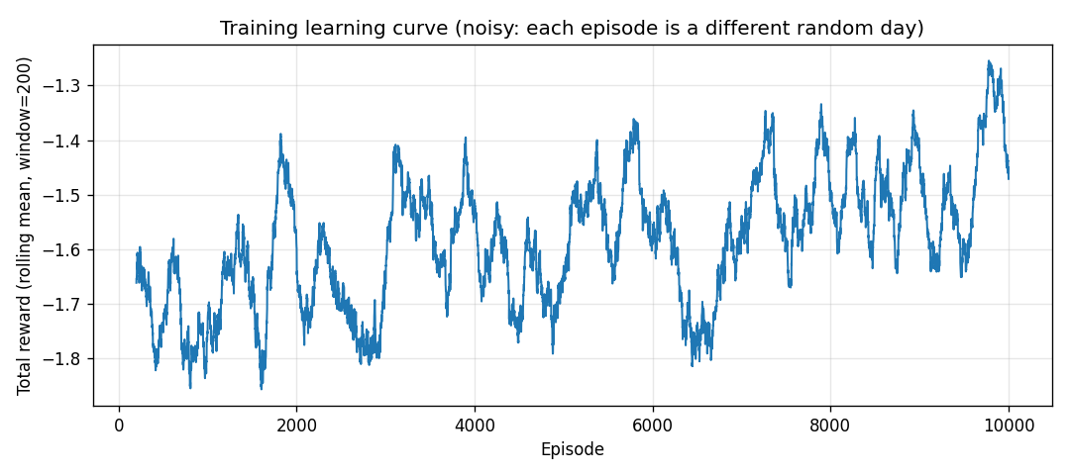
Fig. 4. Q-Learning training reward (200-episode rolling mean, 10,000 episodes).

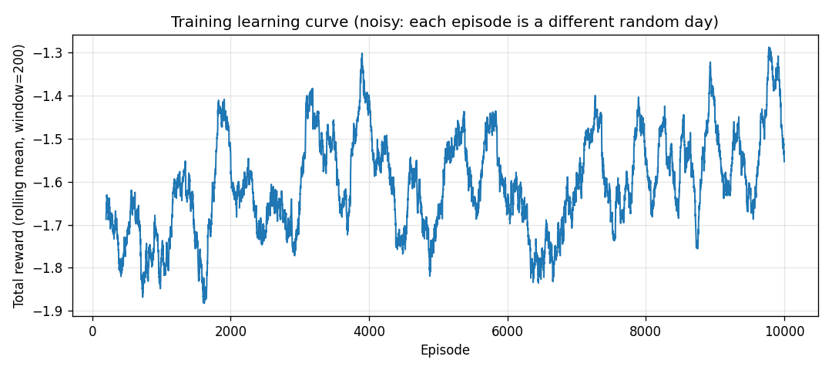
Fig. 5. SARSA training reward (200-episode rolling mean, 10,000 episodes).

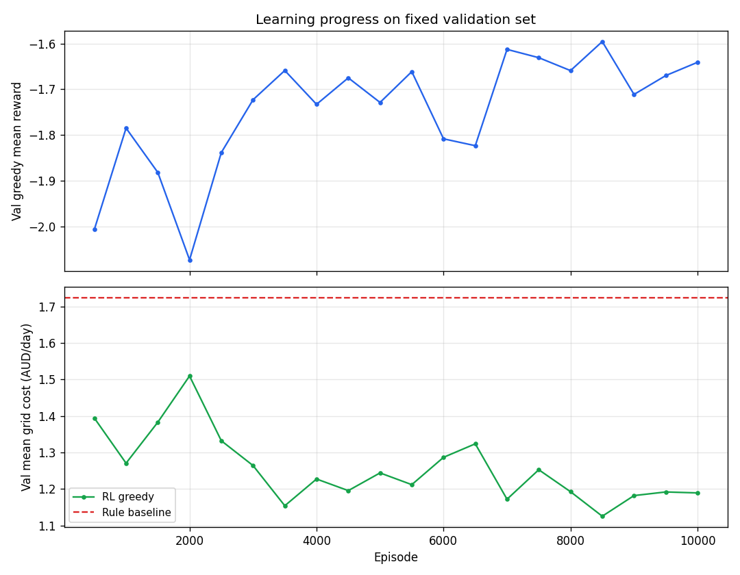
Fig. 6. Q-Learning validation greedy grid cost vs. tertile rule baseline.

4.2 Main Policy Comparison
Table IV ranks all policies on total test import cost. Without a battery, the household pays 160.75 AUD over 53 days (3.03 AUD/day mean). A perfect-foresight oracle with full knowledge of the day's PV and load achieves 49.19 AUD (0.93 AUD/day)—the theoretical lower bound under our physics. Greedy self-consumption reaches 52.15 AUD (0.98 AUD/day), capturing 97.4% of the oracle improvement over the no-battery case. This strong heuristic sets a high bar for learned policies.
The tertile rule baseline costs 92.40 AUD (1.74 AUD/day)—much worse than greedy self-consumption because it waits for top-tertile PV/load before acting. Q-Learning and SARSA achieve 62.02 AUD and 63.75 AUD respectively, reducing cost by 32.9% and 31.0% relative to the tertile rule, but remain 18.9% and 22.2% above greedy self-consumption on absolute bill. Learned policies therefore beat a weak rule but do not surpass the simple myopic baseline in this discretised solar-only setting.
Policy | Total cost (AUD) | Mean/day (AUD) | % oracle gap captured | vs tertile rule
No battery | 160.75 | 3.03 | 0% | —
Oracle (perfect foresight) | 49.19 | 0.93 | 100% | —
Greedy self-consumption | 52.15 | 0.98 | 97.4% | −43.6% cost
Tertile rule | 92.40 | 1.74 | 61.3% | baseline
Q-Learning | 62.02 | 1.17 | 81.4% | −32.9% cost
SARSA | 63.75 | 1.20 | 79.7% | −31.0% cost

Table IV. Test-split policy comparison (53 days, v2 monetised reward).
Secondary KPIs on the test split: greedy self-consumption achieves mean self-consumption rate 0.76 and self-sufficiency 0.80, versus 0.60 / 0.58 for the tertile rule. Evening peak import (after 17:00) is lowest for greedy SC (0.77 kWh/step mean) compared with 1.74 for the tertile rule.

4.3 Q-Learning vs SARSA
On the default configuration (γ = 0.95), Q-Learning marginally outperforms SARSA on total test cost (62.02 vs 63.75 AUD). The difference is small relative to the gap versus greedy self-consumption, suggesting both off-policy and on-policy updates converge to similar sub-optimal policies under coarse discretisation. A hyperparameter variant with γ = 0.99 degrades both agents (Q-Learning 69.62 AUD, SARSA 66.66 AUD), indicating that a longer effective horizon without finer state resolution does not help.

4.4 Tariff Sensitivity
Retail margin sensitivity was tested at m ∈ {0.15, 0.22, 0.35} AUD/kWh with feed-in held at 0.06 AUD/kWh. At every margin, both RL agents beat the tertile rule on total test cost. At m = 0.35, SARSA (84.90 AUD) outperforms Q-Learning (95.06 AUD), suggesting on-policy learning may be more stable when retail spreads are wide.
Margin (AUD/kWh) | Rule (AUD) | Q-Learning (AUD) | SARSA (AUD) | RL beats rule?
0.15 | 68.99 | 47.61 | 52.31 | Yes
0.22 | 92.40 | 62.02 | 63.75 | Yes
0.35 | 135.90 | 95.06 | 84.90 | Yes

Table V. Tariff sensitivity on test split (10,000 episodes per agent).

4.5 Reward Redesign
Table VI contrasts the early wholesale-proxy reward (v1) with the monetised household cost reward (v2). Under v1, Q-Learning achieved higher cumulative reward than the rule baseline while incurring higher grid cost (23.02 vs 18.80 AUD on a comparable run)—a clear reward–metric misalignment. Under v2, ranking by reward matches ranking by bill: both RL agents beat the tertile rule on cost and reward simultaneously.
Phase | Policy | Total grid cost (AUD) | Reward rank vs rule | Cost rank vs rule
v1 (wholesale proxy) | Rule | 18.80 | — | best
v1 (wholesale proxy) | Q-Learning | 23.02 | better | worse
v2 (monetised) | Rule | 92.40 | — | baseline
v2 (monetised) | Q-Learning | 62.02 | better | better (−32.9%)
v2 (monetised) | SARSA | 63.75 | better | better (−31.0%)

Table VI. Reward redesign: aligning training objective with evaluation metric.

4.6 Policy Visualisation
Figure 7 shows the greedy policy map projected onto PV and load tertile bins. Figure 8 shows the Q-value heatmap. Figures 9–10 show the Streamlit digital-twin dashboard: a multi-policy day replay comparing greedy self-consumption, the tertile rule, Q-Learning, SARSA, and Double Q-Learning on the same test day, including solar/load profiles, retail price, SOC trajectories, and per-step actions.
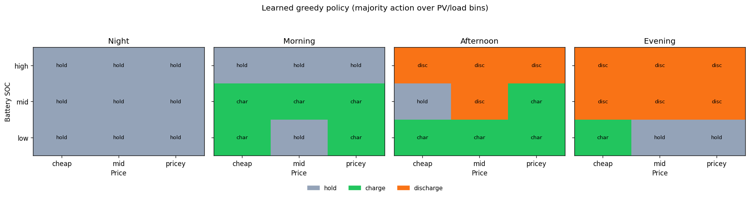
Fig. 7. Q-Learning greedy policy map (PV vs load tertile bins).

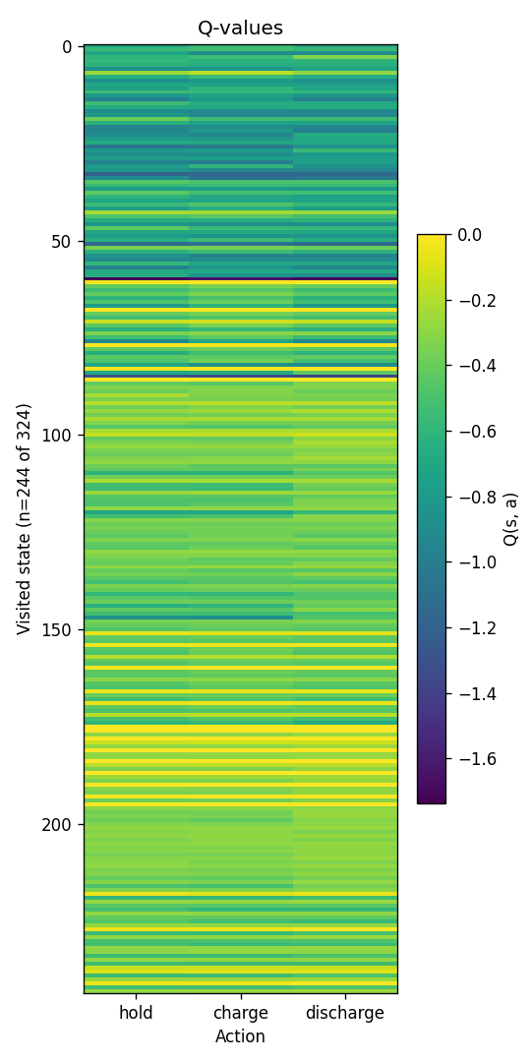
Fig. 8. Q-Learning Q-value heatmap (state vs action).

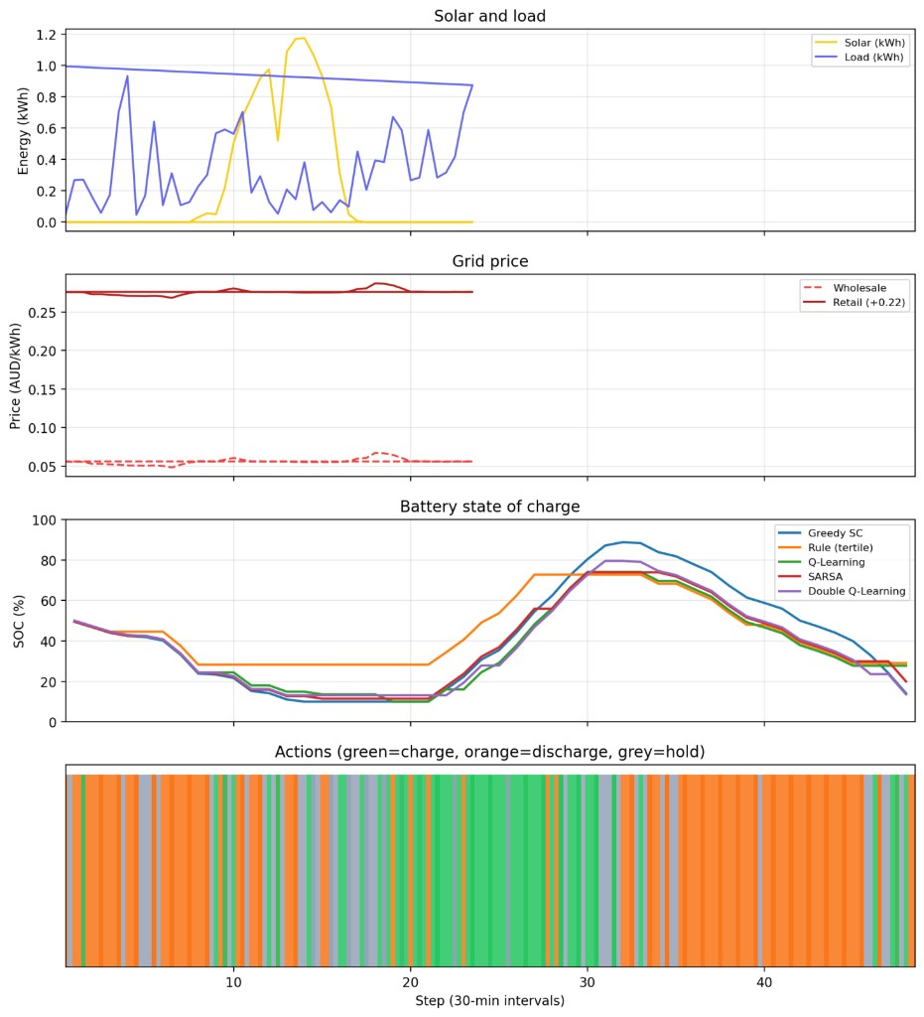
Fig. 9. Digital twin — multi-policy comparison on one test day (Greedy SC, tertile rule, Q-Learning, SARSA, Double Q-Learning).


Fig. 10. Dashboard landing page — GreineGrid dispatch animation (test day 2012-11-12, step 1/48 discharge).

In Fig. 9, all RL agents charge during the midday solar surplus (steps ~22–32) and discharge in the evening, similar to greedy self-consumption but with lower peak SOC than Greedy SC. The tertile rule holds longer before charging, reflecting its weaker responsiveness. The dashboard supports live replay on any train/validation/test day with KPI tables for presentation and qualitative validation; the deployed instance is available at https://greineq-agent.sudocod.com/. Fig. 10 shows the landing page: a step-by-step energy-flow diagram (solar, battery SOC, load, grid import, price) and a 48-cell action timeline (grey=hold, green=charge, orange=discharge).

4.7 Multi-Seed Robustness
Figure 11 summarises a preliminary multi-seed training run. Two seeds at 500 episodes each yielded Q-Learning test costs of 69.95 and 65.44 AUD (mean 67.70 ± 3.19 AUD). Full 10,000-episode multi-seed statistics were not completed before submission.
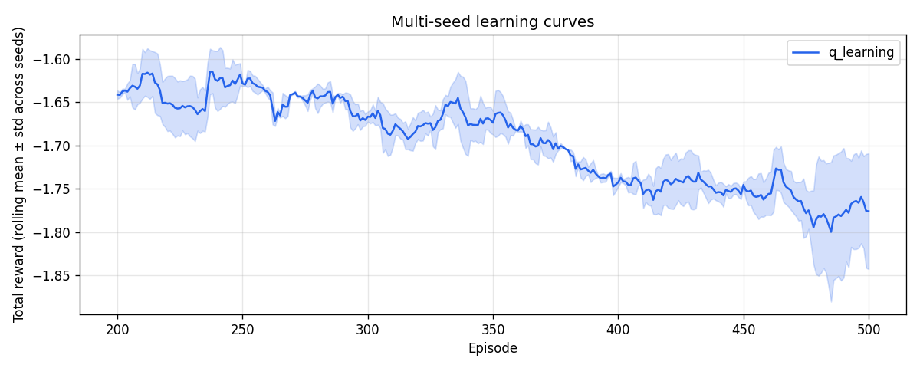
Fig. 11. Multi-seed validation cost curves (preliminary run, 500 episodes per seed).

5. Discussion

5.1 Why Greedy Self-Consumption Is Strong
The most important result is not that RL beats every baseline, but that greedy self-consumption captures 97.4% of the cost reduction available between no-battery and oracle operation. With solar-only charging and discharge limited to current deficit, simply using all surplus PV and covering all deficits from the battery is near-optimal for this household. RL adds value primarily versus the tertile rule—a deliberately weak heuristic—not versus industry-standard self-consumption.

5.2 Reward–Metric Alignment
The v1→v2 reward redesign demonstrates a lesson emphasised in the module: reward design determines what the agent learns. Proxying wholesale price without retail margin produced agents that looked successful in training logs but failed on the bill. Monetising import, curtailed solar, and degradation in AUD resolved this and should be treated as a core methodological contribution rather than a minor tuning step.

5.3 Q-Learning vs SARSA
Off-policy Q-Learning and on-policy SARSA converge to similar costs under default hyperparameters. SARSA's slight advantage at high retail margin (Table V) is consistent with safer on-policy bootstrapping when exploration during training has real monetary cost in the reward signal. Neither algorithm closes the gap to greedy self-consumption, implying the bottleneck is problem structure and state coarseness rather than TD variant.

5.4 Discretisation and Action Limits
324 states compress continuous SOC, PV, load, and price into tertiles. PV bin degeneracy (many zero-PV night intervals) wastes table capacity. Price is observed but grid charging is disallowed, so the agent cannot learn price arbitrage despite price being in the state vector—partial observability of actionable opportunity. Finer SOC bins and daytime-only PV binning are the most promising near-term improvements.

5.5 Markov Approximation
Using four time-of-day bins instead of the exact step index means states at 12:00 and 17:30 may map to the same bin with very different remaining solar availability. This approximation keeps the Q-table tractable but violates strict Markov property and likely caps policy quality below the oracle and greedy baselines.

5.6 Business Relevance
On Customer 1 test data, moving from no-battery operation to greedy self-consumption saves approximately 108 AUD over 53 days (~2.04 AUD/day). The oracle suggests only ~3 AUD/day further savings remain under current physics. For installers and homeowners, this implies that correct wiring and a simple controller may deliver most benefits before investing in learned dispatch. RL value may increase with grid charging, export tariffs, or fleet-level aggregation—extensions flagged for CA2.

5.7 Limitations
Key limitations include: (i) single primary customer for training and evaluation; (ii) solar-only dispatch without grid import charging; (iii) tabular scale preventing continuous SOC; (iv) 2012–2013 data may not reflect 2026 tariff structures; (v) deterministic physics without measurement noise or forecast error; (vi) Double Q-Learning implemented but not fully retrained after a bug fix in terminal updates.

5.8 Threats to Validity
Primary results use one training seed at 10,000 episodes. Preliminary two-seed runs show moderate variance (±3.2 AUD on a shortened schedule). Month-stratified splitting mitigates seasonal leakage but does not guarantee generalisation to other customers—cross-customer scripts are provided but not central to the main claims. Simulation results require live pilot validation before deployment recommendations.

6. Conclusion and Future Work
This project implemented GréineGrid Qagent, a tabular reinforcement learning system for home battery dispatch on real Ausgrid and AEMO data. A custom MDP with monetised AUD rewards, rigorous baselines (no-battery, oracle, greedy self-consumption, tertile rule), and Q-Learning/SARSA agents built from scratch demonstrates end-to-end RL workflow suitable for this module’s continuous assessment requirements.
Main findings: (1) reward design must match the business metric—v2 monetised rewards fixed a v1 misalignment; (2) Q-Learning and SARSA beat the tertile rule by ~31–33% on test cost but do not beat greedy self-consumption; (3) greedy self-consumption captures most of the oracle gap, defining a realistic performance ceiling for solar-only dispatch; (4) RL remains robust to retail margin changes relative to the rule baseline.
The following technical extensions were out of scope for the current simulator release but are planned as future work:
- Price arbitrage / grid charging — requires new actions (grid-charge, export-to-grid), tariff logic, and a substantially revised environment; not feasible before the 7 July deadline.
- Finer SOC bins and daytime-only PV binning — would increase |S| and risk sparse Q-table coverage; limitations are analysed in Sections 3.4 and 5.4 rather than implemented.
- Extended formal MDP — Section 3.2.1 gives the transition specification for the current simulator; full stochastic extensions (forecast uncertainty, multi-day SOC carry-over) remain future modelling work.
- Multi-seed statistical reporting, cross-household transfer, and deep RL if |S| grows beyond tabular feasibility.

6.1 GreineGrid Prototype Platform
A first-version web application has been built and deployed as the GréineGrid digital twin (https://greineq-agent.sudocod.com/; see Section 3.7, Figs. 9–10): landing-page dispatch animation, multi-policy day replay, and live KPI tables. The next development phase is to expand this into a fuller prototype platform beyond the current public demo.
Planned software upgrades include cloud-hosted deployment, user-selectable households and tariff profiles, step-by-step live replay driven by the trained Q-table policy (not only historical batch plots), exportable session logs, and side-by-side comparison of RL agents against greedy self-consumption on streaming or uploaded interval data. The same Python policy core and Q-table artefacts from this project would be reused without retraining for the initial prototype.
In parallel, we plan a small hardware prototype that mirrors agent decisions in physical form: a microcontroller or single-board computer (e.g. Raspberry Pi or Arduino) driving LEDs or a simple robotic display for hold (grey), charge (green), and discharge (orange), plus a servo or LED bar indicating battery SOC. The hardware would subscribe to the same action and SOC signals sent to the web app—serving as a physical digital twin for presentations and stakeholder demos, not as a separate RL environment. No live grid connection is intended; safety isolation and a rule-based fallback policy would apply in lab use.
Together, the advanced web app and hardware prototype would close the gap between offline simulation and deployable product: measurable cost KPIs in software, tangible agent behaviour in hardware, and documented differences between simulated and prototype performance (latency, policy stability, and operator trust). Grid-charging actions and price arbitrage would be added to the environment before the prototype targets true tariff optimisation.

7. References
[1] R. S. Sutton and A. G. Barto, Reinforcement Learning: An Introduction, 2nd ed. Cambridge, MA, USA: MIT Press, 2018.
[2] P. Michailidis, I. Michailidis, and E. Kosmatopoulos, "Reinforcement learning for optimizing renewable energy utilization in buildings: A review on applications and innovations," Energies, vol. 18, no. 7, p. 1724, Mar. 2025. [Online]. Available: https://doi.org/10.3390/en18071724
[3] S. Lee and D. Choi, "Reinforcement learning-based energy management of smart home with rooftop solar photovoltaic system, energy storage system, and home appliances," Sensors, vol. 19, no. 18, p. 3937, Sep. 2019. [Online]. Available: https://doi.org/10.3390/s19183937
[4] G. Wei, M. Chi, Z.-W. Liu, M.-F. Ge, C. Li, and X. Liu, "Deep reinforcement learning for real-time energy management in smart home," IEEE Syst. J., vol. 17, no. 2, pp. 2489–2499, Jun. 2023. [Online]. Available: https://doi.org/10.1109/JSYST.2023.3247592
[5] Y. Liu, Q. Lu, Z. Yu, Y. Chen, and Y. Yang, "Reinforcement learning-enhanced adaptive scheduling of battery energy storage systems in energy markets," Energies, vol. 17, no. 21, p. 5425, Oct. 2024. [Online]. Available: https://doi.org/10.3390/en17215425
[6] Y. Xu, Y. Li, and W. Gao, "Comparative analysis of reinforcement learning approaches for multi-objective optimization in residential hybrid energy systems," Buildings, vol. 14, no. 9, p. 2645, Aug. 2024. [Online]. Available: https://doi.org/10.3390/buildings14092645
[7] M. Gautam, "Deep reinforcement learning for resilient power and energy systems: Progress, prospects, and future avenues," Electricity, vol. 4, no. 4, pp. 336–380, Dec. 2023. [Online]. Available: https://doi.org/10.3390/electricity4040020
[8] D. Vamvakas, P. Michailidis, C. Korkas, and E. Kosmatopoulos, "Review and evaluation of reinforcement learning frameworks on smart grid applications," Energies, vol. 16, no. 14, p. 5326, Jul. 2023. [Online]. Available: https://doi.org/10.3390/en16145326
[9] Ausgrid, "Solar home electricity data," Ausgrid, Sydney, NSW, Australia, 2012–2013. [Online]. Available: https://www.ausgrid.com.au/Industry/Innovation-and-research/Data-to-share/Solar-home-electricity-data
[10] Australian Energy Market Operator (AEMO), "Price and demand datasets — NSW1," 2012–2013. [Online]. Available: https://aemo.com.au/energy-systems/electricity/national-electricity-market-nem/data-nem/aggregated-data

8. Appendix

A. Team Contributions
Member | Role | Contributions
Member 1 | Data & EDA | Ausgrid/AEMO merge, DST alignment, month-stratified split, EDA figures , Environment , dashboard
Member 2 | RL core | Environment, reward, Q-Learning, SARSA, baselines, training, experiments
Member 3 | Report & demo | Report assembly, results write-up, Streamlit presentation, dashboard

B. Sample Q-Table Entry
State index 178 from the trained Q-Learning table (thresholds affect decoded bins):
Action | Hold (0) | Charge (1) | Discharge (2) | Greedy choice
Q-value | −0.858 | −0.872 | −0.480 | Discharge

C. Reproducibility
Repository: github.com/NathanLCR/rl-battery-dispatch (branch Qagent). Train: python -m src.train --agent q_learning --episodes 10000 --tag main. Compare: python -m src.compare with saved .npy models. Dashboard (local): streamlit run dashboard/app.py. Dashboard (live): https://greineq-agent.sudocod.com/. CSV logs are bundled under report/tables/.

D. Generative AI Usage
AI tools assisted with report structuring and documentation. RL algorithms, environment code, and experiments were implemented and verified by the team.

