Dublin Business School

B9AI105 Reinforcement Learning
Master of Science in Artificial Intelligence - Group A
Lecturer Name: Dr. Oleksandr Bezrukavyi
CA01 – Group Assessment

Group Members:
Nathan Lucio - 20082900
Nadeesha Jayasuriya - 20093736
Emmanuel Addoh - 10592825

Submission Date: 8th July 2026
Contents

Abstract 4
1. Introduction 5
1.1. Problem Context 5
1.2. Reinforcement Learning Motivation 5
1.3. Project Contributions 6
2. Literature Review 6
2.1. RL for Battery Dispatch and Energy Scheduling 6
2.2. Tabular RL Methods 7
2.3. Research Gap 7
3. Methodology 8
3.1. Data and Experimental Setup 8
3.2. MDP Formulation 10
3.3. Reward Design 12
3.4. Algorithms and Training 13
3.5. Evaluation Baselines and Implementation 14
4. Results 14
4.1. Training Dynamics 15
4.2. Main Policy Comparison 16
4.3. Q-Learning vs SARSA and Tariff Sensitivity 17
4.4. Reward Redesign 18
4.5. Policy Visualisation and Multi-Seed Robustness 18
5. Discussion 22
5.1. Main Findings 22
5.2. Limitations and Threats to Validity 22
5.3. Business Relevance and Responsible Use 23
6. Conclusion and Future Work 24
7. References 25
Appendix 26
Appendix A. Team Contributions 26
Appendix B. Reproducibility 26
Appendix C. Generative AI Usage 26
Appendix D. Summary of Experimental Variants 27

Abstract
Rising energy demand and fuel costs make household energy control a timely problem. This project presents GréineQ, a tabular reinforcement learning (RL) system that learns battery dispatch policies from real Ausgrid solar data merged with AEMO NSW1 electricity price data for one residential customer. We formulate a custom Markov decision process with 324 discretised states and three actions: hold, charge from surplus solar, and discharge to offset household load. Q-Learning and SARSA agents were implemented from scratch in NumPy and trained using a monetised reward function based on household grid-import cost, curtailed solar opportunity cost, and optional battery degradation.
On the 53-day test split, both Q-Learning and SARSA reduced import cost by about 33% compared with the simple tertile rule baseline. However, they did not perform better than greedy self-consumption, where the battery simply charges when there is surplus solar and discharges when the house needs energy. This result shows that a simple battery rule can already work very well in a solar only setting. It also highlights the importance of comparing RL agents against realistic baselines, not only weak rule-based methods. The evaluation also includes tariff sensitivity testing and a Streamlit dashboard for visually replaying and comparing battery dispatch decisions.
Keywords: Reinforcement learning; Q-Learning; SARSA; home battery; energy management; microgrid; Ausgrid; tabular methods

Introduction

Problem Context
With rising fuel and electricity costs, household energy management has become an important practical problem. In countries such as Australia, many homes now use rooftop solar panels, but households still depend on the grid when solar generation is low. Also, the price paid for exported solar is often much lower than the price charged for importing electricity from the grid. This means households may export surplus solar during the day and later buy electricity back at a higher cost in the evening.
Solar generation usually peaks around midday, while household demand is often higher in the morning and evening. Without storage, surplus solar may be exported at a low feed-in rate, and later demand must be supplied by the grid. A home battery can help by storing midday solar for later use, but the controller must decide at each timestep whether to charge, discharge, or hold. These decisions depend on the battery state of charge (SOC), power limits, household demand, and available solar generation. This makes battery dispatch a realistic sequential decision-making problem.

Reinforcement Learning Motivation
Battery dispatch is a sequential decision-making problem than a simple one-step prediction task. The decision to charge the battery at one timestep can affect the amount of energy is stored available later in the day, especially during peak demand hours. Reinforcement learning (RL) is suitable for this problem because it allows an agent to learn actions through interaction with an environment. At each timestep, the agent observes the current state, chooses an action, receives a reward, and moves to the next state [1].
The input data are time-series records of solar generation, household load, and electricity price. However, the aim of this project is not only to forecast future values. Instead, the aim is to learn a control policy that decides when the battery should hold, charge, or discharge. This is different from supervised learning, where the model would need labelled examples of the correct battery action at each timestep. In real household data, these labels are not directly available.
Simple rule-based controllers can charge the battery when solar generation is high and discharge it when household demand is high. These rules are easy to understand, but they only respond to the current situation. They do not learn whether it is better to save battery energy for later in the day. RL is useful here because it can learn from the whole daily episode and optimise decisions across 48 half-hour steps.
In this project, we implemented tabular Q-Learning and SARSA from scratch in NumPy. We chose tabular methods because the state space is small enough to store in a Q-table: 324 discretised states and three possible actions. This also makes the learned policy easier to inspect and explain. The state includes the main variables needed for battery control: battery state of charge, solar generation, household load, electricity price, and time of day. Previous work on RL for smart grids and buildings also shows that reward design and state representation are important for learning useful energy-control policies [2], [8].

Project Contributions
This project makes the following contributions:
- A custom microgrid battery-dispatch environment built using merged Ausgrid household solar/load data and AEMO NSW1 electricity price data
- A tabular RL formulation with 324 discretised states and Three actions: hold, charge, and discharge.
- Q-Learning and SARSA agents implemented from scratch in NumPy and trained using a monetized reward function linked to household grid-import cost.
- A comparison with simple and practical control methods, including no battery, greedy self-consumption, a tertile rule, and a perfect-foresight benchmark.
- A Streamlit dashboard to show how the battery charges, discharges, and compares with other policies on selected days. (live deployment: https://greineq-agent.sudocod.com/)

Literature Review

RL for Battery Dispatch and Energy Scheduling
Home energy management systems aim to reduce electricity cost and increase the use of locally generated solar energy. A common approach is greedy self-consumption, where solar generation is first used to meet household demand before importing electricity from the grid. More advanced controllers may also consider time-of-use tariffs, demand response, and battery degradation costs [2], [6]. This makes battery dispatch a practical optimisation problem, especially as retail electricity prices, export limits, and behind-the-meter storage become more important for households.
Reinforcement learning has been widely studied for microgrid operation, electric-vehicle charging, and residential battery control. Recent reviews show that RL is useful in energy scheduling because it can learn from repeated interactions with an environment and optimise decisions over time [2], [8]. In smart-home settings, previous studies have used Q-Learning to control energy storage systems and appliances under time-of-use pricing [3], while deep RL methods such as PPO, DQN, DDPG, and TD3 have been explored for more complex or continuous control settings [4], [6]. Other work has also shown that tabular Q-Learning can still be useful for battery energy storage scheduling when the state space is kept small through discretisation [5].
Across these studies, the agent commonly observes variables such as battery state of charge, household load, solar generation, electricity price, and time. These variables closely match the state representation used in this project. While many recent studies use deep RL, this project uses tabular Q-Learning and SARSA because the state space is small enough for a Q-table and the learned policy remains easier to inspect and explain.

Tabular RL Methods
Tabular reinforcement learning is useful when the number of states and actions is small enough to store values directly in a Q-table. Sutton and Barto [1] provide the main foundation for these model free methods. In Q-Learning, the agent updates each state action value using the best estimated action in the next state, so it learns a greedy policy while still exploring. In SARSA, the update uses the action that the agent takes next, making it an on-policy method.
Both methods are relevant to battery dispatch because the agent must repeatedly choose between holding, charging, and discharging. SARSA can sometimes learn more cautious policies because it accounts for the actions taken during exploration, which may matter when poor actions create extra cost or unnecessary battery cycling. Previous studies also show that tabular Q-Learning can still be useful for battery energy storage scheduling when the state space is kept small through discretisation [3], [5].
The main limitation of tabular RL is that the Q-table grows quickly as more state variables or bins are added. This is known as the curse of dimensionality [1]. Therefore, this project uses discretised bins for SOC, solar generation, load, price, and time of day, balancing detail against a manageable table size.

Research Gap
Most of the existing energy based RL literature uses synthetic simulators, simplified tariff settings, or weak baseline comparisons [2], [4], [6]. Although deep RL for power and energy systems is developing quickly, applied residential battery studies using real household meter data and strong practical baselines are still limited [7]. This project addresses that gap by combining real half-hourly Ausgrid household data [9] with AEMO NSW1 price data [10], then evaluating tabular Q-Learning and SARSA in a custom battery-dispatch environment.
A key part of this project is the use of stronger comparison methods. Instead of comparing RL only with a simple rule, we also include greedy self-consumption and a perfect-foresight oracle. This makes it clearer how much improvement is available and whether RL provides extra value in this solar-only setting. In our results, the greedy baseline captures most of the available savings, which helps us discuss the limits of RL rather than claiming that the validity of Q learning agents.

Methodology
This section describes the data pipeline, MDP formulation, reward design, learning algorithms, training protocol, evaluation baselines, and software implementation used in the project.

Data and Experimental Setup
Two public datasets were combined to create daily microgrid simulation episodes. The Ausgrid Solar Home Electricity Data provides half-hourly household electricity consumption and rooftop PV generation for anonymised customers in New South Wales, Australia, during 2012–2013 [9]. Five customers were retained during data preparation, but the main experiments were done with Customer 1.
In the Ausgrid dataset, general consumption and gross solar generation were converted into the project variables load_kwh and pv_kwh. The original wide format data were reshaped into one row per timestamp, giving 48 half hour intervals for each complete day. This format allows each day to be used as one RL episode in the battery-dispatch environment.
Wholesale electricity price data were taken from the Australian Energy Market Operator (AEMO) PRICE_AND_DEMAND files for the NSW1 region [10]. These files provide regional electricity price and demand at 30-minute resolution. The AEMO price was converted from AUD/MWh to AUD/kWh and merged with the Ausgrid household data using aligned timestamps. After merging, each interval contains household load, solar generation, electricity price, and net load, where net_load_kwh = load_kwh − pv_kwh.
Exploratory data analysis on Customer 1 was used to understand the main patterns before designing the RL environment. Figure 1 shows the distribution of NSW spot prices in AUD/kWh. Most prices are concentrated around a low range, but the distribution has a right-skewed tail, meaning there are occasional higher-price periods. Some negative prices also appear, which can happen when electricity supply is greater than demand.
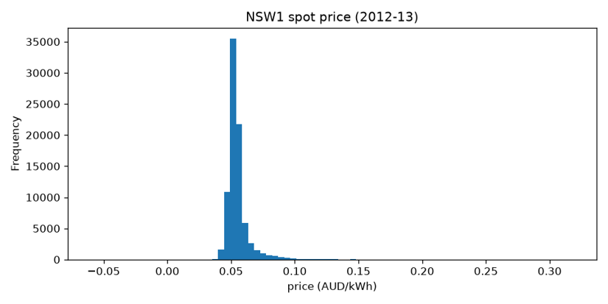
Fig. 1: NSW spot price distribution (AUD/kWh).
Figure 2 shows the average daily pattern for Customer 1, including household load, solar generation, and electricity price. Solar generation usually follows a midday peak, while household demand is higher in the morning and evening. The wholesale price also tends to rise around 18:00. This creates the main battery-control problem: surplus solar is available during the day, but energy is most needed later. Therefore, the controller should ideally store midday solar and use it during the evening demand and price peak.
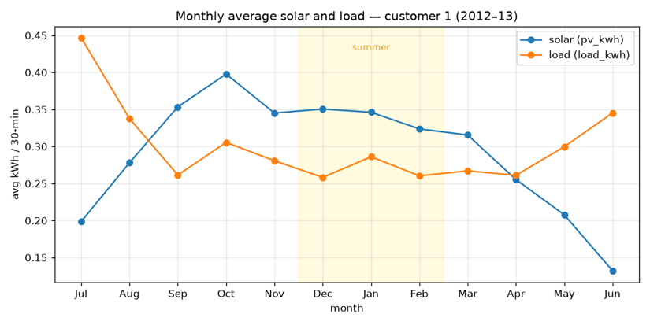
Fig. 2: Average daily profile — Customer 1 load, PV, and price.

Figure 3 shows the monthly average solar generation and household load. The pattern changes across the year, with higher PV generation in summer and higher electricity use in winter. Because of this seasonality, the data were split using a month-stratified train, validation, and test split instead of a simple chronological split. This helps each split include both summer and winter days.
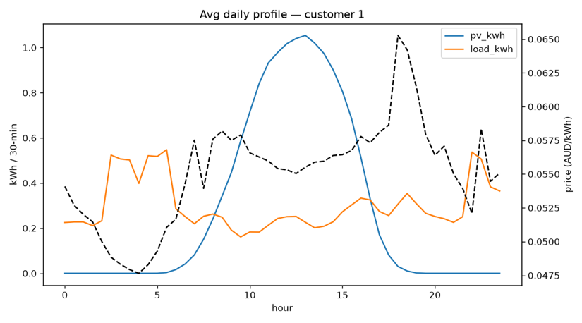
Fig. 3: Monthly average solar generation and load — Customer 1.
Episode construction and data split: Each RL episode represents one calendar day with 48 half-hour timesteps. Days with missing or incomplete readings were removed, including two daylight saving transition days that did not contain the full 48 intervals.
The final day level split used approximately 70% of days for training, 15% for validation, and 15% for testing, giving 256 training days, 54 validation days, and 53 test days.
We used a month-stratified split so that the training, validation, and test sets all included both summer and winter patterns. The discretisation thresholds were calculated from the training data only. Validation days were used to monitor learning during training, and the test days were saved for the final policy comparison in Section 4.
Split | Days | Share | Purpose
Train | 256 | ~70% | Fit discretiser; sample episodes for RL updates
Validation | 54 | ~15% | Greedy policy checkpoint every 500 episodes
Test | 53 | ~15% | Held-out comparison of all policies (primary results)
Table I: Month-stratified day-level partition for Customer 1 (seed = 50).

MDP Formulation
The battery dispatch problem was modelled as a finite-horizon Markov decision process (MDP). In this project, one episode represents one day, with 48 half-hour timesteps. At each timestep, the agent observes the current state, chooses an action, receives a reward, and moves to the next state [1]. The discount factor was set to γ = 0.95, so the agent still considers later rewards in the day, but gives slightly more importance to immediate cost reductions.
The action space contains three possible battery decisions:
Action | Code | Semantics
Hold | 0 | Do not deliberately charge or discharge the battery
Charge | 1 | Store available surplus solar, subject to battery power and SOC limits
Discharge | 2 | Use stored energy to reduce household grid import, subject to battery power and SOC limits
Table II: Battery dispatch action space
The environment uses fixed historical values for solar generation, household load, and electricity price at each timestep. The agent cannot change future weather, demand, or price. it can only decide how to use the battery. In this version, the battery can charge only from surplus solar. Grid charging and selling electricity back to the grid are not included, so the problem focuses on solar self-consumption rather than full price arbitrage.
The battery is modelled as a 10 kWh system with 5 kW charge and discharge limits. Since each timestep is 30 minutes, the maximum energy that can be charged or discharged in one step is 2.5 kWh. The battery starts each day at 50% SOC. Hard SOC limits are set between 10% and 90%, while broader SOC bins are used later for state discretisation.
Parameter | Value
Capacity | 10 kWh
Initial SOC | 50%
Max charge / discharge power | 5 kW
Step duration | 0.5 h (30 min)
SOC hard limits | 10% – 90%
SOC bins (low / high) | 30% / 70%
Table III: Battery and timestep parameters
The battery settings used in the environment are shown in Table III. The battery capacity is set to 10 kWh, with an initial state of charge of 50% at the start of each day. The maximum charge and discharge power is 5 kW. Since each timestep is 30 minutes, the battery can charge or discharge up to 2.5 kWh in one step. SOC is kept within hard limits of 10% to 90%, while 30% and 70% are used as low/high thresholds for discretisation.
At each timestep, the environment calculates whether the household has surplus solar or a load deficit. Surplus is the amount of solar left after meeting household load, while deficit is the amount of load that still needs to be supplied after solar is used. Charge and discharge amounts are limited by the battery power limit and available SOC. Grid import and curtailed solar are then calculated as:
$$grid_import =max⁡\left(0, load-PV-discharge\right)$$
$$solar_waste =max\left(0, PV-load\right)$$
A limitation of this compact MDP design is that the full timestep index is not included directly in the state. Instead, time is represented using four broad time-of-day bins: night, morning, afternoon, and evening. This keeps the Q-table small, but it also means that some different timesteps may be treated as similar states.
State representation and discretisation: At each timestep, the environment reads solar generation, household load, and electricity price from the historical dataset. These values are external inputs, meaning the agent cannot change future weather, household demand, or market price. The agent only controls the battery action: hold, charge, or discharge.
For tabular RL, the continuous variables must be converted into a finite number of states. In this project, the state includes battery SOC, solar generation, household load, electricity price, and time of day. Solar generation, load, and price are divided into tertile bins using thresholds calculated from the training data only. SOC is divided using fixed thresholds at 30% and 70%. Time of day is represented using four bins: night, morning, afternoon, and evening.
The final state representation combines SOC, PV, load, price, and time with dimensions (3, 3, 3, 3, 4). This gives 324 possible states. With three actions, the Q-table contains 324 × 3 = 972 state-action values. This size is small enough for tabular Q-Learning and SARSA, while still representing the main factors that affect battery dispatch.
A limitation of this approach is that different real values can fall into the same bin. For example, many night-time intervals have zero solar generation, which can make the low-PV bin less informative. However, using more bins would increase the Q-table size quickly and could make learning sparse. Therefore, the chosen discretisation is a practical balance between detail and simplicity for this CA1 project. This choice is consistent with previous battery-storage RL studies that discretise continuous states before applying tabular Q-Learning [5].

Reward Design
Reward design is important because the agent learns from the reward signal, not directly from the final electricity bill. If the reward does not match the evaluation metric, the agent may learn behaviour that looks good during training but performs poorly when measured by household cost [2], [6].
An early reward version used wholesale price as a proxy for cost. However, this did not properly include the retail margin or the opportunity cost of curtailed solar. As a result, the training reward and the final grid-import cost were not fully aligned. The final reward version was therefore changed to represent negative household cost at each timestep.

The retail price is calculated as:
$$p_retai=p_wholesale+m$$
where m = 0.22 AUD/kWh is the retail margin. The reward is then defined as:
$$r_t=-w_c∙import_t·p_retail-w_s·waste_t·f-w_d·deg_t-w_i·invalid_t$$

Here, import_t is the grid import in kWh, waste_t is curtailed solar, f = 0.06 AUD/kWh represents the feed-in tariff opportunity cost, deg_t represents battery degradation or SOC-limit penalties, and invalid_t penalises physically invalid actions such as charging when the battery is already full. The default battery-aware reward uses equal weights for import cost, solar waste, and degradation, with a smaller penalty for invalid actions.
Because the reward is expressed in AUD-based cost terms, maximising total reward is closely linked to minimising grid-import cost and reducing unnecessary solar waste or battery stress. The effect of this reward redesign is evaluated in Section 4.4.

Algorithms and Training
Two model-free tabular RL algorithms were implemented from scratch in NumPy: Q-Learning and SARSA. No external RL libraries such as Stable Baselines3 were used. Both algorithms store action values in a Q-table, (Q(s,a)), initialised to zero, and use ε-greedy exploration during training [1], [3], [5].
Q-Learning is an off-policy method. It updates the current state-action value using the best estimated action value in the next state:
$$Q\left(s,a\right)←Q\left(s,a\right)+α\left[r+γ max⁡_a' Q\left(s^{'},a^{'}\right)-Q\left(s,a\right)\right]$$
SARSA is an on-policy method. Instead of using the best possible next action, it uses the action that the agent actually takes next during exploration:
$$Q\left(s,a\right)←Q\left(s,a\right)+α\left[r+γ Q\left(s^{'},a'\right)-Q\left(s,a\right)\right]$$
Double Q-Learning was also implemented as an optional extension to reduce maximisation bias, but the main results focus on Q-Learning and SARSA because these are the two primary algorithms compared for the project.
Hyperparameter | Symbol | Value
Learning rate | α | 0.1 (decays ×0.9995/ep, floor 0.01)
Discount factor | γ | 0.95
Initial ε | ε | 0.1
Minimum ε | ε_min | 0.01
ε decay | — | ×0.999 per episode
Training episodes | — | 10,000
Random seed | — | 42
Q-table shape | — | 324 × 3
Table IV: Default training hyperparameters (config.yaml)
The main hyperparameters are shown in Table IV. Each training episode samples one day from the training split, resets the battery SOC to 50%, and runs through all 48 half-hour timesteps. During training, the agent selects actions using ε-greedy exploration and updates the Q-table after each step. The exploration rate ε decays over time so that the agent gradually shifts from exploration to more greedy decision-making.
Every 500 episodes, the current greedy policy is evaluated on the validation days to monitor learning progress. Final evaluation is carried out on the 53-day test split with ε = 0, meaning the trained policy always selects the action with the highest learned Q-value. The main evaluation metric is total grid import cost in AUD. Additional metrics include self-consumption rate, self-sufficiency, evening peak import, and percentage of oracle savings captured. Extra experiments were also run for reward ablation, tariff sensitivity, and multi-seed robustness.

Evaluation Baselines and Implementation
The trained RL agents were compared with several baseline policies on the same 53 test days.
Policy | Description
no_battery | Battery is not used; all remaining demand is imported from the grid
oracle_perfect_foresight | Best possible benchmark using full knowledge of the day’s load and solar profile
greedy_self_consumption | Charges whenever surplus solar is available and discharges when the household needs energy
rule_tertile | Charges during high-PV periods and discharges during high-load periods
Q-Learning / SARSA | Uses the greedy action selected from the trained Q-table
Table V: Evaluation baseline policies
Greedy self-consumption is used as the main practical baseline because it is simple, commonly used, and difficult to beat in a solar-only battery setting. The tertile rule is included as a simpler rule-based comparison.
Implementation: The project was implemented in Python with separate modules for the environment, battery physics, state discretisation, RL agents, training, evaluation, and visualisation. The main dependencies were NumPy, Pandas, Matplotlib, PyYAML, Streamlit, and SciPy. No external RL frameworks were used, so the Q-Learning and SARSA logic was implemented directly.
A Streamlit dashboard was developed to support the project demonstration. It allows selected train, validation, or test days to be replayed and compares the actions and performance of different policies. Training logs, Q-table checkpoints, plots, and experiment outputs are stored in the project results folders. The configuration and day-split files support reproducibility, and a Google Colab notebook represents the training pipeline for cloud execution.

Results
The main results are reported on the 53-day held-out test split for Customer 1. The default configuration uses the battery-aware reward, γ = 0.95, 10,000 training episodes, and random seed 42. In this section, cost refers to the total grid electricity bill over the full 53-day test period.

Training Dynamics
Figures 4 and 5 show the rolling mean training rewards for Q-Learning and SARSA over 10,000 episodes. In both cases, the reward improves mainly during the early stages of training and then begins to stabilise. This suggests that the agents learned most of the useful battery-dispatch behaviour within the first few thousand episodes.
Validation performance was checked every 500 episodes using the greedy policy learned up to that point. For Q-Learning, the validation grid cost stabilised after around 4,000 episodes, as shown in Figure 6. Based on this pattern, 10,000 training episodes were considered sufficient for convergence without unnecessary computation.
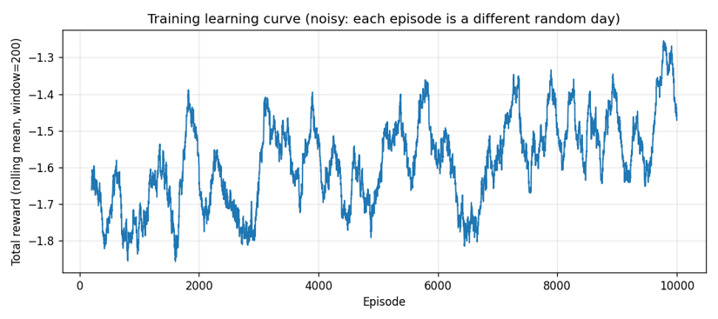
Fig. 4: Q-Learning training reward (200-episode rolling mean, 10,000 episodes).

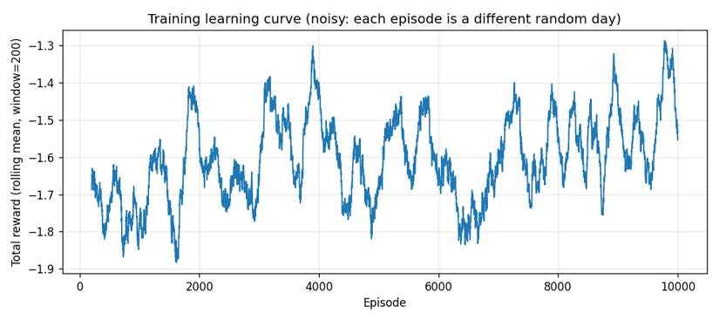
Fig. 5: SARSA training reward (200-episode rolling mean, 10,000 episodes).

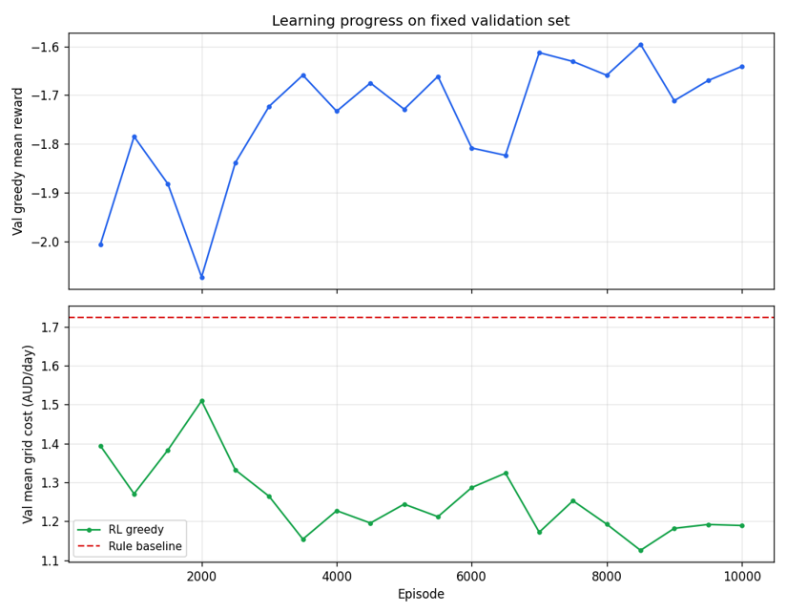
Fig. 6: Q-Learning validation greedy grid cost vs. tertile rule baseline.

Main Policy Comparison
Table IV compares all policies on the 53-day test split. Without a battery, the household grid cost is 160.75 AUD, or 3.03 AUD per day. The perfect-foresight oracle gives the lowest possible cost under the current simulator, reaching 49.19 AUD. Greedy self-consumption performs very close to this benchmark, with a total cost of 52.15 AUD. This means the simple greedy policy captures 97.4% of the possible improvement between no-battery operation and the oracle.
Policy | Total cost (AUD) | Mean/day (AUD) | % oracle gap captured | vs tertile rule
No battery | 160.75 | 3.03 | 0% | —
Oracle (perfect foresight) | 49.19 | 0.93 | 100% | —
Greedy self-consumption | 52.15 | 0.98 | 97.4% | −43.6% cost
Tertile rule | 92.40 | 1.74 | 61.3% | baseline
Q-Learning | 62.02 | 1.17 | 81.4% | −32.9% cost
SARSA | 63.75 | 1.20 | 79.7% | −31.0% cost
Table VI: Test-split policy comparison (53 days, v2 monetised reward).

The tertile rule baseline costs 92.40 AUD. Q-Learning and SARSA perform better than this rule, reducing cost to 62.02 AUD and 63.75 AUD respectively. This is a cost reduction of 32.9% for Q-Learning and 31.0% for SARSA compared with the tertile rule. However, both RL agents still cost more than greedy self-consumption. Therefore, the learned policies improve on a simple rule-based controller, but they do not outperform the stronger greedy baseline in this solar-only setting.
Secondary metrics show the same pattern. Greedy self-consumption achieves higher self-consumption and self-sufficiency than the tertile rule. It also has the lowest evening peak import after 17:00, showing that it uses stored solar energy effectively during the evening demand period.

Q-Learning vs SARSA and Tariff Sensitivity
On the default configuration with γ = 0.95, Q-Learning performs slightly better than SARSA on total test cost, achieving 62.02 AUD compared with 63.75 AUD. However, the difference between the two agents is small. Both methods perform similarly and both remain behind greedy self-consumption. This suggests that the main limitation is not the choice between Q-Learning and SARSA, but the coarse state representation and the solar-only action space.
A second experiment tested a higher discount factor, γ = 0.99. This made performance worse for both agents, with Q-Learning increasing to 69.62 AUD and SARSA to 66.66 AUD. This suggests that increasing the planning horizon does not help unless the state representation is detailed enough to support better long-term decisions.
Agent | γ | Test cost (AUD) | Interpretation
Q-Learning | 0.95 | 62.02 | Default setting
SARSA | 0.95 | 63.75 | Default setting
Q-Learning | 0.99 | 69.62 | Worse than default
SARSA | 0.99 | 66.66 | Worse than default
Table VI: Discount-factor comparison for Q-Learning and SARSA

Tariff sensitivity was also tested using retail margins of 0.15, 0.22, and 0.35 AUD/kWh, while the feed-in tariff was kept at 0.06 AUD/kWh. Across all three tariff settings, both RL agents continued to outperform the tertile rule baseline. At the highest margin, SARSA achieved a lower cost than Q-Learning, which may indicate that on-policy learning is slightly more stable when grid-import costs are higher.
Margin (AUD/kWh) | Rule (AUD) | Q-Learning (AUD) | SARSA (AUD) | RL beats rule?
0.15 | 68.99 | 47.61 | 52.31 | Yes
0.22 | 92.40 | 62.02 | 63.75 | Yes
0.35 | 135.90 | 95.06 | 84.90 | Yes
Table VII: Tariff sensitivity results on the test split

Reward Redesign
Table VIII compares the early wholesale-proxy reward with the final monetised household-cost reward. In the first version, Q-Learning achieved a better training reward than the tertile rule, but its actual grid-import cost was higher. This showed that the reward signal was not properly aligned with the evaluation metric.
After redesigning the reward in AUD-based cost terms, the ranking became more consistent with the final electricity bill. Under the monetised reward, both Q-Learning and SARSA reduced cost compared with the tertile rule. This result shows why reward design is central in RL: the agent learns what the reward measures, so the reward must match the real objective as closely as possible.
Reward phase | Policy | Grid cost (AUD) | Reward result vs rule | Cost result vs rule
v1 wholesale proxy | Rule | 18.80 | — | best
v1 wholesale proxy | Q-Learning | 23.02 | better reward | worse cost
v2 monetised reward | Rule | 92.40 | — | baseline
v2 monetised reward | Q-Learning | 62.02 | better | better (-32.9%)
v2 monetised reward | SARSA | 63.75 | better | better (-31.0%)
Table VIII: Reward redesign comparison

Policy Visualisation and Multi-Seed Robustness
The learned policies were also inspected visually. Figure 7 shows the Q-Learning greedy policy projected onto PV and load bins, while Figure 8 shows the Q-value heatmap. These plots help show how the agent values different actions across the discretised state space.
Figures 9 and 10 show the Streamlit dashboard used for the project demonstration. The dashboard replays selected train, validation, or test days and compares policies such as greedy self-consumption, the tertile rule, Q-Learning, SARSA, and Double Q-Learning. It shows solar/load profiles, grid price, battery SOC, policy actions, and daily cost metrics. This was useful for checking whether the learned behaviour made sense beyond the numeric tables.
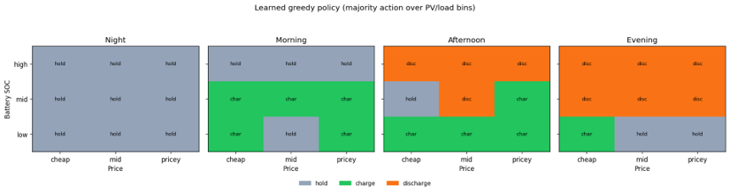
Fig. 7: Q-Learning greedy policy map (PV vs load bins)
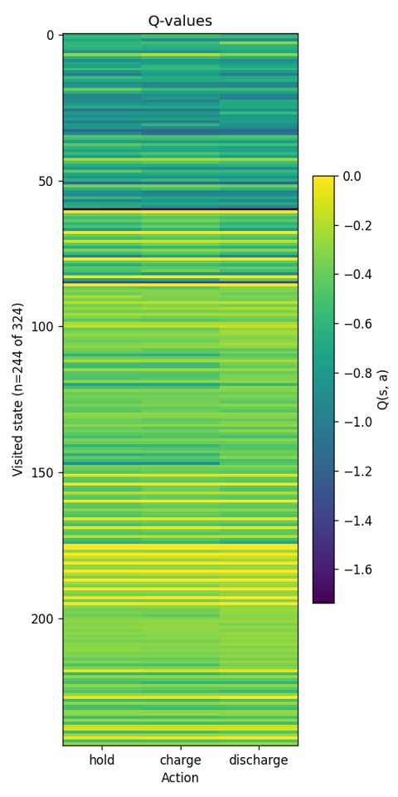
Fig. 8: Q-Learning Q-value heatmap
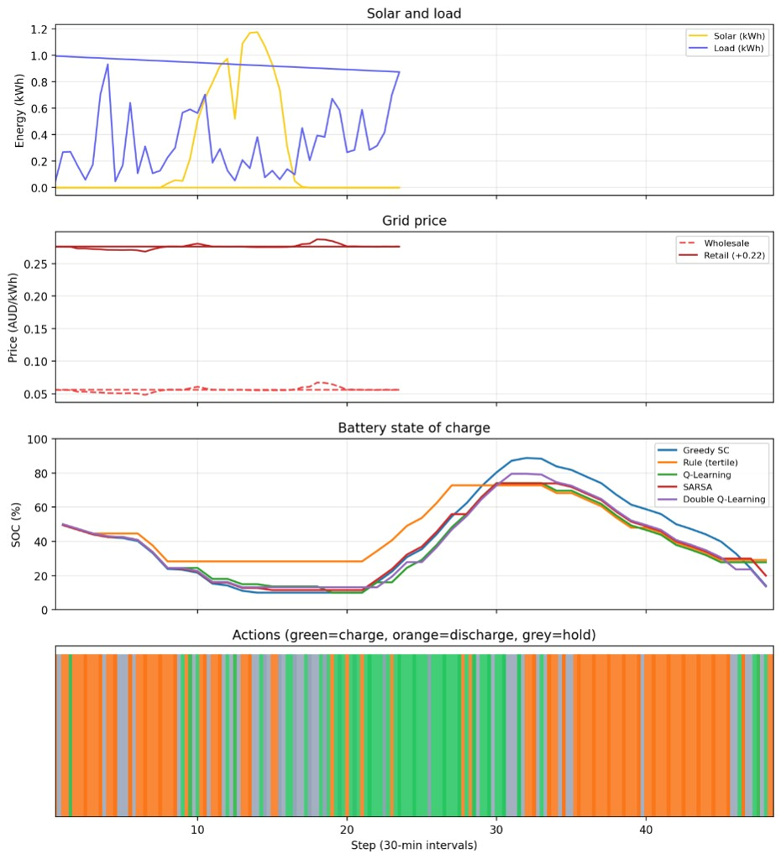
Fig. 9: Digital twin dashboard showing multi-policy comparison on a selected test day
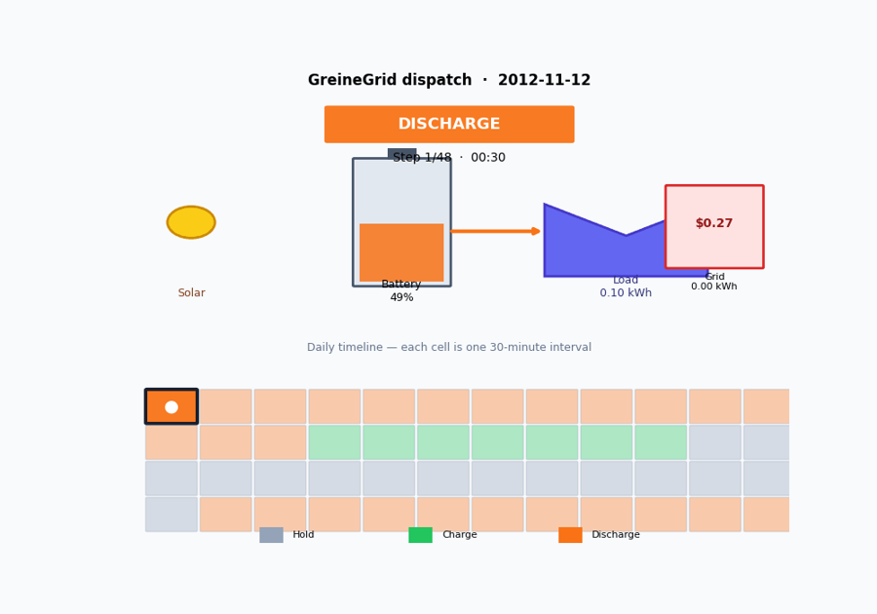
Fig. 10: GréineQ dashboard landing page and dispatch animation.

In the dashboard replay, the RL agents generally charge during midday solar surplus and discharge later in the day. This behaviour is similar to greedy self-consumption, although the learned policies often use a lower peak SOC. The tertile rule responds more slowly because it only acts during high-PV or high-load bins.
To check whether the results depended on one random seed, Q-Learning and SARSA were retrained using five seeds (42-46) at the full 10,000-episode budget. Table IX shows that both algorithms produce similar costs across seeds. Q-Learning has a mean test cost of 61.75 AUD, while SARSA has a mean test cost of 61.62 AUD. A paired t-test shows no statistically significant difference between them (p = 0.90). SARSA has lower seed-to-seed variation, which suggests slightly more stable learning in this setup.
Agent | Seeds | Mean test cost (AUD) | Std (AUD) | 95% CI half-width
Q-Learning | 5 | 61.75 | 2.14 | ±1.88
SARSA | 5 | 61.62 | 0.86 | ±0.76
Table IX: Multi-seed robustness on the test split.
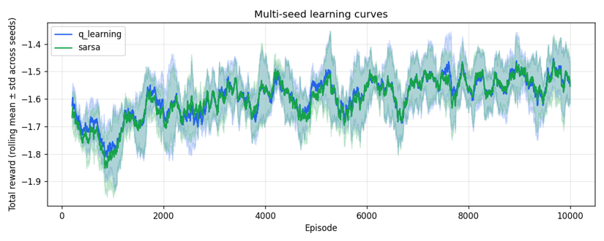
Fig. 11: Multi-seed learning curves for Q-Learning and SARSA.

Discussion

Main Findings
The main finding is that RL improves over the simpler tertile rule, but it does not outperform greedy self-consumption. Greedy self-consumption captures 97.4% of the improvement available between no-battery operation and the perfect-foresight oracle. In the current solar-only setting, simply charging from surplus solar and discharging when the house needs energy is already very effective.
This does not make the RL results unsuccessful. Instead, it shows the importance of using strong baselines. If the comparison had only used the tertile rule, Q-Learning and SARSA would appear clearly better. By also including greedy self-consumption and the oracle, the results give a more honest picture of where RL adds value and where it is limited.
The reward redesign was also an important part of the project. The early wholesale-proxy reward did not match the final household bill, so the agent could appear to learn well while still producing higher grid costs. The final monetised reward aligned the training objective with the evaluation metric, making the results easier to interpret.
Q-Learning and SARSA performed very similarly overall. The five-seed experiment also showed no statistically significant difference between them. This suggests that, for this problem, the main bottleneck is not the choice between off-policy and on-policy tabular learning. The larger limitations are the coarse state representation and the restricted action space.

Limitations and Threats to Validity
Several limitations should be considered when interpreting the results. First, the main experiments use one household customer, so the findings may not transfer directly to all households. Second, the environment only allows the battery to charge from surplus solar. It does not include grid charging or exporting stored energy back to the grid, so the agent cannot learn full price-arbitrage behaviour.
The tabular state space is also deliberately compact. SOC, PV, load, and price are grouped into broad bins, which keeps the Q-table manageable but loses detail. For example, many night-time intervals have zero PV and may fall into the same low-solar bin. Time is represented using four broad time-of-day bins rather than the exact timestep, so different moments in the day may sometimes look similar to the agent.
The data also come from 2012-2013, while current tariffs and household energy behaviour may be different. The simulator uses deterministic battery physics and does not include forecast error, measurement noise, or hardware faults. Double Q-Learning was implemented for the dashboard, but it was not fully retrained for the primary comparison after a terminal-update bug fix, so it is not used as a main result.
Five-seed testing reduces concern that the main result is caused by a single random initialisation. However, the larger validity risk is limited household generalisation and simplified simulation assumptions. A real deployment would require testing across more households, updated tariff structures, and hardware-safe control rules.

Business Relevance and Responsible Use
From a practical viewpoint, the results suggest that a simple battery controller can deliver most of the available savings in a solar-only household setting. On the Customer 1 test split, moving from no battery to greedy self-consumption saves about 108 AUD over 53 days, or around 2.04 AUD per day. The gap between greedy self-consumption and the oracle is only about 0.05 AUD per day, meaning there is limited room for RL to improve under the current action space.
This is useful for homeowners and installers because it shows that correct battery operation and simple self-consumption control may already provide strong benefits. RL may become more valuable when the environment includes grid charging, export tariffs, dynamic pricing, or control across multiple households. In those settings, the decision problem becomes more complex and may give RL more opportunity to improve performance.
GréineQ should be treated as a simulation-based decision-support prototype, not as a controller for real batteries. It should not be connected to grid equipment or live batteries without safety certification, human oversight, hardware protection, and validation under current network and tariff conditions. Any future field trial would need independent checks for SOC limits, fault handling, and compliance with distributor connection rules.

Conclusion and Future Work
This project implemented GréineQ, a tabular reinforcement learning system for home battery dispatch using real Ausgrid household solar/load data and AEMO electricity price data. The project built a custom battery-dispatch environment, designed an AUD-based reward function, implemented Q-Learning and SARSA from scratch, and compared the learned agents against practical baselines.
The main results show that Q-Learning and SARSA reduce cost by about 31-33% compared with the tertile rule baseline. However, they do not beat greedy self-consumption, which is very close to the perfect-foresight oracle in this solar-only setting. This finding is important because it shows that RL should be evaluated against realistic baselines, not only simple rules. The reward redesign and multi-seed testing further show that careful reward design and robustness checks are necessary when applying RL to energy problems.
Future work should first extend the environment to include grid charging, electricity export, and dynamic tariff behaviour. These additions would allow the agent to learn price-arbitrage strategies, not only solar self-consumption. The state representation could also be improved using finer SOC bins, better daytime PV bins, or function approximation if the state space becomes too large for tabular learning.
Further experiments should test transfer across more households and more tariff settings. This would show whether the learned behaviour is specific to Customer 1 or generalises to wider residential energy patterns. Deep RL methods could also be considered if the environment is expanded to include more continuous variables and actions.
The deployed Streamlit dashboard provides a first step towards a usable GréineQ platform. A future CA2 version could improve the dashboard and add a small low-voltage hardware demonstration that mirrors the agent decisions using LEDs or a simple physical display. This would remain a safe educational prototype rather than a live grid-connected controller.

References
[1] R. S. Sutton and A. G. Barto, Reinforcement Learning: An Introduction, 2nd ed. Cambridge, MA, USA: MIT Press, 2018.
[2] P. Michailidis, I. Michailidis, and E. Kosmatopoulos, “Reinforcement learning for optimizing renewable energy utilization in buildings: A review on applications and innovations,” Energies, vol. 18, no. 7, Art. no. 1724, Mar. 2025, doi: 10.3390/en18071724.
[3] S. Lee and D. Choi, “Reinforcement learning-based energy management of smart home with rooftop solar photovoltaic system, energy storage system, and home appliances,” Sensors, vol. 19, no. 18, Art. no. 3937, Sep. 2019, doi: 10.3390/s19183937.
[4] G. Wei, M. Chi, Z.-W. Liu, M.-F. Ge, C. Li, and X. Liu, “Deep reinforcement learning for real-time energy management in smart home,” IEEE Systems Journal, vol. 17, no. 2, pp. 2489–2499, Jun. 2023, doi: 10.1109/JSYST.2023.3247592.
[5] Y. Liu, Q. Lu, Z. Yu, Y. Chen, and Y. Yang, “Reinforcement learning-enhanced adaptive scheduling of battery energy storage systems in energy markets,” Energies, vol. 17, no. 21, Art. no. 5425, Oct. 2024, doi: 10.3390/en17215425.
[6] Y. Xu, Y. Li, and W. Gao, “Comparative analysis of reinforcement learning approaches for multi-objective optimization in residential hybrid energy systems,” Buildings, vol. 14, no. 9, Art. no. 2645, Aug. 2024, doi: 10.3390/buildings14092645.
[7] M. Gautam, “Deep reinforcement learning for resilient power and energy systems: Progress, prospects, and future avenues,” Electricity, vol. 4, no. 4, pp. 336–380, Dec. 2023, doi: 10.3390/electricity4040020.
[8] D. Vamvakas, P. Michailidis, C. Korkas, and E. Kosmatopoulos, “Review and evaluation of reinforcement learning frameworks on smart grid applications,” Energies, vol. 16, no. 14, Art. no. 5326, Jul. 2023, doi: 10.3390/en16145326.
[9] Ausgrid, “Solar home electricity data,” Ausgrid, Sydney, NSW, Australia, 2012–2013. [Online]. Available: https://www.ausgrid.com.au/Industry/Innovation-and-research/Data-to-share/Solar-home-electricity-data. Accessed: Jul. 5, 2026.
[10] Australian Energy Market Operator, “Price and demand datasets — NSW1,” AEMO, 2012–2013. [Online]. Available: https://aemo.com.au/energy-systems/electricity/national-electricity-market-nem/data-nem/aggregated-data. Accessed: Jul. 5, 2026.

Appendix

Appendix A. Team Contributions
The following table summarises each member's contribution to the GréineQ project. All team members reviewed the final report, experiments, and presentation materials.
Member | Role | Contributions
Nathan Lucio | Data & EDA | Ausgrid/AEMO merge, DST alignment, month-stratified split, EDA , Dashboard
Nadeesha Jayasuriya | RL core | Environment, reward design, Q-Learning, SARSA, baselines, training, experiments, dashboard
Emmanuel Addoh | Report & demo | Report assembly, results write-up, Streamlit presentation

Appendix B. Reproducibility
Repository: github.com
Train Q-Learning: python -m src.train --agent q_learning --episodes 10000 --tag main
Train SARSA: python -m src.train --agent sarsa --episodes 10000 --tag main
Compare policies: python -m src.compare (requires saved .npy Q-tables under results/)
Dashboard (local): streamlit run dashboard/app.py
Dashboard (live): https://greineq-agent.sudocod.com/.
Configuration: config.yaml and day_split.json.
Experiment CSV logs are bundled under report/tables/.
A Google Colab notebook (GréineQ_RL_Colab.ipynb) mirrors the training pipeline.

Appendix C. Generative AI Usage
Generative AI tools were used for brainstorming, language refinement, report-structure planning, and debugging support.

Appendix D. Summary of Experimental Variants
GréineQ compares configurations across four axes—learning algorithm, discount factor, reward formulation, and retail tariff margin—all evaluated on the identical 53-day held-out test split unless noted.
Comparison axis | Variant | Key setting | Test cost (AUD) | Beats tertile rule?
Algorithm | Q-Learning (off-policy) | γ=0.95, α=0.1, ε-greedy | 62.02 | Yes (−32.9%)
Algorithm | SARSA (on-policy) | γ=0.95, α=0.1, ε-greedy | 63.75 | Yes (−31.0%)
Algorithm | Double Q-Learning | γ=0.95, twin tables | Dashboard demo only; excluded from primary comparison (incomplete full retraining) | n/a
Discount factor | γ = 0.95 (default) | Q-Learning | 62.02 | Yes
Discount factor | γ = 0.99 | Q-Learning | 69.62 | Yes (worse than γ=0.95)
Discount factor | γ = 0.99 | SARSA | 66.66 | Yes (worse than γ=0.95)
Reward mode | v1 (wholesale proxy) | Q-Learning | Illustrative only; demonstrates reward–metric misalignment | n/a
Reward mode | v2 (monetised, default) | Q-Learning | 62.02 | Yes
Tariff margin | m = 0.15 AUD/kWh | Q-L / SARSA | 47.61 / 52.31 | Yes
Tariff margin | m = 0.22 (default) | Q-L / SARSA | 62.02 / 63.75 | Yes
Tariff margin | m = 0.35 AUD/kWh | Q-L / SARSA | 95.06 / 84.90 | Yes

All costs are on the identical 53-day test split except the v1 reward-mode row, which is not directly comparable to the v2 monetised totals.

