
Meeting 01/22/2026
Data-Driven Retail Insights for Cost Savings & Revenue Growth
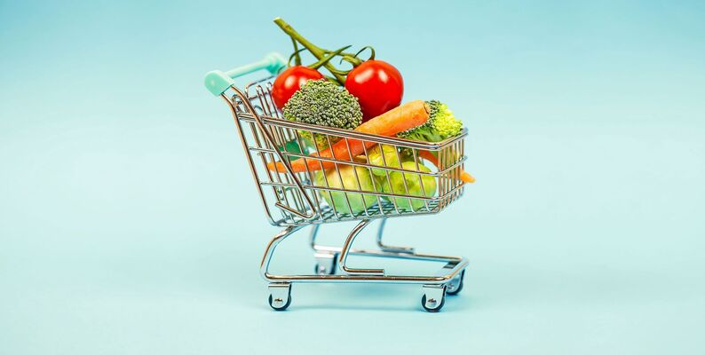
1.Project Goals

InstaCart Online Grocery Basket Analysis Dataset

Nathan Goyer, Disha Srinivasa Chary, Jérémy Trochon, Harini Magudeswaran, Ndifreke Charles, Armand Courvoisier, Hassen Haj Sassi

Data ScienceTech Institute
The objective of this project is to demonstrate how data science and machine learning can generate measurable cost savings and revenue growth for retail shop owners. Using transactional data from Instacart, our team aims to quantify the financial impact of data-driven decisions.

The goal is to help shop owners answer a critical question: How much money can customers save or earn if they listen to the insights from the DSTI team?

- Increase revenue through dynamic product bundling and upselling
- Predict customer purchases to improve inventory and promotions
- Segment customers for targeted marketing strategies
- Estimate potential financial gains from data-driven insights

The expected reasoning behind the dataset is as follows:
- Which departments generate the most value per order ?
- Which products build loyalty AND increase basket size ?
- Where should you invest in promotions to maximise ROI ?
- Does reordering really create value ?
- Are we too dependent on a few products ?
In our context, we define value as the ability of a product/department/customer to generate more frequent and higher-value future orders. So, in our context, the value is behavioural, not direct monetary.
Value got 4 dimensions
- Repetition (product loyalty)
- Basket richness
- Customer purchase frequency
- Driver effect (driver product)
2.Project Structure
The project follows a standard data science lifecycle and is organized collaboratively using GitHub where every member of the team got his own role. [GitHub]

- Data Understanding & Cleaning
- Exploratory Data Analysis (EDA)
- Feature Engineering & Data Enrichment (pricing data)
- Modeling: Association Rule Mining & Predictive Models
- Business Impact Simulation & Evaluation
- Dashboard / Web Application Development
- Final Report & Presentation

3.Short Data Analysis
The Instacart dataset contains over 3 million orders from more than 200,000 customers. Initial analysis will focus on distribute departments, basket size distribution, days & hours where customers purchase the most and popular product categories.

- Number of items ordered per departments
- Products that are the most frequently purchased
- Distribution of purchases by day and time
- Number of items in an average shopping cart
- The departments where products are most often repurchased

4.Tools & Technologies

- Programming: Python (Pandas, Numpy, Scikit-Learn, Seaborn, Matplotlib)
- Association Rule Mining: find out which products are purchased together in customer shopping carts (Apriori, FP-Growth, Eclat, UP-Tree)
- Visualization & Dashboard: Streamlit / Plotly
- Version control: Git & Github
- Data Enrichment:

This document serves as the basis for the project kick-off meeting and will be refined after initial discussions with the Sir Assan Sanogo.

Questions
How Data Enrichment works ?
I would like some explanation about these algorithms ?
Is it important to make figma mockups for the future dashboard on the web server? Does it make sense to provide the mockups in the final rendering?

