**COMP 4003A 2024W  
Assignment #1   
Due: Jan 27@11:59pm**

**Nathan MacDiarmid**

**101098993**

**Instruction**

1. You should do the assignment independently. If copying is found, the case will be reported to the office of the Dean of Science immediately.
2. You need to use [Oracle VM](https://git.scs.carleton.ca/downloads/CourseVirtualMachines/2022F-2023W/COMP3005-W23.ova) to do this assignment and take proper screenshots of execution results for the relevant questions. If there is no screenshot, you will get 0 for the question.
3. First replace Last below with your last name. If your last name is not showing in the screenshot, you will get a 0 for the assignment. Also, rename this document with your last name+first name.
4. Do the assignment directly on this document by copying your programs in this document, and submit it to **brightspace**. Make sure your uploaded file can be opened and is correct. No submission will be accepted after the deadline no matter what reason.

**Application Description**

Given the ER model for Customer Purchase Order application as follows.

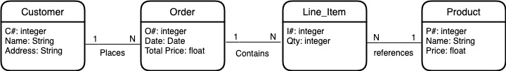

A Customer has a one-to-many relationship with an Order because a customer can place many orders, but a given purchase order can be placed by only one customer. An Order has a one-to-many relationship with a Line Item because an order can list many line items, but a given line item can be listed by only one purchase order. A line item has a many-to-one relationship with a Product because a line item can refer to only one product, but a given product can be referred to by many line items.

1. Use ER mapping rules learned in COMP3005 to create a relational database for this application by giving the relation names, their attributes and types, primary keys underlined, and foreign keys pointing to the corresponding primary keys. (15)

1. Use dynamic SQL method 1 to create the database for this application. You must use execute immediate statement to properly define primary keys and foreign keys of the relations. (15)



1. Use dynamic SQL method 2 to populate this database with five customers: Smith, Jones, Blake, Clark, and MacDiarmid; five products: apple, banana, orange, peach, and watermelon; Smith orders 1 product, Blake 2, …, and MacDiarmid orders everything. (20)
2. Use dynamic SQL method 3 to prompt the user to enter a customer name and/or a product name. For a given customer name, generate a list of complete sale orders placed by the customer. For a given product name, generate the list of customer names and the date of the purchase. If both are given, then display the date and quantity of the purchase. Test all three cases involving MacDiarmid. (50)