**COMP 4003A 2024W  
Assignment #1   
Due: Feb 9 @11:59pm**

**Instruction**

1. You should do the assignment independently. If copying is found, the case will be reported to the office of the Dean of Science immediately.
2. You need to use [Oracle VM](https://git.scs.carleton.ca/downloads/CourseVirtualMachines/2023F-2024W/COMP3005-F23-v3.ova) to do this assignment and take proper screenshots of execution results for the relevant questions. If there is no screenshot, you will get 0 for the question.
3. First replace Last below with your last name. If your last name is not showing in the screenshot, you will get a 0 for the assignment. Also, rename this document with your last name+first name.
4. Do the assignment directly on this document by copying your programs and screenshots in this document, and submit it to brightspace. Make sure your uploaded file can be opened and is correct. No submission will be accepted after the deadline no matter what reason.

### Part 1 (40)

Use dynamic SQL method 4 to write an Embedded SQL program that allows the user to manipulate the database you have created in Assignment#1 with the following command line menu:

1. Add a customer 2. Display a customer

3. Add a product 4. Display a product

5. Add a line_item 6. Add an order of line_items   
7. Add a customer order 8. List all orders of a given customer

9. List customers who ordered the given product 10. Drop all tables

When the user selects an option, prompts the user to enter additional information if needed.   
Use this program to populate the database with five customers: Smith, Jones, Blake, Clark, and MacDiarmid; five products: Apple, Banana, Orange, Peach, and Watermelon; Smith orders the *first* product, Jones *first two* products, …, and MacDiarmid orders everything. The program should first find the highest C#, O#, I#, or P# and generate a new number by adding 1 to it, and also check if the customer or product to be added exists; i.e., customer names and product names are unique. Use MacDiarmid for option 8 and Apple for option 9.

For the context of the screen shots, whenever there is a customer id that is equal to 5, it is the customer id of MacDiarmid. You can check within the database itself to verify, but just making a statement at the beginning so screen shots are clear.

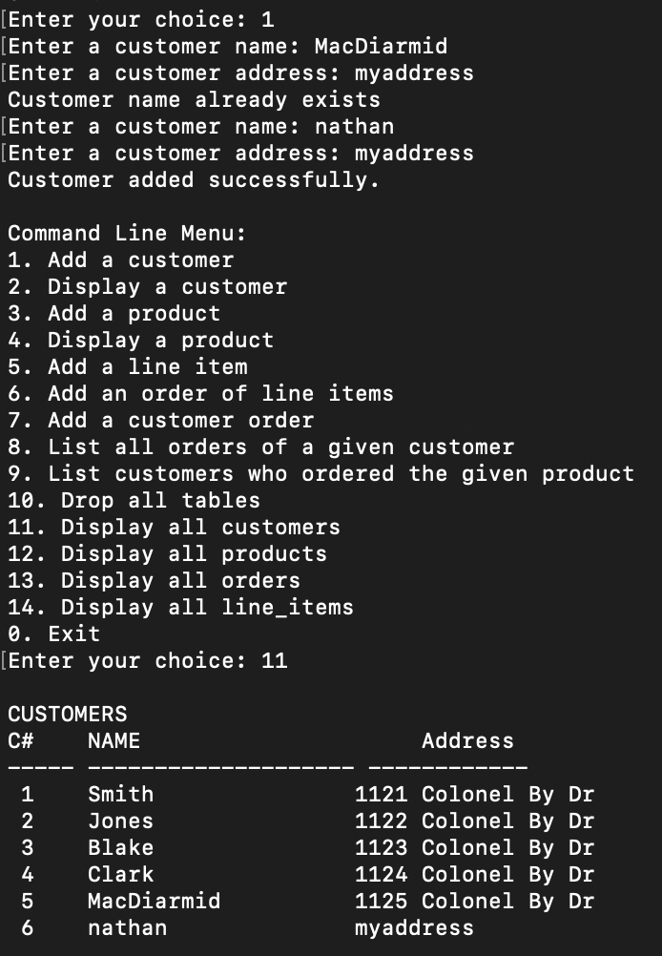

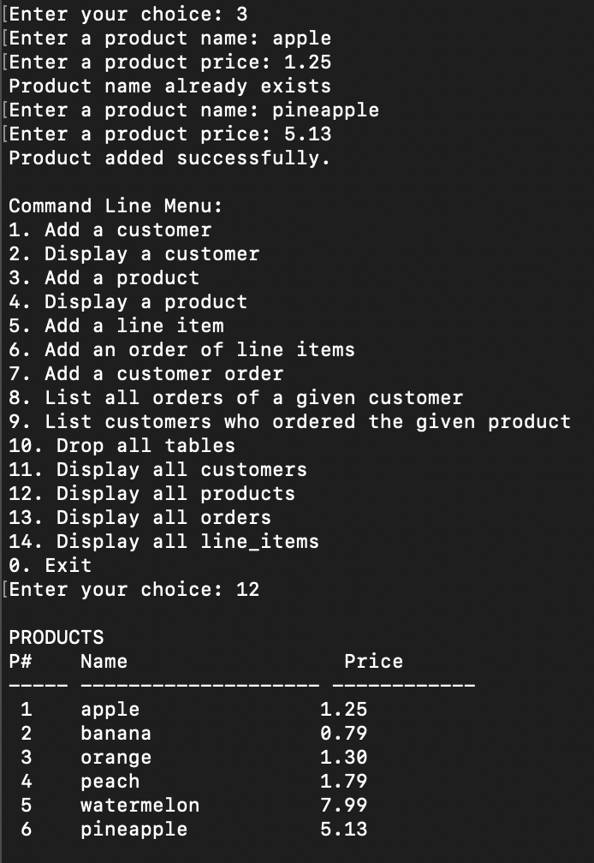

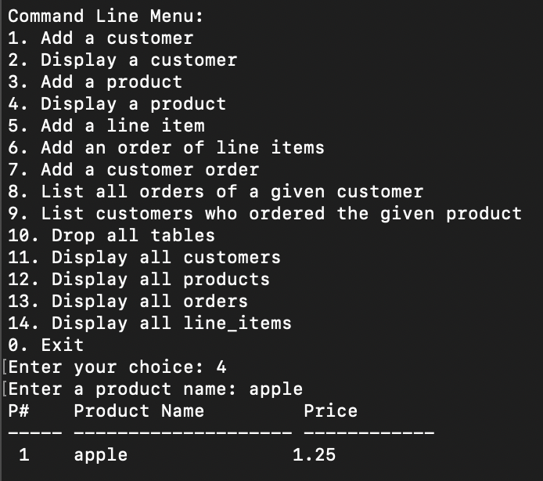

### Part 2 (60)

### Create a PL/SQL package called CPO that contains procedures and/or functions with the corresponding parameters for all the menu options listed in Part 1. It should raise an exception when the value provided are unexpected and display proper error messages. (30)

### Use dynamic SQL method 4 to rewrite an Embedded PL/SQL program that allows the user to choose a menu option and also provide the values needed, and then call the corresponding PL/SQL procedure or function to do the job and test all options. (30)