**COMP 4003A 2024W  
Assignment #3   
Due: March 3 @11:59pm**

**Instruction**

1. You should do the assignment independently. If copying is found, the case will be reported to the office of the Dean of Science immediately.
2. You need to use [Oracle VM](https://git.scs.carleton.ca/downloads/CourseVirtualMachines/2023F-2024W/COMP3005-F23-v3.ova) to do this assignment and take proper screenshots of execution results for the relevant questions. If there is no screenshot, you will get 0 for the question.
3. First replace MacDiarmid below with your last name. If your last name is not showing in the screenshot, you will get a 0 for the assignment. Also, rename this document with your last name+first name.
4. Copy your screenshots into this document and submit it to brightspace. Also submit your source codes as separate files to be Make sure your uploaded file can be opened and is correct. No submission will be accepted after the deadline no matter what reason.

**Part 1 (35)**

Use JDBC to create an application that does the same things as in Assignment #2 with the following options. As all the tables may be dropped, you need to create them if they are not there.

1. Add a customer 2. Display a customer

3. Add a product 4. Display a product

5. Add a line_item 6. Add an order of line_items   
7. Add a customer order 8. List all orders of a given customer

9. List customers who ordered the given product 10. Drop all tables

1. If the customer to be added is already in, then display this message and do nothing. The case for products is similar.
2. Option 2 displays the customer’s information and his/her previous and current orders if available (i.e., all invoices of the customer).
3. It is assumed only one customer’s order can be processed at a time so everything is related to the customer and the order but the customer may first get some items first (option 5) before the complete information is added to Customers and Orders tables. The customer order is done when a new customer is added or the program ends.
4. Option 6 means an order number (O#) is added to all current line_items without O# but the C# may not be available yet.
5. Option 7 creates the C# and also adds it to the order if the order exists.

When the user selects an option, it prompts the user to enter additional information if needed.   
Use this program to populate the database with five customers: Smith, Jones, Blake, Clark, and MacDiarmid; five products: Apple, Banana, Orange, Peach, and Watermelon; Smith orders the *first* product, Jones *first two* products, …, and MacDiarmid orders everything. The program should first find the highest C#, O#, I#, or P# and generate a new number by adding 1 to it, and also check if the customer or product to be added exists; i.e., customer names and product names are unique. Use MacDiarmid for option 8 and Apple for option 9.

Marking scheme:   
- 5 marks for initial setup & option 10 (Drop tables)

- 15 marks for the ADD functions (option 1,5,7)

- 15 marks for the SQL file that defines functions

This screen shot shows the before and after table of adding a customer:

This screen shot displays a customer and their orders:

This screen shot displays adding a product:

This screen shot displays a product:

These next screen shots show adding a line item:

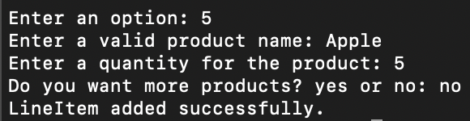

These screen shots show the addition of an order of line items:

These are the screen shots for adding a customer order:

This is a screen shot of listing all orders of a given customer:

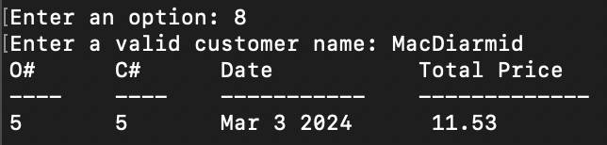

This is a screen shot of all the customers who ordered a given product:

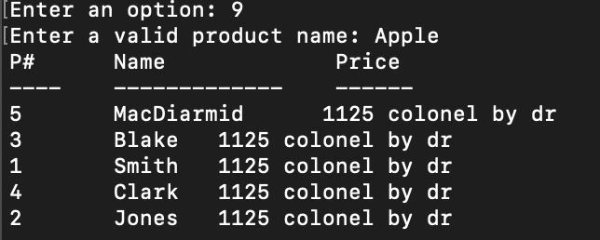

This is a screen shot of the tables being dropped:

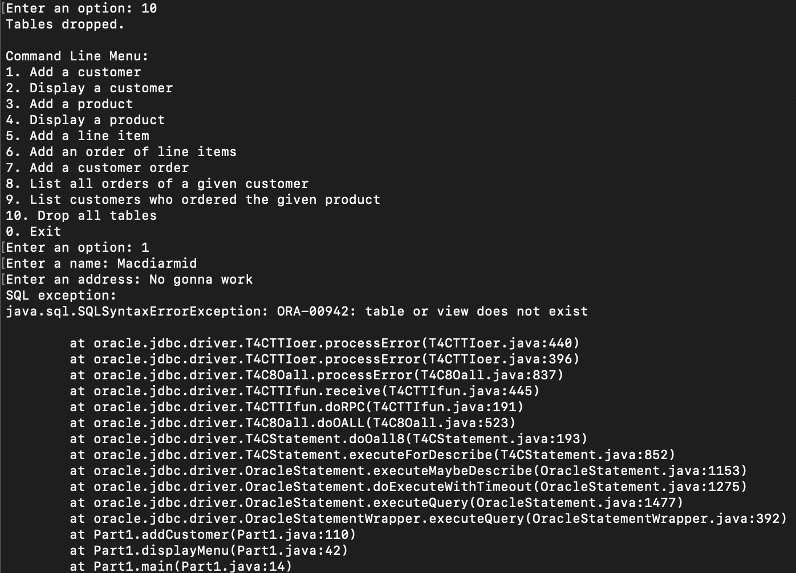

### Part 2 (65)

### Redo Part 1 that calls PL/SQL procedure or function created in Assignment #2 and test all options.

Marking scheme:

- 10 marks for option 2 by calling a function  
- 20 marks for options 2 and 4 (queries of product and customer)

- 15 marks for option 8 with nested line items of products.

- 20 marks for option 9 by calling a function.

This screen shot shows the before and after table of adding a customer:

This screen shot displays a customer and their orders:

This screen shot displays adding a product:

This screen shot displays a product:

These next screen shots show adding a line item:

These screen shots show the addition of an order of line items:

These are the screen shots for adding a customer order:

This is a screen shot of listing all orders of a given customer:

This is a screen shot of all the customers who ordered a given product:

This is a screen shot of the tables being dropped:

### 