**COMP 4003A 2024W  
Assignment #4   
Due: March 19 @11:59pm**Nathan MacDiarmid

**Instruction**

1. You should do the assignment independently. If copying is found, the case will be reported to the office of the Dean of Science immediately.
2. You need to use [Oracle VM](https://git.scs.carleton.ca/downloads/CourseVirtualMachines/2023F-2024W/COMP3005-F23-v3.ova) to do this assignment and take proper screenshots of execution results for the relevant questions. If there is no screenshot, you will get 0 for the question.
3. First replace MacDiarmid below with your last name. If your last name is not showing in the screenshot, you will get a 0 for the assignment. Also, rename this document with your last name+first name.
4. Copy your screenshots into this document and submit it to Brightspace. Also submit your source codes as separate files to be tested. Make sure your uploaded file can be opened and is correct. No submission will be accepted after the deadline no matter what reason.
5. This assignment is based on the ER model as follows.

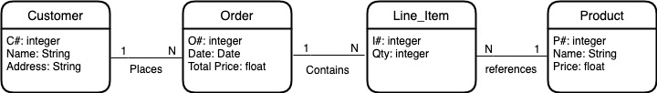

The relational database schema is as follows.

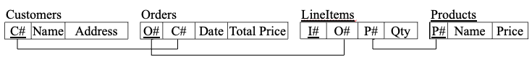

**Part 1 Nested Relational Database (50)**

1. Create a nested relational database that has two tables. The Customers table contains not only customer information but also order attributes as a nested table, which in turn contains line-item attributes as a nested table. The Products table contains not only product attributes but also I# as a varray. (15)
2. Populate this database with five customers: Smith, Jones, Blake, Clark, and MacDiarmid; five products: apple, banana, orange, peach, and watermelon; Smith ordered the first product on Jan 1, 2024, Jones the first two products on Jan 2, 2024, …, and MacDiarmid all products on Jan 5, 2024; Also, MacDiarmid ordered the last product on Feb 1, 2024, Clark ordered last two products on Feb 2, 2024, …, and Smith all products on Feb 5, 2024. (10)
3. Do the following queries and get query results screenshots. Each query is 4 marks and the result is 1 mark.  
   (1) Get each customer’s C#, Name, and Address. (5)  
   (2) Get each product’s P#, Name, and Price. (5)  
   (3) Get the names of customers who ordered banana (5)
4. Get MacDiarmid’s complete order details including all attributes shown in the ER model in a nested way (5)
5. Get the names of customers who ordered everything. (5)

### Part 2 Object Relational Database (50)

### Redo Part 1 by using four object tables Customers, Orders, LineItems, and Products so that they all have system-generated ID instead of C#, O#, I#, and P#. The Customers table contains a set of order references, Orders contains a set of LineItem references, and Products contains a set of LineItem references.

### Create four object table.s (15)

### Populate the four object tables. (10)

1. Do the following queries and get query results. Each query is 4 marks and the result is 1 mark  
   (1) Get each customer’s C#, Name, and Address. (5)  
   (2) Get each product’s P#, Name, and Price. (5)  
   (3) Get the names of customers who ordered banana (5)
2. Get MacDiarmid’s complete order details including all attributes shown in the ER model in a nested way. (5)
3. Get the names of customers who ordered everything. (5)