FYP Report – Nathan McCormack
  - 

  - Final-year Software & Electronic Engineering report for a full-stack web game project

Project Title | Ranger – An AI Quiz Game
Student Name | Nathan McCormack
Programme | Bachelor of Engineering (Honours) in Software and Electronic Engineering
Module | Project Engineering / Final Year Project
Institution | Atlantic Technological University
Academic Year | 2025/2026
Supervisor | Dr Fergus Downey

Declaration
I declare that the work described in this report is my own except where sources are acknowledged and referenced. All external material, documentation, and supporting resources used during the project have been identified where appropriate.

Acknowledgements
I would like to thank my supervisor, Dr Fergus Downey, for his guidance and feedback throughout this project. I would also like to thank the lecturers and classmates whose modules, discussions, and playtesting helped shape the final system. Their input was useful both during development and during evaluation of the finished game.

Summary
This report presents Ranger, a full-stack web-based quiz game built around a number-ordering mechanic. Instead of answering questions through multiple choice or text input, the player drags a question card onto a number line between fixed bounds of zero and infinity. Each placement is checked against neighbouring values, allowing the game to combine general knowledge with judgement about scale and relative position. The aim of the project was to create a more interactive and replayable quiz experience while also demonstrating strong full-stack engineering practice.
The system was implemented using React and Vite on the frontend, FastAPI on the backend, PostgreSQL with SQLAlchemy for persistence, and Docker for reproducible runtime setup. A key feature of the project is AI-assisted question generation through the OpenAI API. For classic play, the backend requests structured question sets, validates the returned data, stores the result against a session identifier, and sends only the required public fields to the frontend. The project also includes a Daily Mode, where one shared challenge is generated and stored per day, and a Legacy Mode for replaying previous daily challenges.
Testing focused on the backend services, daily challenge workflow, and validation logic. The final system includes automated tests, LCOV coverage reporting, and GitHub Actions workflows to support continuous integration and scheduled daily generation. Overall, the project achieved its main aim by delivering a technically coherent, interactive, and extensible game system that demonstrates frontend development, backend validation, AI integration, data modelling, and CI/CD in one project.

Table of Contents

Declaration 2
Acknowledgements 2
Summary 2
Table of Contents 2
List of Abbreviations 7
1. Introduction 7
1.1 Project Overview 7
1.2 Problem Statement 8
1.3 Aim and Objectives 8
1.4 Poster 9
1.5 Report Structure 9
2. Background and Context 10
2.1 Interactive Quiz Games and Player Engagement 10
2.2 Number Ordering and Drag-and-Drop Interaction 10
2.3 Technology Background 10
2.4 Related Design Approaches or Similar Systems 11
2.5 Justification of the Chosen Approach 12
3. Requirements and Specification 13
3.1 Functional Requirements 13
3.2 Non-Functional Requirements 14
3.3 Constraints and Assumptions 14
3.4 Success Criteria 15
4. Project Planning and Management 16
4.1 Initial Project Plan 16
4.2 Development Workflow 16
4.3 Risk Management 17
4.4 Changes from the Original Plan 17
5. System Architecture 19
5.1 High-Level Architecture Overview 19
5.2 Frontend Architecture 19
5.3 Backend Architecture 20
5.4 Database Architecture 20
5.5 External Services and Integrations 21
5.6 Deployment and CI/CD Architecture 21
5.7 Data Flow 21
6. System Design 23
6.1 UI/UX Design 23
6.2 Game Rules and Logic Design 23
6.3 API Design 24
6.4 Data Model Design 24
6.5 Daily Challenge Design 24
6.6 AI Question Generation Design 25
7. Implementation 25
7.1 Frontend Implementation 25
7.2 Backend Implementation 26
7.3 Database Implementation 26
7.4 AI Integration Implementation 26
7.5 Daily Pipeline Implementation 27
7.6 CI/CD and Deployment Implementation 27
8. Testing and Verification 29
8.1 Testing Strategy 29
8.2 Test Environment and Tooling 29
8.3 Backend and API Testing 29
8.4 Daily Mode Testing 30
8.5 CI and Coverage Evidence 30
8.6 Results and Discussion 30
8.7 Validation Against Requirements 31
9. Evaluation and Discussion 32
9.1 Achievement of Objectives 32
9.2 Strengths of the Final System 33
9.3 Challenges Encountered and Problem Solving 33
9.4 Limitations 33
10. Ethics and Professional Considerations 35
10.1 AI Use and Reliability 35
10.2 Data, Privacy, and Security 35
10.3 Academic Integrity and Referencing 35
11. Conclusion 36
11.1 Final Outcome 36
11.2 Main Technical Achievements 36
11.3 Closing Evaluation 36
11.4 Future Work 36
References 38

List of Abbreviations
Abbreviation | Meaning
API | Application Programming Interface
CI/CD | Continuous Integration / Continuous Delivery
ORM | Object-Relational Mapper
UI | User Interface
UX | User Experience
AI | Artificial Intelligence
REST | Representational State Transfer
LCOV | Linux Coverage

1. Introduction

1.1 Project Overview
This project presents the design and development of “Ranger”, a full-stack web-based quiz game that challenges players to place questions with integer answers in the correct position on a number line. The player is shown a question card containing a fact with a non-negative integer answer and must drag the card into what they believe is the correct position on the number line. The number line ranges from values zero to infinity. If the placement is correct, the card remains in the number line and the players score increases. If the placement is incorrect, the game ends and the player must begin again.
The application was implemented as a full-stack system. The frontend was built in React and Vite, with drag-and-drop behaviour provided by dnd-kit [1],[2],[3]. The backend was built in FastAPI and supported by PostgreSQL through SQLAlchemy [4],[5],[6]. In addition to the main classic mode, the system includes a Daily Mode, where all players receive the same stored challenge for the current day, and a Legacy Mode, which allows previous daily challenges to be replayed.
A central feature of the project is AI-assisted question generation. When a classic game begins, the backend requests a structured batch of questions from the OpenAI API, validates the result against a schema, stores the questions against a session identifier, and returns only the public fields required by the frontend [7]. The project therefore combines interactive gameplay, backend validation, persistent storage, scheduled automation, and automated testing within one application.
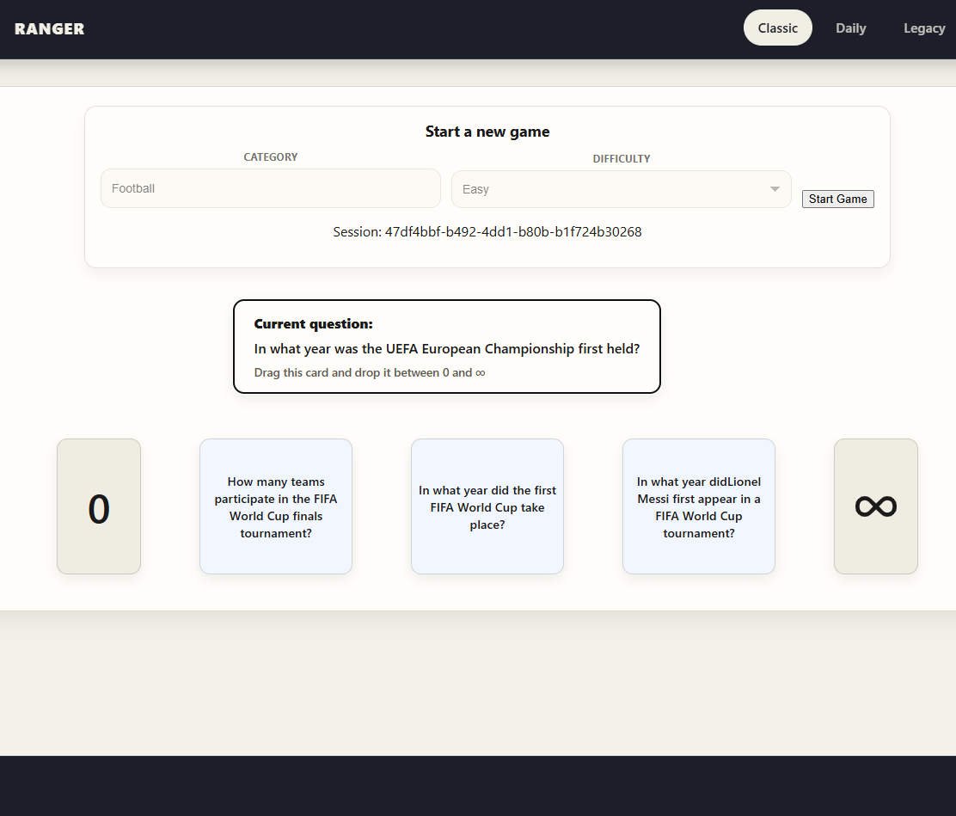

1.2 Problem Statement
Many quiz systems rely on multiple-choice answers or short text input. These formats are easy to build and easy to understand, but they can become repetitive quickly and do not encourage the player to think about scale, ordering, or relative magnitude. For a game built around numeric facts, that is a clear limitation.
This project addresses this by making placement itself the challenge. Instead of entering an exact value, the player must judge where a fact belongs relative to cards that are already on the number line. This makes the interaction more visual and more game-like, while still testing knowledge. The same mechanic also works across a wide range of categories, including years, populations, counts, distances, and durations.
Replayability created a second problem. A fixed question bank would quickly become predictable, so the project needed a way to generate fresh content without giving up reliability. This led to AI-generated question sets for classic play, together with strict schema validation and a stored daily challenge pipeline so that new content could be introduced under backend control.

1.3 Aim and Objectives
The aim of this project was to design and implement a full-stack web application that delivers an engaging number-ordering quiz game supported by AI-generated content, structured backend validation, and reproducible testing and deployment practices.
To achieve this aim, the project defined the following objectives:
- To design and implement a responsive web interface that allows players to interact with the game using a drag-and-drop number-line mechanic.
- To develop a backend service capable of managing question data, validating answer placement, and exposing the required REST API endpoints for gameplay.
- To integrate AI-based question generation in a controlled manner so that category-based and difficulty-based question sets can be created for standard game sessions.
- To design and implement a daily challenge system that generates one shared challenge per day, stores the result, and allows retrieval of both current and previous challenges.
- To create a suitable database structure for storing questions, daily challenge records, and related game data in a consistent and maintainable form.
- To apply software engineering best practices through automated testing, coverage reporting, and CI/CD workflows to improve reliability and maintainability.

1.4 Poster
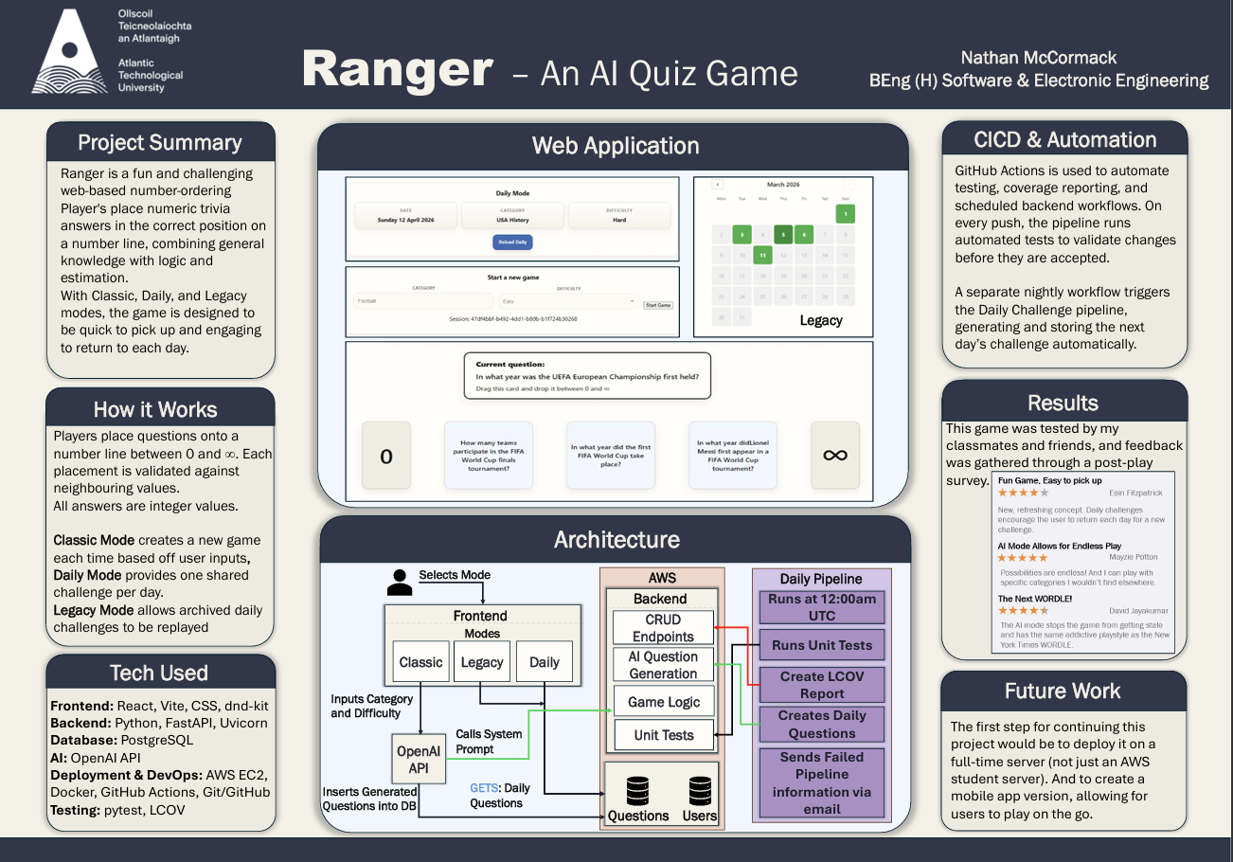

1.5 Report Structure
This report is organised to move from project motivation through to implementation, testing, evaluation, and final reflection. Chapter 1 introduces the project, identifies the problem being addressed, and defines the main objectives. Chapter 2 provides the background and context for the project, including the gameplay influences and the technologies used. Chapter 3 defines the system requirements, constraints, and success criteria.
Chapter 4 explains how the project was planned and managed during development. Chapter 5 presents the overall system architecture, while Chapter 6 focuses on the design of the interface, rules, API, data model, Daily Mode, and AI generation flow. Chapter 7 then describes how those designs were implemented in practice.
Chapter 8 presents the testing and verification evidence, including the automated test strategy, daily mode testing, and coverage results. Chapter 9 evaluates the final system by discussing achievement of objectives, key strengths, technical challenges, and remaining limitations. Chapter 10 considers ethical and professional issues, including the use of AI during development, data and security considerations, and academic integrity. Finally, Chapter 11 concludes the report by summarising the outcome, main technical achievements, closing evaluation, and future work.

2. Background and Context

2.1 Interactive Quiz Games and Player Engagement
Traditional quiz applications are effective for checking recall, but they often depend on the same interaction pattern for every question. Engagement is usually stronger when the player must act on information rather than simply select an answer. Short feedback loops, visible progress, and clear failure condition all help turn a quiz into a game.
This project was designed around that idea. Instead of using a text box or multiple-choice answers, the player must judge where each fact belongs on a number line. That makes the act of answering part of the challenge rather than just the result of it.

2.2 Number Ordering and Drag-and-Drop Interaction
The central gameplay idea behind this project is numerical ordering. Many real-world facts can be expressed as non-negative integers and these values are naturally suited to comparison and ranking, making them appropriate for a game based on relative placement rather than exact typed answers.
Ordering mechanics introduce a different kind of reasoning from standard question-and-answer systems. Instead of asking only whether the player knows the exact answer, the game also allows the player to make an informed estimate based on context and comparison. This creates a broader range of possible play, as players can succeed not only through memorisation, but also through logical judgement about magnitude and sequence.
The use of a number line provides a simple visual model for this interaction. It gives the player an immediate sense of scale and allows new information to be interpreted relative to already placed values. The fixed boundary values of zero and infinity make the interface easy to understand, while the growing sequence of placed cards increases challenge over time. This approach supports both clarity and tension: the rules remain simple, but the decision becomes harder as more cards appear on the line.
The drag-and-drop interaction further strengthens this design. Direct manipulation allows the player to physically place a card where they believe it belongs, which is more intuitive than entering a position numerically or selecting from fixed options. It also contributes to the game-like feel of the system, helping the application feel closer to an interactive puzzle than a conventional revision tool.

2.3 Technology Background
This project was built using a modern full-stack web development approach, combining a JavaScript frontend, a Python backend, persistent database storage, containerised deployment tooling, and automated development workflows [8], [9].
React was chosen because it supports component-based development, reusable UI elements, and efficient state-driven rendering, all of which are important in an interactive web application. In this project specifically, React is used to manage the gameplay interface, page routing, score updates, modal behaviour, and reusable layout elements such as the header, footer, and question card components. Vite was used as the frontend build tool and development server, providing fast startup times, efficient reloading during deployment, and a straightforward configuration for API proxying between the frontend and backend services.
A key part of the frontend interaction model is the drag and drop gameplay mechanic. To support this, I used dnd-kit, which is an external drag-and-drop library for React. This library provides the core draggable and droppable behaviour required for placing question cards on the number line. Using a dedicated drag-and-drop library made it possible to implement a more reliable and maintainable solution than building complex pointer and drop logic manually, while still allowing the interaction design to remain closely aligned with the game rules.
The backend was developed using FastAPI, a python framework designed for building REST APIs. FastAPI was well suited to the project because it supports clear route definitions, request and response validation, automatic interactive API documentation, and straightforward integration with Python data models. These features were useful for implementing gameplay endpoints, placement validation, question retrieval, and daily challenge generation.
For the database system, I used Postgres, as it provides reliable storage for the projects structured game data, including questions, game sessions, and daily challenge information. SQLAlchemy allows the system to define models and relationships in Python while maintaining a clear separation between database logic and application code. This combination supports consistency, maintainability, and a schema that can scale beyond a lightweight prototype.
To support reproducible development and deployment, the project uses Docker and Docker Compose [10], [11]. These tools allow the backend and database services to be run in a consistent environment, reducing configuration problems and making the project easier to start, test, and deploy across different machines. I implemented automated workflows using GitHub Actions, which were used to run tests, generate coverage artefacts, and support scheduled tasks such as the daily challenge pipeline [12].
OpenAI’s API was also used to create quiz questions dynamically. Rather than accepting free-form AI outputs directly, the backend validates generated questions against a defined schema containing fields such as question text, answer, category, and difficulty. This allows the system to benefit from dynamic content generation while maintaining engineering control over correctness, structure, and usability.

2.4 Related Design Approaches or Similar Systems
The main inspiration for this project came from the card game “Bang Out of Order”, which uses ordering as the source of challenge [13]. This project adapts that idea into a browser-based system and extends it with features that are only practical in software, including AI-generated question sets, category and difficulty selection, and a stored daily challenge.
The project was also influenced by daily browser games such as Wordle, particularly the idea of giving all players the same challenge on a given day [14]. On the development side, the backend structure was influenced by service patterns used in a CI/CD module, while the frontend organisation followed the component and routing structure used in a Full Stack Development module [15], [16].

2.5 Justification of the Chosen Approach
The approach taken in this project was suitable because it allowed me to turn a simple but effective game idea into a technically strong software project. The original concept of ordering cards by value already had a good balance of simplicity and challenge, so it gave me a solid starting point for the gameplay. From there, I was able to build on that idea and develop it into a full web application with additional features that would not be possible in a physical card game.
This approach was also a good fit because I wanted the game to feel more interactive than a typical quiz. A lot of quiz systems are based on selecting an answer or typing one in, but that can become repetitive very quickly. By using a drag-and-drop number-line mechanic, I was able to make the player think more carefully about relative values and create a more engaging gameplay loop.
From a technical point of view, this project was a good choice because it let me bring together several areas of software development in one system. It involved frontend development, backend API design, database modelling, AI integration, testing, and CI/CD. That made it more suitable for a final year project than something with a narrower scope, as it gave me the chance to demonstrate a wider range of engineering skills.
Overall, I believe this was the right approach because it matched both the practical and academic goals of the project. It gave me a game concept that was simple to understand but strong enough to develop further, while also allowing me to produce a project that demonstrates full-stack development, structured problem solving, and technical decision-making.

3. Requirements and Specification

3.1 Functional Requirements
ID | Requirement
FR1 | The system should allow a user to start a classic game session
FR2 | The system should allow the player to choose a difficulty and category
FR3 | The system should generate a batch of questions using the AI question generation
FR4 | The system should display one active question card at a time for the player to place on the number line
FR5 | The system should allow the player to drag and drop the question card onto the number line
FR6 | The system should validate the players placement by comparing answer values with the neighbouring question cards
FR7 | The system should increase the players’ score after a correct placement
FR8 | The system should end the game when the player makes an incorrect placement
FR9 | The system should provide a Daily Mode that gives all players the same challenge for the current day
FR10 | The system should prevent multiple daily challenges from being generated on the same day
FR11 | The system should provide access to previous daily challenges through a Legacy Mode
FR12 | The system should store relevant question and daily challenges data in a relational database
FR13 | The system should protect the daily generation endpoint using a backend token
FR14 | The system should provide feedback when endpoints fail

3.2 Non-Functional Requirements
ID | Requirement
NFR1 | The system should provide a responsive and readable UI
NFR2 | The gameplay interface should be clear enough for a new player to understand basic interaction
NFR3 | The drag and drop interaction should be clean and behave consistently
NFR4 | The backend should validate incoming and generated data using schemas
NFR5 | The codebase should follow a structured layout consistent with previous module practice
NFR6 | The project should support automated testing through a CI/CD pipeline
NFR7 | The project should generate test coverage evidence
NFR8 | The system should handle AI generation failures – avoiding crashes

3.3 Constraints and Assumptions
This project was developed within several practical and technical constraints. These constraints influenced both the scope of the final system and the decisions made during development.
One important constraint was the use of OpenAI’s API. The outputs could not simply be trusted without validation. The project therefore had to assume that generated questions might be incorrectly formatted, duplicated or unsuitable for gameplay. This constraint led directly to the use of structured schema validation and controlled backend filtering.
A second constraint was the limited time available within the academic year along with the pressure from other modules. Because of this, the implementation had to focus on the most important features first. This meant prioritising the core game loop, backend validation, daily challenge generation, and testing over fewer essential extensions.
The system also assumes that question answers are non-negative integers and that these values can be compared meaningfully within the number line mechanic. This assumption Is central to the gameplay design, as it allows all questions to be validated using one consistent ordering rule.

3.4 Success Criteria
For me to judge whether the final version of the project was successful, it was necessary to define clear success criteria. These criteria provide a practical way of measuring whether the final implementation achieved its intended goals.
ID | Criteria
SC1 | A player can start and complete a standard game session through the web interface.
SC2 | The player can drag and drop cards onto the number line, and the system correctly validates each placement.
SC3 | The backend can generate and validate AI-based question sets
SC4 | The application provides a working Daily Mode
SC5 | Previously generated daily challenges can be accessed through legacy mode.
SC6 | Questions are stored correctly in the database
SC7 | The project includes automated tests for important backend and daily mode behaviours
SC8 | Test execution and coverage reporting are integrated into the CI/CD workflow.

4. Project Planning and Management

4.1 Initial Project Plan
The initial goal was to recreate the core ordering mechanic of “Bang Out of Order” in a digital format. That gave the project a clear starting point: a draggable card, a number line, and a simple success-or-failure rule. Once that core was defined, the scope expanded to include AI-generated questions, a stored daily challenge, and replay of previous daily challenges.
A timeline was maintained in Jira to help plan and track the overall progress of the project [17]. This gave structure to the work across the academic year and helped break the project into more manageable stages. In practice, the work was approached in phases, beginning with the core gameplay concept and frontend/backend foundation, then expanding into AI integration, daily challenge functionality, testing, and final refinement.

4.2 Development Workflow
Development was managed using Jira, GitHub, and personal progress notes kept in OneNote [18], [19]. Jira was used to organise the work into epics, stories, and tasks, which helped separate larger project areas from individual implementation steps. A board structure was used to track the state of work, with tasks moving through columns such as To Do, In Progress, Blocked, and Done. When necessary, unfinished work could be moved back into the backlog and replanned for a later sprint.
The project was developed using two-week sprints. Sprint work was planned in advance, which helped maintain momentum and gave each development period a clearer focus. This made it easier to manage the workload alongside other final-year modules and reduced the risk of trying to implement too many features at once. OneNote logs were used alongside Jira to record important notes, development decisions, and progress updates throughout the project.
Version control was managed using GitHub with two main long-term branches: main and development. The main branch was always kept stable and was used only for working, reliable code. New tasks were branched from development, implemented separately, and then merged back into development when complete. Once a larger milestone had been reached and tested, the updated code would then be merged into main. This branching strategy helped reduce the risk of unstable work affecting the main version of the project.
Automated testing also formed part of the workflow. When code was pushed, unit tests were run automatically, and merges were not allowed unless the code coverage threshold remained above 70%. This introduced an additional quality check into the development process and encouraged testing to be treated as part of normal implementation rather than something left until the end.
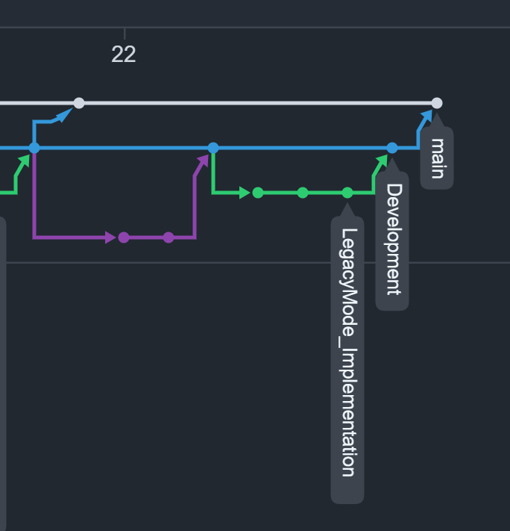

4.3 Risk Management
Several risks affected the planning and delivery of the project. One of the most important was the pressure of completing the work alongside multiple other final-year modules. Time management was therefore a genuine project risk, as delays in one area of the project could have affected both implementation quality and completion. The use of sprint planning, Jira tracking, and backlog management helped reduce this risk by breaking the work into smaller and more manageable sections.
Another risk was the technical complexity of some parts of the system. Certain features, particularly AI-assisted question generation, daily challenge logic, and backend validation, required more time to understand and implement properly than simpler frontend tasks. This meant that some parts of the project involved a steeper learning curve and could not be treated as straightforward development work. To manage this, the project focused first on establishing a working core system and then expanded into more advanced features incrementally.
A further risk was maintaining software stability while continuing to add features. Because the project included multiple connected parts across the frontend, backend, database, and CI/CD workflow, it was important to avoid breaking previously working code while implementing new functionality. The use of a stable main branch, a separate development branch, and automated test checks helped reduce this risk

4.4 Changes from the Original Plan
Although the original goal was to recreate the core idea of a numeric ordering card game in digital form, the final project developed well beyond that initial concept. Early on, the focus was mainly on the gameplay mechanic itself, but as the project progressed, additional features were added that significantly increased both the scope and the technical depth of the system.
One important change was the introduction of AI-generated question sets for standard gameplay. This shifted the project away from relying on a fixed question source and towards a more dynamic and replayable system. Another major addition was the development of Daily Mode, where all players receive the same pre-generated challenge for the day. This feature was influenced by other successful daily games and added a stronger sense of repeated engagement. The system was then extended further through Legacy Mode, allowing previous daily challenges to remain accessible rather than being lost after a single day.
At the same time, not every planned feature was completed within the final version of the project. Several additional ideas remained in the project backlog, including extra gameplay features and a user login system. These were considered valuable extensions, but they were not prioritised ahead of the core gameplay loop, backend validation, daily challenge functionality, and testing. Given the time constraints of the academic year and the need to deliver a stable and well-tested final system, it was more important to complete the core platform properly than to include partially finished features.
The project also became more structured from an engineering perspective as development continued. Features such as automated testing, coverage enforcement, CI/CD workflows, and a more deliberate branching strategy became increasingly important as the system grew. As a result, the final version of the project was not just a digital version of an existing game idea, but a more complete full-stack application shaped by iterative development, technical learning, and realistic decisions about scope.

5. System Architecture

5.1 High-Level Architecture Overview
At a high level, Ranger uses a client-server architecture. The player interacts with the system through a web browser, which loads the React frontend. The frontend is responsible for the visible interface and sends HTTP requests to the backend whenever a gameplay action happens. The backend then processes those requests, applies the game rules, generates questions where needed, and reads from or writes to the database.
The system also includes an external AI integration through the OpenAI API. This is used to generate question batches for the main game mode and for the daily challenge workflow. Instead of relying on a fixed bank of hard-coded questions, the backend requests structured output from the AI service, validates it, stores it in the database, and then returns the required data to the frontend.
Alongside the main runtime architecture, the project also includes a CI/CD and automation layer. GitHub Actions is used for automated testing, coverage reporting, and the scheduled daily generation pipeline.
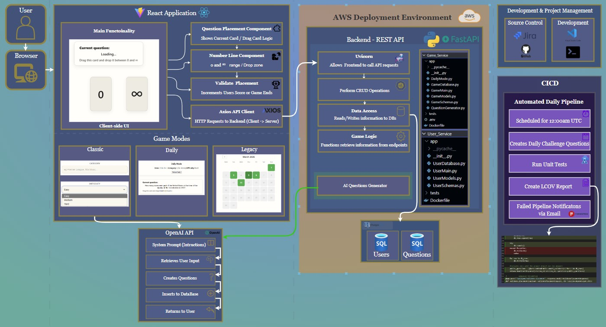

5.2 Frontend Architecture
The frontend was built using React with Vite and is responsible for the interactive side of the application. As shown in Figure 5.1, the frontend is centred around the main React application, which contains the gameplay interface and the different game modes available to the player.
The core gameplay view contains the current question card, the number line, and the controls used during placement. The current question is shown as a draggable card, while the number line displays the fixed lower and upper bounds of zero and infinity, along with any cards already placed during the run. The player interacts with this view by dragging the active card into a chosen position, after which the attempted placement is sent to the backend for validation.
Figure 5.1 also shows the main frontend sub-components involved in this flow. These include the question placement component, the number-line display, the placement handling logic, and the score update behaviour that follows a correct move
Communication between the frontend and backend is handled using Axios [20]. This is used to send HTTP requests from the browser to the backend REST API. Keeping the request logic separate in this way helps keep the frontend decoupled from the backend implementation while still allowing the UI to retrieve data and submit gameplay actions.

5.3 Backend Architecture
The backend was developed using FastAPI and acts as the main control layer of the system. It receives requests from the frontend, applies the game rules, communicates with the database, and manages the AI-based question generation process.
As shown in Figure 5.1, the backend architecture is organised around a few main areas. The first is the routing layer, which handles incoming API requests from the frontend. The second is the CRUD and data-access layer, which is responsible for reading and writing structured data. The third is the game logic layer, which contains the application-specific behaviour needed for gameplay.
This backend structure supports the main functions of the system. It validates player placements by comparing the value of the current question against the neighbouring cards already placed on the number line. It also handles standard game session creation, retrieval of stored data, and the daily challenge workflow. Keeping these responsibilities on the backend ensures that the frontend is not treated as the final authority for gameplay correctness.
The diagram also reflects part of the backend file structure. During development, the backend was kept organised through separate files for schemas, routes, models, and game-specific logic. This followed a structure similar to the service layout used in previous module work and made the application easier to extend as the project grew.

5.4 Database Architecture
The database layer provides persistent storage for the structured data used by the application. This project uses a relational database, accessed through the backend, to store question data and support the different game modes.
In Figure 5.1, the database is shown beneath the backend to reflect its role as the main persistence layer of the system. The backend communicates with it whenever generated questions need to be stored, gameplay data needs to be retrieved, or daily challenge records need to be read or updated.
The database design supports both the standard game mode and the Daily and Legacy modes. For standard gameplay, generated questions can be linked to a game session so that the player receives a consistent set of questions during that run. For the daily system, the database stores the questions generated for a particular date so that all players receive the same challenge on that day. Because Legacy Mode depends on access to past daily challenges, the database also supports retrieval of historical daily entries rather than only the current one.

5.5 External Services and Integrations
This project relies on several external tools and services beyond the main frontend/backend/database structure. The most important of which is the OpenAI API, which is used to generate quiz questions dynamically.
As shown in figure 5.1, the OpenAI integration follows a structured process. The backend prepares a system prompt and user input, sends the request to the API, receives generated question data, and then inserts validated results into the database before returning them to the user through the normal application flow. This process was designed to keep AI generation under backend control rather than allowing free-form AI responses to reach the frontend directly.

5.6 Deployment and CI/CD Architecture
The right-hand side of Figure 5.1 shows the deployment and CI/CD support environment for the project. This includes both the development environment and the automated workflow used to support testing and daily challenge generation.
GitHub Actions is used as part of the CI/CD workflow. This pipeline performs several important tasks automatically, including running unit tests, generating LCOV coverage reports, and supporting the scheduled daily challenge pipeline [21]. The daily pipeline runs at a fixed time and creates the daily challenge used in Daily Mode. The diagram also shows that pipeline failures can trigger email notifications via Formspree, which adds another layer of visibility to the automation [27].
The wider development workflow is also reflected in this part of the architecture. Source control was managed through GitHub, project planning and task tracking were managed through Jira, and implementation work was carried out in the development environment shown in the diagram. Together, these tools formed the non-runtime support structure that helped the project be built, tested, and maintained in a controlled way.

5.7 Data Flow
The overall data flow of the project can be explained by following the main paths shown in Figure 5.1. When the player interacts with the browser interface, the React frontend updates the visible UI and sends requests to the backend using Axios. The backend then handles those requests depending on which part of the system is being used.
In Classic Mode, the player selects a category and difficulty before starting a game. That request is sent to the backend, which triggers the AI question generation process through the OpenAI API. The generated questions are validated, stored in the database, and returned to the frontend for play. The player then drags the active card into position on the number line, and the attempted placement is submitted to the backend. The backend checks the neighbouring values, decides whether the move is valid, and returns the result so that the frontend can either continue the game or end it.
In Daily Mode, the flow is slightly different because the question set is created in advance through the automated daily pipeline. The scheduled workflow generates and stores the daily challenge for the current date. When the player opens Daily Mode, the frontend requests that stored challenge from the backend rather than generating a new one. After that, the gameplay flow follows the same validation pattern as standard play.
In Legacy Mode, the player accesses previously stored daily challenges. The frontend sends a request for historical challenge data, the backend retrieves the relevant stored records from the database, and the selected challenge is then displayed in the browser.

6. System Design

6.1 UI/UX Design
The UI was designed to keep the gameplay clear, immediate, and easy to follow. Because the main mechanic depends on placing values correctly on a number line, the interface needed to make the current task obvious without crowding the screen with unnecessary information. For that reason, the layout was built around three main elements: the active question card, the number line, and the player’s score.
A major design goal was to make the game feel more like a modern browser-based puzzle than a traditional quiz form. This influenced the decision to use a clean central play area, clear spacing between interface elements, and a layout that naturally draws the player’s attention to the current card and its possible placement. The score display and game controls were kept visible, but secondary to the main gameplay action.
The interface was also designed so that the different modes could feel like parts of the same application rather than separate systems. Classic Mode, Daily Mode, and Legacy Mode each have their own view, but the visual structure and interaction style were kept consistent across them. This makes it easier for the player to move between modes without having to learn a completely different interface each time.

6.2 Game Rules and Logic Design
The gameplay rules were designed to be simple to understand but capable of producing increasing challenge as the game progresses. Each question has a non-negative integer answer, and the player must place the current card in what they believe is the correct position on the number line relative to the cards already placed.
The core validation rule is based on neighbouring values. A placement is considered correct if the answer on the current card falls between the values of the cards immediately to its left and right. Where only one neighbour exists, the placement must still satisfy the valid ordering rule relative to that neighbour. This rule allows the same validation logic to be used consistently throughout the game, regardless of how many cards have already been placed.
if left is null and right is null:
correct = true
elif left is null:
correct = placed <= right
elif right is null:
correct = left <= placed
else:
correct = left <= placed <= right
The scoring design was intentionally simple. Each correct placement increases the player’s score, while an incorrect placement ends the run. This creates a straightforward risk-and-reward structure and supports the fast replay loop that was intended for the project. Rather than introducing multiple scoring factors or complicated bonus systems, the design keeps the player focused on placement accuracy.
The difficulty of the game comes naturally from the structure of play. At the start of a session, the number line contains very little information, but as more cards are added, the remaining gaps become narrower and the choices become harder. This allows the challenge to increase without making the rules themselves more complicated.

6.3 API Design
The API was designed to support the frontend in a clear and task-focused way. Rather than exposing unnecessary complexity to the client, the backend endpoints were structured around the main actions required by the application, such as starting a game, retrieving questions, validating placements, and working with daily challenge data.
A major design goal was to keep responsibilities clear between frontend and backend. The frontend is responsible for presenting the interface and capturing the player’s actions, while the backend acts as the authoritative source for rule enforcement and structured data handling. This is particularly important for placement validation, as the correctness of a move should not depend only on frontend logic.
The API design also needed to support different game modes without making the service layer inconsistent. For that reason, standard gameplay and daily gameplay follow similar patterns where possible, while still using distinct routes where their behaviour differs. This keeps the API easier to understand and avoids forcing unrelated logic into the same endpoint structure.

6.4 Data Model Design
The data model was designed to support both the core gameplay loop and the additional daily challenge functionality without mixing unrelated concerns. A key requirement was to store generated question data in a structured way while still allowing the system to distinguish between standard game sessions and date-based daily challenges.
For standard gameplay, the design needed to support batches of questions generated for a particular run. This meant the player could receive one consistent question set for that session rather than triggering fresh generation on every interaction. For daily gameplay, the design instead needed to support one stored challenge per date so that all players would receive the same question set on the same day.
Because Daily Mode and Legacy Mode both depend on stored historical data, the model also needed to preserve previous daily challenges rather than replacing them. This influenced the decision to use separate daily-related records instead of treating daily content as temporary data. The resulting structure supports both retrieval of the current challenge and access to earlier challenges through Legacy Mode.

6.5 Daily Challenge Design
Daily Mode was designed around the idea of one stored challenge per date. To make that reliable, the generation process had to be idempotent, meaning the backend checks whether the current day already exists before creating anything new. Category rotation was handled through stored daily categories rather than one-off random prompting, which helped reduce repetition from day to day.

Legacy Mode followed naturally from this design. Once daily challenges were being stored by date, it became possible to expose previous challenges to the player instead of limiting access only to the current day. This gave more long-term value to the stored data and made the daily system feel like a proper part of the overall application rather than just an add-on feature.

6.6 AI Question Generation Design
The AI question generation feature was designed to provide variety and replayability without giving up backend control over question quality. The project needed dynamic content generation, but it also needed the resulting questions to fit the game rules and the structure of the application.
For that reason, the design did not rely on unrestricted free-form AI responses. Instead, generated questions were required to follow a defined structure including fields such as question text, answer, category, and difficulty. This made it possible to validate outputs before they were stored or returned to the frontend.
Another important design concern was gameplay suitability. It was not enough for a generated result to be syntactically valid; it also had to make sense within the number-ordering mechanic. That meant the generation process had to be constrained so that answers were non-negative integers and questions were phrased clearly enough to avoid ambiguity during play. AI generation was therefore treated as a controlled content source rather than as an independent decision-maker.
Error handling was also part of the design. Because external AI generation can fail or return unsuitable data, the system needed a way to reject bad outputs and prevent them from affecting gameplay.

7. Implementation

7.1 Frontend Implementation
The frontend was implemented around feature-based modules. QuestionPlacement.jsx handles classic play, DailyModePage.jsx handles the current daily challenge, and LegacyModePage.jsx handles replay of previous daily challenges. Shared layout elements such as TopBar.jsx and FooterBar.jsx are kept separate from the game-specific components. To keep question order varied during play, the frontend also uses a Fisher–Yates style shuffle when preparing question arrays on the client side [28].
Within the game feature itself, components such as CurrentQuestionCard.jsx, LineQuestions.jsx, DroppableSlot.jsx, and GameOverPopUp.jsx break the interface into smaller units. API requests are separated into files such as gameApi.js, dailyApi.js, and legacyApi.js, which keeps Axios logic out of the visual components. In practice, most of the main frontend state is managed in QuestionPlacement.jsx, including the current question, deck, placed cards, score, session ID, and game-over state.

7.2 Backend Implementation
The backend was split across smaller modules rather than being written as one large application file. GameMain.py contains the main game routes, including question CRUD, random question retrieval, session start, placement validation, game-run storage, user statistics, and leaderboard endpoints. DailyMode.py provides the daily router, including generate-today, today, history, history-by-date, and daily placement validation. UserMain.py provides CRUD routes for user records.
A key implementation decision was to keep validation on the server side. The validate-placement endpoint receives the placed question ID together with the IDs of the neighbouring cards, looks up the answer values in the database, and then applies the ordering rule. The same pattern is used again for daily placements, but against DailyQuestionDB records instead of standard QuestionDB records.

7.3 Database Implementation
The database layer was implemented using PostgreSQL with SQLAlchemy. The models were defined in Python and mapped to relational tables used by both the standard game mode and the daily system.
For classic gameplay, generated questions were stored with a game session identifier. This allowed the backend to keep one generated batch tied to a particular run and avoid mixing questions from different sessions. That session-linked approach was important because standard mode depends on a controlled set of generated questions rather than a single shared question pool.
For the daily system, separate daily records were implemented so that one challenge could be stored against a specific date and then reused. Additional daily-related tables supported the structure needed for the current day’s challenge and for previously generated daily content. This separation between standard session-based questions and date-based daily data made the database easier to manage and reduced the risk of the two modes interfering with each other.
Database access was handled through SQLAlchemy sessions in the backend, with configuration provided through environment variables. This made it easier to move between local and containerised environments without changing the application logic.

7.4 AI Integration Implementation
Question generation is implemented in QuestionGenerator.py. The backend defines two Pydantic models, GeneratedQuestion and GeneratedQuestionSet, and then calls client.responses.parse(...) so that the OpenAI response is parsed directly into the required schema. The generator also enforces that exactly eight questions are returned for a game start request.
After parsing, the backend sanitises each question before storage. Question text is stripped, answers are cast to integers, and the final category and difficulty are overwritten with the values requested by the user. If generation fails, or if the response does not match the expected count, the game start endpoint returns a 502 response instead of storing partial or invalid data

Algorithm 7.1 Structured question generation
response = parse_openai(system_prompt, user_prompt, GeneratedQuestionSet)
if len(response.questions) != 8:
raise generation_error
for each question in response.questions:
clean text
cast answer to integer
overwrite category and difficulty with requested values
store question against current session

7.5 Daily Pipeline Implementation
The daily pipeline was implemented using a combination of backend logic and scheduled automation. A protected backend endpoint was created for daily generation, and this endpoint checks whether the challenge for the current day already exists before attempting to create a new one. This makes the process idempotent and prevents duplicate daily challenges from being stored for the same date.
The generation endpoint was secured using a backend token so that it could not be triggered freely outside the intended workflow. Once the daily challenge had been created and stored, it could then be retrieved by the frontend through the normal daily route.
This pipeline was connected to GitHub Actions, which ran the daily generation process on a schedule. This meant the challenge for a new day could be created automatically without manual intervention. Because previous challenges remained stored, the same daily pipeline also supported later retrieval of historical daily content in Legacy Mode.
Algorithm 7.2 Daily challenge generation
today = current_utc_date()
if successful challenge exists for today:
return already_exists
create pending daily challenge
select difficulty from date
pick an unused category
questions = generate_questions(category, difficulty, count=8)
store daily question rows
mark challenge success
if generation fails:
mark challenge failed
return 502

7.6 CI/CD and Deployment Implementation
The repository contains three GitHub Actions workflows: a CI workflow for running pytest on main, a daily generator workflow triggered on a cron schedule, and a coverage workflow that produces HTML and LCOV artefacts. The daily workflow uses a protected trigger URL and job token, and it can notify an admin if generation fails.
Deployment support is provided through Dockerfiles for the game and user services and a docker-compose.yml file that starts three services: db, game_service, and user_service. The game service is exposed on port 8002, the user service on localhost port 8000, and PostgreSQL on localhost port 5432. This keeps the runtime setup reproducible without hard-coding environment-specific values into the application.

8. Testing and Verification

8.1 Testing Strategy
Testing was planned as a layered activity rather than a single final step. The main emphasis was on automated backend verification because the most critical correctness rules in this project — question validation, daily generation, schema enforcement, and persistence behaviour — all live on the server side. Manual testing was still used on the frontend for interface behaviour, drag-and-drop interaction, and overall game flow, but automated tests were focused on the API and service logic.
The automated strategy combined endpoint-level testing, service-level checks, validation testing, and CI execution. Standard gameplay, daily challenge behaviour, run statistics, and user-service CRUD operations were each tested in isolation so that failures could be traced back to a specific part of the system. This approach was particularly important for AI-assisted generation, where the reliability of the surrounding validation logic mattered as much as the generation step itself.
At the time of writing, the repository contains 54 automated tests: 45 for the Game Service and 9 for the User Service. These tests are supplemented by manual playtesting of Classic, Daily, and Legacy modes in the browser.

8.2 Test Environment and Tooling
The backend tests were implemented using pytest and FastAPI’s TestClient [22], [23]. Test fixtures in conftest.py override the normal database dependency and replace it with an in-memory SQLite database [24]. StaticPool is used so that the same in-memory database can be shared across requests during a test session, while FastAPI dependency overrides ensure that the application uses the test session instead of the normal runtime database connection [25].
For the Game Service, this setup allowed the endpoints to be tested without starting external containers or using a live PostgreSQL instance. For the User Service, a similar in-memory approach was used to test user CRUD operations and validation rules independently from the main game backend. This made the tests fast, repeatable, and isolated from deployment concerns.

8.3 Backend and API Testing
The backend and API tests were grouped around the main service responsibilities. Question endpoint tests check health responses, empty-list behaviour, CRUD operations, validation errors, and not-found cases. Gameplay tests focus on the placement validation logic and ensure that the endpoint behaves correctly for empty lines, one-sided bounds, full left/right neighbour ranges, and invalid references. Run and stats tests verify that user-run records are stored correctly and that statistics and leaderboard responses are aggregated as expected.
The User Service was also tested separately. These tests focused on input validation, duplicate handling, retrieval of missing users, update behaviour, and deletion. Although the full login flow was not integrated into the frontend, the service-level CRUD behaviour was still validated at API level.

Test File | Main area Covered |  | No. of Tests
Test_game_endpoints.py | CRUD, validation errors |  | 15
Test_gameplay_endpoints.py | Placement validation logic |  | 12
Test_run_stats_endpoints.py | Game runs, leaderboards, user stats |  | 6
Test_users.py | User CRUD and validation behaviour |  | 9

8.4 Daily Mode Testing
Daily Mode required its own test coverage because it combines generation, persistence, retrieval, and error handling. The daily tests cover the most important behaviours of this workflow: returning 404 when no challenge exists for the current day, creating a new daily challenge successfully, preventing duplicate generation for the same date, marking a challenge as failed when generation raises an exception, and retrieving historical challenges through the history endpoints.
The history tests are particularly important because Legacy Mode depends on historical daily data remaining correct. These tests check that only successful past challenges are returned, that today’s challenge is excluded from the history list, that past challenges are ordered most recent first, that answers are omitted from public question payloads, and that invalid date requests return the expected 404 or 422 responses.

8.5 CI and Coverage Evidence
The LCOV artefact included in the repository reports 322 covered lines out of 336 measured lines for the Game Service application modules, which corresponds to 95.8% line coverage. This is comfortably above the project’s 70% coverage gate and provides evidence that the critical server-side logic has been exercised by automated tests.
Coverage should not be treated as proof that every possible defect has been removed, but in this project it is still a useful indicator because the most important gameplay rules are implemented on the backend. High line coverage, when combined with targeted endpoint tests, gives stronger confidence than raw percentage alone.

8.6 Results and Discussion
The test results show that the backend implementation is well verified for the core project requirements. Session start, placement validation, daily challenge generation, historical challenge retrieval, game-run recording, and user-service CRUD behaviour are all exercised by automated tests. The strongest evidence is around the server-side rules, which are also the most important source of correctness in the project.
The results also show where verification is lighter. Frontend behaviour was tested manually rather than with an automated browser test framework, so drag-and-drop UX, component rendering, and layout responsiveness do not yet have the same automated evidence as the backend.
Overall, the evidence gives high confidence in the correctness of the backend services and in the reliability of the daily pipeline. Confidence is lower in areas such as accessibility, browser-specific interaction behaviour, and production-grade account management, which are discussed later as limitations rather than overlooked issues.

8.7 Validation Against Requirements
This table maps the main requirements defined in chapter 3 to implementation and verification evidence.
Requirement | Evidence |  | Status
FR1-FR3 | Classic start flow implemented in QuestionPlacement.jsx and /api/game/start; AI batch generation parsed and validated in QuestionGenerator.py. |  | Achieved
FR4-FR8 | Single active card, drag-and-drop placement, backend validation, score updates, and game-over flow implemented in frontend and tested through gameplay endpoint tests. |  | Achieved
FR9-FR11 | Daily and Legacy modes implemented in DailyModePage.jsx and LegacyModePage.jsx; daily history and retrieval verified by daily-mode tests. |  | Achieved
FR12-FR13 | Question, run, and daily challenge records stored in PostgreSQL/SQLAlchemy; daily generation endpoint protected by X-Daily-Job-Token. |  | Achieved
FR14 | Backend returns explicit 404/409/422/502 responses and frontend displays failure messages where required. |  | Achieved
NFR1-NFR3 | Responsive browser UI, consistent drag-and-drop behaviour, and manual play-testing across the three main modes. |  | Achieved  (manual evidence)
NFR4-NFR5 | Pydantic schemas, structured backend layout, and separated modules for routes, models, and daily logic. |  | Achieved
NFR6-NFR7 | GitHub Actions workflows, pytest execution, and LCOV evidence showing 95.8% Game Service line coverage. |  | Achieved
NFR8 | AI generation exceptions handled through controlled 502 responses and failed daily challenge status updates. |  | Achieved

9. Evaluation and Discussion

9.1 Achievement of Objectives
Objective 1, to build a responsive drag-and-drop web interface, was achieved through the React frontend and the use of dnd-kit. The final application supports Classic, Daily, and Legacy modes through a consistent browser-based UI.
Objective 2, to develop a backend service for question management and placement validation, was achieved through the FastAPI Game Service. The backend exposes the required endpoints, enforces the game rules, and supports run statistics and leaderboard queries.
Objective 3, controlled AI-based question generation, was achieved through OpenAI structured parsing and Pydantic validation. Generated questions are not accepted as free-form text; they are checked before being stored and used.
Objective 4, a stored Daily Mode with access to both current and past challenges, was achieved through the daily router, daily database tables, and the scheduled generation workflow.
Objective 5, a suitable relational data model, was achieved through the SQLAlchemy models used for session-linked questions, daily challenge storage, run tracking, and user records.
Objective 6, the use of software engineering practices such as testing, coverage reporting, and CI/CD, was achieved through pytest, GitHub Actions workflows, and the coverage artefacts generated for the Game Service.
These outcomes show that the project met its stated objectives to a high standard, even though some future-facing features such as full account integration remain unfinished.

9.2 Strengths of the Final System
One of the strongest parts of the final system is the gameplay mechanic itself. The number-line placement rule is easy to understand, but it still produces challenge as the gaps become narrower. This gives Ranger a stronger identity than a standard quiz form and makes the project feel like an actual game rather than just a revision tool with questions on a screen.
A second strength is the decision to keep correctness on the backend. By validating placements server-side and treating AI generation as a controlled backend service rather than a direct frontend feature, the project avoids relying on the client for critical logic. This makes the implementation more robust and more in line with good engineering practice.
Daily Mode and Legacy Mode also add a lot beyond the core game loop. The system does not just generate questions on demand; it supports a date-based challenge model with persistence and replay. This gives the project more structure and makes it feel like a more complete application.
Finally, the project is strengthened by the engineering built around it. Automated tests, coverage artefacts, Docker-based setup, and GitHub Actions workflows make the final result much stronger than a project that only works as a one-off demo.

9.3 Challenges Encountered and Problem Solving
One of the main technical challenges was making AI-assisted content generation reliable enough for gameplay. A general-purpose model can return output that looks plausible but is still unsuitable for a game, for example duplicated answers, unclear wording, or values that do not fit the rules. This was addressed through structured parsing, strict field validation, and backend-side sanitisation before any generated questions were stored.
Another challenge was implementing Daily Mode so that it behaved as a true shared challenge rather than just another version of Classic Mode. The backend had to generate one challenge per day, avoid duplicates, preserve history, and recover cleanly from generator errors. The idempotent generate-today flow and the daily challenge status model were added to solve this.
The frontend also needed careful state handling because drag-and-drop gameplay depends on the active card, placed cards, score, and backend response all staying in sync. This was handled by keeping the placement attempt lightweight on the client and using backend validation as the single source of truth.
A final challenge was scope. Features such as Daily Mode, Legacy Mode, AI integration, testing, and CI/CD all added complexity to the project. Rather than trying to complete every possible backlog item, development was kept focused on the strongest features and on bringing those to a good standard.

9.4 Limitations
Despite the strengths of the final system, several limitations remain. The most important is that authentication and account management are not yet production ready. Although a separate User Service exists and run statistics can be linked to user IDs, there is no fully integrated login flow in the gameplay interface.
A related limitation is security hardening. The User Service currently represents an early CRUD implementation rather than a finished identity system. Password hashing, full authentication, and session- or token-based access control would all be needed before public deployment.
The project also remains dependent on external AI generation for classic-mode question creation. The backend reduces the risk by validating structure and constraining prompts, but it cannot completely guarantee factual accuracy or perfect difficulty balance in every generated set.
Automated verification is strongest on the backend. Frontend interaction, browser-specific behaviour, and accessibility were tested mainly through manual use rather than through a dedicated UI automation framework. That is acceptable for the current project scope, but it does limit the overall depth of verification.

10. Ethics and Professional Considerations

10.1 AI Use and Reliability
AI was used in two different ways during this project: as part of the final system for runtime question generation, and as a development support tool while building the project. During development, AI was helpful for exploring different approaches to CSS styling, comparing frontend and backend technologies such as Vite, GitHub Actions, and Docker, debugging more difficult pieces of code, and working through implementation tasks such as LCOV coverage reports, workflow configuration, and API integration [26]. It was also useful when I needed quick suggestions for refactoring or for understanding why a particular configuration or piece of logic was failing.
However, AI was not used as a blind code-generation tool. Any code, configuration, or technical suggestion produced through AI assistance was treated as a starting point only. I reviewed it, adapted it to the structure of my own project, tested it locally, and only kept it when it fit the actual system and behaved correctly. This was especially important for backend validation logic, GitHub Actions workflows, coverage reporting, and deployment-related configuration, where copying output directly could have introduced errors or hidden misunderstandings.
It is also important to distinguish this development-time use of AI from the runtime use of the OpenAI API inside the final application itself. In this project, AI-generated questions are not accepted unchecked. They are requested through a controlled backend flow, validate2d against a defined schema, and rejected when they do not meet the project’s requirements. Overall, AI was useful throughout the project, but it functioned as a support tool rather than as the author of the work.

10.2 Data, Privacy, and Security
The main gameplay flow does not require personal data. Classic, Daily, and Legacy modes can all operate without the player creating an account, which limits privacy exposure in the current user-facing system. In that sense, the core game is relatively low-risk from a personal-data perspective.
Where data and security do become more important is in supporting services. The backend uses environment variables for configuration and secrets, and the daily generation endpoint is protected with a dedicated job token compared using a constant-time check. OpenAI requests are also sent with store=False so that request and response data are not retained through that API setting.
At the same time, the current project should not be presented as a finished security-hardened system. The user service represents groundwork for future account support, but it would need additional protection before real deployment. Password hashing, stronger authentication, stricter API exposure, and a review of permissive CORS settings would all be required before public use.

10.3 Academic Integrity and Referencing
Academic integrity was an important consideration throughout the project and the report writing process. External documentation, framework references, and other supporting technical sources were used where appropriate, but these should be clearly acknowledged in the final report rather than presented as original work. Any code patterns influenced by tutorials, examples, or official documentation should also be referenced where relevant.
This report uses IEEE referencing consistently so that sources are clearly identified and the technical discussion remains properly supported. This is especially important in areas such as framework choice, API behaviour, testing tools, deployment tools, and any background discussion used to justify design decisions.

11. Conclusion

11.1 Final Outcome
The final outcome of this project is a working full-stack web application that turns numeric trivia into an ordering game. The finished system supports classic session-based play, a shared Daily Mode, replay of previous daily challenges through Legacy Mode, backend run tracking, and a separate user-service foundation for future account-based features.
The project exists as a codebase with a React frontend, FastAPI services, SQLAlchemy-backed database models, automated workflows, and supporting Docker configuration. It is therefore more than a gameplay prototype; it is a structured software system that can be demonstrated, tested, and extended.

11.2 Main Technical Achievements
The main technical achievements of this project are the backend placement validation, the structured AI question generation flow, the idempotent daily challenge pipeline, and the testing and CI/CD setup that supports the system.
From a software engineering perspective, one of the strongest parts of the project is the separation of concerns across the system. The frontend, game backend, daily mode logic, user service, and database layer were developed as separate parts with clear responsibilities, rather than being combined into one messy application. This makes the system easier to understand, easier to maintain, and gives the project more technical depth overall.
Another major achievement is the testing evidence behind the project. High coverage on the Game Service, focused endpoint tests, and automated workflows make the final system much more credible than a project that only appears to work during a demonstration. This shows that my application was not only built but also verified in a structured and repeatable way.

11.3 Closing Evaluation
Overall, the project achieved its main aim. It delivered an interactive number-ordering quiz game supported by AI-generated content, backend validation, and reproducible development practices. The clearest evidence for this is the completed feature set, the automated test suite, and the successful implementation of Daily and Legacy modes alongside the core classic gameplay loop.
The project is not completely finished in the sense of being production-ready, and there are still limitations in areas such as authentication, accessibility, and deployment hardening.

11.4 Future Work
The most important next step would be proper user account integration. This would include password hashing, authentication, and session- or token-based access control, along with connecting the User Service fully to the frontend so that player statistics and leaderboard features become part of the normal user experience.
Another useful area for future work is content quality control. If the project were to be deployed publicly, it would benefit from an extra review or moderation layer for AI-generated questions. A curated fallback bank of verified questions could also be used when AI generation fails or produces unsuitable output.
There is also room for further improvement in testing and accessibility. Frontend automation, keyboard-based alternatives to drag-and-drop, improved screen-reader support, and broader testing across devices would all strengthen the overall quality of the application.
Finally, the project could be extended through deployment to a more permanent production environment and, in the longer term, through a mobile version that keeps the same core gameplay and challenge structure

References
[1] React, “Get Started,” React Documentation. [Online]. Available: https://react.dev/
[2] Vite, “Getting Started,” Vite Documentation. [Online]. Available: https://vite.dev/
[3] dnd kit, “React Quickstart,” dnd kit Documentation. [Online]. Available: https://dndkit.com/react/quickstart
[4] FastAPI, “FastAPI Documentation,” FastAPI. [Online]. Available: https://fastapi.tiangolo.com
[5] PostgreSQL Global Development Group, “PostgreSQL: Documentation,” PostgreSQL Documentation. [Online]. Available: https://www.postgresql.org/docs/
[6] SQLAlchemy, “SQLAlchemy Documentation,” SQLAlchemy 2.0 Documentation. [Online]. Available: https://docs.sqlalchemy.org/
[7] OpenAI, “OpenAI API Platform Documentation,” OpenAI Platform Docs. [Online]. Available: https://developers.openai.com/api/docs
[8] Ecma International, “ECMA-262: ECMAScript® 2025 Language Specification,” Ecma International. [Online]. Available: https://ecma-international.org/publications-and-standards/standards/ecma-262
[9] Python Software Foundation, “Python 3.14.4 Documentation,” Python Documentation. [Online]. Available: https://docs.python.org/
[10] Docker, “Get started,” Docker Docs. [Online]. Available: https://docs.docker.com/get-started/
[11] Docker, “Docker Compose,” Docker Docs. [Online]. Available: https://docs.docker.com/compose/
[12] GitHub, “GitHub Actions documentation,” GitHub Docs. [Online]. Available: https://docs.github.com/actions
[13] Gamely Games, “Bang! Out of Order,” Gamely Games. [Online]. Available: https://gamelygames.com/products/bang-out-of-order
[14] The New York Times, “NYT Games: Wordle ” The New York Times [Online]. Available: https://www.nytimes.com/games/wordle/index.html
[15] Atlantic Technological University, “CI/CD Module Labs and Assignments,” Project material provided through ATU module resources, 2025
16] Atlantic Technological University, “Full Stack Development Module Labs and Assignments,” Project material provided through ATU module resources, 2025.
[17] Atlassian, “Jira Documentation,” Atlassian Support. [Online]. Available: https://confluence.atlassian.com/jira
[18] GitHub, “GitHub Docs,” GitHub Docs. [Online]. Available: https://docs.github.com/
[19] Microsoft, “OneNote help & learning,” Microsoft Support. [Online]. Available: https://support.microsoft.com/en-us/onenote
[20] Axios, “Getting Started,” Axios Docs. [Online]. Available: https://axios-http.com/docs/intro
[21] LCOV Documentation “lcov,” lcov. [Online]. Available: https://lcov.readthedocs.io/en/latest/
[22] pytest-dev, “pytest documentation,” pytest Documentation. [Online]. Available: https://docs.pytest.org/
[23] FastAPI, “Test Client - TestClient,” FastAPI Documentation. [Online]. Available: https://fastapi.tiangolo.com/reference/testclient/
[24] SQLite, “SQLite Documentation,” SQLite Documentation. [Online]. Available: https://sqlite.org/docs.html
[25] SQLAlchemy, “Connection Pooling,” SQLAlchemy 2.1 Documentation. [Online]. Available: https://docs.sqlalchemy.org/en/latest/core/pooling.html
[26] World Wide Web Consortium, “Cascading Style Sheets home page,” W3C. [Online]. Available: https://www.w3.org/Style/CSS/Overview.en.html
[27] Formspree, “Help Center,” Formspree Help Center. [Online]. Available: https://help.formspree.io/.
[28] P. E. Black, “Fisher-Yates shuffle,” Dictionary of Algorithms and Data Structures, National Institute of Standards and Technology. [Online]. Available: https://xlinux.nist.gov/dads/HTML/fisherYatesShuffle.html.

