**IMS 222 (Introduction to Interaction Design and Development)**

**Assignment#1 (25 pts)**

Assignment#1 is to use a partially completed **html** and **css** files and develop the Oxford Town Hall website with Home and Membership pages (see attached screens). For completing this assignment, you need to download and unzip **assignment1.zip** file from **Canvas-Assignments-Assignment1**. The detailed instruction for the assignment is as follows.

**HOME.HTML and HOME.CSS**

1. Open **home.html** file and add the html code to <section>…</section> based on the following instruction.

* add <iframe> code to include YouTube video about Oxford. The video’s URL is <https://www.youtube.com/watch?v=011_wIKIXxE&t=16s>. after embedding the video, change its width and height to width="300" height="200". The code should be located below the last <p> tag inside <section>.
* Add html code for inserting the table to show the following information. You need to find hyperlink URL info for each place and add it to connect with its website (e.g. for Miami university, use <a href=”<https://www.miamioh.edu>”>Miami University</a>). After adding the table and its elements, present them as shown in the completed homepage screenshot by adding css rules to home.css (see page 6 in this instruction). The css rules to add are listed in page 2 - <iframe and table style> part in this instruction

|  |  |
| --- | --- |
| Type | Places |
| College | [Miami University](https://www.miamioh.edu/) |
| Park | [Hueston Woods](https://ohiodnr.gov/go-and-do/plan-a-visit/find-a-property/hueston-woods-state-park) |
| Breakfast | [Patterson's Cafe](https://pattersonscafe.com/) |
| Dinner | [Paesano's](https://paesanospastahouse.com/) |
| Coffee | [Kofenya](https://www.kofenyacoffee.com/) |
| Pizza | [SDS](https://sdspizza.com/) |

1. Add css code to **home.css** file (go to line 47) using the following information. Before writing css code, please take a careful look at html code in home.html. Specially, id, classes, attributes used in each html tag.

<header style>

* header
  + 2em padding bottom
  + border bottom with 2px width, solid style and #ef9c00 color
* header h1
  + #ef9c00 color
  + 2px 3px 0px black text shadow
  + 120px left margin and 0.25em bottom margin
* header h2
  + green color, italic font style and 120px left margin
* header img
  + left float
  + 80px width and 60px height

<navigation bar style>: Use **nav_bar** for creating CSS syntax

* #nav_bar
  + clear: left
  + 0 margin and padding
  + 2px solid #ef9c00 bottom border
* #nav_bar ul
  + 0 left margin
  + 0.5em bottom margin
  + No list style
  + 0.5em 2em 0 0 padding
* #nav_bar li
  + inline display
  + 0 1.5em padding
  + 2px solid black right border
* #nav_bar a
  + No underline for manu bar items
  + <a> tag whose class name is **current,** blue font color

<section style>

* section
  + 560px width
  + left float
  + 20px right padding
* section h1 and h2
  + 0.35em bottom margin
* section p
  + 0.5em bottom margin

<iframe and table style>

* iframe
  + Left float
  + Right margin 30px
* table
  + For table, td, th, add
    - 1px solid #ddd border
    - padding top and bottom 5.3px and right and left 5px
    - center text align
    - Set border collapse to collapse
  + For <a> tag within the table, set text decoration to none
  + For even rows in the table, add #f2f2f2 background color (hint: use nth-child())
  + Change background color to lightblue when you hover each row.

<side bar style>

* aside
  + 360px width
  + right float
  + 2px solid #ef9c00 border left
  + 20px left padding
* aside h1
  + 125% fontsize
  + 0.5em bottom padding
* aside h2
  + 100% font-size
  + blue color
  + 0.5em bottom padding
* aside p {
  + 0.5em bottom margin
* For id name **contact_us**
  + 1em top margin
* For class name **date_passed**
  + gray color

<footer style>

* footer
  + clear both
  + 1em top margin
  + 2px solid #ef9c00 border top
  + 0.7em top padding
* footer p
  + 80% fontsize
  + right text alignment

**MEMBERSHIP.HTML AND MEMBERSHIP.CSS**

1. **MEMBERSHIP.HTML**

* Open the **membership.html** file and add html codes to create the web page attached.
* For the **Membership Type**, use <**select**> element assuming that there are four membership options such as **Platinum, Gold, Silver**, and **Bronze.**
* There are two types of input fields: Required and Optional.
  + **Required** fields: E-mail, Password, Verify Password, First Name, Last Name, Phone Number.
  + **Optional** fields: Address, City, State, Zip code

You should code accordingly to reflect the required and optional fields.

* In sidebar
  + Add html code for 2023-24 guest speakers using a table as shown the completed membership image in page 8. Add the relevant CSS to membership.css to show the table accordingly to the designated area (i.e. sidebar area). You may reuse some CSS code that you used in home.css for the table formatting.
  + Add header “**Location**” using h1 tag and Google map of Miami University. Adjust width and height of the map to fit into the sidebar (hint: see how to embed a map to html <https://support.google.com/maps/answer/144361?co=GENIE.Platform%3DDesktop&hl=en>).
* Form
  + Add code to enable the data entered to form elements to be submitted to your email. Follow the instruction for form-email connection described in [**https://formsubmit.co/**](https://formsubmit.co/)
  + After completing the assignment, upload completed files to your webserver and test whether the form data is successfully sent to your email system.

1. **MEMBERSHIP.CSS**

* Open the **membership.css** file.
* Style **<legend>** element: green color and bold font weight, 85% font size and 0.5em bottom margin.
* Style **<label>** element: left float, 12em width and right text alignment.
* Style two types of input fields. If needed, refer to <https://developer.mozilla.org/en-US/docs/Web/CSS/Pseudo-classes> to know how to use a pseudo code.
  + For the **required** fields, border: 3px, solid, red.
  + For the **optional** fields (i.e. address, phone number), border: 2px, solid, blue.
* Change the width of **Submit** and **Reset** buttons to 7em and locate them accordingly as shown in the completed membership page.
* Remove **underline** for hyperlinked items in the navigation bar and side bar.

**SUBMISSION GUIDELINE:**

You need to submit the completed assignment files to Canvas. You should **zip** all html, css, and image file and create ‘**asssignment1.zip**’ file and **upload** it to Canvas-Assignments-Assignment#1 before the due date. It is a **team assignment#1, so only one team representative on behalf of his/her team needs to upload the completed assignment files to Canvas**.

**Incomplete home.html**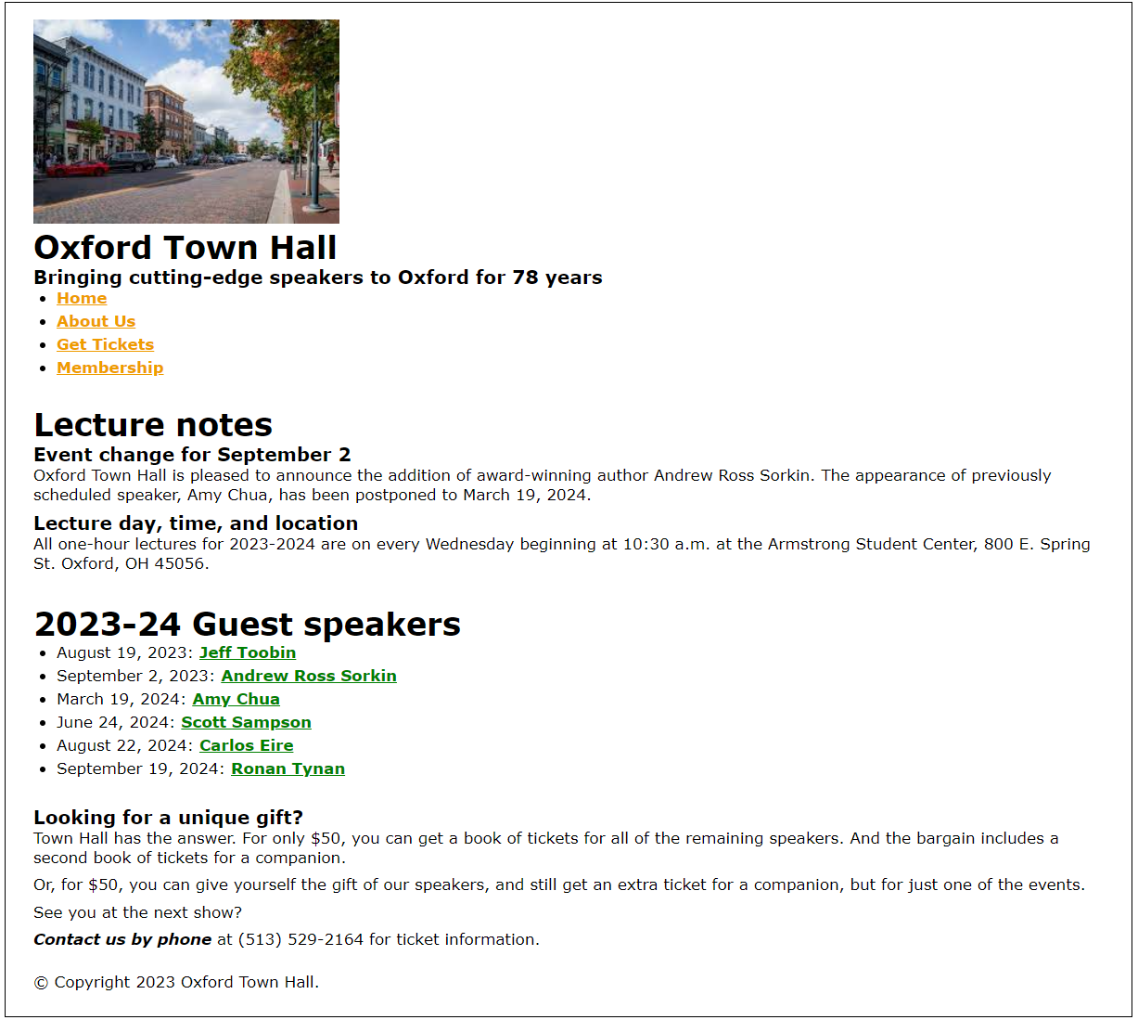

**The completed home.html**

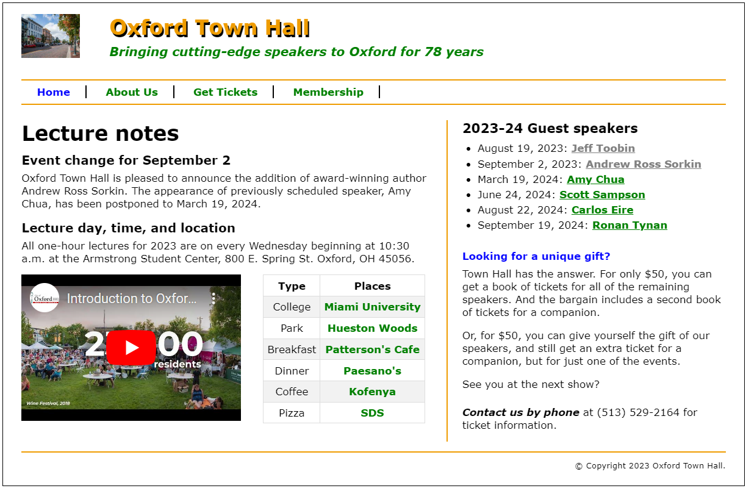

**Incomplete membership.html**

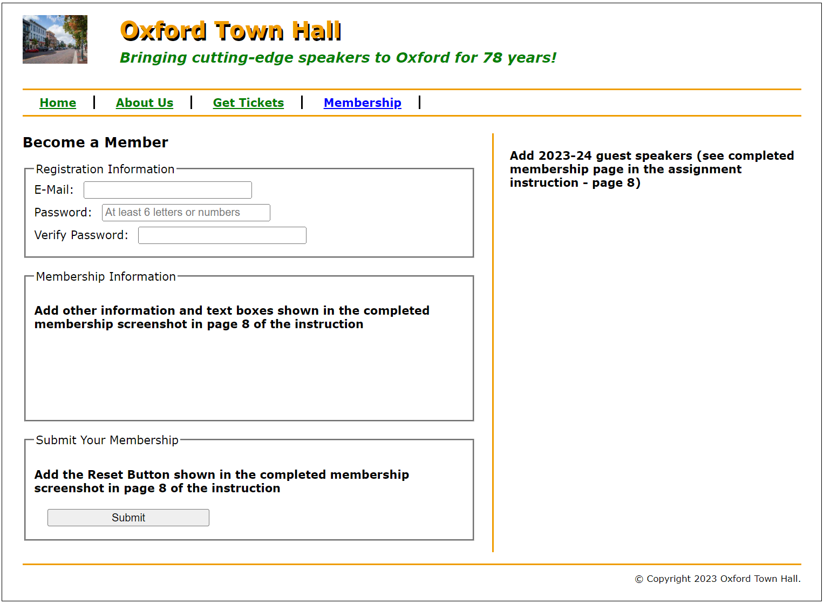

**The completed membership.html**

