{{company_name}}

{{location}}

{{ today_date }}

Technical {{position_name}} - Internship

To whom it may concern,

I am extremely excited to learn of potential student employment opportunities available at {{company_name}}, and wish to apply to such positions. I believe that my background and experience, combined with my passion for physics and integrated systems makes me a well-suited candidate for such a role. My engineering studies and previous employment experiences have allowed me to develop many skills that would be valuable to {{company_name}}. I am currently studying Engineering Physics and Computing at Queen’s University with a GPA of 3.84.

As a Project Engineering Co-op in the New Technology and Innovation Labs at Magna Mechatronics, I am responsible for developing several technical systems using a combination of electrical, mechanical and software design. Through the utilization of applied mathematics, I was able to develop laser animations for a Quantum Dot taillight that I designed and created computer vision algorithms for collision detection. I also designed programs in Python and C++ for several embedded devices and robotic systems utilizing a variety of sensors including IR, Radar and Ultrasonic.

As a Mechanical Design Intern, I have used tools such as SolidWorks and CAD software to assist in product design and {{company_name}} for connected devices. Please find the solid models of many of my work on my [GrabCAD](https://grabcad.com/nathan.pacey-1) and in the following pages of this document.

I am competent in programming languages such as; Python, C, C++, MATLAB, Java, HTML5 and CSS and have been responsible for data collection and analysis related to new product testing, design, and development. I am incredibly interested in using programming to simulate and solve real world problems using optimization algorithms and simple machine learning as illustrated in my [GitHub](https://github.com/NathanPaceydev/).

I am familiar with all aspects of Microsoft Office and have experience developing customer-facing documents as well as front-end/customer-facing web sites. Furthermore, I am competent in computer-aided design, software development and mathematical problem solving with a proficiency in technically challenging problems.

Throughout my career, I have contributed to positive business results by being effectively organized, able to manage multiple priorities at once and ensuring that I follow through assigned tasks to their conclusion. While I am independently motivated, I am also a team player that appreciates collective efforts and collaborates productively within group settings.

Simply put, I would be highly motivated to advance my knowledge of software engineering and physics by working for an enterprise that is leading the charge to innovate {{field_type}} technologies.

Thank you for your kind consideration and would enjoy the opportunity to discuss my application with you in the near future.

Sincerely,

Nathan Pacey

226-988-3313

Npacey01@gmail.com

Grab CAD: https://grabcad.com/nathan.pacey-1

GitHub: https://github.com/NathanPaceydev/

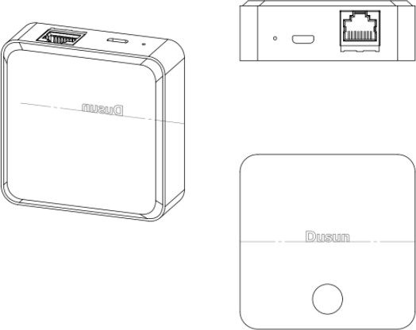

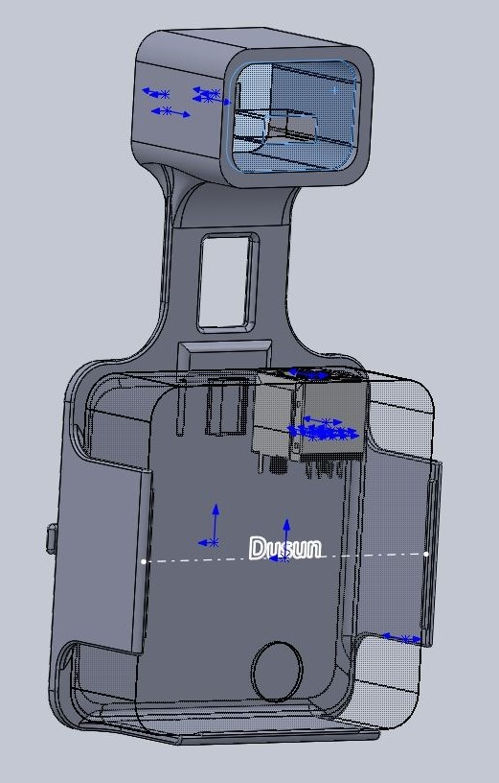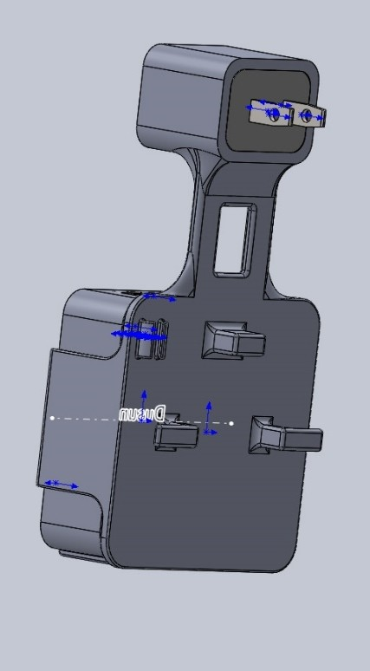*Figure 1: Heyyoka – Designed a mount and cable management bracket for a Smart Home Hub.*

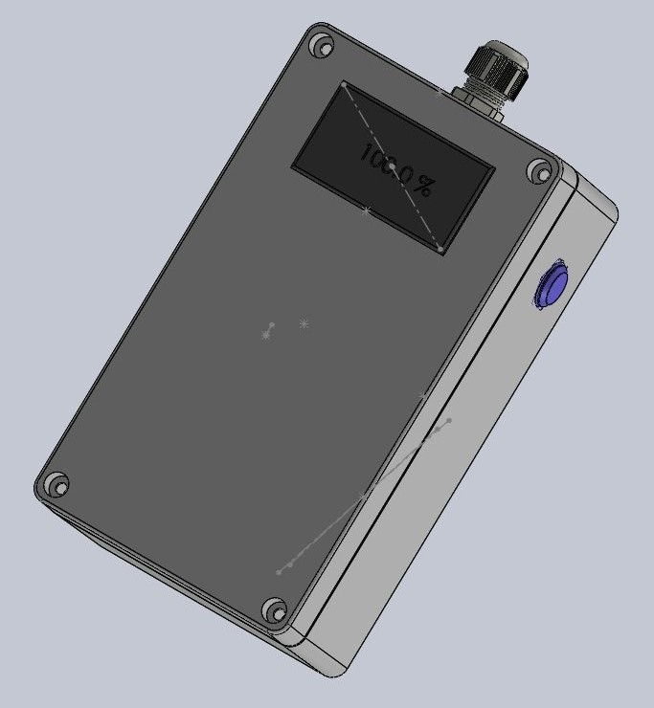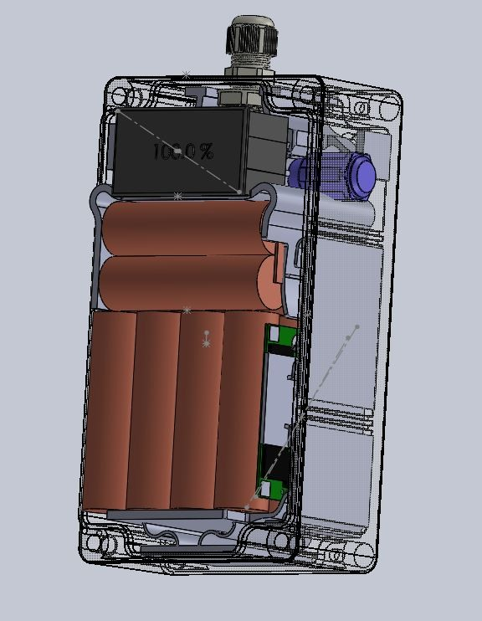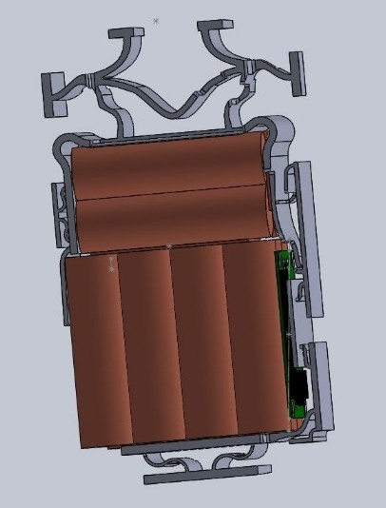

*Figure 2: Vision Spatial Technologies – Sourced and designed a battery system for SmartPatrol, a rugged environment intelligent alert system used at recreational resorts.*

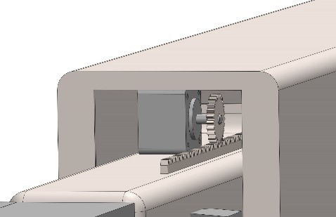

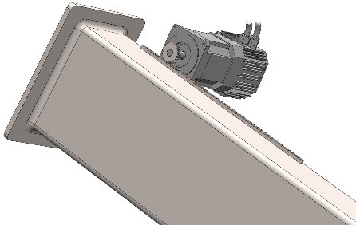*Figure 3: Queen's University and the Canadian Space Agency - Asteroid Sample Collection Device Concept for Osiris Rex.*

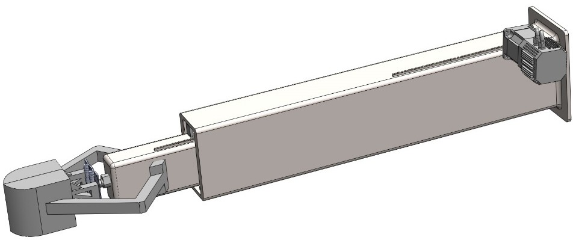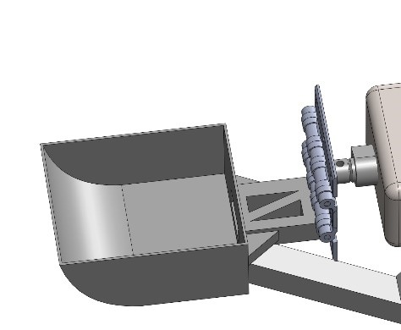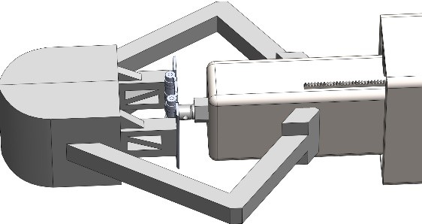

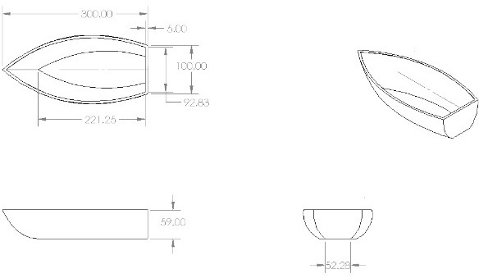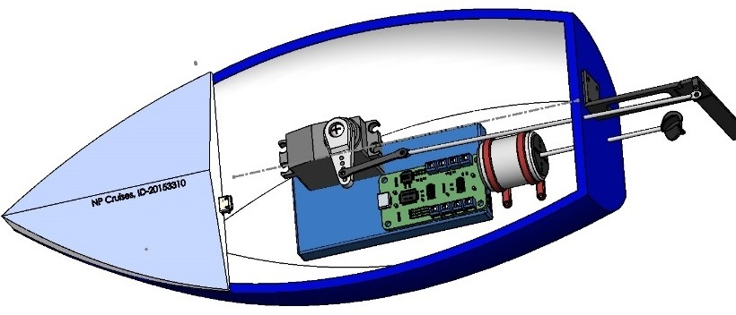

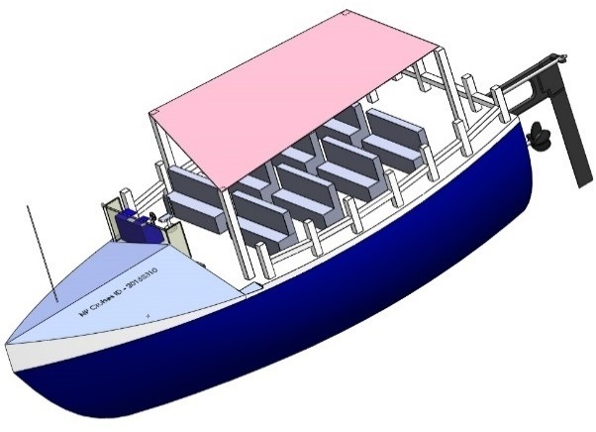

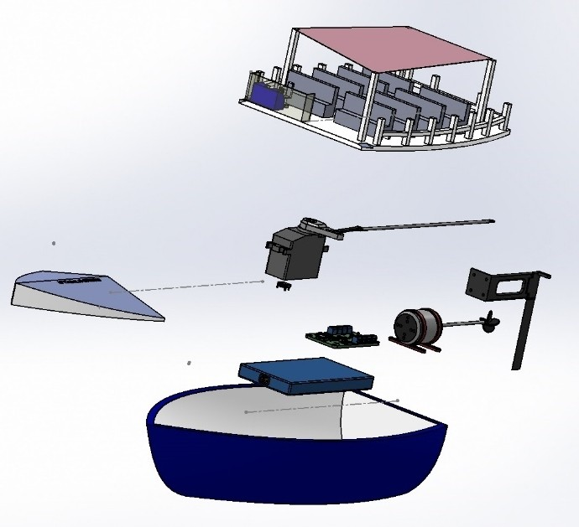*Figure 4: Queen's University - RC Boat Design.*