15.5 Surface Area

Methods of Computing the area of a surface
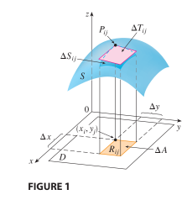

Figure 1: Visualization of Surface Area (Stewart 8th Edition).

To understand how one can, find the area of a surface lets look at how one finds the area of under a curve in x and y using the fundamental theorem of calculus.

Revisiting Computation of 2-D Areas
To conceptualize how to use calculus to compute the area under curves, one can take a certain domain of that function and slice several rectangles with width $∆x$ and a height of y in that domain. The smaller $∆x$ the more rectangles can fit in the domain. Further as the number of rectangles increases the sum of the rectangles approach the true area under the curve. Figure 3 and 4 display this fundamental concept.
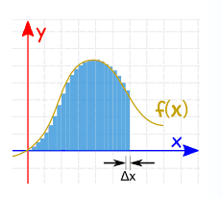
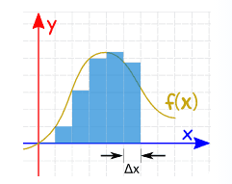
Figure 2: Area under Curvature using 5 rectangles.
Figure 3: Area Under a Curve using n rectangles.
It is clear that Figure 3 will have a much more accurate approximation to the area under f(x). But what would this expression look like mathematically? We would need the sum of all the rectangles area in the domain.
$$Area under f\left(x\right)=\sum_{k=1}^{n}{A_{rectangles}}=\sum_{k=1}^{n}{f(x_{k})∆x}$$
One can find the total area across the whole domain of the function using the limit as n approaches infinity.
$$Area= \lim_{n→∞}{\sum_{k=1}^{n}{f(x_{k})∆x}}$$
The expression above is equivalent to an integral of the function for the whole function’s domain.
$$Area=\lim_{n→∞}{\sum_{k=1}^{n}{f\left(x_{k}\right)∆x≐\int{f\left(x\right)dx}}}$$

Applying the Basic Summation Theorem to Surfaces
To compute the surface area of a function of two variables, for example, $z=f\left(x,y\right)$ one can apply the same principles of calculus. Further if we have a surface $S$ that is continuous for all of its partial derivatives, one can take the domain of the function as a rectangle. To simplify we can look at the domain D, only when $f(x,y)≥0$. One can divide the domain into small rectangles where the area of set rectangles can be described as $A=∆x×∆y$. If the point (x_{i}, y_{j}) on the small rectangle is closet to the origin, then let $P_{ij}$ be the point above (x_{i}, y_{j}) on surface $S$ with the coordinates, (x_{i}, y_{j,} f(x_{i}, y_{j})). If one takes the tangent plane (T) at point $P_{ij}$ it will approximate the value of S, when it is close to $P_{ij}.$ Further, the area of $∆T$ at $P_{ij}$, is approximately the surface area of $∆S$ at $P_{ij}$. Therefore, just like with one variable function the summation of the tangent for small increments approximates the surface area. And as the number of rectangles approaches infinity the surface area approaches its actual value.
$$Surface Area=\lim_{n,m→∞}{\sum_{i=1}^{n}{\sum_{j=1}^{m}{∆T_{ij}}}}$$
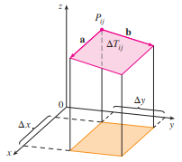
In order to make this relationship more useful we must further define the tangent plane.
Figure 4: Exploring the Tangent Plane properties. (Stewart 8th Edition)

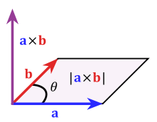
If the tagent plane starts at $P_{ij}$ one can compute the area of $∆T_{ij}$ by taking the magnitude of the cross products of two vectors of $∆T$, a and b; As shown in Figures 4 and 5. Note that a is parallel to the x-axis and b is parrallel to the y-axis.
Figure 5: Area of the Tangent Plane using the cross product.
Since the slope of tangent lines can be described by the partial derivatives of the vectors the equations for a and b are shown below. Note that i, j and k are the notation for the components of x,y,z terms respectively.
$$\vec{a}= ∆x\hat{i}+f_{x}(x_{i},y_{j})∆x\hat{k}$$
$$\vec{b}= ∆y\hat{j}+f_{y}(x_{i},y_{j})∆y\hat{k}$$
Therefore, using these equations one can find $∆T_{ij} by$computing the magnitude of their cross product.
$$\vec{a}×\vec{b}=\left|\begin{aligned}\begin{matrix}\hat{i} & \hat{j} & \hat{k}\end{matrix} \\ \begin{matrix}∆x & 0 & f_{x}(x_{i},y_{j})∆x\end{matrix} \\ \begin{matrix}0 & ∆y & f_{y}(x_{i},y_{j})∆y\end{matrix}\end{aligned}\right|$$
$$\vec{a}×\vec{b}=-f_{x}\left(x_{i},y_{j}\right)∆x∆y\hat{i}-f_{y}\left(x_{i},y_{j}\right)∆x∆y\hat{j}+∆x∆y\hat{k}$$
Since the Area of $∆T_{ij},$the small parallelogram is equal to $∆A=∆x∆y$ the equation can be written.
$$\vec{a}×\vec{b}=(-f_{x}\left(x_{i},y_{j}\right)\hat{i}-f_{y}\left(x_{i},y_{j}\right)\hat{j}+\hat{k})∆A$$
Now taking the magnitude:
$$∆T_{ij}=|\vec{a}×\vec{b}|= \sqrt{{[f_{x}\left(x_{i},y_{j}\right)]}^{2}+{[f_{y}\left(x_{i},y_{j}\right)]}^{2}+1} ∆A$$
Using the summation equation, we can now substitute for $∆T_{ij}$
$$Surface Area=\lim_{n,m→∞}{\sum_{i=1}^{n}{\sum_{j=1}^{m}{∆T_{ij}}}}=\lim_{n,m→∞}{\sum_{i=1}^{n}{\sum_{j=1}^{m}{\sqrt{{[f_{x}\left(x_{i},y_{j}\right)]}^{2}+{[f_{y}\left(x_{i},y_{j}\right)]}^{2}+1} ∆A}}}$$
Now we can use our knowledge of integration from single variable functions and convert this summation equation.
$$Surface Area= \iint_{D}{ ∆T_{ij}}$$

$$Surface Area= \iint_{D}{\sqrt{{[f_{x}\left(x_{i},y_{j}\right)]}^{2}+{[f_{y}\left(x_{i},y_{j}\right)]}^{2}+1} ∆A}$$
This will be the general formula for computing the surface area of a surface.

Application Examples
To understand how the relationships described above can be utilized we must go through some examples!

Example 1.
Find the exact area of the surface $z = 1+2x+3y+4y^{2}, 1≤x≤4, 0≤y≤1$:
The domain D can be described by $D = \left\{(x,y)| 1≤x≤4, 0≤y≤1\right\}$
To find the Surface area one must first compute the partial derivatives in terms of x and y.
$${z }_{x}= 2$$
And $z_{y} =3+8y$
$$Surface Area= \iint_{D}{\sqrt{{[2]}^{2}+{[3+8y]}^{2}+1} dA}$$
$$Surface Area= \iint_{D}{\sqrt{5+{[3+8y]}^{2}} dA}$$
Expanding and substituting the bounds for x and y
$$Surface Area= \int_{1}^{4}{\int_{0}^{1}{\sqrt{5+9+48y+64y^{2}} dydx}}$$
$$Surface Area=\int_{1}^{4}{\int_{0}^{1}{\sqrt{14+48y+64y^{2} }dydx}}$$
$$Surface Area=\int_{1}^{4}{\frac{5}{32}\left(12\sqrt{14}+2ln(11+3\sqrt{14})-ln(5)-2ln\left(\frac{3}{\sqrt{5}}+\sqrt{\frac{14}{5}}\right)\right)}dx$$
$$Surface Area=\frac{15}{32}\left(12\sqrt{14}+2ln(11+3\sqrt{14})-ln(5)-2ln\left(\frac{3}{\sqrt{5}}+\sqrt{\frac{14}{5}}\right)\right)$$

$Surface Area ≅ 22.16517661$units²

Example 2.
Find the surface area of the portion of the sphere of radius 4 that lies inside the cylinder $x^{2}+y^{2}=12$ and above the x-y plane.
First it may be helpful to visualize:
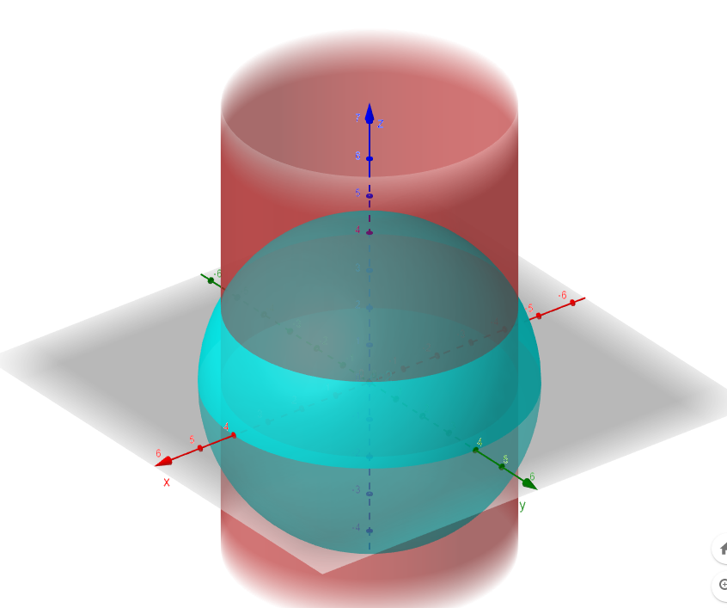
We know the equation a spere centered at the origin (0,0,0) has an equation: $x^{2}+y^{2}+z^{2}=16$
The parametric form of the equation is $r\left(θ,φ\right)=4sinφcosθ\hat{i}+4sinφsinθ\hat{j}+4cosφ\hat{k}$
Since we are not restricting the z coordinates on the sphere the range of theta is 0≤θ≤2π.
Since we are dealing with an intersection of surfaces, we can insert the equation of the cylinder into the equation of the sphere and solve for z.
$x^{2}+y^{2}=12$
insert into equation 2: $12+z^{2}=16$
$$z^{2}=4$$
$$z=±2$$
Now we can find the range of $φ$ by using the positive value of z since it is above the xy-plane.
$$z=2=4cosφ$$
$$cosφ=1/2$$
$$∴φ=π/3$$
range of $φ is 0≤φ ≤\frac{π}{3}$
Now to Find the surface area, we can take the partial derivatives of the function with respect to $θ and φ.$
$$r_{θ}\left(θ,φ\right)=-4sinφsinθi+4sinφcosθj$$
$$rφ(θ,φ)=4cosφcosθi+4cosφsinθj-4sinφk$$
Now we have to take the cross product of these vectors and find the magnitude.
$$r_{θ}×r_{φ}= -16sin^{2}φcosθi-16sin^{2}φsinθj-16sinφcosφk$$
Now the magnitude:
$$\left\|r_{θ}×r_{φ}\right\|= \sqrt{(16sin^{2}φcosθ)^{2}+(16sin^{2}φsinθ)^{2}(16sinφcosφ)^{2}}$$
$$\left\|r_{θ}×r_{φ}\right\|= \sqrt{256sin^{4}φ\left(cos^{2}θ+sin^{2}θ\right)+256sin^{2}φcos^{2}φ}$$
Simplifying: $\left\|r_{θ}×r_{φ}\right\|= \sqrt{256sin^{2}φ\left(cos^{2}θ+sin^{2}θ\right)}= \sqrt{256sin^{2}φ}$
$$\left\|r_{θ}×r_{φ}\right\|= 16sinφ$$
Now we can insert the magnitude of the cross product into the formula for surface area:
$$Surface Area= \iint_{D}{ \left\|r_{θ}×r_{φ}\right\|∆A}$$
Insert the bounds for$θ and φ:$ $Surface Area= \int_{0}^{2π}{\int_{0}^{π/3}{16sinφ dφdθ}}$
$$=\int_{0}^{2π}{\left[-16cos⁡(π/3)\right]-\left[-16cos⁡(0)\right]}dθ$$
$$=\int_{0}^{2π}{8dθ=8\left(2π\right)-0}$$

$$∴Surface Area=16π units^{2}$$

Bonus Surface Area of a Pumpkin
In the spirit of Halloween, we will be exploring how to utilize our calculus skills to find the surface area of a pumpkin! The pumpkin surface can be constructed using an epicycloid equation and extending it into 3-space. To visualize a 2D epicycloid see Figure 6.
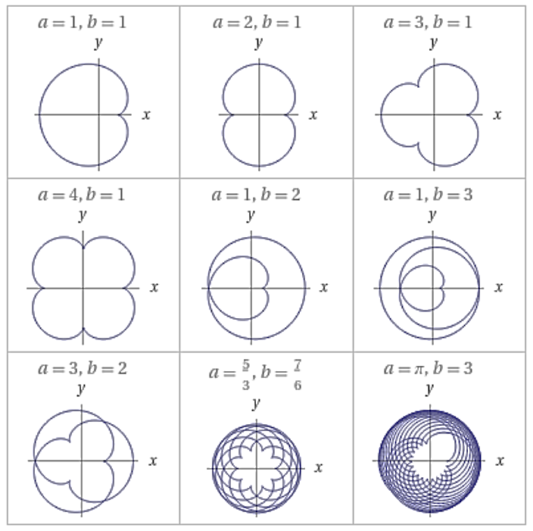
Figure 6: Epicycloid Plots (Wolfram Alpha)
The general parametric equations for an epicycloid centered about (0,0) are shown below. Note the different patterns achieved when changing a and b values. To learn more about epicycloids see (link).
$$x(t) = (a + b) cos(t) - b cos(\frac{t (a + b)}{b})$$
$$y(t) = (a + b) sin(t) - b sin(\frac{t \left(a + b\right)}{b})$$
The 3D plots of a pumpkin surfaces are shown below in Figure 7. Note the different shapes based on the different a, h and n values.
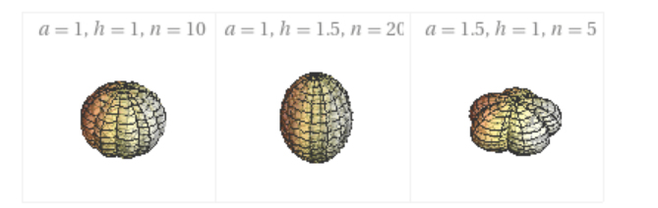
Figure 7: "Pumpkin" Surfaces 3D Plots (Wolfram Alpha)
The plots are graphed for $ϕ=0 to π$ and $θ=0 to 2π$
The general parameterized equations of the “Pumpkins” centered about (0,0,0) are shown below:
$$x(θ, ϕ) = \frac{a sin(ϕ) (\left(n + 1\right)cos\left(θ\right)- cos\left(θ \left(n + 1\right)\right))}{n}$$
$$y(θ, ϕ) = \frac{(a sin(ϕ) ((n + 1) sin(θ) - sin(θ (n + 1)))}{n}$$
$$z(θ, ϕ) = h cos(ϕ)$$

Bonus Question.
Now that you know the equation for a pumpkin like surface you can find the surface area.
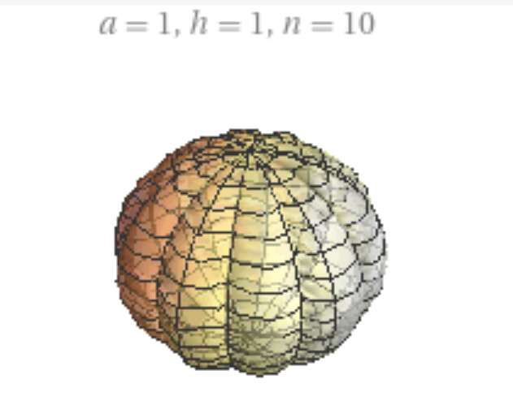
Given a pumpkin (3D Epicycloid) with an a value of 1(internal spherical radius), h value of 1 and an n value of 10. Find the Surface Area equation of the pumpkin, as shown in Figure 8.
Figure 8: Pumpkin Surface (Wolfram Alpha)

Solution:
One can sub in the values of a=1, h=1 and n=10 and find the parametrized equations.
$$x(θ, ϕ) = \frac{ sin(ϕ) (\left(10 + 1\right)cos\left(θ\right)- cos\left(θ \left(10 + 1\right)\right))}{10}$$
$$y(θ, ϕ) = \frac{ sin(ϕ) ((10 + 1) sin(θ) - sin(θ (10 + 1)))}{10}$$
$$z(θ, ϕ) = cos(ϕ)$$
Now one can find the equation for the partial derivatives of the equation with respect to x and y.
Let the equation of the surface be $f(θ, ϕ) = (x(θ, ϕ), y(θ, ϕ), z(θ, ϕ))$
$$f_{θ }(θ,ϕ)= \frac{ sin(ϕ) (-11sin\left(θ\right)+11 sin\left(11θ\right))}{10}\hat{i} +\frac{ sin(ϕ) (11cos\left(θ\right)- cos\left(11θ\right))}{10}\hat{j}+0\hat{K}$$
$$f_{ϕ }(θ,ϕ)=\frac{cos\left(ϕ\right)\left(11cos\left(θ\right)-11cos\left(11θ\right)\right)}{10}\hat{i}+\frac{ cos(ϕ) (11sin\left(θ\right)-11 sin\left(11θ\right))}{10}\hat{j}-sin(ϕ)\hat{k}$$

Now we can use the relationship of the tangent planes’ cross product to find the equation for the area of the surface. Below are the equations described earlier:
$$\vec{a}×\vec{b}=(-f_{x}\left(x_{i},y_{j}\right)\hat{i}-f_{y}\left(x_{i},y_{j}\right)\hat{j}+\hat{k})∆A$$
$$Surface Area= \iint_{D}{\sqrt{{[f_{x}\left(x_{i},y_{j}\right)]}^{2}+{[f_{y}\left(x_{i},y_{j}\right)]}^{2}+1} ∆A}$$
Therefore, $$Surface Area= \iint_{D}{| f_{θ }×f_{ϕ}| ∆A}$$

$$\left| f_{θ }×f_{ϕ}\right|=$$
$$\sqrt{\begin{aligned}{\left[\frac{-sin^{2}(ϕ) (11cos\left(θ\right)-11cos\left(11θ\right))}{10}\right]}^{2}+{\left[\frac{ sin^{2}\left(ϕ\right)\left(11sin\left(11θ\right)-11 sin\left(θ\right)\right)}{10}\right]}^{2} \\ +{\left[\frac{-cos(ϕ) sin⁡(ϕ)(11sin\left(θ\right)-11 sin{\left(11θ\right))}^{2}-\sin\left(ϕ\right)cos⁡(ϕ)\left[11\cos\left(θ\right)-11cos⁡(11θ)^{2}\right]}{10}\right]}^{2}\end{aligned}}$$
Where the bounds of the equation are $ϕ=0 to π$ and $θ=0 to 2π$
$$Surface Area= \int_{0}^{π}{\int_{0}^{2π}{ \left| f_{θ }×f_{ϕ}\right| dθdϕ}}$$
Therefore, the full equation is shown below

$$Surface Area=\int_{0}^{π}{\int_{0}^{2π}{\sqrt{\begin{aligned}{\left[\frac{-sin^{2}(ϕ) (11cos\left(θ\right)-11cos\left(11θ\right))}{10}\right]}^{2}+{\left[\frac{ sin^{2}\left(ϕ\right)\left(11sin\left(11θ\right)-11 sin\left(θ\right)\right)}{10}\right]}^{2}+{\left[\frac{-cos(ϕ) sin⁡(ϕ)(11sin\left(θ\right)-11 sin{\left(11θ\right))}^{2}-\sin\left(ϕ\right)cos⁡(ϕ)\left[11\cos\left(θ\right)-11cos⁡(11θ)^{2}\right]}{10}\right]}^{2}\end{aligned}}dθdϕ}}$$

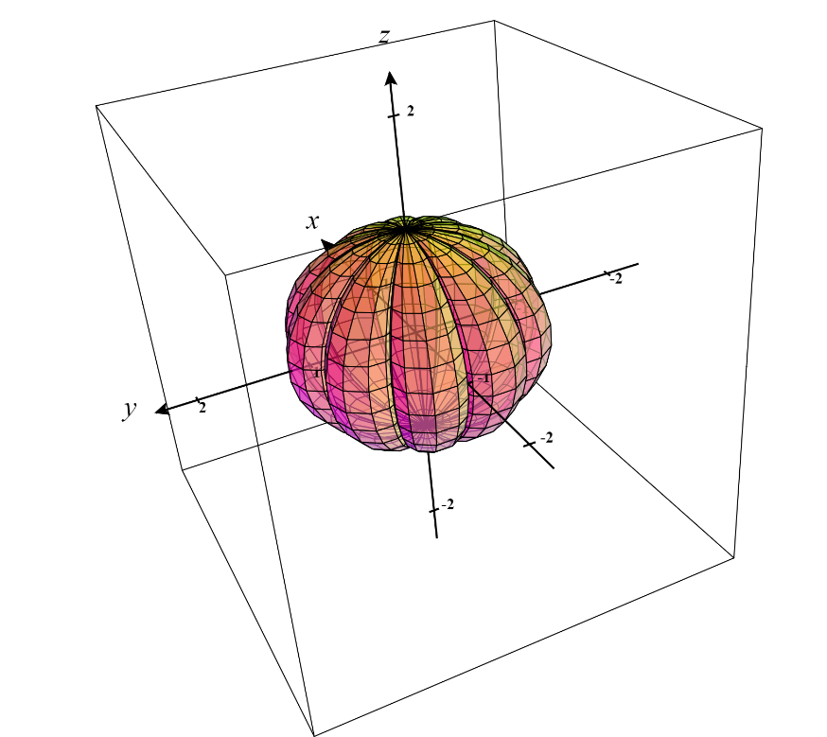
Figure 9: Pumpkin in Coordinate plane

