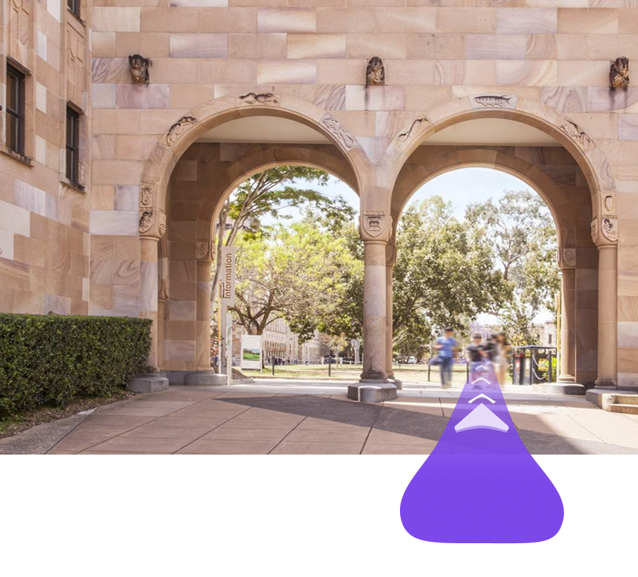

|  |
| --- |
| 2025 Waypoint Proposal |
|  |
| April 11  Waypoint  Founder: Nathan Perrier |



Contents

The Problem 3

UQ Map 3

Google and Apple Maps 3

The Solution 4

What is Waypoint? 4

How Does It Work? 4

Benefits Over Competitors 4

The Feedback 5

General Feedback 5

The Data 5

Open Day Performance 5

The Operation Cost 6

Mapbox API 6

Domain Cost 6

Hosting Cost 6

The Revenue 7

Enrollments 7

Sponsorship and Promotion 7

RoadMap and Implementation At UQ 8

Acquisition of Waypoint 9

# The Problem

|  |
| --- |
| UQ Map UQ has a vast campus that has so much to offer but can often be overwhelming or hard to navigate. While solutions do exist such as UQ’s own map, they lack accuracy and ease of use.  Currently UQ’s own map application is being received poorly due to various bugs and inaccuracies that initially prompted the creation of this project. With its reviews averaging 1.4/5 stars on Apple’s marketplace, it is undoubtably reflecting poorly on UQ’s prestigious image. |
| *“I’m a first year undergraduate and was really relying on this app to help me but it just made me more lost. Your location dot doesn’t update or show the direction you are facing.” - Chloe_King1 09/02/2024 (App Store Review)* |
| Google and Apple Maps As the last update to the app was over 2 years ago it is clear that there is no intention of fixing this app, often leaving its users having to resort to competitors such as Google Maps and Apple Maps.  While Google and Apple offer better services than the custom UQ map, they lack the accuracy and personalization required for a campus specific navigation app. This is primarily because these apps are targeted at automotive situations, often neglecting the granular detail required for a pedestrian-focused campus environment that our students and visitors require.  New students and visitors need a better option. Starting at UQ is already overwhelming so there is no need to add the extra stress of struggling to find your class. UQ needs a modern, accurate, and user-friendly navigation solution tailored specifically to its campus environment. The SolutionWhat is Waypoint? Waypoint is a functional, web-based Augmented Reality navigation application specifically designed for the UQ campus. Users simply select a destination on campus, and the app uses their phone's camera and GPS/location services to provide overlaid directional cues (arrows, paths) in real-time, guiding them visually to their target. How Does It Work? Waypoint leverages modern web technologies to deliver a seamless experience. It utilizes:   * **WebXR and AR.js:** To create the augmented reality overlay directly within the mobile web browser, eliminating the need for a native app installation. * **SMapbox API:** To access up-to-date, detailed campus mapping data, perform accurate geocoding (finding coordinates for locations), and calculate pedestrian-friendly routes and provide dynamic suggestions. * **Progressive Web App (PWA) Technology:** This allows Waypoint to function like an app (e.g., can be added to the home screen) but remains accessible via a simple URL across **all platforms (iOS, Android, Desktop, etc.)**. Anyone with a smartphone and internet connection can use it instantly. * **Framework7 and Vite:** Allows for an app-like design language.  Benefits Over Competitors  |  |  |  |  | | --- | --- | --- | --- | | FEATURE | Waypoint | UQ Map | Google/Apple | | Guidance Method | AR/3D | 2D | 2D | | Accuracy | High | Low | Moderate | | Ease Of Use | Intuitive | Poor | Decent | | Installation | None | App/website | App | | Platform | All | Most | IOS/Android | | Innovation | High | Low | Moderate | | Campus Specific | Very | Moderate | Low | | Development | MVP | Stagnant | General Purpose | |

# The Feedback

## General Feedback

During Open Day 2025, the Waypoint beta was released to the public in a trial run. Through the sites data and feedback from the users…

## The Data

## Open Day Performance

# The Operation Cost

## Mapbox API

Transparency regarding ongoing costs is essential. Waypoint's core mapping and routing functionality relies on the industry-leading Mapbox platform via its API (Application Programming Interface).

* **Nature of Cost:** This is a usage-based cost. Charges are typically incurred based on map loads, route calculations, and geocoding requests.
* **Estimated Range:** Based on Mapbox pricing tiers and projected usage patterns for a campus-wide deployment, the estimated monthly cost falls within the range of **$1,000 - $5,000 AUD**. Actual costs will fluctuate depending on adoption rates and user activity (e.g., higher during O-Week).
* **Management & Optimization:** This cost, while significant, powers the application's core value. Strategies to manage this upon university adoption could include:
  + Exploring potential educational institution discounts with Mapbox.
  + Implementing technical optimizations (e.g., intelligent caching, rate limiting) to reduce unnecessary API calls.
  + Monitoring usage analytics to understand peak loads and cost drivers.

## Domain Cost

Currently Waypoint is registered under the domain waypointuq.com on a 3-year contract. After the 3 years it would induce a fee of **$30-100** dollars for each continues year depending on any price changes.

## Hosting Cost

As Waypoint is a PWA it can be hosted for **free** on services such as Github pages or AWS pages.

# The Revenue

## Enrollments

With the overwhelming criticism of the current UQ map there is no doubt that it has a negative effect on the universities’ appeal. While this might have a minute impact, even one student not enrolling because of a poor open day experience due to finding the campus hard to navigate could result in a **$35,000** loss in revenue.

Furthermore, as UQ enrolls approximately 56,000 students every year, if you assume Waypoint will lead to as little as 0.05% increase in enrollment it would increase revenue by up to **$980,000**.

In addition, this figure does not include any students that might want to drop out due to poor university services and support.

## Sponsorship and Promotion

To monetize the application the use of sponsorships or promotions could be used. As Waypoint provides dynamic AR suggestions as users travel through the campus, this feature could be monetized to local shops or cafes to appear more frequently. Furthermore, event promotion could be implemented through sponsored navigation routes or push notifications alerting events in the user’s area.

Assuming 10 business pay $1,000 for sponsored AR placement that would provide additional yearly revenue of **$10,000.**

Finally, through promoting an estimate of 10 events per year with a cost of $500-$1000 depending on the scale of the promotion it would provide a yearly revenue of **$5,000-10,000**.

Through the monetization of Waypoint, it would potentially allow the webapp to be self-sustaining depending on the number of sponsors and promotions and the number of users using the service.

# RoadMap and Implementation At UQ

## Phase 1: Acquisition & Handover (Months 1-3 Post-Agreement)

* Formal transfer of codebase, IP, domain name (waypointuq.com).
* Knowledge Transfer: Detailed walkthroughs of the architecture, codebase, APIs, and operational requirements with designated UQ IT/technical staff.
* Infrastructure Setup: Assist UQ team in setting up necessary hosting (leveraging existing free tiers like GitHub Pages/AWS Pages initially, or UQ infrastructure) and configuring Mapbox API keys under UQ's account.
* Initial Documentation: Provide comprehensive documentation for setup, maintenance, and basic troubleshooting.

## Phase 2: Pilot Program & Refinement (Months 4-6)

* Targeted Launch: Roll out Waypoint to a specific user group (e.g., new students during O-Week, a single faculty/school, specific campus zones, or staff volunteers).
* Focused Feedback Collection: Gather detailed feedback from pilot users on usability, accuracy, performance, and desired features within the UQ environment.
* Infrastructure Scalability Test: Monitor performance under controlled load to anticipate needs for a wider rollout.
* Iterative Improvements: Make necessary adjustments and bug fixes based on pilot feedback and performance data. Refine Mapbox cost optimization strategies.

## Phase 3: Campus-Wide Launch & Promotion (Months 7-9)

* Marketing & Communication: Develop a communication plan with UQ Marketing/Student Services to announce Waypoint. Promote via UQ websites, student portals (MyUQ), social media, O-Week materials, and potentially QR codes on campus signage.
* Staff Training: Provide brief training/information materials for key staff (e.g., AskUQ, library staff, security) who assist with directions.
* Full Rollout: Make Waypoint accessible to all students, staff, and visitors.

## Phase 4: Ongoing Operation, Maintenance & Enhancement (Month 10 onwards)

* Routine Maintenance: Regular updates for security, dependency management, and browser compatibility.
* Continuous Monitoring: Ongoing tracking of usage, performance, and costs (Mapbox API).
* Feature Enhancements (Based on feedback & UQ priorities): Potential additions could include:
  + Integration with UQ event calendars.
  + Accessibility features (e.g., routes avoiding stairs).
  + Monetization features
  + Add language modes for international students
  + Indoor navigation capabilities (a significant future step requiring different tech/mapping).
  + Integration/takeover of current UQ map (utilize their campus specific data such as bike rack locations)
  + Implement analytics (e.g., Google Analytics, or Mapbox's built-in analytics) to track key metrics: active users, session duration, popular destinations, route calculation frequency, etc.
  + Timetable integration (linking classes to locations).
* Support: Establish a clear channel for user support and bug reporting within UQ's existing structures.

# Acquisition of Waypoint

We propose that the University of Queensland acquire the Waypoint application. This would include:

* Full ownership and rights to the application codebase and intellectual property.
* Transfer of the waypointuq.com domain name.
* 3-month handover period
* Optional contract of services to continue development of Waypoint after handover period

Acquiring Waypoint offers the university a significantly faster and potentially more cost-effective path to deploying an innovative AR navigation solution compared to developing a similar application from scratch internally or commissioning an external agency.

We believe a fair valuation of the acquisition, reflecting the development effort, innovation, functionality, and strategic value, would be in the range of **$35,000-45,000**. This acquisition cost is separate from the ongoing operational expenses. Furthermore, if UQ requires further development of Waypoint after the handover period, each contract will incur a fee of **$15,000** over a 12-month period.