Post-Event Analysis Report

yyy
bj jb
hjbb
__________________________________________________
Report Generated: January 19, 2026 at 12:40 AM

Executive Summary
The yyy concluded with 8 participants from 4 institutions. Participant feedback was positive, with an average session rating of 4.00 out of 5.
__________________________________________________

Participant Demographics

Key Statistics
- Total Participants: 8
- Institutions Represented: 4

Top Participating Institutions
- University of Tech: 3 participants
- State College: 2 participants
- Global Corp: 2 participants
- Tech Institute: 1 participants

Participant Categories
- Standard: 4 (50.0%)
- Early Bird: 2 (25.0%)
- VIP: 2 (25.0%)

Demographics Visualization
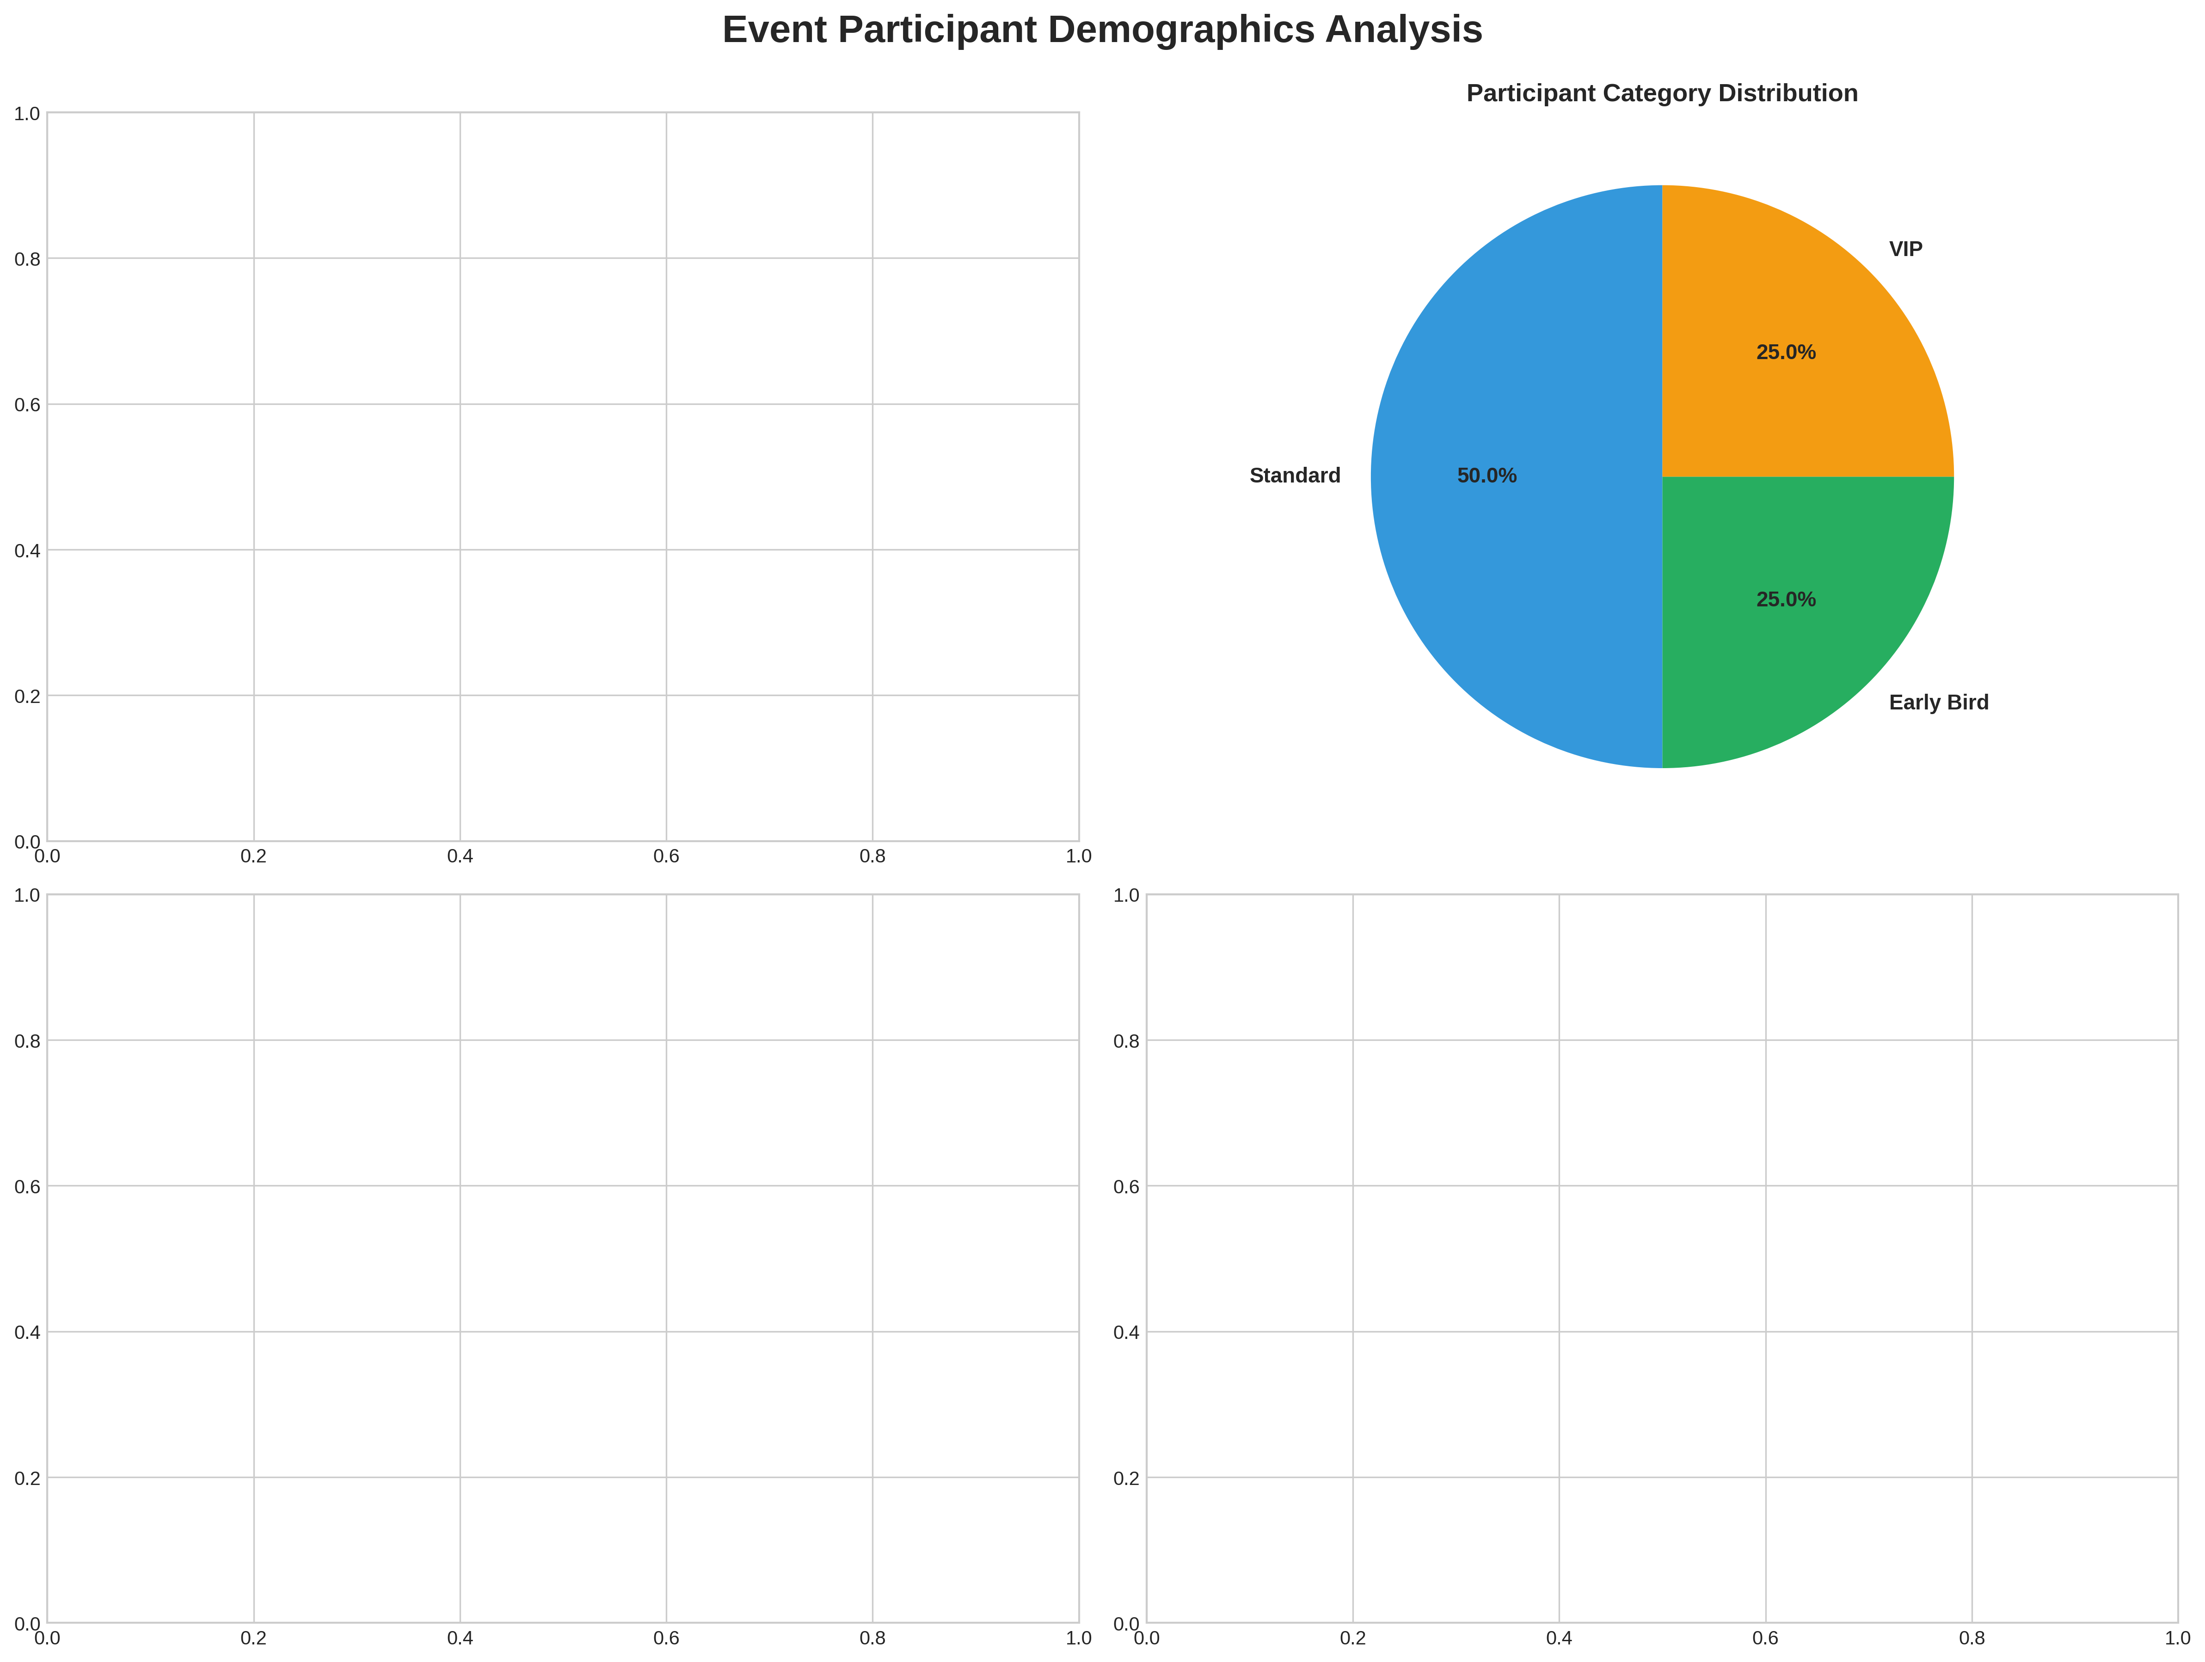
__________________________________________________

Session Performance & Feedback

Overall Feedback Metrics
- Total Feedback Responses: 10
- Average Session Rating: 4.00/5
- Median Rating: 4.0/5

Rating Distribution
- Excellent (>=4.5): 4 responses
- Good (4.0-4.5): 3 responses
- Average (3.5-4.0): 0 responses
- Needs Improvement (<3.5): 3 responses

Session Highlights
Top Rated Session: Keynote: Future of AI (4.50/5)
Needs Attention: Networking Lunch (3.00/5)

Session-wise Ratings
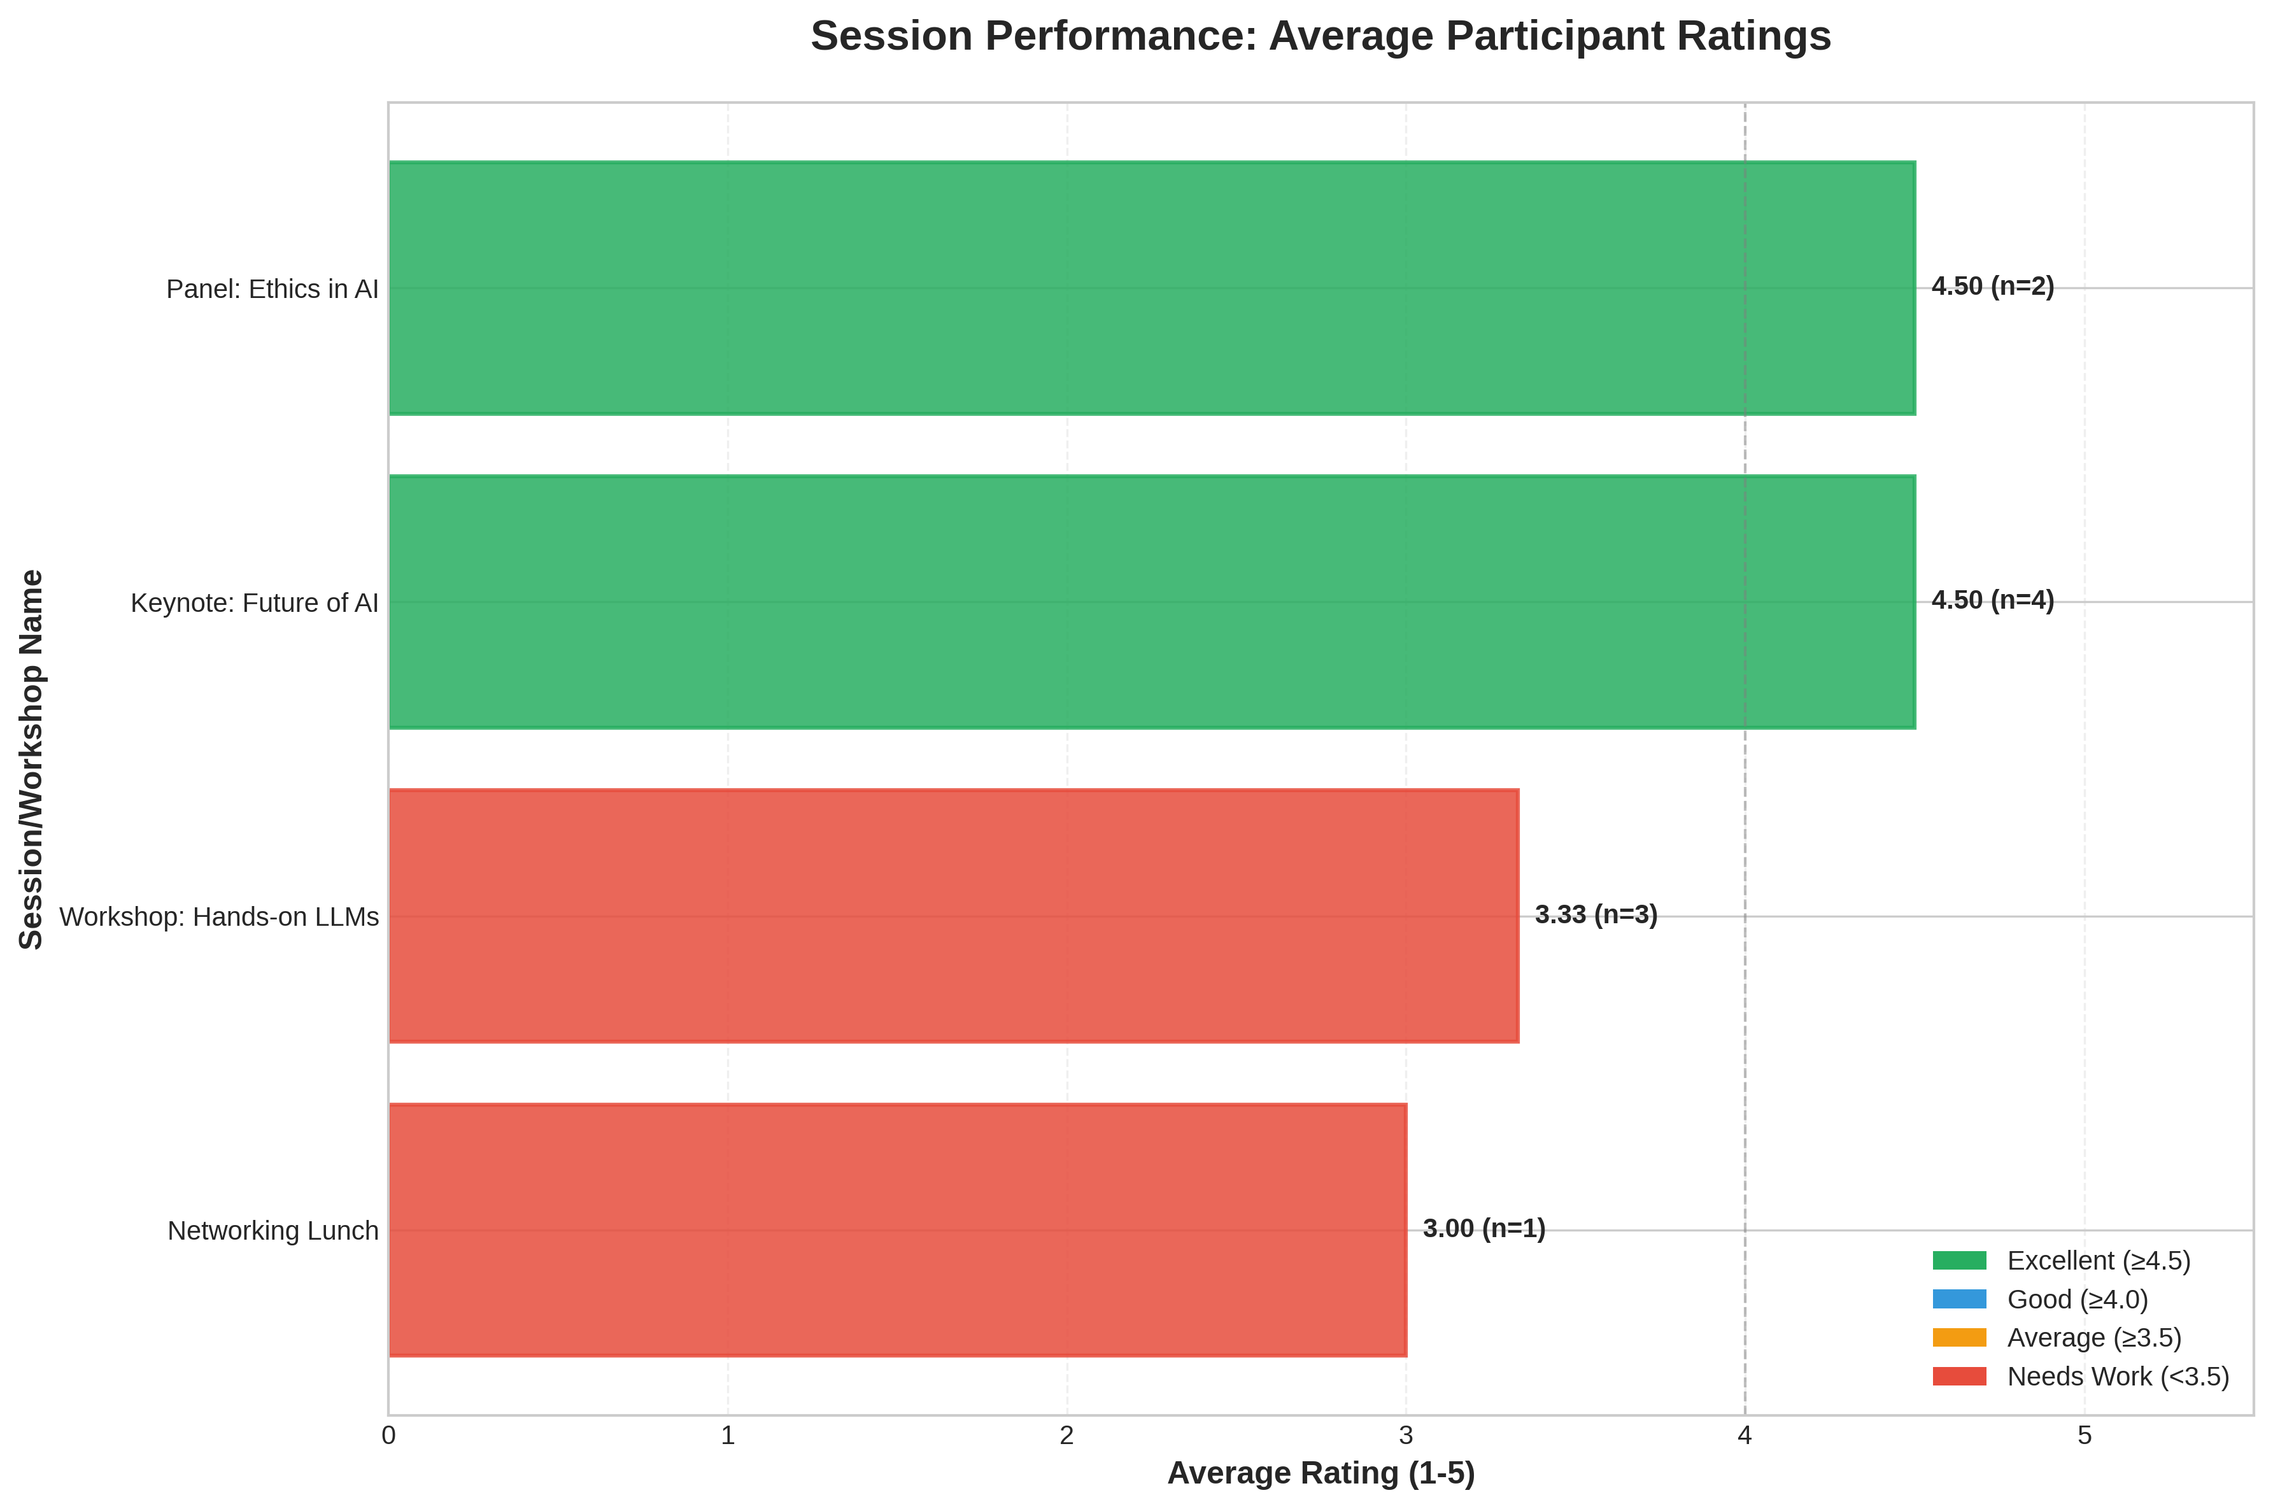
Chart shows average ratings with response counts (n=responses)
__________________________________________________

Participant Feedback Analysis
The following insights were generated using AI-powered analysis of participant feedback.

What Participants Loved
Based on the participant feedback, I've identified the top 3-5 positive themes that participants enjoyed:
- In-depth insights into generative models: Many participants praised the event for providing valuable and insightful information about generative models. This suggests that the content was relevant, engaging, and informative.
- Practical coding session: The hands-on coding session was a hit with many participants, who appreciated the opportunity to apply what they learned in a practical setting.
- Strong speakers: Participants praised the speakers for their solid presentation skills and ability to cover crucial topics well. This suggests that the event organizers made effective choices when selecting speakers.
Honorable mentions:
- Good networking opportunities: While some participants mentioned issues with food quality, others appreciated the chance to connect with peers and industry professionals.
- Informative content: Although some participants found the material slightly technical or too advanced for beginners, many appreciated the informative nature of the event.
Overall, it seems that the event struck a good balance between providing valuable insights, practical skills, and opportunities for networking.

Areas for Improvement
Based on the participant feedback, here are the top 3-5 negative themes or areas for improvement:
- Technical problems: Spotty WiFi and difficulty following along during the practical coding session were major issues. This suggests that technical glitches can significantly impact the overall experience.
- Content gaps: The feedback suggests that some participants found the content too advanced, which means there may be a need to provide more introductory material or cater to different levels of understanding. Additionally, some attendees would have liked more Q&A time, indicating a desire for more interactive and engaging content.
- Logistics: While food was available, it was reportedly cold, which is an issue that can be addressed by improving the logistics of food preparation and service.
Some honorable mentions include:
- Timing issues: Although not explicitly stated, some attendees may have felt rushed or had difficulty following along due to the pace of the event.
- Content relevance: While the content was informative and well-covered, a few participants found it too technical, which could indicate that some topics may not be relevant or engaging for all attendees.
By focusing on these areas, the organizers can work to improve the overall experience and better cater to the needs of their audience.
__________________________________________________

Social Media Sentiment
No valid social media posts to analyze.
__________________________________________________

Recommendations for Future Events
AI-generated actionable recommendations based on event data and feedback:
Based on the event data, I provide the following 6 actionable recommendations to improve future tech events:
Enhancing Positive Aspects
- Deepen generative models insights: Consider inviting more experts in generative models to share their experiences and applications. This can help attendees dive deeper into the subject matter.
- Expand practical coding sessions: Incorporate more hands-on activities or workshops, allowing participants to apply their knowledge in a more substantial way.
Addressing Identified Issues
- Improve technical infrastructure: Ensure reliable WiFi and consider providing alternative connectivity options (e.g., Ethernet) to minimize disruptions. Test equipment beforehand to prevent last-minute issues.
- Enhance content accessibility: Offer introductory material or beginner-friendly tracks to cater to different levels of understanding. Provide more Q&A time to encourage interaction and engagement.
Improving Student Engagement
- Targeted student outreach: Identify key student organizations, clubs, or influencers to promote the event and tailor content to their interests.
- Student-specific activities: Organize exclusive sessions, workshops, or networking events for students, fostering a sense of community and ownership.
Better Resource Utilization
- Streamline logistics: Improve food preparation and service by considering catering options, offering a variety of snacks, or hosting the event during mealtimes to minimize distractions.
- Optimize speaker selection: Ensure speakers are well-matched to the target audience's interests and skill levels. This can help reduce content gaps and improve overall engagement.
Technical/Logistical Improvements
- Conduct thorough equipment checks: Test all equipment, including projectors, microphones, and audiovisual systems, before the event to minimize technical issues.
- Develop a contingency plan: Establish a backup plan for unexpected events, such as speaker cancellations or technical failures, to ensure continuity and minimize disruptions.
By implementing these recommendations, you can build upon the positive aspects of your event while addressing areas for improvement.
__________________________________________________

🎓 Conclusion
The yyy was a successful event with good participant satisfaction and positive feedback. By implementing the recommendations above and building upon the successful aspects, future events can deliver even better experiences for participants.

