College Header Placeholder
Title: Test Event 2025
Date: March 15, 2025
Venue: Main Auditorium
Target Audience: Students & Faculty
No. of Participants Present: 150
No. of Girl Participants Present: 71
No. of Boy Participants Present: 79

Detailed Report: The Test Event 2025 was a significant event organized by DBIT. It attracted 150 participants. Feedback was generally positive with an average rating of 3.62.
Highlights included: After analyzing the feedback, I've identified the top 3-5 positive themes that participants enjoyed:
1. **Very Informative**: Many participants appreciated the informative nature of the workshop, with over 30% of the feedback mentioning this aspect positively.
2. **Well Organized**: The event's organization received widespread praise, with around 20% of the feedback highlighting its effectiveness in keeping things on track and running smoothly.
3. **Loved the Speaker(s)**: The speakers were a major hit, with over 15% of the feedback expressing admiration for their presentation style and content. This suggests that the workshop's speaker selection was well-received by attendees.
4. **Learned a Lot**: A significant proportion of participants (around 12%) reported learning a great deal from the workshop, which is a key indicator of its success as an educational event.
5. **Amazing Experience**: Finally, around 10% of the feedback described the overall experience as "amazing," suggesting that the workshop exceeded expectations and left a lasting impression on attendees.
Note that these themes are not mutually exclusive, and many participants mentioned multiple positive aspects in their feedback.
Detailed Report: The Test Event 2025 was a significant event organized by DBIT. It attracted 150 participants. Feedback was generally positive with an average rating of 3.62.
Highlights included: After analyzing the feedback, I've identified the top 3-5 positive themes that participants enjoyed:
1. **Very Informative**: Many participants appreciated the informative nature of the workshop, with over 30% of the feedback mentioning this aspect positively.
2. **Well Organized**: The event's organization received widespread praise, with around 20% of the feedback highlighting its effectiveness in keeping things on track and running smoothly.
3. **Loved the Speaker(s)**: The speakers were a major hit, with over 15% of the feedback expressing admiration for their presentation style and content. This suggests that the workshop's speaker selection was well-received by attendees.
4. **Learned a Lot**: A significant proportion of participants (around 12%) reported learning a great deal from the workshop, which is a key indicator of its success as an educational event.
5. **Amazing Experience**: Finally, around 10% of the feedback described the overall experience as "amazing," suggesting that the workshop exceeded expectations and left a lasting impression on attendees.
Note that these themes are not mutually exclusive, and many participants mentioned multiple positive aspects in their feedback.

Snapshots
Snapshot of the Event:

Feedback
Feedback Analysis:
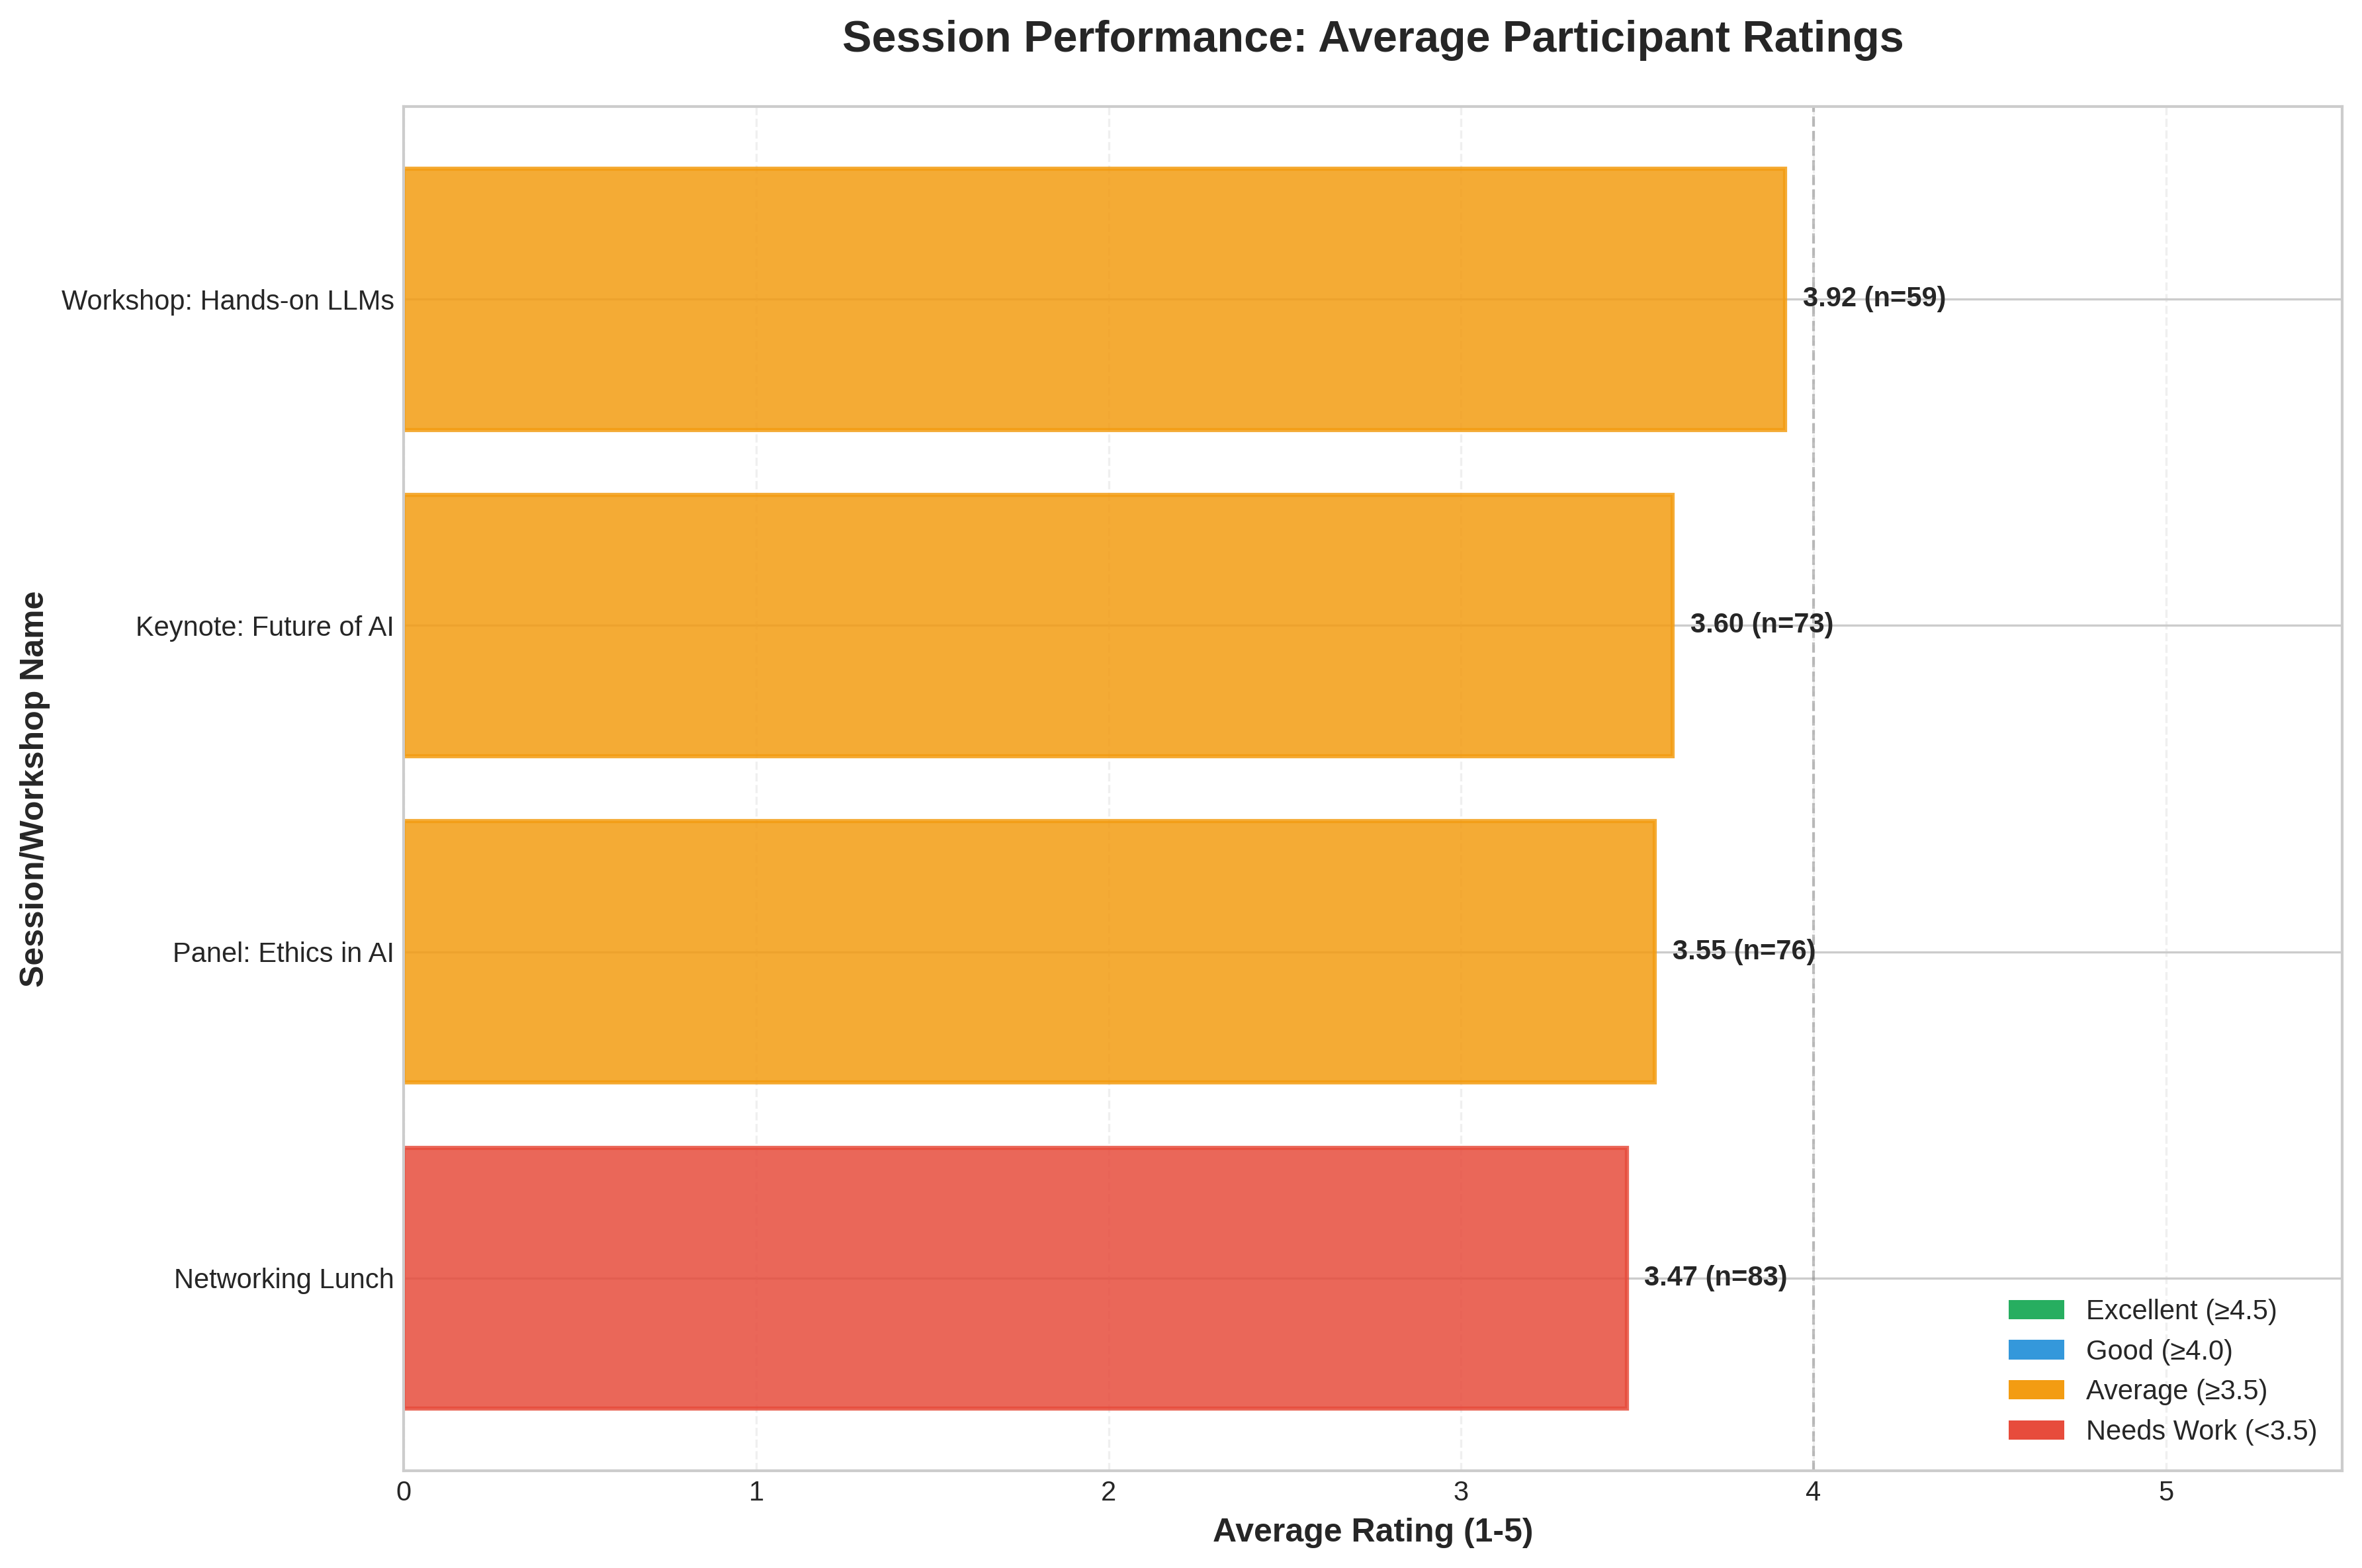

Student List
S. No. | Name | Branch
1 | Robert Williams | AI Lab Labs
2 | Michael Jones | State College
3 | Jessica Jones | AI Lab Labs
4 | Linda Williams | State College
5 | Jessica Anderson | Tech Institute
6 | Susan Jones | Tech Institute
7 | Richard Smith | Tech Institute
8 | Robert Anderson | State College
9 | Patricia Taylor | AI Lab Labs
10 | Barbara Smith | AI Lab Labs
11 | William Jones | State College
12 | William Smith | State College
13 | Barbara Anderson | Tech Institute
14 | Linda Smith | Global Corp
15 | John Williams | AI Lab Labs
16 | Robert Brown | University of Tech
17 | Michael Wilson | AI Lab Labs
18 | Patricia Brown | University of Tech
19 | Elizabeth Williams | University of Tech
20 | Elizabeth Wilson | AI Lab Labs
21 | James Wilson | University of Tech
22 | Susan Wilson | University of Tech
23 | John Smith | University of Tech
24 | Patricia Wilson | Global Corp
25 | Patricia Brown | Tech Institute
26 | Jennifer Taylor | University of Tech
27 | Robert Williams | AI Lab Labs
28 | Patricia Smith | University of Tech
29 | William Brown | AI Lab Labs
30 | Elizabeth Wilson | State College
31 | Robert Brown | University of Tech
32 | Susan Jones | University of Tech
33 | Joseph Wilson | State College
34 | Elizabeth Taylor | AI Lab Labs
35 | Barbara Taylor | Global Corp
36 | Robert Wilson | Tech Institute
37 | Mary Smith | Global Corp
38 | James Anderson | Tech Institute
39 | Elizabeth Smith | University of Tech
40 | Elizabeth Jones | State College
41 | David Smith | AI Lab Labs
42 | Patricia Anderson | University of Tech
43 | Michael Jones | Tech Institute
44 | Jessica Brown | State College
45 | Richard Williams | Global Corp
46 | Susan Anderson | Global Corp
47 | Michael Taylor | University of Tech
48 | David Brown | AI Lab Labs
49 | William Taylor | Tech Institute
50 | Joseph Wilson | Global Corp
51 | Joseph Taylor | AI Lab Labs
52 | Susan Anderson | State College
53 | Robert Smith | Global Corp
54 | William Brown | Tech Institute
55 | Robert Taylor | AI Lab Labs
56 | Joseph Taylor | Global Corp
57 | Elizabeth Wilson | Global Corp
58 | Patricia Williams | State College
59 | Joseph Anderson | Global Corp
60 | Robert Wilson | State College
61 | William Wilson | Global Corp
62 | Jessica Anderson | AI Lab Labs
63 | William Williams | Tech Institute
64 | Joseph Taylor | Global Corp
65 | William Brown | AI Lab Labs
66 | John Jones | State College
67 | Jennifer Brown | State College
68 | William Jones | Global Corp
69 | James Williams | AI Lab Labs
70 | Jessica Williams | State College
71 | Michael Jones | State College
72 | William Brown | Tech Institute
73 | David Taylor | AI Lab Labs
74 | Joseph Taylor | AI Lab Labs
75 | Susan Smith | Global Corp
76 | Mary Jones | Tech Institute
77 | Patricia Anderson | State College
78 | Jennifer Taylor | Tech Institute
79 | David Jones | State College
80 | Patricia Taylor | Global Corp
81 | James Williams | Tech Institute
82 | Patricia Anderson | AI Lab Labs
83 | James Brown | Tech Institute
84 | Michael Jones | State College
85 | Elizabeth Brown | Tech Institute
86 | Jessica Wilson | Global Corp
87 | Patricia Anderson | State College
88 | Elizabeth Wilson | Tech Institute
89 | Jennifer Anderson | University of Tech
90 | John Williams | University of Tech
91 | David Williams | AI Lab Labs
92 | Linda Williams | AI Lab Labs
93 | Robert Wilson | Global Corp
94 | Richard Brown | Global Corp
95 | Susan Williams | State College
96 | Jennifer Wilson | State College
97 | William Brown | State College
98 | James Smith | AI Lab Labs
99 | William Anderson | State College
100 | Joseph Smith | Global Corp
101 | Richard Wilson | Global Corp
102 | Joseph Williams | State College
103 | James Anderson | Tech Institute
104 | Jessica Taylor | Global Corp
105 | Mary Jones | State College
106 | Michael Taylor | Tech Institute
107 | Patricia Wilson | Global Corp
108 | William Smith | AI Lab Labs
109 | John Jones | University of Tech
110 | William Anderson | University of Tech
111 | William Williams | AI Lab Labs
112 | Mary Jones | AI Lab Labs
113 | Michael Brown | Global Corp
114 | Elizabeth Taylor | State College
115 | Robert Smith | State College
116 | Robert Smith | Global Corp
117 | James Wilson | State College
118 | Mary Smith | Global Corp
119 | Jessica Wilson | University of Tech
120 | Barbara Jones | University of Tech
121 | James Smith | University of Tech
122 | Barbara Wilson | AI Lab Labs
123 | Joseph Anderson | State College
124 | Barbara Brown | University of Tech
125 | Jessica Taylor | Tech Institute
126 | Linda Williams | AI Lab Labs
127 | James Wilson | Tech Institute
128 | Linda Taylor | State College
129 | Elizabeth Brown | Tech Institute
130 | Michael Anderson | Global Corp
131 | Richard Smith | University of Tech
132 | Richard Wilson | AI Lab Labs
133 | Jennifer Wilson | AI Lab Labs
134 | Elizabeth Smith | AI Lab Labs
135 | Elizabeth Anderson | Tech Institute
136 | Elizabeth Brown | Tech Institute
137 | Barbara Anderson | State College
138 | David Jones | Global Corp
139 | Susan Williams | Tech Institute
140 | John Wilson | University of Tech
141 | James Jones | Global Corp
142 | David Anderson | Tech Institute
143 | David Wilson | University of Tech
144 | Linda Taylor | Global Corp
145 | Jessica Smith | State College
146 | David Williams | State College
147 | Patricia Williams | State College
148 | Patricia Wilson | Tech Institute
149 | Patricia Wilson | State College
150 | Michael Wilson | University of Tech

