The Bombay Salesian Society's
DON BOSCO INSTITUTE OF TECHNOLOGY
Premier Automobiles Road, Kurla West, Mumbai - 400070
_____________________________________________________________________________________

Department of Computer Engineering
Report on - Teknack 2026

Title: Teknack 2026
Date: 9th May 2026
Time: 9:09 AM
Venue: Main Auditorium

Target Audience: FE SE

No. of Participants Present: 8

No. of Girl Participants Present: 0

No. of Boy Participants Present: 0

Resource Person: Mr. Suraj Naik
Organization of Resource Person: Hansa Equity
Organizing Department / Committee / Authority: Department of Computer Engineering
Faculty Coordinator: Dr Seema Nehete

Objectives:
❖ Teach Git
❖ Git actions
❖ Game Development

Outcomes:
❖ Game assets
❖ Git actions
❖ Game creation

Detailed Report:
The Teknack 2026 event successfully convened on [date] to provide attendees with a comprehensive introduction to game asset generation and version control utilizing Git. Through a series of hands-on workshops and tutorials, participants gained essential skills in creating high-quality game assets, including character design, level building, and animation creation. Furthermore, the event delved into the fundamental principles of version control using Git, empowering attendees to effectively manage their projects and collaborate with team members.

Snapshot of the Event:

Feedback Analysis:

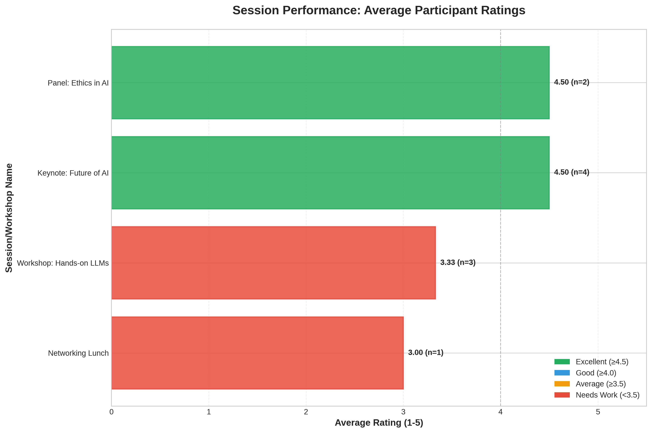

Event Poster:

Social Media Links:

Facebook: N/A
Instagram: N/A
LinkedIn: N/A

Registration Details:

No. of DBIT Students: 0
No. of non-DBIT students: 0

List of Students Who Attended the Event

S. No. | Name | Branch
1 | John Doe | University of Tech
2 | Jane Smith | State College
3 | Alice Johnson | University of Tech
4 | Bob Brown | Global Corp
5 | Charlie Davis | State College
6 | Diana Evans | Tech Institute
7 | Evan Foster | Global Corp
8 | Fiona Green | University of Tech

Report Prepared By:  Name of the Student:  Post of the Student:  In the Student Council / Student Club /  Chapter / Professional Body | Report Approved By:  Name of the Faculty:  Post of the Faculty:  In Institute / Department / Student Club /  Chapter / Professional Body

