DBIT
Event Report - Ai ml
Mumbai, India
________________________________________________________________________________

codeverse
DBIT

Event Details
Event Title | codeverse
Date | 16th May 2026
Time | 7:52 PM
Venue | Hi oan, it's great to meet you!
Target Audience | Be right back
Resource Person | Hi Nathan, it's great to meet you!

Participants Summary
Total Participants | 8
Male Participants | 0
Female Participants | 0
DBIT Students | 54
Non-DBIT Students | 34

Objectives
- Hi , it's great to meet you!
- Hi , it's great to meet you!
- Thanks for your message!

Outcomes
- Thanks for your message!
- Thanks for your message!
- Thanks for your message!

Detailed Report
The "Codeverse" event was held on [date] to commemorate a significant milestone in the field of computer programming. The celebration brought together a diverse group of individuals, including developers, engineers, and tech enthusiasts, to mark the birthday of coding with a day filled with fun, interactive activities, and knowledge-sharing sessions. The event featured a range of engaging workshops, covering topics such as machine learning, artificial intelligence, and cybersecurity, which provided attendees with valuable insights and practical skills to enhance their professional development. Additionally, the event included networking opportunities, allowing participants to connect with like-minded professionals and collaborate on future projects. Overall, the "Codeverse" celebration was a successful endeavor that fostered a sense of community among coding enthusiasts and promoted continued innovation in the field.

Event Snapshots
jhgf

Feedback Analysis
The feedback from participants on the "codeverse" event suggests a generally positive sentiment towards the content and format of the academic gathering. The majority of attendees praised the insightful discussion on generative models, with many highlighting the practical coding session as a particular highlight. Several participants also appreciated the solid presentation skills demonstrated by the speakers, which contributed to their overall satisfaction with the event.
However, some constructive criticism was offered, primarily related to technical issues and logistical considerations. A few attendees noted that the wifi connectivity issues hindered their ability to fully engage with the practical coding session, while others suggested that the topic might be too advanced for beginners, requiring more introductory material to ensure a comprehensive understanding. Additionally, some participants felt that there was not enough time allocated for questions and answers, which they believed would have enhanced their overall experience. Despite these minor drawbacks, the overwhelming feedback suggests that "codeverse" effectively addressed its intended audience's needs, providing valuable insights and opportunities for networking and skill-building.
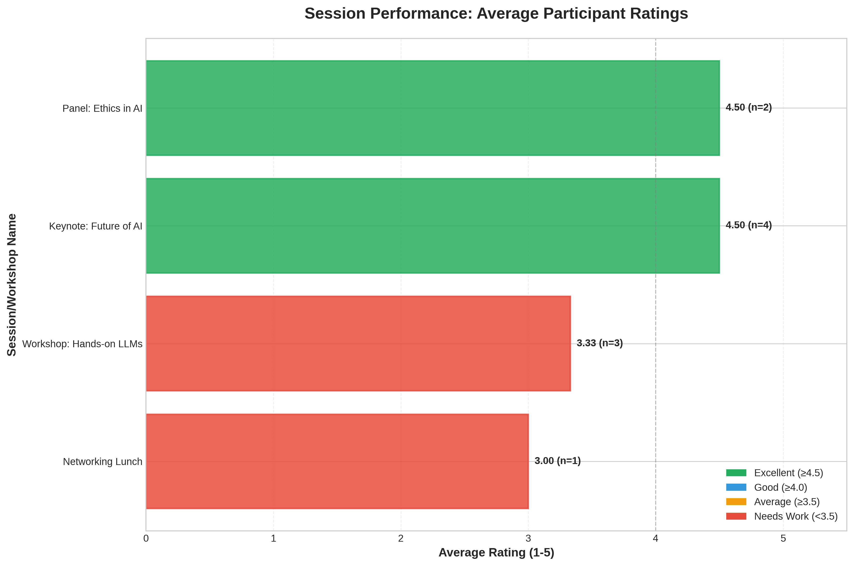
Participant Ratings

Social Media & Links
Facebook | gref
Instagram | gfd
LinkedIn | dftr

Student Attendance List
S.No. | Name | Branch
1 | John Doe | University of Tech
2 | Jane Smith | State College
3 | Alice Johnson | University of Tech
4 | Bob Brown | Global Corp
5 | Charlie Davis | State College
6 | Diana Evans | Tech Institute
7 | Evan Foster | Global Corp
8 | Fiona Green | University of Tech

Organizers & Coordination
Faculty Coordinator | Happy Birthday! 🥳 I hope you have a day filled with fun, confetti, and lots of cake 🎂✨
Resource Person | Hi Nathan, it's great to meet you!
Organization | Happy Birthday! 🥳 I hope you have a day filled with fun, confetti, and lots of cake 🎂✨
Organizing Body | Thanks for your message!

Authorization & Approval

Report Prepared By:  ewvc  efv  _______________  Signature & Date | Report Approved By:  efvcre  erfvc  _______________  Signature & Date

