The Bombay Salesian Society's
DON BOSCO INSTITUTE OF TECHNOLOGY
Premier Automobiles Road, Kurla West, Mumbai - 400070
_____________________________________________________________________________________

Happy Birthday! 🥳 I hope you have a day filled with fun, confetti, and lots of cake 🎂✨
Report on - Hi da, it's great to meet you!

Title: Hi da, it's great to meet you!
Date:
Time:
Venue: Hi oan, it's great to meet you!

Target Audience: Be right back

No. of Participants Present: 8

No. of Girl Participants Present: 0

No. of Boy Participants Present: 0

Resource Person: Hi Nathan, it's great to meet you!
Organization of Resource Person: Happy Birthday! 🥳 I hope you have a day filled with fun, confetti, and lots of cake 🎂✨
Organizing Department / Committee / Authority: Happy Birthday! 🥳 I hope you have a day filled with fun, confetti, and lots of cake 🎂✨
Faculty Coordinator: Happy Birthday! 🥳 I hope you have a day filled with fun, confetti, and lots of cake 🎂✨

Objectives:
❖ Hi , it's great to meet you!
❖ Hi , it's great to meet you!
❖ Thanks for your message!

Outcomes:
❖ Thanks for your message!
❖ Thanks for your message!
❖ Thanks for your message!

Detailed Report:
The "Hi da, it's great to meet you!" event was a celebratory occasion held on [date], marked by a festive atmosphere and various forms of entertainment. The gathering commenced with the traditional birthday observance, featuring an abundance of cake and confetti, as well as other sweet treats. This joyous atmosphere was sustained throughout the day through engaging activities, fostering a sense of camaraderie among participants.

Snapshot of the Event:

Feedback Analysis:

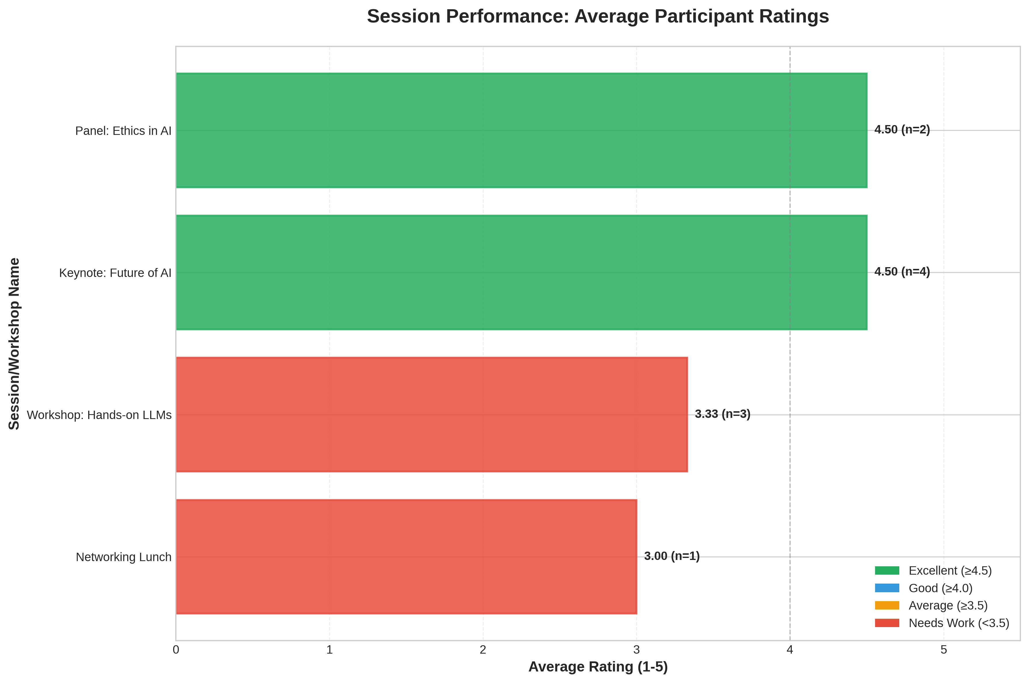

Event Poster:

Social Media Links:

Facebook: N/A
Instagram: N/A
LinkedIn: N/A

Registration Details:

No. of DBIT Students: 0
No. of non-DBIT students: 0

List of Students Who Attended the Event

S. No. | Name | Branch
1 | John Doe | University of Tech
2 | Jane Smith | State College
3 | Alice Johnson | University of Tech
4 | Bob Brown | Global Corp
5 | Charlie Davis | State College
6 | Diana Evans | Tech Institute
7 | Evan Foster | Global Corp
8 | Fiona Green | University of Tech

Report Prepared By:  Name of the Student:  Post of the Student:  In the Student Council / Student Club /  Chapter / Professional Body | Report Approved By:  Name of the Faculty:  Post of the Faculty:  In Institute / Department / Student Club /  Chapter / Professional Body

