(Header 1.25 cm from top and footer 1.25 cm from bottom)
(College Logo Left Alignment, absolute horizontal position is -0.75 cm to the right of column, absolute vertical position is 0.01 cm to the below, size is 1.96cm x 1.96 cm. Maintain the similar size & position for student club logo (if any).)
(College Name Centre Aligned, 16 point font size, Times Roman New, 1.15 line spacing)
(College Address Centre Aligned, 11 point font size, Times Roman New, 1.15 line spacing)
(College Logo
Department Name (Centre Aligned, 15 point font size, Times Roman New, 1.15 line spacing) Department of Computer Engineering
Report on - Name of the Event (Centre Aligned, 14 point font size, Times Roman New, 1.15 line spacing) Teknack 2026

Double spacing ** Text in RED should be replaced with suitable data in BOLD and Text in Blue to be deleted **
Title:Name of the event/ lecture/ workshop (Left Justified, 13 point font size, Times Roman New)
Date: (Left Justified, 13 point font size, Times Roman New, 1.15 line spacing)
Time: (Left Justified, 13 point font size, Times Roman New, 1.15 line spacing)
Venue:(Left Justified, 13 point font size, Times Roman New, 1.15 line spacing) Teknack 2026 March 15, 2025 Main Auditorium
Target Audience:FE/COMP/EXTC/IT/MECH (Left Justified, 13 point font size, Times Roman New, 1.15 line spacing) Students & Faculty
No. of Participants Present:(Left Justified, 13 point font size, Times Roman New, 1.15 line spacing) 8
No. of Girl Participants Present: (Left Justified, 13 point font size, Times Roman New, 1.15 line spacing) 0
No. of Boy Participants Present: (Left Justified, 13 point font size, Times Roman New, 1.15 line spacing) 0
Resource Person:(Left Justified, 13 point font size, Times Roman New, 1.15 line spacing) Dr. Alan Turing
Organization of Recourse Person: (Left Justified, 13 point font size, Times Roman New, 1.15 line spacing)
Organizing Department(Left Justified, 13 point font size, Times Roman New, 1.15 line spacing) Computer Engineering / Committee / Authority:
Faculty Coordinator:(Left Justified, 13 point font size, Times Roman New, 1.15 line spacing) Prof. Smith

Objectives: (Justified, 12 point font size, Times Roman New, 1.15 line spacing)
❖
❖
❖
Outcomes: (Justified, 12 point font size, Times Roman New, 1.15 line spacing)
❖
❖
❖

Detailed Report: (Justified, 12 point font size, Times Roman New, 1.15 line spacing) The Teknack 2026 was a significant event organized by Department of Computer Engineering. It attracted 8 participants. Feedback was generally positive with an average rating of 4.00.
Highlights included: Based on the participant feedback, the top 3-5 positive themes that emerged are:
1. **Innovative Content**: Participants appreciated the insightful discussions and practical coding sessions, particularly those focused on generative models. Many were impressed by the depth of knowledge shared, with one attendee commenting that it was "mind blown" and the best session of the day.
2. **Expert Speakers**: The speakers' ability to present complex topics in a clear and concise manner was widely praised. Participants valued the insights gained from the discussions and appreciated the speakers' solid presentation skills.
3. **Practical Hands-on Activities**: The practical coding session was a hit with participants, who enjoyed the opportunity to engage with the material hands-on. This theme is closely tied to the innovative content theme, as attendees appreciated being able to apply their knowledge through coding exercises.
Additionally, there were mentions of good organization and great networking opportunities, although these themes are not as prominent in the feedback. It's worth noting that some participants did mention a few areas for improvement, such as the need for more introductory materials or better wifi connectivity.

Snapshot of the Event: (Justified, Text in 12 point font size, Times Roman New, 1.15 line spacing)
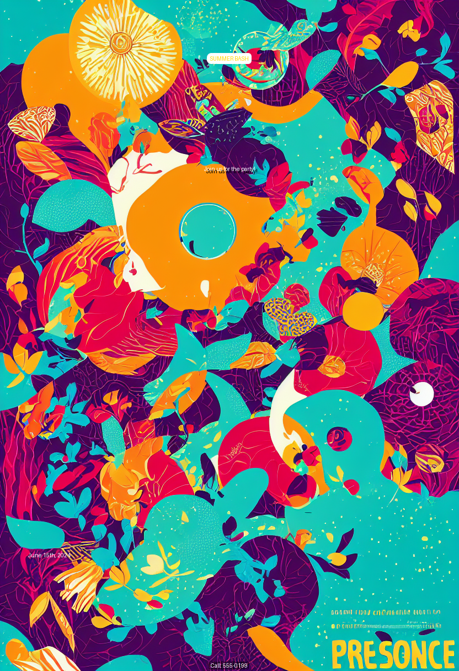
Photographs should capture the candid moments of the activity. There should be at least 2 geotagged photographs. Photographs included should be clear, with well-lit backgrounds.

Feedback Analysis: (Justified, Text in 12 point font size, Times Roman New, 1.15 line spacing)
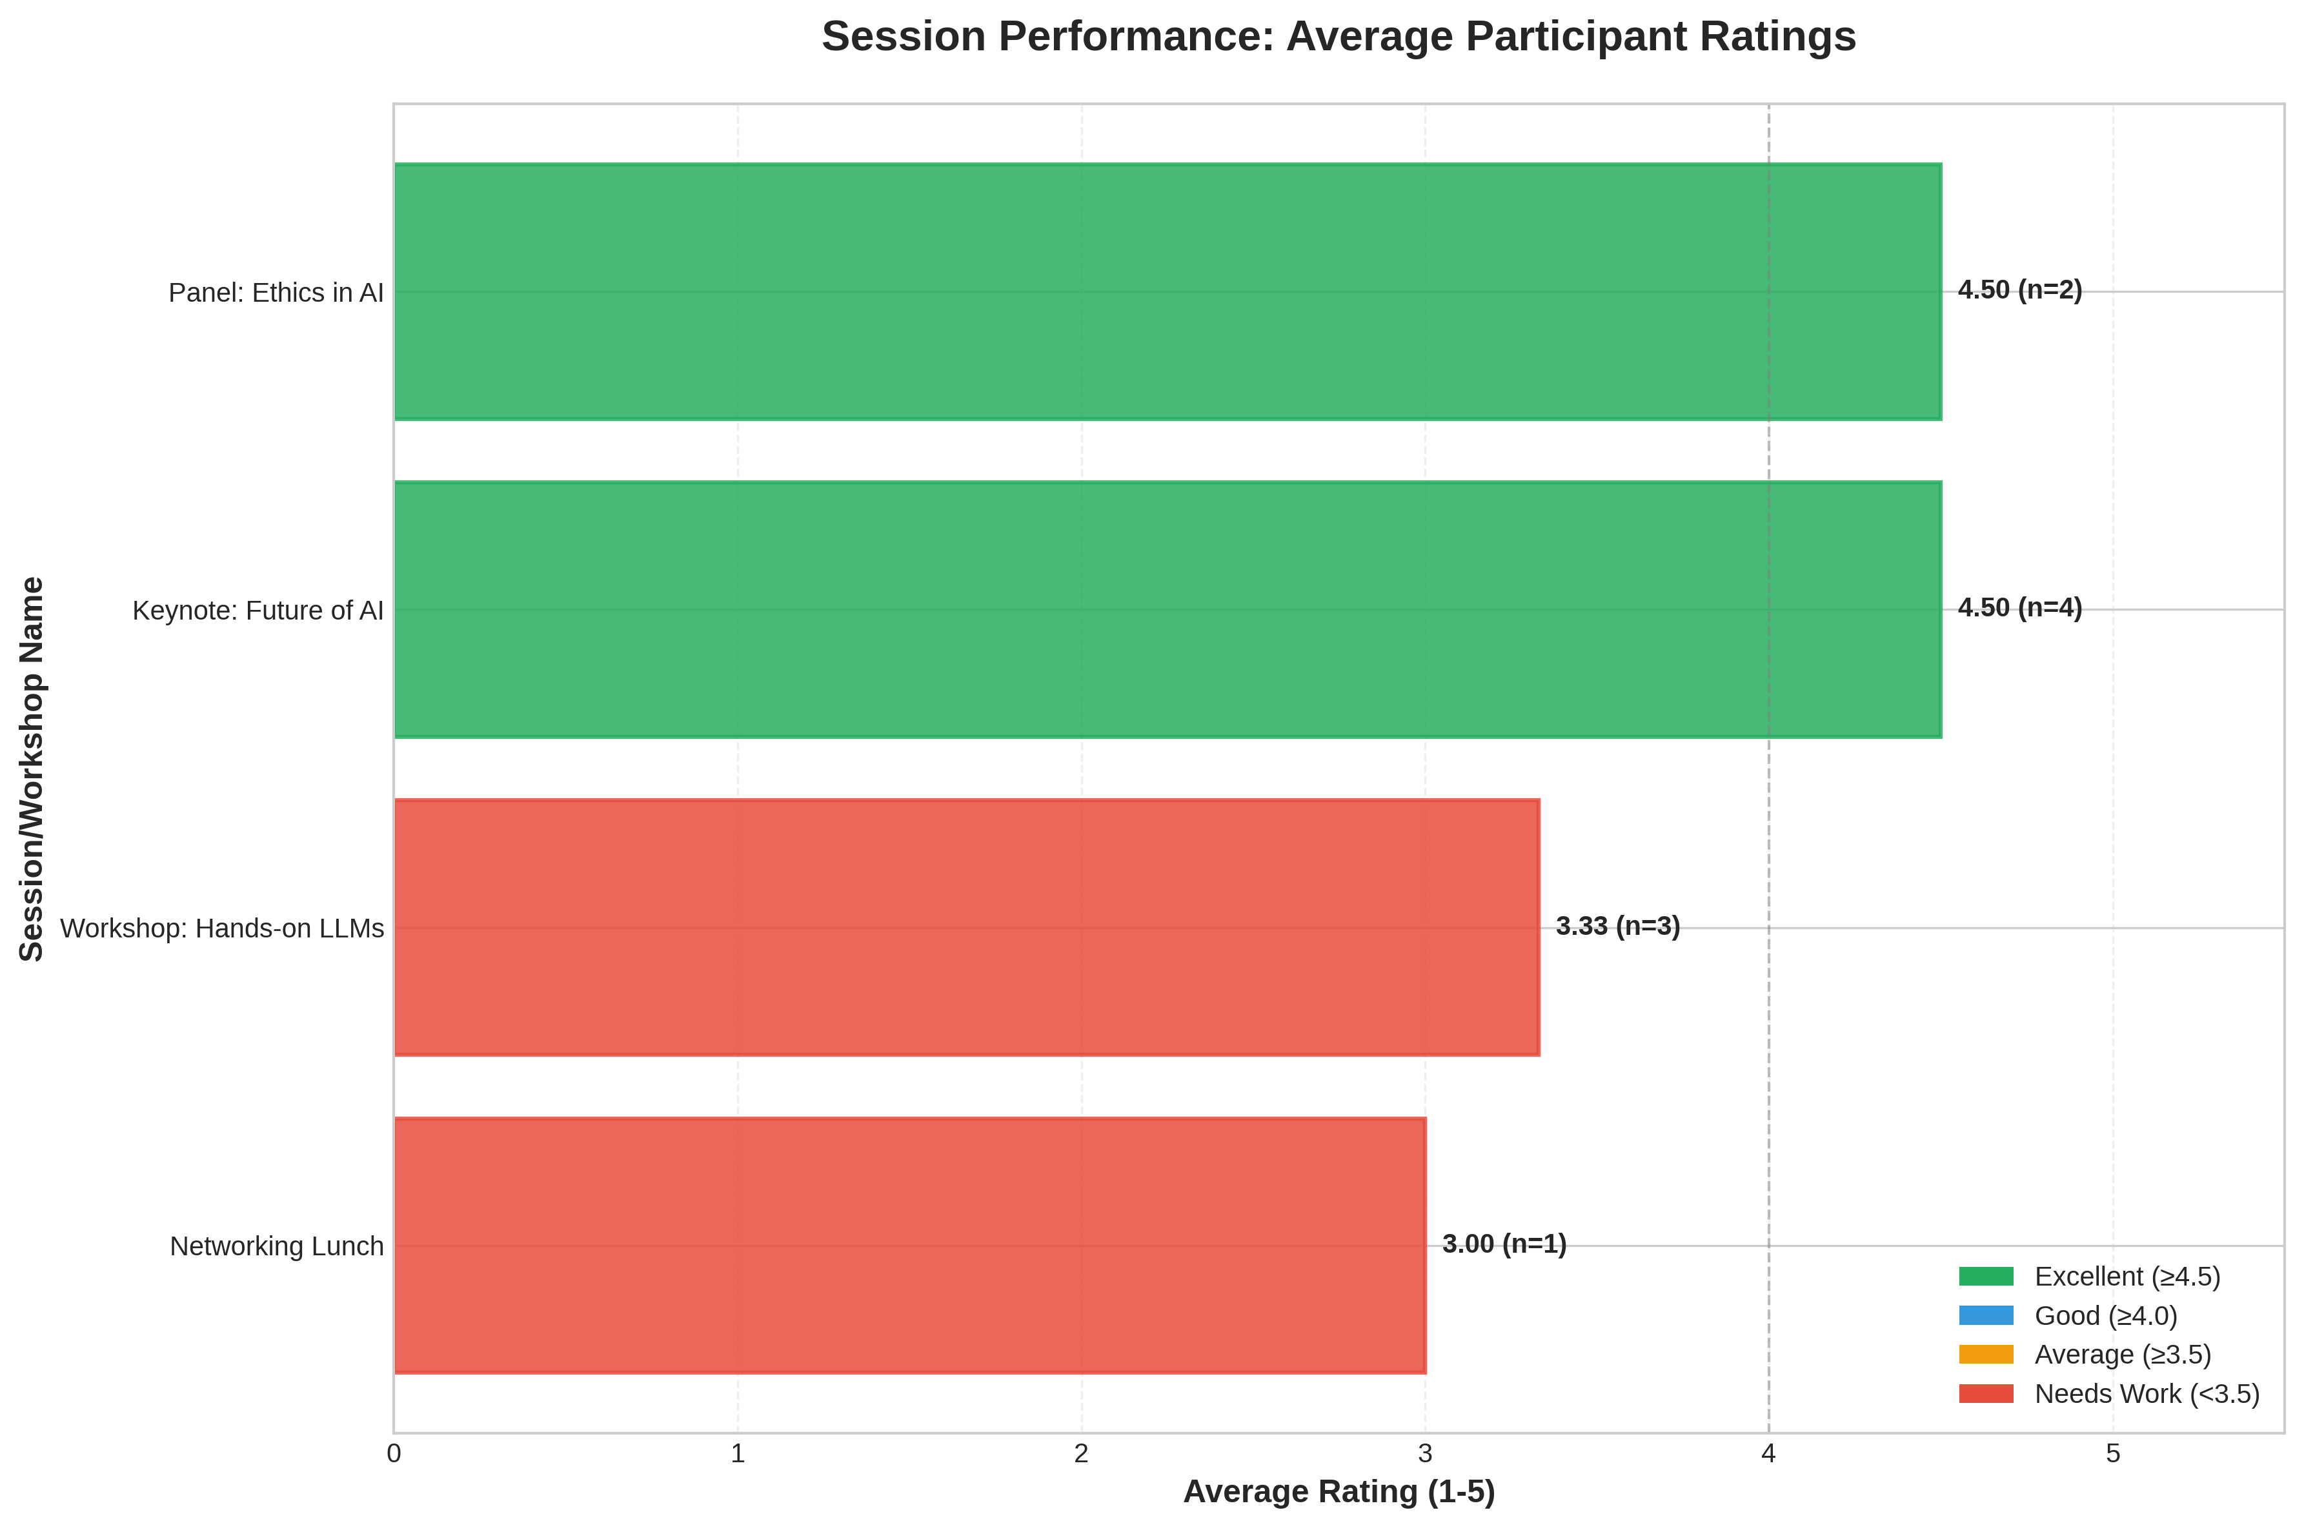
Feedback should include google form responses in terms of bar graphs or pie charts.

Event Poster: (Justified Text in 12 point font size, Times Roman New, 1.15 line spacing)

To be pasted here

Social Media Links: Facebook: @techfest, Instagram: @techfest_ai
Include the Facebook, Instagram, LinkedIn (Text in 12 point font size, Times Roman New, 1.15 line spacing)

Registration Details: (Text in 12 point font size, Times Roman New, 1.15 line spacing)
In case the event is open for non-DBIT students:
No. of DBIT Students:
No. of non-DBIT students:

Include list of students who attended the event. (Table to be centre aligned)
S. No. | Name | Branch  (To be included only if the event is open for other branch students)
(Centre Aligned text in 12 point font size, Times Roman New) | (Left Aligned text in 12 point font size, Times Roman New, 1 line spacing) | (Centre Aligned text in 12 point font size, Times Roman New)
1 | John Doe | University of Tech
2 | Jane Smith | State College
3 | Alice Johnson | University of Tech
4 | Bob Brown | Global Corp
5 | Charlie Davis | State College
6 | Diana Evans | Tech Institute
7 | Evan Foster | Global Corp
8 | Fiona Green | University of Tech

(Left Aligned, Text in 12 point font size, Times Roman New, 1.15 line spacing)
Report Approved By:
Name of the Faculty:
Post of the Faculty:
In Institute/ Department/ Student Club/ Chapter/ Professional Body
(Left Aligned, Text in 12 point font size, Times Roman New, 1.15 line spacing)
Report Prepared By:
Name of the Student:
Post of the student:
In the Student Council/ Student Club/ Chapter/ Professional Body

