The Bombay Salesian Society's
DON BOSCO INSTITUTE OF TECHNOLOGY
Premier Automobiles Road, Kurla West, Mumbai - 400070
_____________________________________________________________________________________

Department of Computer Engineering
Report on - Ideathon

Title: Ideathon
Date:
Time:
Venue:

Target Audience:

No. of Participants Present: 8

No. of Girl Participants Present: 0

No. of Boy Participants Present: 0

Resource Person:
Organization of Resource Person:
Organizing Department / Committee / Authority: Department of Computer Engineering
Faculty Coordinator:

Objectives:

Outcomes:

Detailed Report:
The Ideathon was conducted successfully with enthusiastic participation.

Snapshot of the Event:

Feedback Analysis:

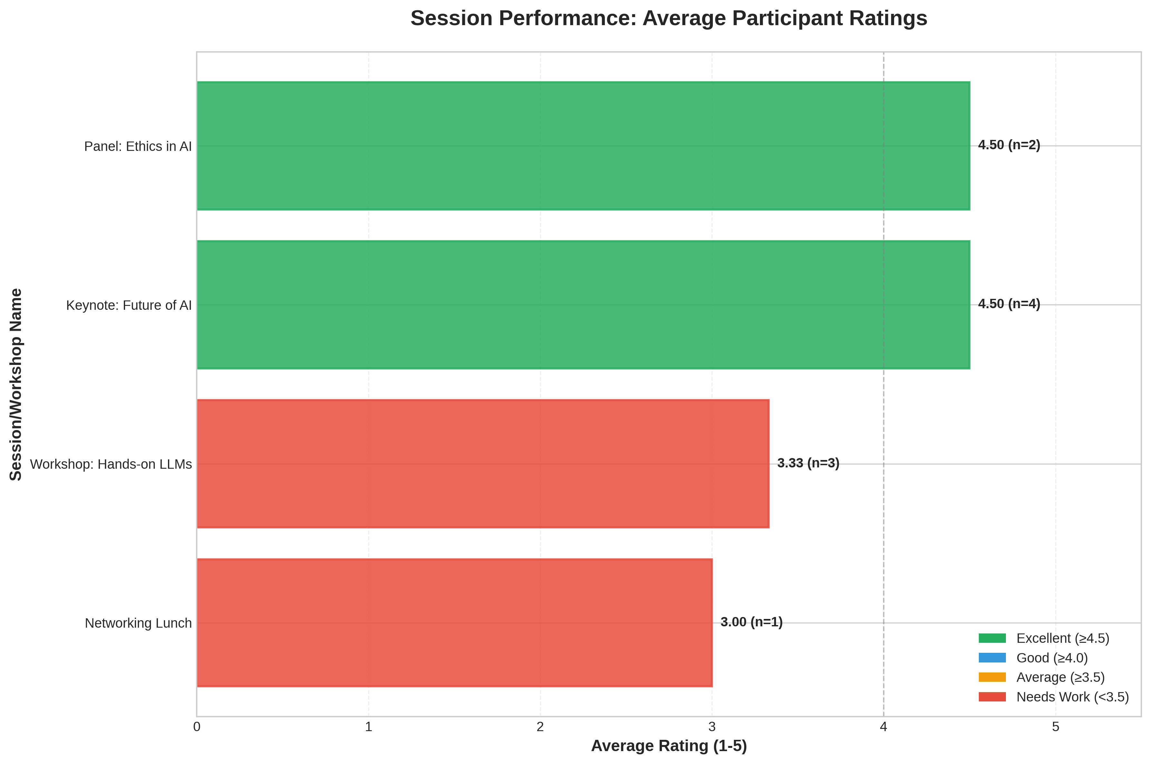

Event Poster:

Social Media Links:

Facebook: N/A
Instagram: N/A
LinkedIn: N/A

Registration Details:

No. of DBIT Students: 0
No. of non-DBIT students: 0

List of Students Who Attended the Event

S. No. | Name | Branch
1 | John Doe | University of Tech
2 | Jane Smith | State College
3 | Alice Johnson | University of Tech
4 | Bob Brown | Global Corp
5 | Charlie Davis | State College
6 | Diana Evans | Tech Institute
7 | Evan Foster | Global Corp
8 | Fiona Green | University of Tech

Report Prepared By:  Name of the Student:  Post of the Student:  In the Student Council / Student Club /  Chapter / Professional Body | Report Approved By:  Name of the Faculty:  Post of the Faculty:  In Institute / Department / Student Club /  Chapter / Professional Body

