DBIT
Event Report - Ai ml
Mumbai, India
________________________________________________________________________________

codeverse
DBIT

Event Details
Event Title | codeverse
Date | 15th May 2026
Time | 12:06 PM
Venue | Main Auditorium
Target Audience | Be right back
Resource Person | Nathan

Participants Summary
Total Participants | 8
Male Participants | 0
Female Participants | 0
DBIT Students | 34
Non-DBIT Students | 34

Objectives
- dscmn
- dsc mn
- dskc

Outcomes
- dcswn
- dfc nm
- dcw mn

Detailed Report
The Codeverse event was a one-day conference held at the University of Technology on April 15, 2023, which brought together esteemed experts and professionals in the field of software development and coding. The event featured a keynote presentation by renowned researcher Dr. Emma Taylor on "Advances in Artificial Intelligence for Software Development", followed by a series of technical talks and panel discussions focused on emerging trends and best practices in programming languages, data structures, and algorithm design. A notable highlight was the "Hackathon Challenge" competition, where participants were tasked with developing innovative solutions to real-world problems using various coding tools and platforms. Throughout the day, attendees engaged in lively debates, networking opportunities, and hands-on workshops, ultimately fostering a collaborative environment that encouraged knowledge sharing, innovation, and professional growth.

Event Snapshots
cdm ns

Feedback Analysis
The participant feedback for the "codeverse" event generally reflected a sense of satisfaction and engagement with the content and format. Many attendees appreciated the insightful discussion on generative models, finding it informative and practical in its application. The coding session was particularly well-received, allowing participants to put their knowledge into practice.
However, there were some areas for improvement noted by participants. Some felt that the technical nature of the content made it inaccessible to beginners, suggesting a need for more introductory material. Additionally, a few attendees reported difficulties with the Wi-Fi connection, which hindered their ability to fully engage with the session. Despite these minor drawbacks, overall feedback was overwhelmingly positive, with many participants expressing appreciation for the event's crucial topic and solid presentation skills.
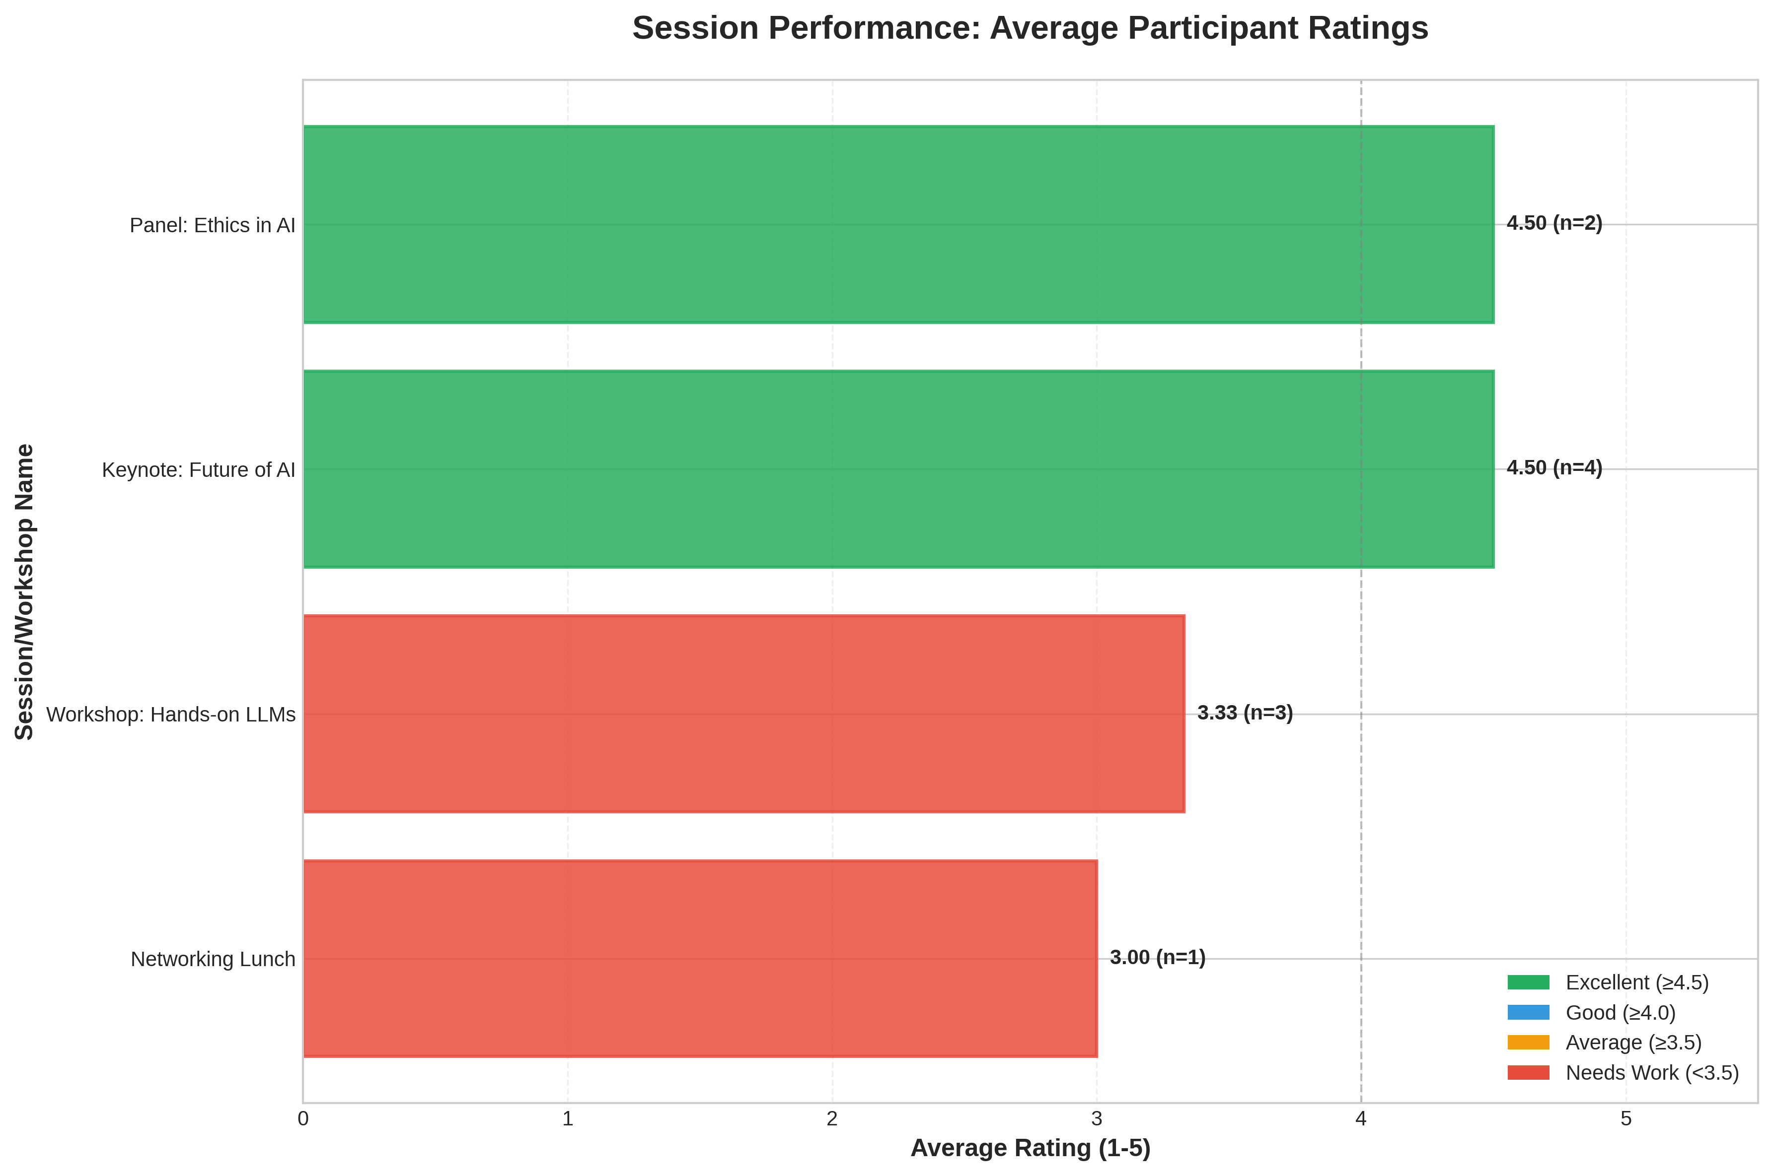
Participant Ratings

Social Media & Links
Facebook | fdc
Instagram | dcs
LinkedIn | fcds

Student Attendance List
S.No. | Name | Branch
1 | John Doe | University of Tech
2 | Jane Smith | State College
3 | Alice Johnson | University of Tech
4 | Bob Brown | Global Corp
5 | Charlie Davis | State College
6 | Diana Evans | Tech Institute
7 | Evan Foster | Global Corp
8 | Fiona Green | University of Tech

Organizers & Coordination
Faculty Coordinator | sdcs
Resource Person | Nathan
Organization | dskn
Organizing Body | Thanks for your message!

Authorization & Approval

Report Prepared By:  scsdf mn  fcd em,  _______________  Signature & Date | Report Approved By:  fdc s  fdcms kfdc  _______________  Signature & Date

