------------------------------------------------------------
DON BOSCO INSTITUTE OF TECHNOLOGY
Premier Automobiles Road, Kurla West, Mumbai - 400070
Department of Computer Engineering
Report on - Ideathon
------------------------------------------------------------
Title: Ideathon
Date:
Time:
Venue:
Target Audience:
No. of Participants Present: 8
No. of Girl Participants Present: 0
No. of Boy Participants Present: 0
Resource Person:
Organization of Recourse Person:
Organizing Department / Committee / Authority: Department of Computer Engineering
Faculty Coordinator:
------------------------------------------------------------
Objectives:
------------------------------------------------------------
Outcomes:
------------------------------------------------------------
Detailed Report:
The Ideathon was conducted successfully with enthusiastic participation.
------------------------------------------------------------
Snapshot of the Event:
[USER_UPLOAD_REQUIRED: GEOTAGGED_PHOTOGRAPH_1]

[USER_UPLOAD_REQUIRED: GEOTAGGED_PHOTOGRAPH_2]
------------------------------------------------------------
Feedback Analysis:
[Analysis generated by AI will be appended here based on data]
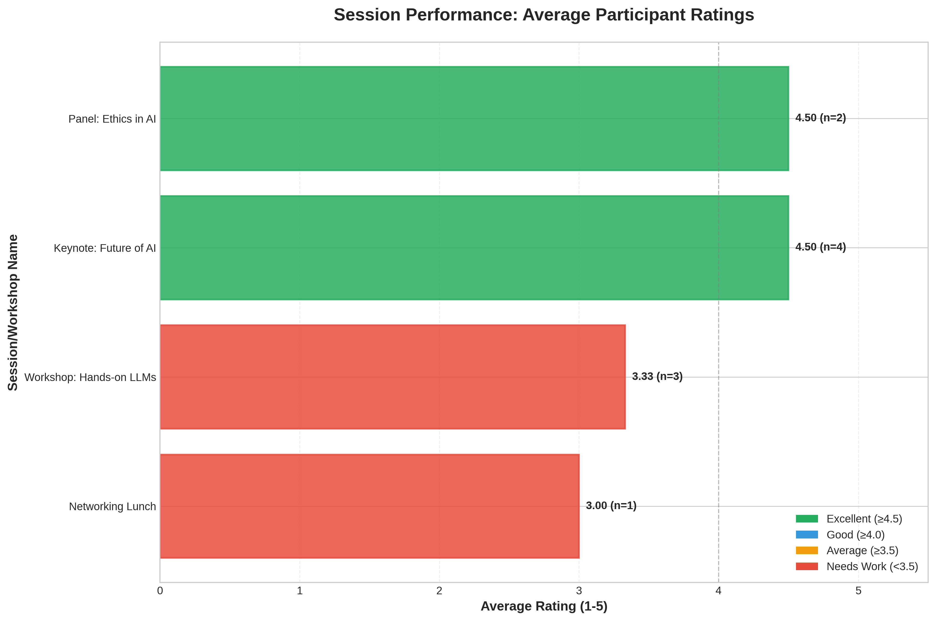
------------------------------------------------------------
Event Poster:
[USER_UPLOAD_REQUIRED: EVENT_POSTER_IMAGE]
------------------------------------------------------------
Social Media Links:
Facebook: N/A, Instagram: N/A, LinkedIn: N/A
------------------------------------------------------------
Registration Details:
No. of DBIT Students: 0
No. of non-DBIT students: 0
------------------------------------------------------------
List of Students Who Attended the Event:
S. No. | Name | Branch
1 | John Doe | University of Tech
2 | Jane Smith | State College
3 | Alice Johnson | University of Tech
4 | Bob Brown | Global Corp
5 | Charlie Davis | State College
6 | Diana Evans | Tech Institute
7 | Evan Foster | Global Corp
8 | Fiona Green | University of Tech
------------------------------------------------------------
Report Approved By:
Name of the Faculty:
Post of the Faculty:
In Institute/ Department/ Student Club/ Chapter/ Professional Body
------------------------------------------------------------
Report Approved By:
Name of the Faculty:
Post of the Faculty:
In Institute/ Department/ Student Club/ Chapter/ Professional Body
------------------------------------------------------------
Report Prepared By:
Name of the Student:
Post of the Student:
In the Student Council/ Student Club/ Chapter/ Professional Body
------------------------------------------------------------
Report Prepared By:
Name of the Student:
Post of the Student:
In the Student Council/ Student Club/ Chapter/ Professional Body
------------------------------------------------------------
END OF REPORT

