**EENG 2910 Project III – Digital System Design**

Design Project 7

Nathan A Ruprecht

Ayodele Ojo

Maher Alsanwi

Yang Qi

Due 02 November 2016

# Introduction:

For our seventh project, we were required to answer theory questions before jumping into the implementation of our processor. We were to read the documents on blackboard titled “SimpleProcessor” and “SimpleProcessorInstSet” to provide answers to the items below.

# Questions and Answers:

1. What are the system requirements?
   1. Requirements for Processor:
      1. Implement add, subtract, multiply, divide and data movement operations (no shortcut on multiplication and division).
      2. Design 3 types of instructions: Data handling and manipulation, branch instruction, and I/O instruction.
   2. Requirements to be addressed in order to complete the project:
      1. Make a table for how to clear, increment, rotate, add, subtract, and move using the basic instruction in Table-1 and 2.
      2. Draw a layout of our processor and its different components.
      3. Draw a block diagram showing interconnections
      4. Write a program for multiplication of 2 numbers
      5. Design a Control Unit that picks up instruction from memory, fetches operands, and feeds them to ALU and store results in DST. In case of branch, load the PC with DST address. In case of display, DST will be forwarded to the LEDs on the FPGA.
2. What are the functional blocks required?

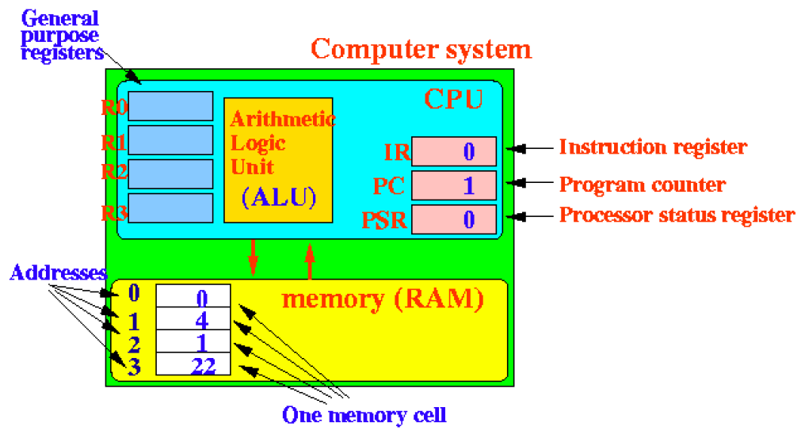

1. General purpose register.
2. Arithmetic logic units (ALU).
3. CPU

i. IR - Instruction register

ii. PC - Program counter

iii. PSR - Processor status register

d. Memory (RAM)

i. Addresses

ii. One memory cell

1. What is the size of each of your instructions?
   1. 8-bit instructions
      1. Including the OP code, carriers, and addresses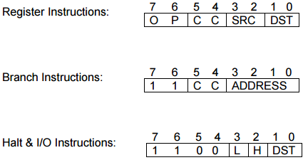
2. What all controls (e.g. Load address, load data, start, reset, etc.), inputs and outputs can you have on the Basys2 board? For example toggle switches may be used for providing system inputs (control or data).
   1. Switches
      1. Instruction set
      2. Input of Data
      3. 8 slide switches
   2. 4 Push Buttons
      1. Start/pause/reset
   3. 8 LEDs or 4-digit, 7 segment display
      1. Output of data

d. Xilinx Spartan 3E FPGA

i. CPU

1. Provide a high-level block diagram/architecture of the simple processor and its main components.

Untitled Diagram.png

1. Prepare a table of the following instructions: CLEAR (you can subtract a register from itself to clear it), INCREMENT, ROTATE, ADD, SUBTRACT, and MOVE using the basic instructions in Table-1 and CC bit information in Table-2 (refer to “SimpleProcessorInstSet”). Many powerful arithmetic and logical instructions can be constructed using these 2 tables.
2. CLEAR - register instruction - 10 00 SRC SRC
3. INCREMENT - register instruction - 00 01 SRC DST
4. ROTATE
   1. left
      1. 01 00 SRC SRC
      2. 00 10 SRC DST
   2. right
      1. Shift left by (#bits -1) times
5. ADD - register instruction - 01 00 SRC DST
6. SUBTRACT - register instruction - 10 00 SRC DST
7. MOVE - register instruction
   1. CLEAR - 10 00 DST DST
   2. ADD - 01 00 SRC DST

# References:

None

# Source Code:

None