EENG 3910: Project V – Digital Signal Processing System Design

Assignment 5

Due 21 March 2016

Nathan Ruprecht

UNT – Electrical Engineering

***Introduction***

The purpose of assignment 4 was to use SSI/SPI along with ADC/DAC. We were able to see the effects of different sample frequencies on the signal by using an oscilloscope as well as a LPF to clean it up.

***Results and Discussion***

Problem 1 Part 1: Simulation and implementation of input and output interface circuits.

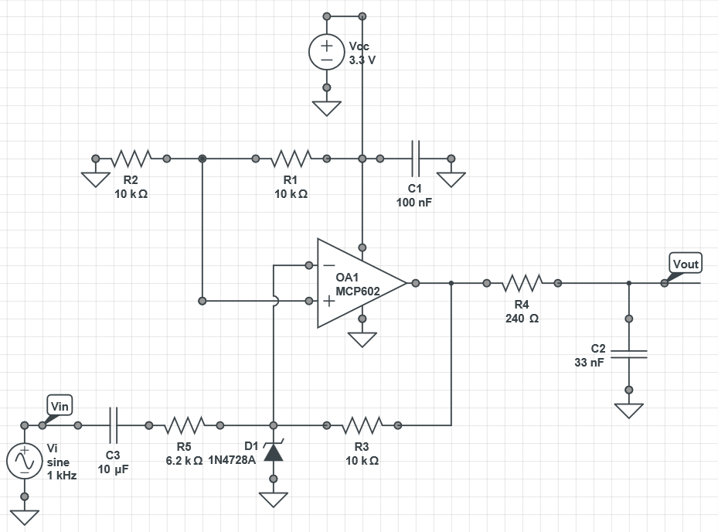

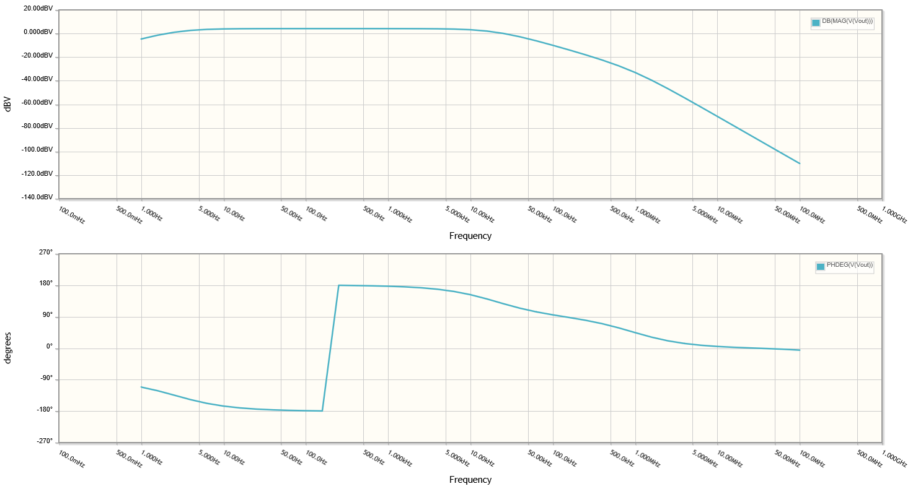

Problem 1 Part 2: Experimentation with audio signals.

***Summary and Conclusion***

I have no idea what I’m doing.

Modified Source Code: